Software Requirements Specification
for
Stock Market Dashboard
Version 1.0 approved
Prepared by
Vaishnavi Mishra(16IT145)
Farris Suhale (16IT218)
Software Engineering (IT350) Mini-Project
Date created: 17/01/2019
Table of Contents
Table of Contents ii
Revision History ii
1. Introduction 1
1.1 Purpose 1
1.2 Document Conventions 1
1.3 Intended Audience and Reading Suggestions 1
1.4 Product Scope 1
1.5 References 1
2. Overall Description 2
2.1 Product Perspective 2
2.2 Product Functions 2
2.3 User Classes and Characteristics 2
2.4 Operating Environment 2
2.5 Design and Implementation Constraints 2
2.6 User Documentation 2
2.7 Assumptions and Dependencies 3
3. External Interface Requirements 3
3.1 User Interfaces 3
3.2 Hardware Interfaces 3
3.3 Software Interfaces 3
3.4 Communications Interfaces 3
4. System Features 4
4.1 System Feature 1 4
4.2 System Feature 2 (and so on) 4
5. Other Nonfunctional Requirements 4
5.1 Performance Requirements 4
5.2 Safety Requirements 5
5.3 Security Requirements 5
5.4 Software Quality Attributes 5
5.5 Business Rules 5
6. Other Requirements 5
Appendix A: Glossary 5
Appendix B: Analysis Models 5
Appendix C: To Be Determined List 6

Revision History
Name | Date | Reason For Changes | Version
Created SRS | 17.01.19 | Initial commit | 1.0
SRS structuring | 23.02.19 | Structured document using IEEE format | 1.0

Introduction

Purpose
Stock Market Dashboard is a website with real time stock prices, stock history of selected stocks, live news updates related to stocks and chatroom facilities for discussing with experts. Login capabilities enable personalization. The purpose of this document is to present a detailed description of the E-commerce web application. It will explain the purpose and features of the system, the interfaces of the system, what the system will do, the constraints under which it must operate and how the system will react to external stimuli. This document is intended for both the stakeholders and the developers of the system.
Release 1, revision 1.

Document Conventions
- The document is prepared in standard IEEE template using Google Docs .
- All the headings in the document are in 18 point Times New Roman with single spacing.
- The sub-headings are 14 point Times New Roman.
- The font of the corresponding body is 11 point Arial.

Intended Audience and Reading Suggestions
The Software Requirements Specification document provided in intended for a plethora of
readers. These include and not limited to,Developers,Project Managers,Database
Managers,Marketing Staff,Quality Assurance testers,Interface Designers,Documentation Writers
and the Users.
The intended order of reading to be followed is to start from the beginning,followed by the
particular sections intended for each of the different types of readers.
For example,it is imperative for a Developer or Quality Assurance tester to read all the
sections:Introduction,Overall Description,External Interface Requirements,System
Features,Non-functional Requirements and Other Requirements along with the glossary,as they
need to understand the project thoroughly to implement it further or test the various features that
the project offers.
However,a User,Marketing Employee or Manager who will not directly be affecting the
development of the project need not have a technical understanding of the project.They will
however be required to read the sections of:Introduction,Overall Description and System
Features to gain a good understanding of the workings of the project.

A Designer would have to understand the project in order to create the design language and
features in the User Interface,therefore the sections pertinent to him/her are:Introduction,Overall
Description,External Interface Requirements and System Features.

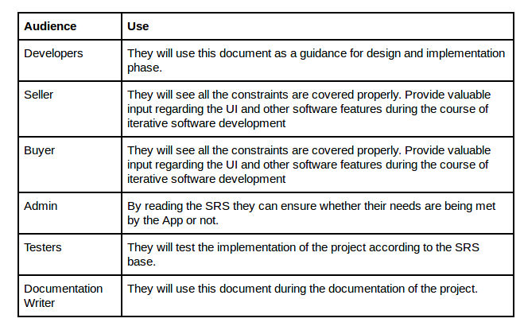

Product Scope
This software system will be a Web Application which is created for users to check real time stock prices along with stock history of selected stocks, live news updates related to stocks and chatroom facilities. This helps in better understand of the stock market and understanding what to invest in when.

References
IEEE. IEEE Std 830-1998 IEEE Recommended Practice for Software Requirements
Specifications. IEEE Computer Society, 1998.

Overall Description

Product Perspective
The product originated from our interest in the stock market but lack of understanding of it. Using financial experts and graphical displays stock market trends can be analyzed more easily. This is our replacement for existing stock market dashboards as real-time news updates enable better up-to-date decisions.
This software system will be a Web Application which is created for users to check real time stock prices along with stock history of selected stocks, live news updates related to stocks and chatroom facilities. This helps in better understand of the stock market and understanding what to invest in when.

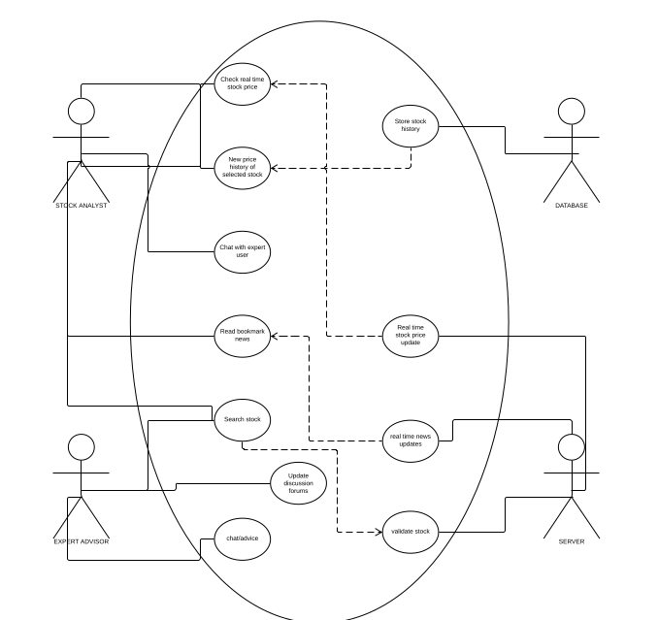

Product Functions
Functions of our software include:
1. View live stock prices
2. View stock price history and trends
3. View real time news updates related to stocks
4. Chat with experts or other users
5. Login and personalize- bookmark stocks

User Classes and Characteristics
User classes that would use this software:
1. Stock market analysts – login functions to save favourite stocks.
2. Financial experts – provide advise
3. Novice user requiring real time stock market updates- will require pictorial graphs for better understanding of financial trends. Require advise of financial experts
The most important user class of these is the Stock market analyst.

Operating Environment
Regarding Hardware and Software environments,the application has been optimized to run on
all browsers. It has also been optimized to run on all devices,including Personal
Computers,Laptops,Tablets and Mobile Phones.
The only other software required to run the application is any Web Browser(Mozilla
Firefox,Google Chrome,Apple Safari,Opera etc).
The application is not resource- or graphics-intensive, so there are no practical hardware constraints. The application will rely on Django for the backend and Bootstrap for the frontend.

Design and Implementation Constraints
Our web application, being easy to use and requiring no programming, designing or financial skills, is usable by all users.
No items or issues will limit the options available to the developers. These include: corporate or regulatory policies; hardware limitations (timing requirements, memory requirements); interfaces to other applications; specific technologies, tools, and databases to be used; parallel operations; language requirements; communications protocols; security considerations; design conventions or programming standards.
Simply opening up the dashboard will get you started.

User Documentation
SRS will be delivered along with the website.
<List the user documentation components (such as user manuals, on-line help, and tutorials) that will be delivered along with the software. Identify any known user documentation delivery formats or standards.>

Assumptions and Dependencies
We assume that the user is capable physically and mentally of accessing the internet and therefore our application.

External Interface Requirements

User Interfaces
The website is user friendly, easily navigable by novice users and intuitive. The colour schemes, positioning of text, images, news updates etc are all aesthetic, understandable and follows logical sequencing or positioning. Standard buttons and functions (e.g., help) will appear on every screen, keyboard shortcuts, error message display standards, and so on and any user familiarizing with this website will understand it easily and adapt to using it.
<Describe the logical characteristics of each interface between the software product and the users. This may include sample screen images, any GUI standards or product family style guides that are to be followed, screen layout constraints, standard buttons and functions (e.g., help) that will appear on every screen, keyboard shortcuts, error message display standards, and so on. Define the software components for which a user interface is needed. Details of the user interface design should be documented in a separate user interface specification.>

Hardware Interfaces
Our website deals with front end and therefore hardware interfaces are irrelevant here.
<Describe the logical and physical characteristics of each interface between the software product and the hardware components of the system. This may include the supported device types, the nature of the data and control interactions between the software and the hardware, and communication protocols to be used.>

Software Interfaces

<Describe the connections between this product and other specific software components (name and version), including databases, operating systems, tools, libraries, and integrated commercial components. Identify the data items or messages coming into the system and going out and describe the purpose of each. Describe the services needed and the nature of communications. Refer to documents that describe detailed application programming interface protocols. Identify data that will be shared across software components. If the data sharing mechanism must be implemented in a specific way (for example, use of a global data area in a multitasking operating system), specify this as an implementation constraint.>

Communications Interfaces
Chatroom facilities require a communication-based API known as
<Describe the requirements associated with any communications functions required by this product, including e-mail, web browser, network server communications protocols, electronic forms, and so on. Define any pertinent message formatting. Identify any communication standards that will be used, such as FTP or HTTP. Specify any communication security or encryption issues, data transfer rates, and synchronization mechanisms.>

System Features
<This template illustrates organizing the functional requirements for the product by system features, the major services provided by the product. You may prefer to organize this section by use case, mode of operation, user class, object class, functional hierarchy, or combinations of these, whatever makes the most logical sense for your product.>

Live Stock Prices
4.1.1 Description and Priority
This high priority feature is the focus of our website. Real-time stock prices are fetched by the server using an API and returned to the user at a time interval that is selectable by the user.
<Provide a short description of the feature and indicate whether it is of High, Medium, or Low priority. You could also include specific priority component ratings, such as benefit, penalty, cost, and risk (each rated on a relative scale from a low of 1 to a high of 9).>
4.1.2 Stimulus/Response Sequences
<List the sequences of user actions and system responses that stimulate the behavior defined for this feature. These will correspond to the dialog elements associated with use cases.>
4.1.3 Functional Requirements
<Itemize the detailed functional requirements associated with this feature. These are the software capabilities that must be present in order for the user to carry out the services provided by the feature, or to execute the use case. Include how the product should respond to anticipated error conditions or invalid inputs. Requirements should be concise, complete, unambiguous, verifiable, and necessary. Use “TBD” as a placeholder to indicate when necessary information is not yet available.>

<Each requirement should be uniquely identified with a sequence number or a meaningful tag of some kind.>

REQ-1:
REQ-2:

System Feature 2 (and so on)

Other Nonfunctional Requirements

Performance Requirements
- Data from the server should be fetched within 2 seconds.
- Query results must return within 5 seconds
- News updates must be fetched within 2 seconds

<If there are performance requirements for the product under various circumstances, state them here and explain their rationale, to help the developers understand the intent and make suitable design choices. Specify the timing relationships for real time systems. Make such requirements as specific as possible. You may need to state performance requirements for individual functional requirements or features.>

Safety Requirements
- Under failure, system should be able to come back at normal operation in one or two hours.
- Stock prices should be made available within 5 seconds of change in actual index

<Specify those requirements that are concerned with possible loss, damage, or harm that could result from the use of the product. Define any safeguards or actions that must be taken, as well as actions that must be prevented. Refer to any external policies or regulations that state safety issues that affect the product’s design or use. Define any safety certifications that must be satisfied.>

Security Requirements
- All external communications between the data’s server and client must be encrypted.
- All data must be stored and protected.

<Specify any requirements regarding security or privacy issues surrounding use of the product or protection of the data used or created by the product. Define any user identity authentication requirements. Refer to any external policies or regulations containing security issues that affect the product. Define any security or privacy certifications that must be satisfied.>

Software Quality Attributes
- The website is easy to use.
- All the features present in the website are easy to locate.
- The website uses simple English so that the user does not get confused with the terms

<Specify any additional quality characteristics for the product that will be important to either the customers or the developers. Some to consider are: adaptability, availability, correctness, flexibility, interoperability, maintainability, portability, reliability, reusability, robustness, testability, and usability. Write these to be specific, quantitative, and verifiable when possible. At the least, clarify the relative preferences for various attributes, such as ease of use over ease of learning.>

Business Rules
- System Admin - It will be the system administrator. He will maintain the overall website.
- Stock analyst - It includes the people who will view stock-related information.
- Financial expert- Academia who gives advice about stocks and trends

<List any operating principles about the product, such as which individuals or roles can perform which functions under specific circumstances. These are not functional requirements in themselves, but they may imply certain functional requirements to enforce the rules.>

Other Requirements
<Define any other requirements not covered elsewhere in the SRS. This might include database requirements, internationalization requirements, legal requirements, reuse objectives for the project, and so on. Add any new sections that are pertinent to the project.>
Appendix A: Glossary
<Define all the terms necessary to properly interpret the SRS, including acronyms and abbreviations. You may wish to build a separate glossary that spans multiple projects or the entire organization, and just include terms specific to a single project in each SRS.>
Appendix B: Analysis Models
<Optionally, include any pertinent analysis models, such as data flow diagrams, class diagrams, state-transition diagrams, or entity-relationship diagrams.>
Appendix C: To Be Determined List
<Collect a numbered list of the TBD (to be determined) references that remain in the SRS so they can be tracked to closure.>

