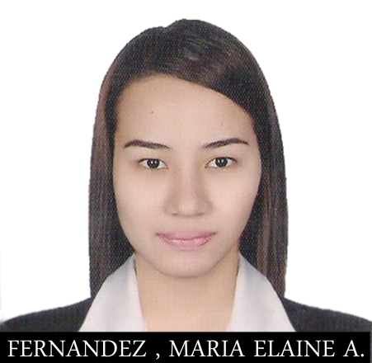**Maria Elaine A. Fernandez, RN**

Blk1 Lot 4 Tangili Barnarty Subdivision

Bag-bag Novalichez Quezon City

Fernandezmariaelaine@gmail.com

+639279054801

**Objective**

To obtain a career opportunity where i can apply my diversified background and skills inn meeting the organization’s goals that will enable me to grow professionally as person in the industry.

**Qualification and Skills**

* Able to establish rapport with a variety of clientele and maintain a calm professional manner in dealing with a difficult situation encounter.
* Highly motivated, reliable and committed to professional standards.
* Enthusiastic, quick to learn and willing to undergo rigid training.
* High sense of responsibility.
* Skilled on verbal and written communication skill.
* Goal oriented and competent.
* Computer Literate : MS office, excel , powerpoint.

**Education**

**Our Lady of Fatima University**

Formerly Fatima Medical Science foundation Inc,

Valuenzuela City Philippines

Class Attended: 2007-2011

Degree: Bachelor of Science in Nursing

**Licenses and Certifications**

* Registered Nurse

2012

* Intravenous Therapy Nurse

Novaliches General Hospital

2012

* BLS-CPR Health Care Provider

Dr Fe Del Mundo Training Center

2014

* Advance Cardiac Life Support Provider

Dr Fe Del Mundo Training Center

2014

* Licensed First Aider

Dr Fe Del Mundo Training Center

2014

* ECG and Pharmacology Course

Dr Fe Del Mundo Training Center

2014

Maria Elaine A. Fernandez

Applicant