Android Kotlin-Hello World (Part 1)

In this article you will learn how to create first Android app (Hello World app) using Android Kotlin.

**Introduction:**

Kotlin is a new programming language developed by JetBrains, runs on Java Virtual Machine (JVM). Google announced Kotlin as its official programming language for Android app development.

From [Kotlin official site](https://kotlinlang.org/docs/reference/android-overview.html), it has following advantages:

* **Compatibility**: Kotlin is fully compatible with JDK 6, ensuring that Kotlin applications can run on older Android devices with no issues. The Kotlin tooling is fully supported in Android Studio and compatible with the Android build system.
* **Performance**: A Kotlin application runs as fast as an equivalent Java one, thanks to very similar bytecode structure. With Kotlin's support for inline functions, code using lambdas often runs even faster than the same code written in Java.
* **Interoperability**: Kotlin is 100% interoperable with Java, allowing to use all existing Android libraries in a Kotlin application. This includes annotation processing, so databinding and Dagger work too.
* **Footprint**: Kotlin has a very compact runtime library, which can be further reduced through the use of ProGuard. In a [real application](https://blog.gouline.net/kotlin-production-tales-62b56057dc8a), the Kotlin runtime adds only a few hundred methods and less than 100K to the size of the .apk file.
* **Compilation Time**: Kotlin supports efficient incremental compilation, so while there's some additional overhead for clean builds, [incremental builds are usually as fast or faster than with Java](https://medium.com/keepsafe-engineering/kotlin-vs-java-compilation-speed-e6c174b39b5d).
* **Learning Curve**: For a Java developer, getting started with Kotlin is very easy. The automated Java to Kotlin converter included in the Kotlin plugin helps with the first steps. [Kotlin Koans](https://kotlinlang.org/docs/tutorials/koans.html) offer a guide through the key features of the language with a series of interactive exercises.

Let’s get started.

**Step 1:**

Create a new project. In Android Studio, go to **File, New,** then **New** **Project.** Give application name, company domain, specify its location, and finally important thing select **Include Kotlin support.**

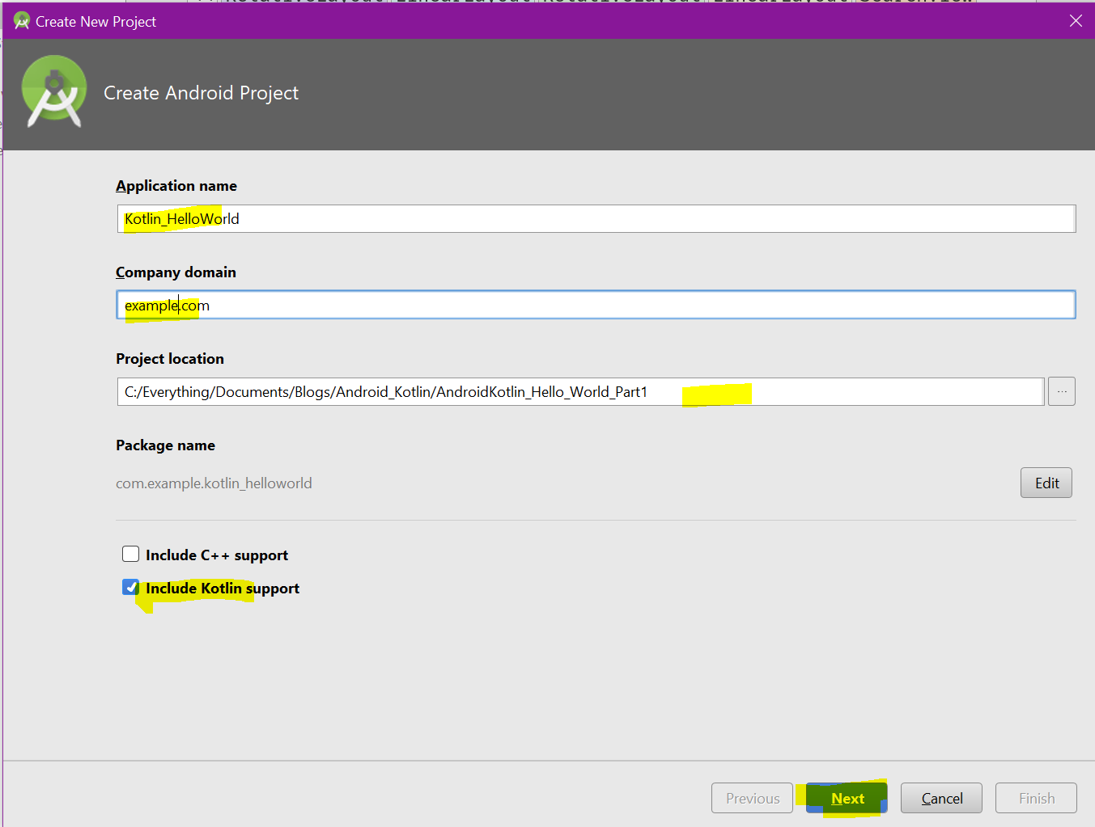

Click Next. Select target devices. I have set API version to 15.

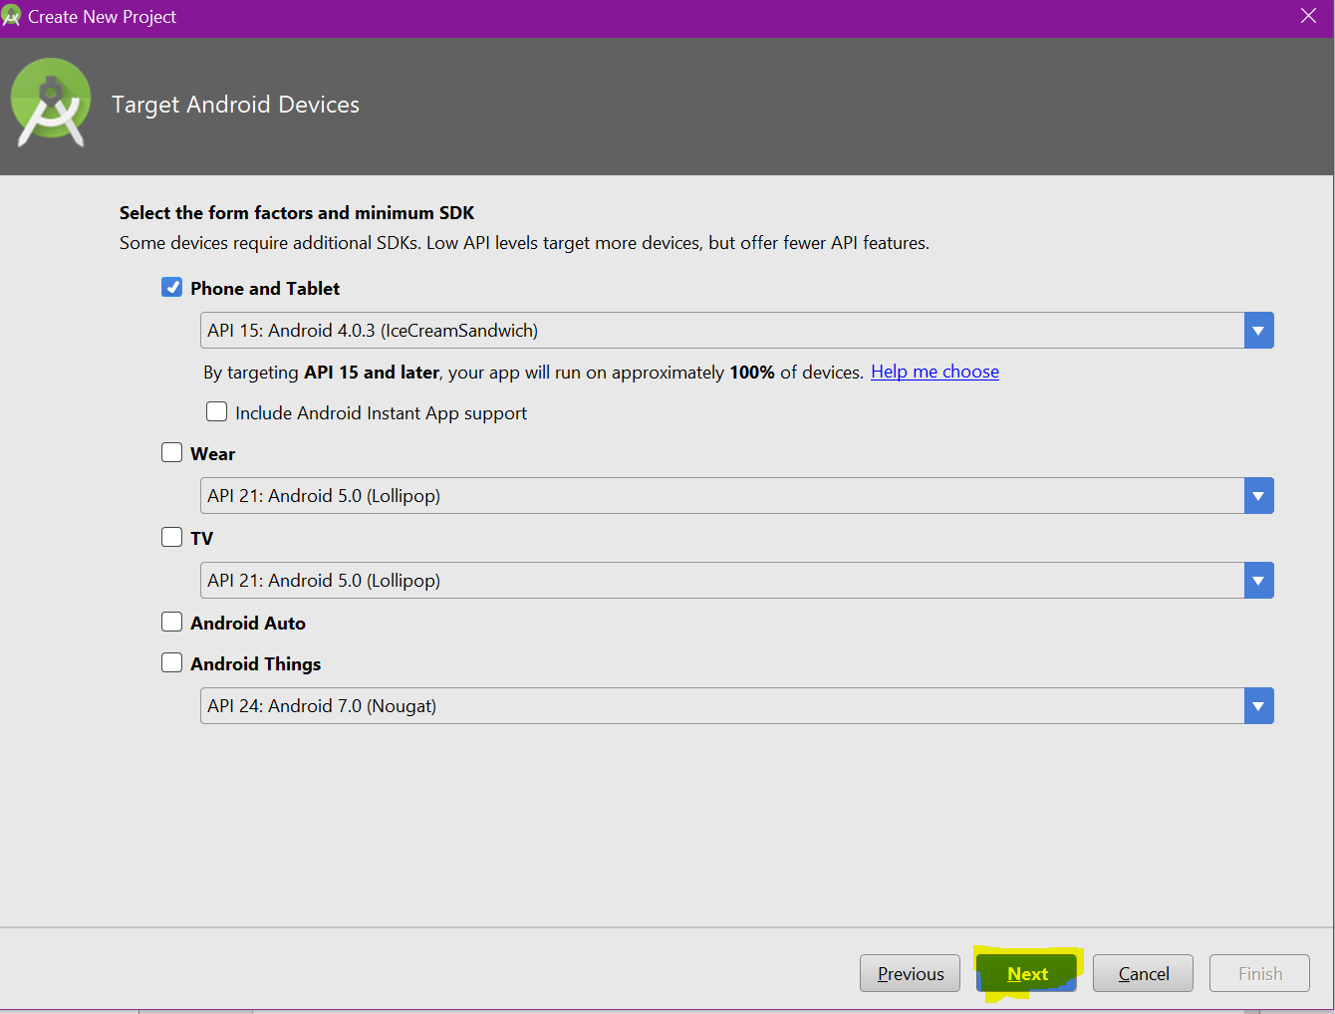

Click Next. Select Empty Activity.

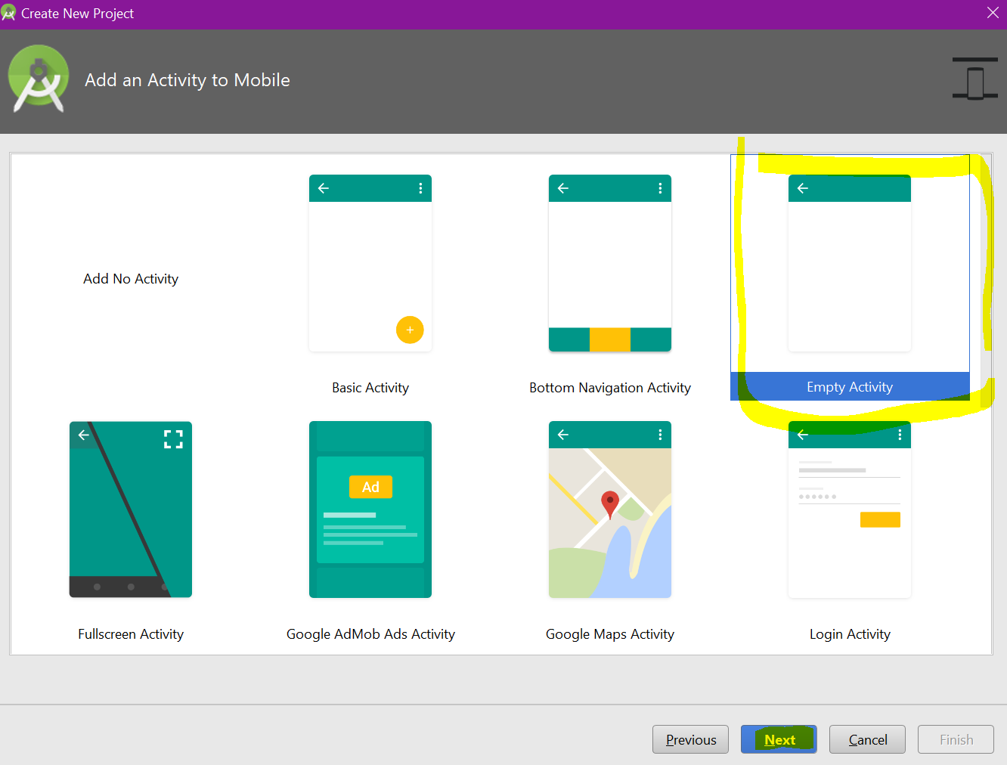

**Step 2:**

You have created your application. Now in the Project solution explorer you’ll see **MainActivity.kt with its activity_main.xml inside layout folder.**

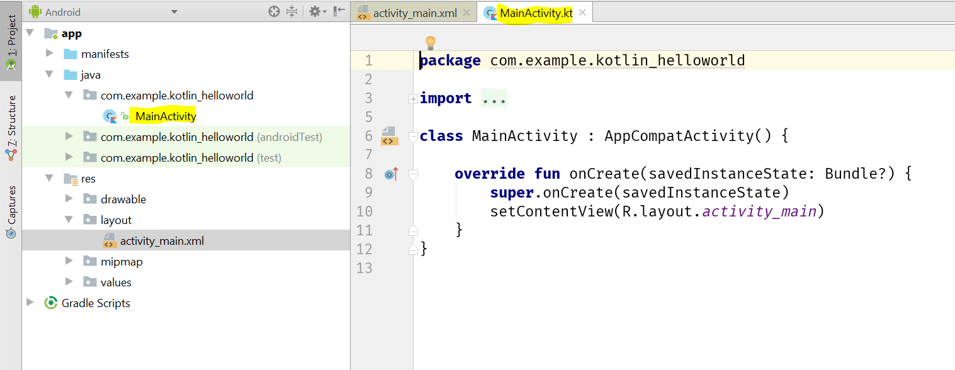

**Code snippet:**

**class** MainActivity : AppCompatActivity() {  
  
 **override fun** onCreate(savedInstanceState: Bundle?) {  
 **super**.onCreate(savedInstanceState)  
 setContentView(R.layout.activity_main)  
 }  
}

**We have a TextView, lets change default text “Hello world” to some other texts in activity_main.xml.**

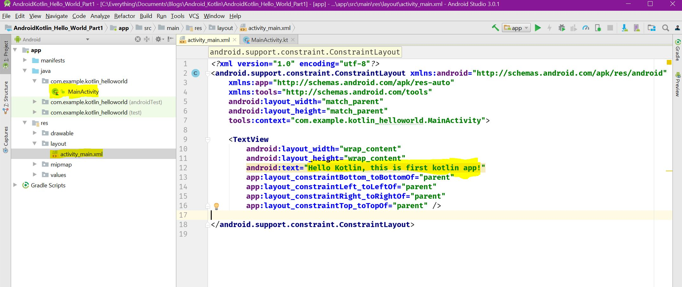

Code snippet:

*<?***xml version="1.0" encoding="utf-8"***?>*<**android.support.constraint.ConstraintLayout xmlns:android="http://schemas.android.com/apk/res/android"  
 xmlns:app="http://schemas.android.com/apk/res-auto"  
 xmlns:tools="http://schemas.android.com/tools"  
 android:layout_width="match_parent"  
 android:layout_height="match_parent"  
 tools:context="com.example.kotlin_helloworld.MainActivity"**>  
  
 <**TextView  
 android:layout_width="wrap_content"  
 android:layout_height="wrap_content"  
 android:text="Hello Kotlin, this is first kotlin app!"  
 app:layout_constraintBottom_toBottomOf="parent"  
 app:layout_constraintLeft_toLeftOf="parent"  
 app:layout_constraintRight_toRightOf="parent"  
 app:layout_constraintTop_toTopOf="parent"** />  
  
</**android.support.constraint.ConstraintLayout**>

**Step 3:**  
Now we are ready to run our application. Press Shift+ F10 to run the application.

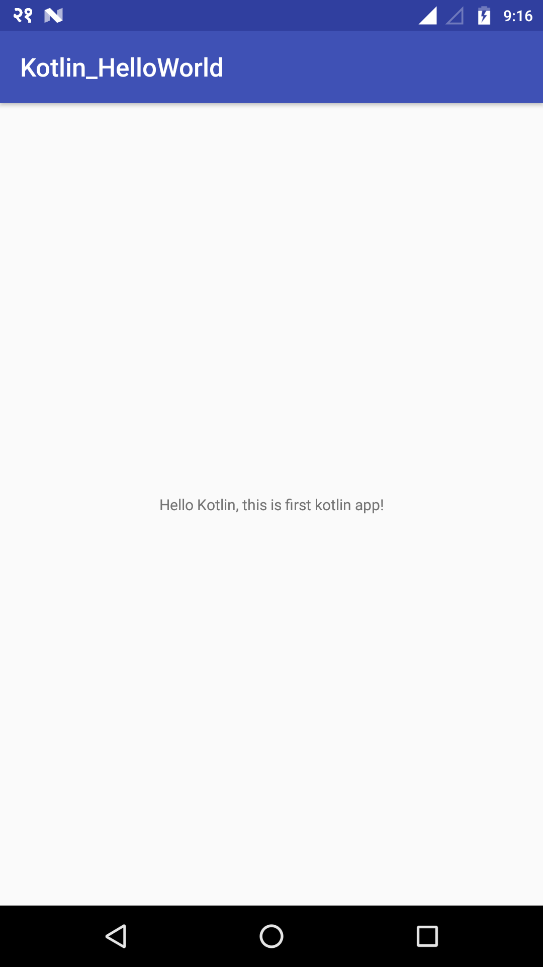

You can get this project here in [Github](https://github.com/olikishor/Android_Kotlin_HelloWorld).

That’s it.

Thanks. Happy Coding.