Abstract
Driver drowsiness and distracted driving are among the leading contributors to traffic accidents worldwide, posing significant threats to road safety. This dissertation proposes a real-time, vision-based driver monitoring system that integrates deep learning–based object detection with geometric facial feature modelling to achieve robust and safety-oriented driver state assessment.
The proposed framework formulates driver monitoring as a temporal risk estimation problem rather than a single-frame classification task. A dual-model architecture based on YOLOv5 is designed to decouple drowsiness detection and distraction detection tasks. The first branch performs facial localisation and fatigue-related behaviour recognition, while the second branch detects distracted behaviours such as mobile phone usage and drinking. To enhance interpretability and robustness, geometric features including Eye Aspect Ratio (EAR), Mouth Aspect Ratio (MAR), and PERCLOS are incorporated for fatigue modelling. A sliding-window temporal aggregation mechanism is introduced to suppress frame-level noise and capture behavioural continuity.
At the decision level, a linear weighted risk fusion strategy is proposed to integrate fatigue indicators and distraction confidence scores. This additive formulation reflects the cumulative nature of driver risk and maintains system transparency, controllability, and real-time efficiency. Unlike competitive normalisation or neural fusion approaches, the proposed method prioritises interpretability and recall-oriented optimisation, aligning with safety-critical design principles.
Comprehensive experiments are conducted on the Driver Drowsiness Dataset (DDD) and the StateFarm Distracted Driver Detection Dataset. Comparative analysis of YOLOv5, YOLOv8, and Faster R-CNN demonstrates that YOLOv5 achieves the highest recall (0.95) in drowsiness detection, which is prioritised due to the asymmetric safety cost of missed detections. In distraction detection, the system achieves perfect recall across categories while maintaining acceptable localisation performance (mAP@0.5 = 0.602). Real-time evaluation confirms that the dual-model system operates near real-time under practical computational constraints.
Overall, the proposed system achieves a balanced trade-off among detection sensitivity, computational efficiency, interpretability, and deployment feasibility. The research provides a practical and safety-oriented solution for vision-based driver monitoring systems and offers a foundation for future multimodal integration and embedded deployment optimisation.

Content
Abstract 1
Content 3
Figure Content 7
Table Content 8
Chapter 1 Introduction 9
1.1 Background 9
1.2 Motivation 10
1.3 Objectives and Specifications 11
1.4 Organisations 12
Chapter 2 Related Work 14
2.1 Overview of Driving Drowsiness Detection Methods 14
2.2 Drowsiness Detection Method Based on Vehicle Behaviour 15
2.3 Drowsiness Detection Method Based on Physiological Signals 15
2.4 Drowsiness Detection Method Based on Vision 16
2.4.1 Methods Based on Handcrafted Geometric Feature 16
2.4.2 Methods Based on Deep Learning 16
2.5 Multi-feature Fusion Method 17
2.6 Comparative Analysis of Existing Methods 18
Chapter 3 Methodology 19
3.1 Problem Formulation and System Overview 19
3.2 Object Detection Architectures for Driver State Analysis 20
3.2.1 YOLOv5 20
3.2.2 YOLOv8 21
3.2.3 Faster R-CNN 22
3.2.4 Preliminary Comparison of Detection Architectures 23
3.3 Facial Key Point Detection and Geometric Feature Extraction 24
3.4 Time Modelling and Risk Scoring Mechanism 26
3.4.1 Temporal Behaviour Modelling 26
3.4.2 Linear Weighted Risk Fusion 27
3.4.3 Comparison with SoftMax-Based Fusion 28
3.4.4 Comparison with Neural Fusion Mechanisms 28
3.4.6 Weight Parameter Calibration 29
3.5 Evaluation Metrics 29
3.5.1 Confusion Matrix and Basic Definitions 30
3.5.2 Precision 30
3.5.3 Recall 30
3.5.4 F1-Score 31
3.5.5 Intersection-over-Union (IoU) 31
3.5.6 Average Precision (AP) 32
3.5.7 Mean Average Precision (mAP) 32
3.5.8 Metric Interpretation in Driver Monitoring Context 33
3.6 Model Training Strategy and Optimisation 33
3.6.1 Transfer Learning and Weight Initialisation 33
3.6.2 Layer Freezing Strategy 34
3.6.3 Optimiser Selection 34
3.6.4 Learning Rate Scheduling 35
3.6.5 Regularisation and Overfitting Control 35
3.6.6 Handling Class Imbalance 37
3.6.7 Batch Size and Computational Consideration 37
3.7 Real-time Deployment and Performance Optimisation 38
Chapter 4 System Implementation 39
4.1 System Structure 39
4.2 Model Deployment and Reasoning Realisation 40
4.3 Fusion Score Design 41
4.4 Graphical User Interface (UI) Design 42
4.4.1 GUI of Drowsiness Detection 43
4.4.2 GUI of Distraction Detection 45
4.4.3 Anti-interference function 47
Chapter 5 Project Results 48
5.1 Performance of Drowsiness Detection Model 48
5.1.1 Driver Drowsiness Dataset Overview 48
5.1.2 Training Performance Analysis of YOLOv5 49
5.1.3 Training Performance Analysis of YOLOv8 51
5.1.4 Training Performance Analysis of Faster R-CNN 53
5.1.5 Model Compare 54
5.2 Performance of Distraction Detection Model 57
5.2.1 StateFarm Distracted Driver Detection Dataset Overview 57
5.2.2 Results and Performance Evaluation 58
5.3 Real-time Performance Analysis 62
Chapter 6 Conclusions and future work 63
6.1 Conclusion 63
6.2 Limitations 64
6.3 Future Work 64
References 66

Figure Content
Figure 1 The architecture of YOLOv5 22
Figure 2 The architecture of YOLOv8 23
Figure 3 The architecture of Faster R-CNN 24
Figure 4 68 Facial Landmark 25
Figure 5 The Geometric Origin of EAR 26
Figure 6 The Geometric Origin of MAR 27
Figure 7 System Architecture Diagram 41
Figure 8 System GUI in NORMAL status 44
Figure 9 Close eyes detected 45
Figure 10 Yawning detected 45
Figure 11 System in HIGH RISK status 46
Figure 12 Drinking water detected 47
Figure 13 Using phone detected 47
Figure 14 Two faces detected 48
Figure 15 Pictures in Driver Drowsiness Dataset 50
Figure 16 Training result curve of YOLOv5 50
Figure 17 Prediction result of YOLOv5 51
Figure 18 Training result curve of YOLOv8 52
Figure 19 Prediction result of YOLOv8 53
Figure 20 Training result curve of Faster R-CNN 54
Figure 21 Training Stability Comparison 56
Figure 22 Computational Cost vs Performance 57
Figure 23 Pictures in StateFarm Distracted Driver Detection Dataset 59
Figure 24 Training result curve of distraction detection model 59
Figure 25 Prediction result of distraction detection model 60

Table Content
Table 1 Comparative Analysis of Existing Methods 19
Table 2 Comparison Table of Hyperparameters for Three Model Networks 24
Table 3 Scores for different detections 42
Table 4 Risk Level Classification 43
Table 5 Test results of YOLOv5, YOLOv8 and Faster R-CNN 55
Table 6 Test results of distraction detection 60

Chapter 1
Introduction

1.1 Background
Road traffic accidents remain a major global public health concern. According to the World Health Organization (WHO), approximately 1.19 million people die each year as a result of road traffic crashes, and tens of millions more suffer non-fatal injuries, many of which lead to long-term disability[1]. Road traffic injuries are currently among the leading causes of death for individuals aged between 5 and 29 years, highlighting the critical importance of improving driving safety worldwide.
Among the various contributing factors to traffic accidents, driver drowsiness has been identified as a significant and often underestimated cause[2]. Reports from the National Highway Traffic Safety Administration (NHTSA) indicate that drowsy driving is responsible for approximately 9%–20% of serious road accidents in the United States[3]. Furthermore, drowsy-related crashes are more likely to result in severe injuries or fatalities compared with other types of accidents, due to delayed reaction times and the absence of evasive manoeuvres prior to impact.
From a physiological and cognitive perspective, drowsiness impairs alertness, vigilance, attention, and decision-making capability[4]. Research has shown that prolonged wakefulness can produce performance degradation comparable to alcohol intoxication [5]. For instance, staying awake for more than 18 hours may result in cognitive impairment similar to a blood alcohol concentration (BAC) of 0.05%, which approaches legal driving limits in many countries.
Typical manifestations of driver drowsiness include prolonged eye closure, increased blink duration, frequent yawning, head nodding, and reduced responsiveness to external stimuli[6]. These behavioural cues often develop gradually, making early detection particularly challenging. Drowsiness is especially prevalent in scenarios involving long-duration driving, night-time driving, and monotonous road environments, where drivers may transition from an alert state to a drowsiness state without conscious awareness[7].
Given the significant social, economic, and safety implications of drowsiness-related crashes, the development of reliable and real-time driver drowsiness detection systems has become an important research topic in the field of intelligent transportation systems and advanced driver assistance systems.

1.2 Motivation
Despite notable advances in vision-based driver drowsiness detection, several critical challenges remain unresolved, particularly in real-world in-vehicle deployment[8]. Practical driving environments involve substantial variations in illumination conditions, head pose, facial occlusions, and inter-subject differences, which frequently degrade system robustness[9].
Another challenge lies in balancing detection accuracy with computational efficiency. Although deep learning models have achieved remarkable recognition performance, many architectures remain computationally intensive and may not satisfy real-time constraints on embedded platforms commonly used in in-vehicle systems[10].
Furthermore, many existing studies focus on a single drowsiness-related cue, such as eye closure or yawning, as the sole indicator of driver fatigue[11]. However, drowsiness manifests through multiple behavioural cues and may co-occur with risky behaviours such as mobile phone use, drinking, or smoking[12]. These behaviours not only indicate reduced vigilance but may also occlude facial features, complicating detection tasks.
Recent developments in Intelligent Transportation Systems (ITS) and Advanced Driver Assistance Systems (ADAS) have further accelerated the demand for reliable Driver Monitoring Systems (DMS), and regulatory bodies such as the European Union have begun mandating driver monitoring functionalities in new vehicle models[13]. This regulatory and technological trend highlights the importance of developing comprehensive, robust, and real-time drowsiness detection systems.
Furthermore, most existing studies focus on a single drowsiness-related cue, such as eye closure or yawning, while overlooking the multi-dimensional and dynamic nature of driver fatigue. In real-world scenarios, drowsiness may co-occur with other risky behaviours, including mobile phone usage or drinking, which not only indicate reduced vigilance but may also obscure facial features. However, such behaviours are often treated independently rather than integrated into a unified risk assessment framework.
Therefore, there is a clear need for a comprehensive, efficient, and real-time vision-based system capable of integrating multiple behavioural cues and addressing practical deployment challenges.

1.3 Objectives and Specifications
The primary objective of this dissertation is to design, implement, and systematically evaluate a vision-based driver drowsiness detection system that is both accurate and suitable for real-time in-vehicle deployment. The proposed system aims to address the limitations of existing approaches by integrating multiple visual cues related to driver drowsiness and risky driving behaviours within a unified and efficient framework. To achieve this overarching goal, the specific research objectives of this study are defined as follows:
- To investigate and characterize visual indicators of driver drowsiness, with a particular focus on eye blinking patterns (including blink duration and frequency) and yawning behaviour, which are widely recognized as reliable manifestations of reduced alertness.
- To design a unified detection framework that integrates facial feature extraction, drowsiness-related behaviour recognition, and decision-level fusion, enabling comprehensive analysis of driver state from visual input.
- To develop and implement deep learning–based models for detecting drowsiness-related facial behaviours and additional risky driving behaviours, such as drinking, smoking, and mobile phone usage, and to combine these models with geometric facial feature–based methods in order to enhance robustness under real-world conditions.
- To evaluate the proposed system comprehensively, assessing its detection accuracy, robustness to variations in illumination, facial appearance, and driving behaviour, as well as its real-time processing capability on practical hardware configurations.
Based on the above objectives, the proposed driver drowsiness detection system is designed in accordance with the following specifications:
- The system shall operate in real time, enabling continuous and timely monitoring of driver drowsiness and risky behaviours during driving.
- The system shall be non-intrusive, relying exclusively on visual data acquired from a camera, without requiring wearable devices or physical contact with the driver.
- The system shall demonstrate robustness to environmental and individual variations, including changes in lighting conditions, facial occlusions, head pose, and differences in driver appearance and behaviour.
- The system architecture shall be modular and extensible, allowing for future enhancements, such as the integration of additional behavioural indicators or alternative detection models, without requiring fundamental redesign.

1.4 Organisations
This dissertation is organised into six chapters. Chapter 1 introduces the research background, motivation, objectives, and overall problem formulation for driver drowsiness detection. Chapter 2 reviews existing driver monitoring approaches and identifies the research gap that motivates a vision-based lightweight fusion framework. Chapter 3 presents the proposed methodology, including the dual YOLO-based detection models, geometric fatigue modelling, temporal aggregation, and decision-level risk scoring mechanism. Chapter 4 describes the system implementation, detailing the modular architecture and real-time processing design. Chapter 5 reports the experimental results and comparative performance evaluation of different detection models. Finally, Chapter 6 summarises the main findings, discusses limitations, and outlines directions for future work.

Chapter 2
Related Work
This chapter presents a systematic review of existing driver drowsiness detection approaches, including vehicle behaviour–based, physiological signal–based, and vision-based methods. Comparative analysis is provided to justify the need for a vision-centric lightweight fusion framework.

2.1 Overview of Driving Drowsiness Detection Methods
In recent years, with Intelligent Transportation Systems (ITS) and Advanced Driver Assistance Systems (A With the rapid development of DAS, driver status monitoring has gradually become an important research direction to ensure road safety. Driving drowsiness is considered to be one of the key factors that cause traffic accidents. Therefore, it is of great theoretical significance and engineering value to build an efficient, reliable and real-time driving drowsiness detection system.
Driver drowsiness detection has been extensively studied over the past two decades within the domains of intelligent transportation systems and computer vision[4][14]. Existing methods can generally be grouped into methods based on vehicle behaviour, methods based on physiological signals and methods based on visual information[15]. With the rapid development of deep learning technology, the research focus has gradually shifted from traditional artificial feature analysis to data-driven end-to-end modelling. However, the system to achieve robust, stable and real-time operation in a complex real-driving environment is still a problem that has not been completely solved.

2.2 Drowsiness Detection Method Based on Vehicle Behaviour
The method based on vehicle behaviour indirectly infers the driver's drowsiness status by analysing the vehicle's operating status and driving operation behaviour[15][16]. Early studies pointed out that drivers often show increased frequency of steering wheel correction, unstable lane maintenance and increased lateral offset in drowsiness[2]. Therefore, many studies use indicators such as steering wheel angle change rate, lane deviation frequency, acceleration mode and accelerator brake operation to establish fatigue prediction models. This method does not require additional sensors. It can directly utilise the data of the on-board system and is easy to integrate into engineering.
But its essence is "indirect inference", which has certain limitations. This kind of method is highly sensitive to road geometry, traffic flow density and driving style, and the disturbance of environmental factors is easy to lead to false alarms. In addition, individual differences between different drivers make it difficult to generalise the unified threshold, thus limiting the reliability of its independent application. Therefore, in recent years, research is more inclined to use vehicle behaviour as an auxiliary signal and integrate it with other detection methods, rather than as the only basis for judgement[17].

2.3 Drowsiness Detection Method Based on Physiological Signals
Compared with the vehicle behaviour method, the detection method based on physiological signals can more directly reflect the internal state of the driver. Common physiological signals include electroencephalogram (EEG), electrocardiogram (ECG), ophthalmology (EOG) and electromyoelectricity (EMG) [18]. Research shows that the electroencephalographic signal (EEG) will have obvious spectral changes in the state of drowsiness, in which the activity of θ waves and α waves is enhanced[19]. Changes in heart rate variability (HRV) in electrocardiogram signals (ECGs) have also been confirmed to be closely related to alertness levels[20]. In recent years, researchers have gradually applied convolutional neural networks, circular neural networks and attention mechanisms to physiological signal analysis to improve classification accuracy[21]. In a laboratory environment, such methods can usually obtain high recognition accuracy.
However, physiological signals will face great challenges in the actual deployment process. Firstly, sensors usually require wearable or contact devices, which may affect the comfort of driving; secondly, physiological signals are easily disturbed by motion artefacts and environmental noise[22]; in addition, the cost of long-term use and maintenance is high[18]. Therefore, although this kind of method is theoretically highly accurate, it is difficult to apply it on a large scale in daily driving scenarios.

2.4 Drowsiness Detection Method Based on Vision
Vision-based methods have emerged as the dominant research direction due to their non-intrusive nature and compatibility with camera-based driver monitoring systems[23]. These approaches can be further divided into handcrafted geometric feature–based methods and deep learning–based methods.

2.4.1 Methods Based on Handcrafted Geometric Feature
Early visual offense relies on handcrafted geometric features, including eye ratio (EAR) [11], mouth ratio (MAR), blinking frequency, PERCLOS indicator[24] and head posture estimation. This kind of method has low computational complexity and is easy to realise real-time operation. However, there are also obvious disadvantages, such as sensitivity to light, sensitivity to occlusion, and insufficient adaptability to individual differences. This method is difficult to maintain robustness in complex environments[23].

2.4.2 Methods Based on Deep Learning
Deep learning methods can significantly improve the recognition ability in complex scenarios by automatically learning visual features through convolutional neural networks (CNN). Park and others used deep CNN to classify the driver's status, which significantly improved the recognition accuracy in low-light environments[25]. Baheti and others combined with the deep network to identify the driver's distracted behaviour and pointed out that there is a risk superposition effect between mobile phone use and drowsiness[26]. In addition, the drowsiness state has obvious time continuity characteristics. Ji and others pointed out that single-frame discrimination is prone to misjudgement[27], so it takes time to model the mechanism. Subsequent research uses LSTM or chronological convolutional network to model frame-level features to capture the dynamic evolution of drowsiness.
Experimental results show that the depth model has a stronger generalisation ability in complex environments than the artificial feature method. However, with the increase in the complexity of the model structure, its computing cost has also increased significantly, and some models are difficult to meet the real-time requirements of embedded in-vehicle platforms. In addition, most studies still focus on a single visual indicator and ignore the multi-dimensional performance characteristics of the drowsiness state, so there are still problems of mischecking and missing inspection in actual scenarios.

2.5 Multi-feature Fusion Method
In view of the limitations of a single signalling source, more and more studies have begun to explore multimodal fusion strategies in recent years. The relevant review points out that the integration of visual information with vehicle dynamic characteristics or physiological signals can significantly improve the robustness of the system[28]. Integration methods usually include data layer fusion, feature layer fusion and decision-making layer fusion, etc. However, multimodal systems face problems such as sensor synchronisation, computing resource allocation, and cost control in actual deployment. Therefore, reducing complexity while ensuring system performance is still an important direction of current research.

2.6 Comparative Analysis of Existing Methods
Table 1 Comparative Analysis of Existing Methods
Method Type | Intrusiveness | Real-time Capability | Robustness | Deployment Difficulty
Vehicle based | Low | High | Low | Low
Physiological based | High | Medium | High | High
Handcrafted Vision | Low | High | Medium-Low | Low
Deep Learning Vision | Low | Medium-High | High | Medium
Multimodal Fusion | Medium-High | Medium | Very High | High
From this comparison, it can be observed that vision-based approaches are the most practical and deployable foundation for driver monitoring systems. However, relying solely on a single visual cue may still lead to instability under complex real-world conditions. Therefore, rather than introducing heavy multimodal sensor fusion, a lightweight fusion strategy within the visual domain, which integrates multiple behavioural cues at the decision level, may achieve a better balance between robustness, computational efficiency, and deployment feasibility.

Chapter 3
Methodology
This chapter describes the proposed methodology in detail. It formulates driver drowsiness detection as a temporal risk estimation problem and introduces the dual YOLO-based detection framework, facial landmark–based geometric modelling, sliding window temporal aggregation, and decision-level risk fusion mechanism. The mathematical definitions of evaluation metrics and model selection criteria are also established in this chapter.

3.1 Problem Formulation and System Overview
Driver drowsiness detection in this study is formulated as a temporal visual risk estimation problem rather than a single-frame classification task[4]. Given a continuous video stream:
$$V=\{I_{1},I_{2},…,I_{T}\}$$
the objective is to estimate the driver risk level at time t:
$$St​∈\{Normal,Mild Drowsiness,High Risk\}$$
based on accumulated visual evidence extracted from facial behavior and distracted driving actions.
Unlike traditional binary fatigue detection methods, which directly classify frames as drowsy or non-drowsy, this work models fatigue as a progressive phenomenon that evolves over time. Therefore, the proposed framework integrates object detection, geometric modelling, temporal aggregation, and decision-level fusion within a unified vision-based architecture.

3.2 Object Detection Architectures for Driver State Analysis
Object detection is the core component used to localize facial regions and identify distracted behaviors such as phone usage and drinking. Object detection aims to predict bounding boxes and class labels simultaneously from an input image[29]. Formally, for an input image I, the detector outputs:
$$\hat{Y}=\{(b_{i},c_{i},s_{i})\}_{i=1}^{N}$$where: $b_{i}$denotes bounding box coordinates, $c_{i}$denotes predicted class, and $s_{i}$denotes confidence score.
Three representative detection architectures are considered in this study to evaluate performance trade-offs: YOLOv5, YOLOv8, and Faster R-CNN.

3.2.1 YOLOv5
YOLOv5 is a typical one-stage target detection model from the YOLO family introduced by Ultralytics[29]. The model completes the target positioning and classification tasks in one network, which has a higher reasoning speed than the two-stage detection method. YOLOv5 uses CSPDarknet as the main network for feature extraction and combines FPN and PAN structures to realize multi-scale feature fusion, which can maintain good detection accuracy while ensuring real-time. Its loss function combines bounding box regression loss, objectness loss, and classification loss:
$$L=L_{box}+L_{obj}+L_{cls}$$
Its detection header is based on the anchor mechanism for boundary box regression and category prediction, and provides models of different scales (s, m, l, x) to adapt to different computing environments, so it has high practical value in real-time video monitoring, embedded systems, and industrial vision applications[30].
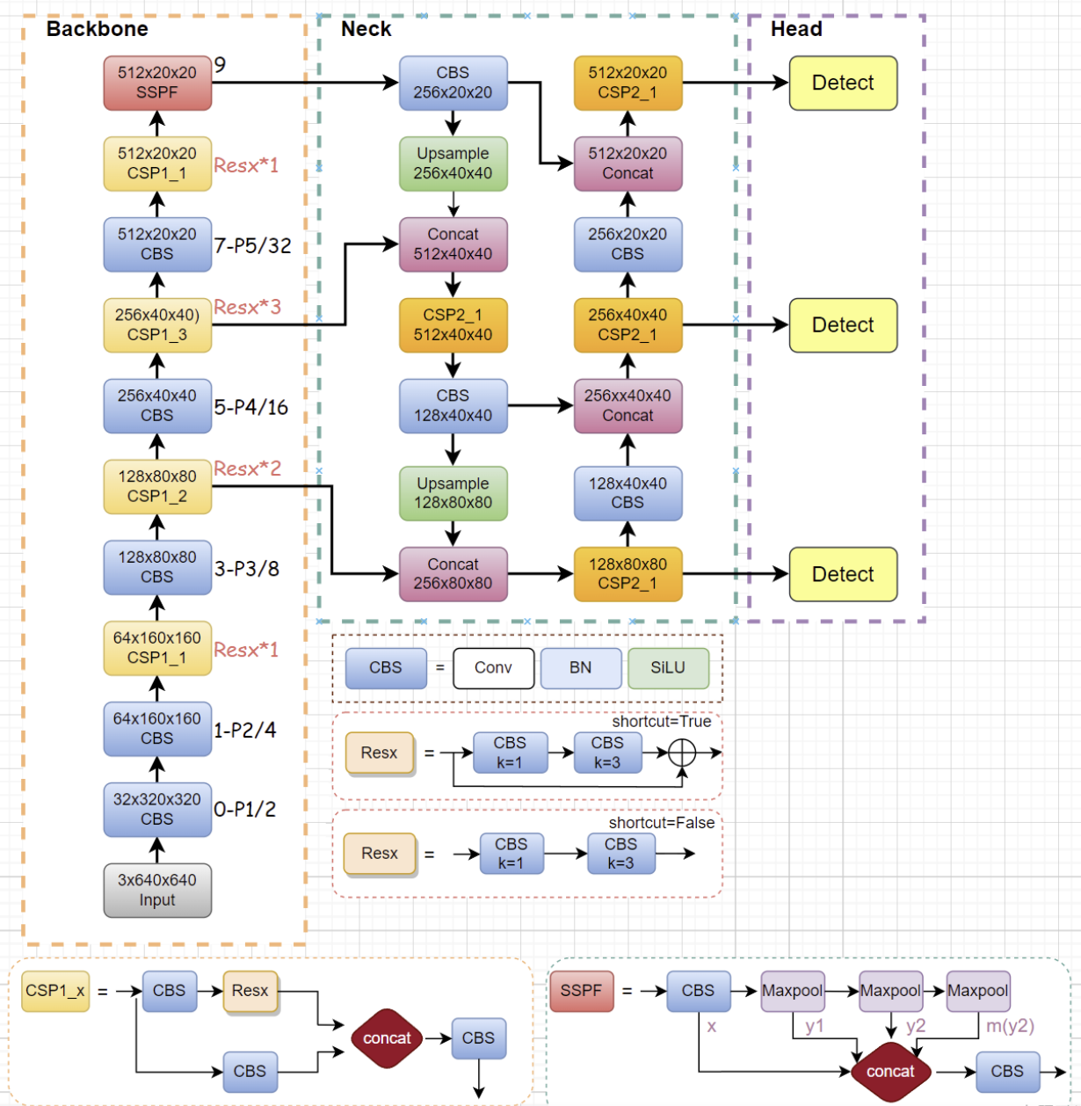
Figure 1 The architecture of YOLOv5

3.2.2 YOLOv8
YOLOv8 is also proposed by Ultralytics. It is a newer version of the YOLO series, which has improved the structural design and training mechanism. Unlike YOLOv5, YOLOv8 introduces anchor-free detection and uses improved C2f modules to enhance feature expression capabilities. Anchor-free detection eliminates predefined anchor boxes and predicts object centers directly, reducing anchor matching complexity[31]. At the same time, it introduces decoupling detection heads to optimize classification and regression tasks respectively, to improve model convergence stability and detection accuracy. The model further improves the detection performance of small targets while maintaining high real-time, and supports multi-task extensions such as detection, segmentation, and attitude estimation. It is suitable for vision systems with higher accuracy requirements or stronger functional integration.
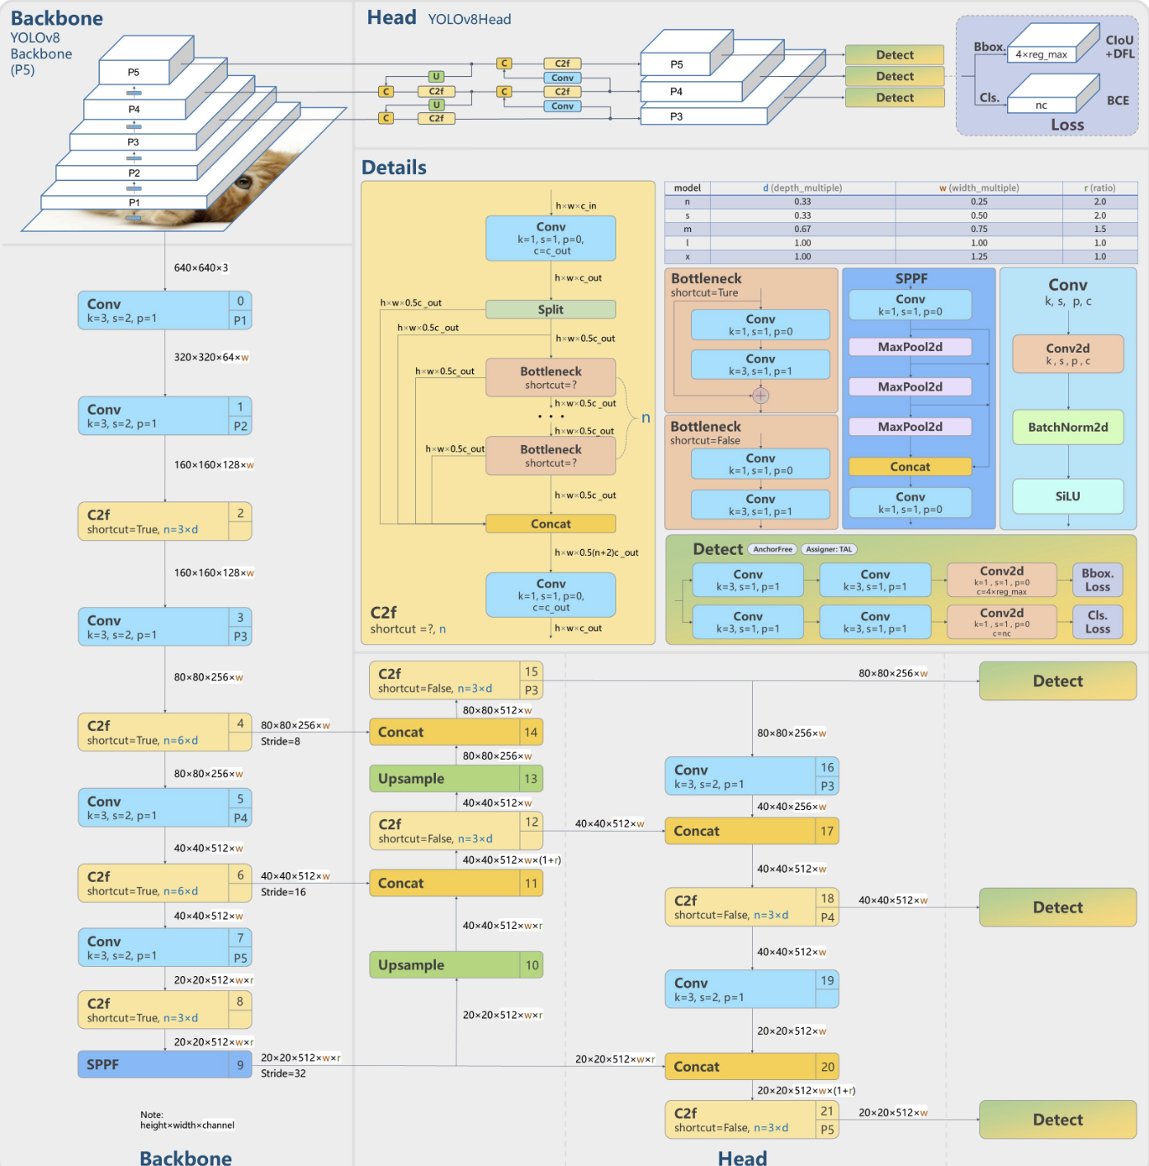
Figure 2 The architecture of YOLOv8

3.2.3 Faster R-CNN
Faster R-CNN is a classic two-stage target detection model proposed by Microsoft Research[32]. The model first generates candidate target areas through the Region Proposal Network (RPN), and then fine-classifies these candidate areas and returns to the boundary box in the second stage. Due to the phased processing mechanism, Faster R-CNN usually has high detection accuracy, especially stable performance in small targets or complex background scenes, but its calculation complexity is high and the reasoning speed is relatively slow, so it is more suitable for offline analysis with low real-time requirements but emphasizing accuracy or high-performance computing environment[33].
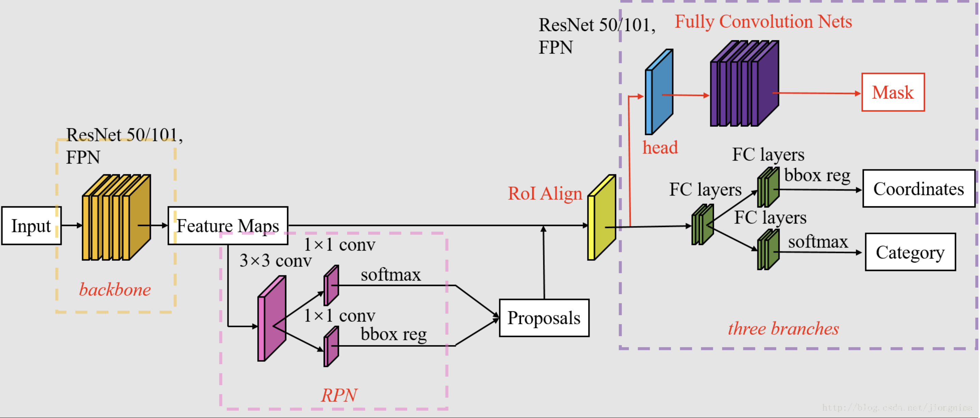
Figure 3 The architecture of Faster R-CNN

3.2.4 Preliminary Comparison of Detection Architectures
Before selecting the final detection backbone for the proposed driver monitoring system, a preliminary comparison of the three candidate architectures—YOLOv5n, YOLOv8n, and Faster R-CNN (ResNet50-FPN)—is conducted from the perspective of model complexity and computational efficiency.
Table 2 Comparison Table of Hyperparameters for Three Model Networks
Model | Parameters | GFLOPs | Inference Speed (FPS, GPU)
YOLOv5n | 1.9M | 4.5 GFLOPs | ~140 FPS
YOLOv8n | 3.2M | 8.7 GFLOPs | ~120 FPS
Faster R-CNN | 41M | ~180 GFLOPs | ~18 FPS
In terms of parameter size, YOLOv5n is the most lightweight model, containing approximately 1.9 million parameters. YOLOv8n has a slightly larger structure with around 3.2 million parameters due to architectural refinements and enhanced feature extraction modules. In contrast, Faster R-CNN employs a deep backbone network and a two-stage detection pipeline, resulting in over 40 million parameters. The significantly larger parameter scale of Faster R-CNN implies higher memory consumption and greater deployment difficulty on embedded platforms.
Regarding computational complexity, YOLOv5n requires approximately 4.5 GFLOPs under a 640×640 input resolution, while YOLOv8n increases the computation to around 8.7 GFLOPs. Faster R-CNN introduces substantially higher computational costs, reaching approximately 180 GFLOPs due to its Region Proposal Network (RPN) and ROI-based refinement stage. This two-stage structure improves localization capability but significantly increases processing overhead.
Inference speed further reflects these differences. On a standard GPU platform, YOLOv5n can achieve around 140 FPS, and YOLOv8n operates at approximately 120 FPS, both satisfying real-time requirements. In contrast, Faster R-CNN achieves only about 18 FPS, which may not be sufficient for continuous real-time driver monitoring.

3.3 Facial Key Point Detection and Geometric Feature Extraction
To achieve lightweight and explainable closed eye and yawn detection, this system adopts a face feature positioning based on the 68-point face key point model[34]:
$$P=\{(x_{i},y_{i})\}_{i=1}^{68}$$
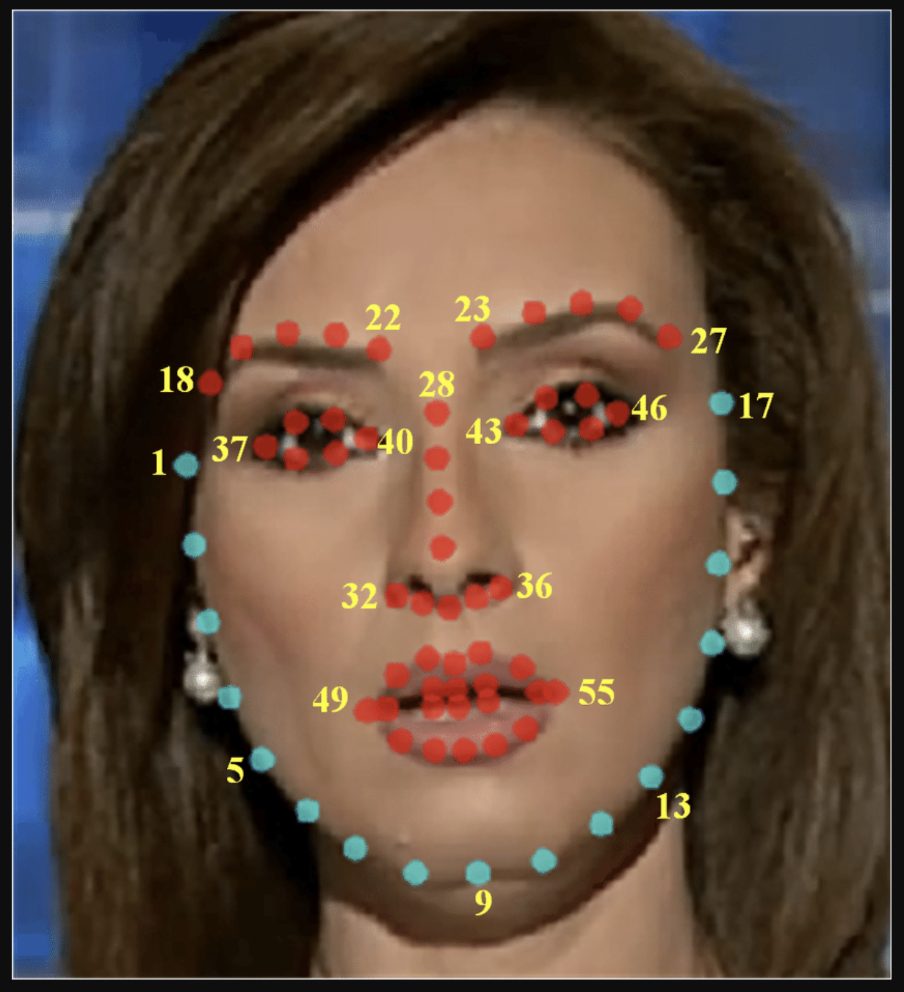
Figure 4 68 Facial Landmark
The key point model can accurately calibrate the position of the eye and the mouth area, providing a basis for subsequent geometric calculations. In the extraction of eye features, the system adopts Eye Aspect Ratio (EAR) as a closed-eye judgement indicator. EAR is defined as[11]:
$$EAR=\frac{∣∣p_{2}-p_{6}∣∣+∣∣p_{3}-p_{5}∣∣}{2∣∣p_{1}-p_{4}∣∣}$$
Where: $p_{1}$ to $p_{6}$ are the coordinates of the key points of the eye.
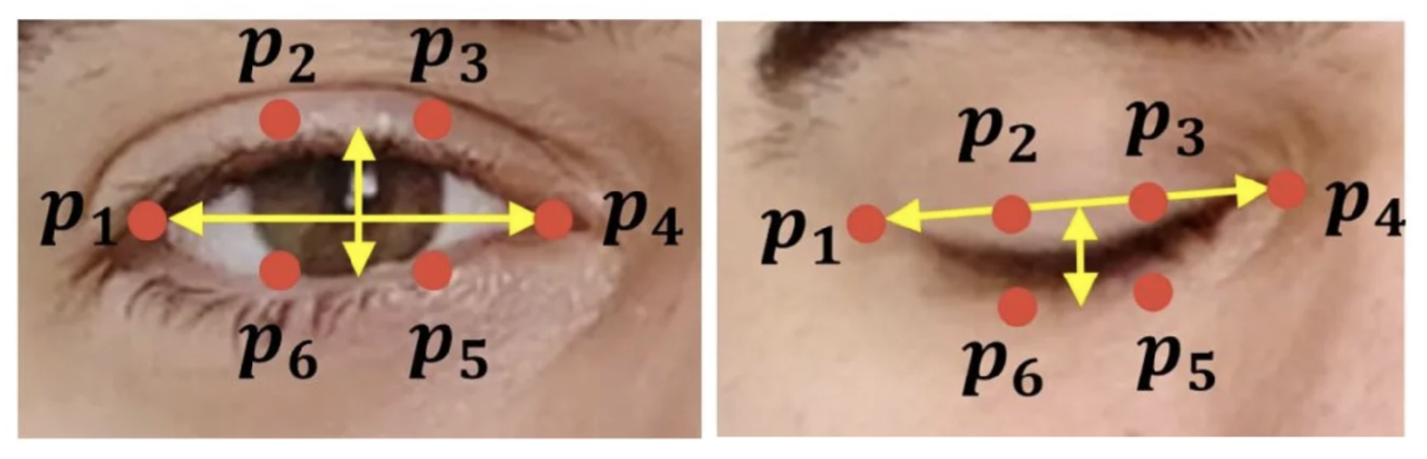
Figure 5 The Geometric Origin of EAR
EAR decreases significantly when eyes close while remaining relatively stable during normal blinking. Due to its scale invariance and low computational complexity, EAR is widely used in real-time fatigue detection systems[11]. When EAR is continuously below the set threshold, the system determines that it is in a closed state.
To extend frame-level detection into a temporal metric, PERCLOS (Percentage of Eye Closure) is introduced. PERCLOS is recognised as one of the most reliable fatigue indicators in transportation safety research [24]. Over a sliding window of length T:
$$PERCLOS=\frac{1}{T}\sum_{i=1}^{T}{I(EA}R_{i}<θ_{EAR})$$
High PERCLOS values correlate strongly with reduced alertness and performance degradation[6].
In the extraction of mouth features, the system calculates the Mouth Aspect Ratio (MAR) to identify yawning behaviour[8]. MAR is calculated based on the longitudinal and transverse distance ratio of the key points of the mouth:
$$MAR=\frac{∣∣p_{2}-p_{8}∣∣+∣∣p_{3}-p_{7}∣∣+∣∣p_{4}-p_{6}∣∣}{2∣∣p_{1}-p_{5}∣∣}$$
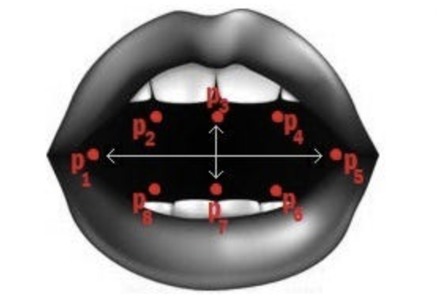
Figure 6 The Geometric Origin of MAR
Sustained elevation of MAR indicates yawning events, which are commonly associated with drowsiness onset[8]. When MAR exceeds the set threshold and lasts for several frames, the system determines that it is yawning.

3.4 Time Modelling and Risk Scoring Mechanism
Driver drowsiness is not an instantaneous binary event but a progressive behavioural degradation process that evolves over time[2][7]. Therefore, rather than directly performing frame-level classification, this study formulates driver state estimation as a temporal risk accumulation problem. The objective is to construct a stable and interpretable risk scoring function that integrates multiple behavioural cues while maintaining real-time performance.

3.4.1 Temporal Behaviour Modelling
Let a sliding window of length T be defined over consecutive video frames:
$$W_{t}=\{f_{t-T+1},...,f_{t}\}$$
Within each window, the following fatigue-related indicators are computed:
- PERCLOS
$$P_{t}=\frac{N_{\text{closed}}}{T}$$where $N_{\text{closed}}$ denotes the number of frames where EAR is below the threshold.
- MAR super threshold duration
$$M_{t}=\frac{N_{\text{yawn}}}{T}$$where $N_{\text{yawn}}$denotes the number of frames exceeding MAR threshold.
- Distraction Score
$$D_{t}=\frac{1}{T}\sum_{i=1}^{T}{C_{i}}$$where $C_{i}$represents the confidence score of distraction detection (phone/drinking) in frame $i$.
These temporal descriptors transform instantaneous behavioural measurements into persistent risk indicators, thereby suppressing single-frame noise and capturing behavioural continuity.

3.4.2 Linear Weighted Risk Fusion
Based on the aggregated behavioural indicators, the overall driver risk score at time t is defined as a linear weighted combination:
$$Risk=α⋅PERCLOS+β⋅MAR_{duration}+γ⋅Distraction_{score}$$
Where α, β and γ are the weighted parameters, which are determined by experimental parameter adjustment.
The selection of linear weighted fusion is grounded in both safety-oriented design considerations and engineering feasibility. From a modelling perspective, fatigue risk in real driving scenarios is cumulative rather than competitive. Eye closure, yawning, and distraction behaviours may co-occur and jointly increase the overall risk level. A linear additive formulation naturally reflects this accumulation property, allowing multiple behavioural cues to contribute simultaneously to the final score.
From an interpretability standpoint, linear fusion provides transparent parameter semantics. Each coefficient directly represents the contribution strength of a specific behavioural factor. This explicit mapping between behavioural indicators and risk output is particularly important in safety-critical systems, where explainability and controllability are essential. System designers can adjust the coefficients to reflect domain knowledge or regulatory requirements without retraining the model.
Furthermore, linear fusion introduces negligible computational overhead. Since no additional trainable layers are required, inference latency remains unchanged. This is crucial in a dual-model architecture where real-time performance must be preserved. Compared with more complex fusion strategies, the linear formulation achieves a favourable trade-off between modelling expressiveness and deployment efficiency.

3.4.3 Comparison with SoftMax-Based Fusion
An alternative approach for combining behavioural indicators is SoftMax-based normalisation, in which intermediate logits are transformed into a probability distribution. However, such a formulation enforces a competitive relationship among input components, since the SoftMax output is constrained to sum to one. In the context of driver monitoring, fatigue and distraction behaviours are not mutually exclusive events; they may co-occur and reinforce overall risk. Competitive normalisation may therefore suppress the joint contribution of multiple risk factors.
In addition, SoftMax outputs relative probabilities rather than absolute risk magnitudes. Driver fatigue is inherently cumulative, and its severity should increase proportionally with behavioural persistence. Probability normalisation weakens this additive characteristic and reduces the interpretability of absolute risk escalation. For these reasons, SoftMax-based fusion is less aligned with the additive and progressive nature of fatigue modelling.

3.4.4 Comparison with Neural Fusion Mechanisms
Neural fusion strategies, such as multilayer perceptron or attention-based modules, can model non-linear relationships among behavioural indicators. While such approaches may enhance representational capacity, they introduce additional trainable parameters and increase the risk of overfitting, particularly under limited cross-modal training data. Since the drowsiness and distraction branches are trained independently on different datasets, learning a reliable joint fusion network would require extensive multi-behaviour annotations, which are not always available.
Moreover, neural fusion reduces system transparency. The mapping between behavioural indicators and risk output becomes implicit within hidden layers, making it difficult to interpret or manually calibrate risk sensitivity. In safety-sensitive driver monitoring systems, deterministic and controllable risk generation mechanisms are often preferred over black-box models. Considering real-time constraints, overfitting risks, and interpretability requirements, the linear weighted fusion strategy provides a more robust and practical solution.

3.4.6 Weight Parameter Calibration
The weighting coefficients 𝛼, 𝛽, and 𝛾 determine the relative contribution of each behavioural factor to the final risk score. Their selection follows a safety-priority principle in which recall performance is emphasised over precision. Since missed fatigue detection (false negatives) poses a higher safety risk than false alarms, fatigue-related indicators are assigned relatively higher weights compared with auxiliary distraction cues.
In practice, weight calibration is performed through empirical grid search within a constrained range. Candidate combinations are evaluated based on recall, false-negative rate, and overall stability of risk transitions. The selected parameters aim to maximise detection sensitivity while maintaining acceptable false-alarm levels. Once calibrated, risk thresholds are defined to categorise driver states into NORMAL, WARNING, and HIGH-RISK levels. This piecewise mapping ensures smooth transitions between states and prevents oscillatory behaviour near decision boundaries.
$$S_{t}=\left\{\begin{matrix}NORMAL & R_{t}<τ_{1} \\ WARNING & τ_{1}≤R_{t}<τ_{2} \\ HIGH-RISK & R_{t}≥τ_{2}\end{matrix}\right.$$

3.5 Evaluation Metrics
Reliable performance evaluation is critical for driver monitoring systems, particularly in safety-sensitive applications where missed detections may lead to severe consequences. In this study, detection performance is assessed using Precision, Recall, F1-score, Intersection-over-Union (IoU), mAP@0.5, and mAP@0.5:0.95[35][36]. These metrics are widely adopted in object detection benchmarks such as PASCAL VOC and COCO and provide complementary insights into detection quality.

3.5.1 Confusion Matrix and Basic Definitions
For each detection class, predictions can be categorised into four outcomes:
- True Positive (TP): A fatigue or distracted behaviour instance correctly detected.
- False Positive (FP): A normal instance incorrectly detected as fatigue/distraction.
- False Negative (FN): A fatigue/distraction instance that was not detected.
- True Negative (TN): A normal instance correctly classified as normal.
These four quantities form the confusion matrix:
$$\left[\begin{matrix}TP & FP \\ FN & TN\end{matrix}\right]$$
In driver monitoring systems, False Negatives are particularly critical, because failing to detect a drowsy driver may result in severe accidents.

3.5.2 Precision
Precision measures prediction correctness:
$$Precision=\frac{TP}{TP+FP}$$
Precision answers the question “Among all predicted fatigue events, how many are correct?” High Precision means low false alarm rate. In practice, high Precision reduces unnecessary warnings, and low Precision may annoy drivers due to frequent false alerts.
However, in this safety applications, Precision is often secondary to Recall.

3.5.3 Recall
Recall measures detection completeness:
$$Recall=\frac{TP}{TP+FN}$$
Recall answers the question “Among all actual fatigue events, how many were detected?” In driver drowsiness detection, Recall is the most important because false Negatives correspond to missed dangerous events, and missed detection has higher safety cost than false alarms.
Therefore, this study prioritises recall-oriented optimisation when selecting detection models.

3.5.4 F1-Score
Precision and Recall often exhibit trade-offs. F1-score provides a harmonic mean:
$$F1=\frac{2⋅Precision⋅Recall}{Precision+Recall}$$
The harmonic mean penalises extreme imbalance between Precision and Recall. F1-score is useful when both missed detection and false alarms are undesirable and balanced system performance is required.
However, in drowsiness monitoring, Recall will still be prioritised over F1 in safety-sensitive scenarios.

3.5.5 Intersection-over-Union (IoU)
In object detection, correct classification alone is insufficient; bounding box localisation accuracy must also be evaluated.
IoU measures geometric overlap between predicted bounding box $B_{p}$and ground truth box $B_{g}$:
$$IoU=\frac{Area(B_{p}∩B_{g})}{Area(B_{p}∪B_{g})}$$where: $B_{p}∩B_{g}$= overlap area, $B_{p}∪B_{g}$= union area. IoU ranges from 0 to 1.
A detection is considered to be correct if:
$$IoU≥τ$$where: $τ$ is a predefined threshold.
IoU ensures that the predicted bounding box is spatially accurate and object localization is dependable.

3.5.6 Average Precision (AP)
Average Precision summarizes the Precision–Recall (PR) curve. For each class:
- Sort predictions by confidence score.
- Compute Precision and Recall at each threshold.
- Plot the PR curve.
- Compute the area under the curve.
$$AP=\int_{0}^{1}{Precision(Recall) dRecall}$$AP reflects both ranking quality and localisation accuracy.

3.5.7 Mean Average Precision (mAP)
For multi-class detection tasks, AP is computed for each class, and mean Average Precision (mAP) is defined as:
$$mAP=\frac{1}{C}\sum_{c=1}^{C}{A}P_{c}$$where: C is number of classes.
Two mAP metrics are adopted: mAP@0.5 and mAP@0.5:0.95.

3.5.7.1 mAP@0.5
This is AP computed with IoU threshold = 0.5. And it is less strict and evaluates coarse localisation quality.

3.5.7.2 mAP@0.5:0.95
This is average AP over IoU thresholds:
$$τ∈\{0.5,0.55,...,0.95\}$$
This metric is stricter and reflects precise bounding box quality. And this is commonly used in COCO evaluation and provides more comprehensive localisation assessment.

3.5.8 Metric Interpretation in Driver Monitoring Context
In conventional object detection tasks, mAP is often the primary performance indicator. However, in driver drowsiness detection systems, metric prioritisation differs due to safety requirements.
Recall is critical for preventing missed fatigue events; Precision affects driver experience; mAP reflects detection stability and localisation quality; IoU ensures correct spatial grounding.
Given the asymmetric risk between false positives and false negatives, Recall-oriented optimisation is adopted as the guiding principle in model selection.

3.6 Model Training Strategy and Optimisation
Effective model training is critical to ensure both generalisation performance and stability under limited dataset conditions. This study adopts a structured training strategy combining transfer learning, regularisation control, data augmentation, and optimisation tuning to improve detection robustness while preventing overfitting.

3.6.1 Transfer Learning and Weight Initialisation
Deep object detection models contain millions of parameters and require large-scale datasets for stable convergence. However, driver drowsiness datasets are typically smaller compared to general object detection benchmarks. Therefore, transfer learning is adopted.
Pretrained weights obtained from large-scale datasets such as COCO are used to initialise model parameters. Formally, given pretrained parameters $θ_{pre}$, training starts from: $θ_{0}=θ_{pre}$, rather than random initialisation.
Transfer learning improves convergence speed, feature generalisation and stability in early epochs.
Low-level convolutional layers can capture generic visual features such as edges and textures, which are transferable across tasks.

3.6.2 Layer Freezing Strategy
To further reduce overfitting risk, partial layer freezing is applied in the drowsiness detection branch. Let model parameters be divided into:
$$θ=\{θ_{low},θ_{high}\}$$where: $θ_{low}$= early backbone layers, $θ_{high}$= higher-level detection layers
During training, $θ_{low}\text{ is frozen}\text{ and }θ_{high}\text{ is updated}$
Freezing early layers stabilises feature extraction and reduces parameter update variance when training data is limited. This strategy is particularly useful when dataset is small, domain shift is moderate or overfitting risk is high.

3.6.3 Optimiser Selection
The AdamW optimiser is adopted for parameter updates. Unlike standard Adam, AdamW decouples weight decay from gradient-based update, improving regularisation stability. Parameter update rule is:
$$θ_{t+1}=θ_{t}-η⋅{\hat{m}}_{t}-λθ_{t}$$where:
- $η$= learning rate
- ${\hat{m}}_{t}$= bias-corrected momentum term
- $λ$= weight decay coefficient
AdamW provides faster convergence, better handling of sparse gradients and improved generalisation.

3.6.4 Learning Rate Scheduling
A reduced initial learning rate (η0​=0.0001) is adopted for fine-tuning. Lower learning rates prevent destructive weight updates when using pretrained parameters.
Additionally, learning rate decay is applied:
$$η_{t}=η_{0}⋅γ^{t}$$where $γ<1$.
This ensures stable convergence in later epochs.

3.6.5 Regularisation and Overfitting Control
Overfitting occurs when a model learns dataset-specific patterns rather than generalisable representations, leading to high training accuracy but degraded validation performance. In driver monitoring tasks, overfitting risk is particularly prominent due to limited dataset size, controlled recording environments, and relatively homogeneous facial appearances. Therefore, structured regularisation strategies are necessary to improve generalisation robustness.

3.6.5.1 L2 weight decay
L2 weight decay is applied to constrain parameter magnitude. The total loss function is modified as:
$$L_{total}=L_{original}+λ∣∣θ∣∣^{2}$$where $θ$ denotes model parameters and $λ$ is the regularisation coefficient.
The L2 penalty discourages excessively large weights by shrinking parameter magnitude during optimisation. From a geometric perspective, L2 regularisation biases the solution toward smoother decision boundaries and reduces model complexity. This is beneficial in object detection tasks where high-capacity networks may otherwise memorise specific lighting conditions, facial identities, or background patterns. By limiting parameter growth, L2 regularisation improves model stability across different drivers and environmental variations.

3.6.5.2 Data Augmentation
Data augmentation is employed to artificially expand the effective training distribution. Rather than directly modifying the model structure, data augmentation increases input diversity by applying transformations such as colour jittering (HSV perturbation), scaling, translation, Mosaic combination, and MixUp blending. Augmentation constructs a transformed distribution:
$$D^{'}=Aug(D)$$where $D$ is the original data distribution
This process forces the model to learn invariant features rather than memorising specific pixel patterns. In fatigue detection, illumination variation and head pose changes are common in real driving environments; augmentation therefore improves robustness to domain shift. Mosaic augmentation further enhances contextual diversity by combining multiple images into a single training sample, which improves small-object detection stability and reduces background dependency.

3.6.5.3 Early Stopping
Early Stopping is implemented as a validation-driven regularisation mechanism. During training, validation metrics such as Recall and mAP are continuously monitored. If validation performance does not improve for p consecutive epochs, training is terminated and the best-performing weights are restored. This strategy prevents the model from continuing optimisation after reaching its generalisation peak, which would otherwise lead to memorisation of training noise.
$$M_{t-k}≥M_{t }\text{for }k=1,…,p$$where $M_{t}$ is the validation metric, and training is stopped at epoch $t$.
Early stopping acts as an implicit regulariser by controlling effective training time and preventing parameter over-adjustment.

3.6.6 Handling Class Imbalance
In distraction detection tasks, class imbalance may occur. For example, in this project, more phone samples exist than drinking samples. To mitigate imbalance effects:
- Class-wise loss weighting is considered
- Recall-oriented threshold tuning is applied
- Confidence threshold is adjusted to reduce false negatives

3.6.7 Batch Size and Computational Consideration
Batch size influences gradient stability and memory usage. In this project, batch size is 32 for drowsiness detection model and 8 for distraction detection model.
Drowsiness detection model is a binary classification model, and it has relatively lower inter-class visual diversity. Under such conditions, smoother gradient estimation is beneficial for stable feature learning and convergence. A larger batch size reduces gradient variance, producing more consistent parameter updates and improving optimisation stability during training. Moreover, the drowsiness dataset exhibits relatively balanced class distribution, allowing each mini batch to contain representative samples from both classes, thereby reducing sampling bias. From a computational perspective, face localisation does not involve numerous small objects or dense anchor matching, which results in moderate memory consumption and permits a larger batch size without exceeding hardware constraints. Consequently, using batch size = 32 improves convergence efficiency by reducing the number of update iterations per epoch while maintaining stable localisation learning and controlled optimisation variance.
In contrast, the distraction detection model adopts a smaller batch size of 8 due to its higher task complexity and data characteristics. This branch addresses multi-class object detection with significant intra-class variation and class imbalance, particularly between frequently occurring behaviours (e.g., phone usage) and minority classes (e.g., drinking). In such scenarios, smaller batch sizes introduce controlled stochasticity into gradient estimation, which helps prevent overfitting to dominant classes and improves generalisation across visually diverse samples. Furthermore, detecting small objects such as mobile phones or bottles requires fine-grained feature learning, and increased gradient diversity across iterations can enhance the model’s ability to capture subtle object features. From a computational standpoint, multi-class detection with anchor-based predictions generates larger intermediate tensors, and increasing the batch size would significantly elevate GPU memory usage. Therefore, a smaller batch size not only alleviates memory pressure but also contributes to improved recall stability, particularly for minority classes, which aligns with the safety-oriented objective of minimising missed detection events. As a result, batch size = 8 provides a balanced trade-off between generalisation, computational feasibility, and recall robustness in distraction behaviour detection.

3.7 Real-time Deployment and Performance Optimisation
To meet the real-time operation needs of the system, the system uses the YOLOv5 lightweight model version, enables FP16 semi-precision computing in the reasoning stage, controls the input resolution to reduce the calculation volume, and adopts a multi-threaded structure to separate video acquisition and model reasoning. In the case of dual-model parallel operation, the system can achieve a frame rate close to real-time in the conventional GPU environment. If hardware resources are limited, performance can be optimised by reducing the resolution or processing frame rate.

Chapter 4
System Implementation
This chapter introduces the engineering implementation process of the system in detail, including dual YOLOv5 model deployment, EAR/MAR geometric feature calculation, time window statistical mechanism, and graphical user interface design. The system adopts a modular structure to realise multi-task parallel processing and ensures real-time performance through multi-threading and lightweight model design. This realisation provides a complete technical basis for subsequent experimental verification and performance evaluation.

4.1 System Structure
The system is based on Python and adopts a modular structure to realise the complete closed-loop process of video input, model reasoning, feature calculation, risk assessment, and interface display. The core operation process of the system includes video acquisition module, dual YOLOv5 reasoning module, key point and geometric feature calculation module, time window statistics module, and graphical interface display module.
The system takes the video stream as the input and enters the two YOLOv5 models in parallel after unified preprocessing. The first branch is used for facial area detection and positioning to provide stable spatial constraints for subsequent fatigue characteristic calculation; the second branch is used for distracted behaviour detection to identify high-risk behaviours that may cause safety risks during driving. The facial detection results are further entered into the key point detection module, which is used to extract the key point coordinates of the eye and mouth, and calculate the EAR and MAR indicators. Subsequently, the system introduces a sliding window mechanism in the time dimension, statistically models fatigue-related characteristics, and integrates them with the results of distracted behaviour detection, and finally outputs the driving risk level.
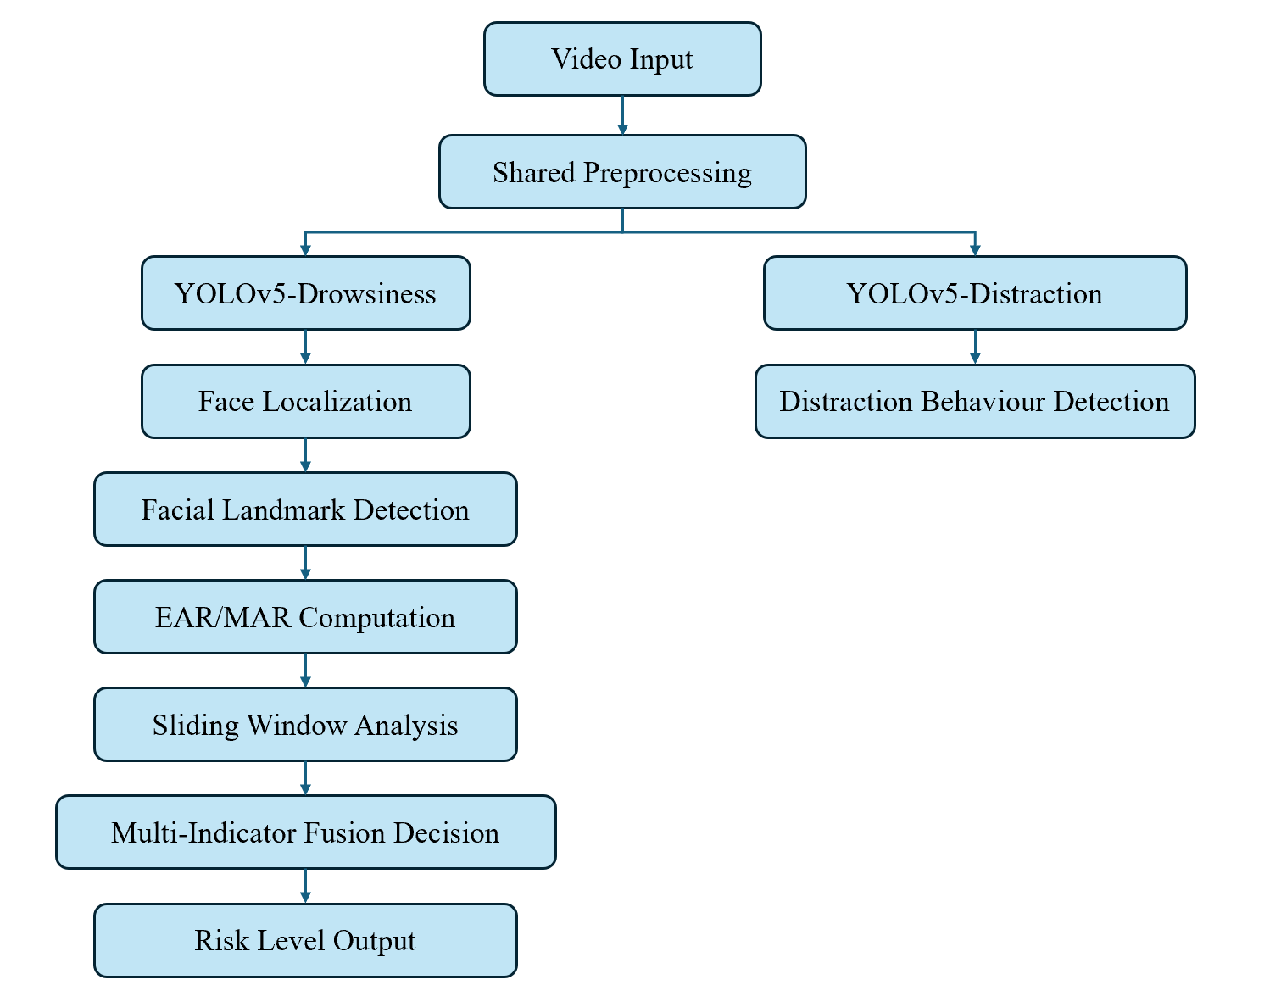
Figure 7 System Architecture Diagram
Through functional decoupling and hierarchical modelling, the structure effectively avoids the category conflict problem caused by multi-task hybrid training and improves the scalability and module independence of the system. The system combines serial logic control with parallel reasoning to ensure real-time and stability.

4.2 Model Deployment and Reasoning Realisation
After the training completed, the double YOLOv5 model loads the best weight file best.pt for reasoning. The following optimisation strategies are adopted in the reasoning stage: use the YOLOv5 nano (yolov5n) lightweight model; the input resolution is unified to 416×416; the gradient calculation is turned off in the reasoning stage; if the hardware supports, semi-precision calculation is enabled.
In the single-frame processing process:
- Execute YOLOv5-Drowsiness reasoning to obtain the face boundary box.
- Perform YOLOv5-Distraction reasoning to obtain distraction behaviour categories and confidence.
- Conduct key point detection on the face area.
- Calculate EAR and MAR.
- Update the sliding window cache.
- Calculate the current Risk Score.
- Update the UI display.
To avoid GUI jamming, the system adopts a multi-threaded mechanism to couple the video reading with the model, to ensure that the interface is refreshed smoothly.

4.3 Fusion Score Design
Drowsiness detection model is an independent image recognition model that outputs labels in real time for each frame, which may include eyes closed or yawning, with no time threshold, directly entering the fusion layer.
And for distraction detection model, each frame is checked for the presence of a phone or drink. In the fusion layer, a score is only counted if it appears in 2 consecutive frames (to prevent false positives from a single frame).
In the fusion layer, the scores for the behaviours are as follows:
Table 3 Scores for different detections
Trigger Conditions | Scores
EAR/MAR Detected eyes closed (duration ≥2s) | +3
EAR/MAR Detected yawning (duration ≥2s) | +3
Distracted behaviour (phone/drink for ≥2 consecutive frames) | +3

Table 4 Risk Level Classification
Total Score | Risk Level | Colour of UI
≥5 | HIGH RISK | Red
≥3 | WARNING | Yellow
<3 | NORMAL | Green
Examples of Typical Trigger Scenarios:
- Eyes closed for more than 2 seconds: Total score will be 3 and the risk level will be “WARNING”.
- Just a normal blink (< 2 seconds): Timer did not reach 2 seconds, the risk level will be “NORMAL”.
- Using a phone for more than 2 consecutive frames: Total score will be 3 and the risk level will be “WARNING”.
- Yawning for more than 2 seconds and using a phone: Total score will be 6 and the risk level will be “HIGH RISK”.

4.4 Graphical User Interface (UI) Design
To improve the visualisation effect and interactive experience of the system, this study has designed a real-time monitoring interface to display the detection results and risk status. The interface includes real-time video display area; face detection and distracted behaviour boundary box visualisation; EAR and MAR real-time numerical display; PERCLOS current value display and risk level indication module. When the face detection is successful, the interface marks the face area with a rectangular box.
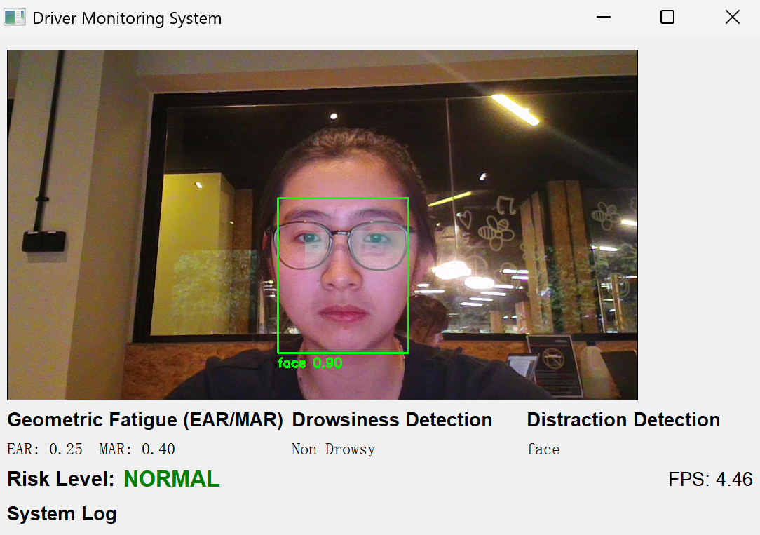
Figure 8 System GUI in NORMAL status
The drowsiness index is updated in real time in numerical form, and the risk level is displayed by colour, including green (Normal), yellow (Warning), red (High Risk).

4.4.1 GUI of Drowsiness Detection
When users blink and yawn, it can be seen that the real-time EAR and MAR indicators have changed significantly. When the system detects that the eyes are closed (EAR<0.20) for more than 2 seconds, it will determine the state as 'closed eyes' and trigger a WARNING alert.
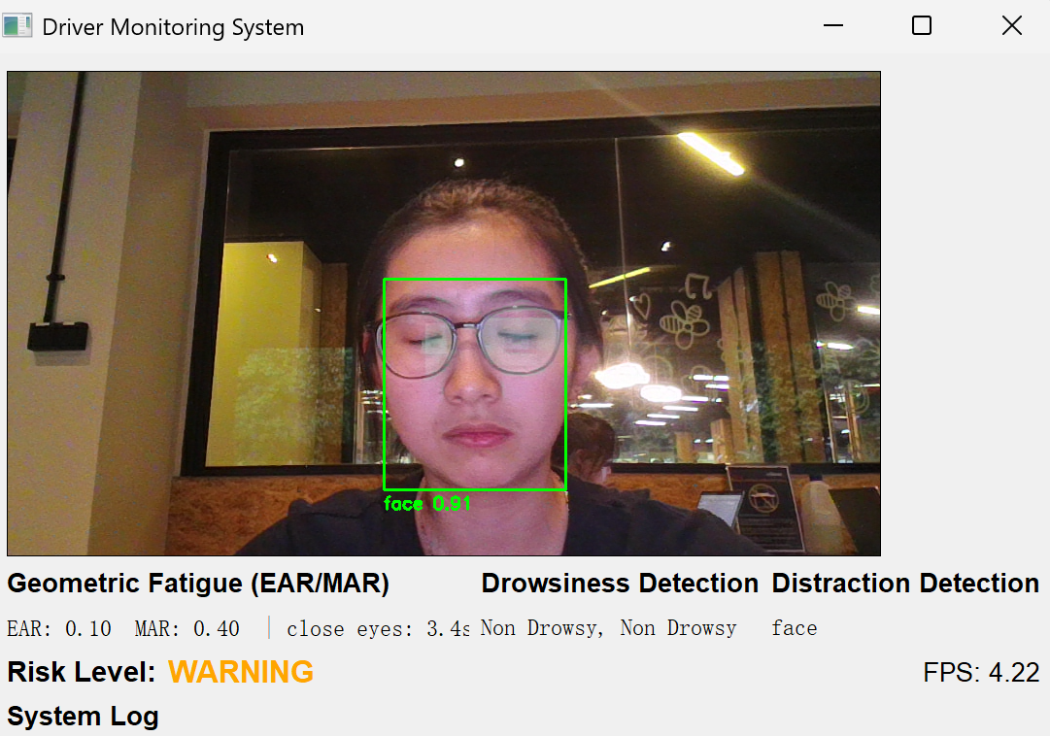
Figure 9 Close eyes detected
When a yawn is detected for more than 2 seconds, the system will classify it as a yawn and trigger a WARNING alert.
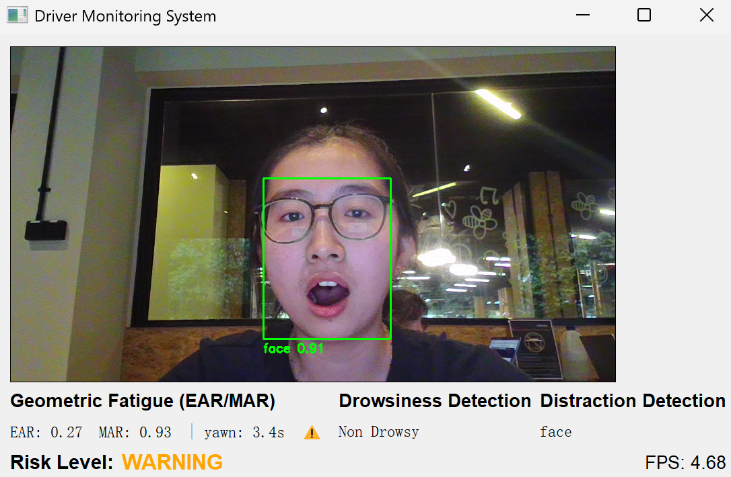
Figure 10 Yawning detected
It is noteworthy that closing your eyes alone and yawning alone can both trigger a WARNING state. However, closing your eyes and yawning at the same time will trigger a “HIGH RISK” red alert.
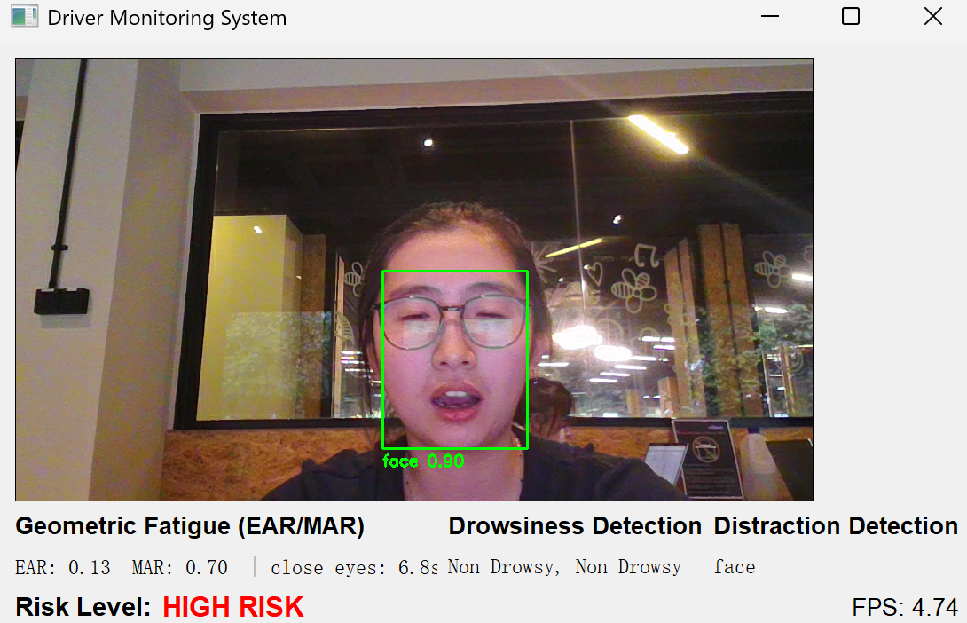
Figure 11 System in HIGH RISK status

4.4.2 GUI of Distraction Detection
If the distracted behaviour detected, the behaviour category and confidence are displayed around the corresponding target. When the system detects that the user is drinking water, it will trigger a WARNING alert.
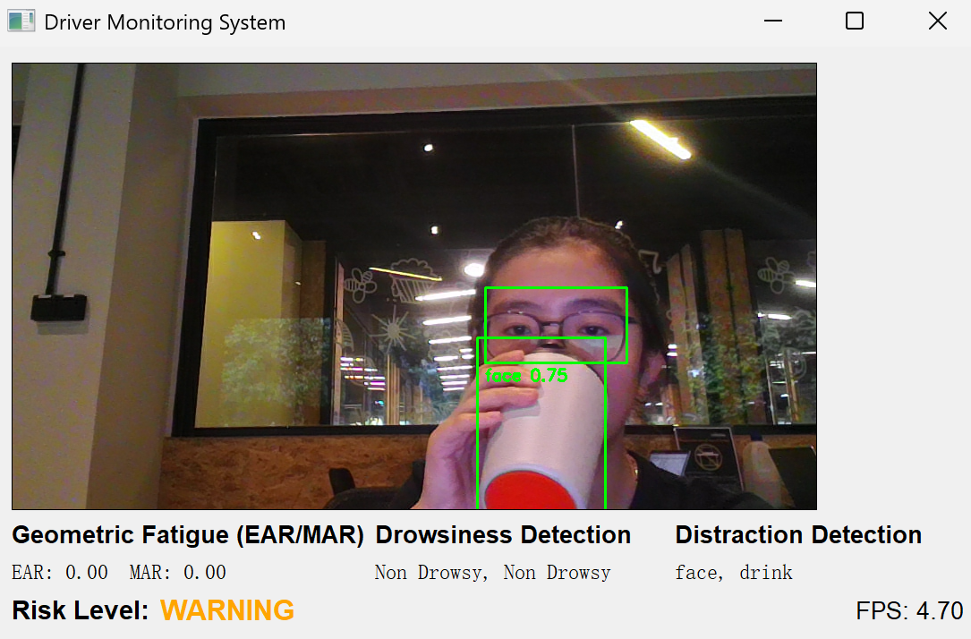
Figure 12 Drinking water detected
And when the system detects that the user is using their phone (whether typing or answering a call), it will also trigger a WARNING alert.
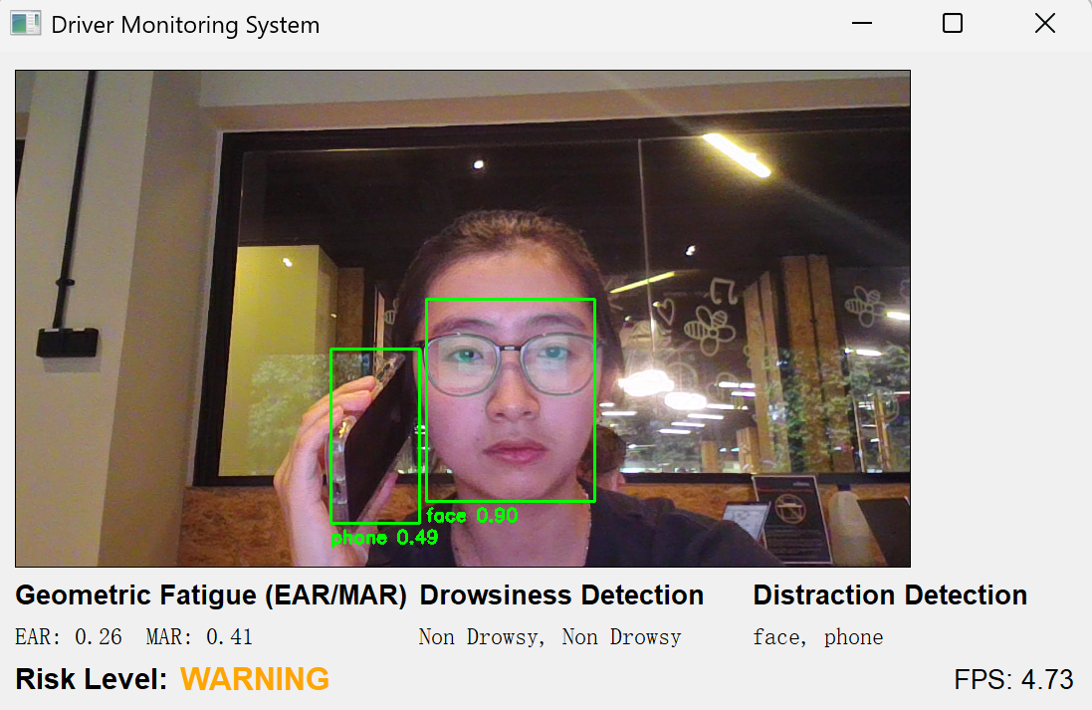
Figure 13 Using phone detected

4.4.3 Anti-interference function
When the system detects two faces simultaneously, it will only recognize the first face. For example, when someone other than the driver yawns, the system's MAR will not change. This design reduces interference from the front passenger and rear passengers in the fatigue driving detection system.
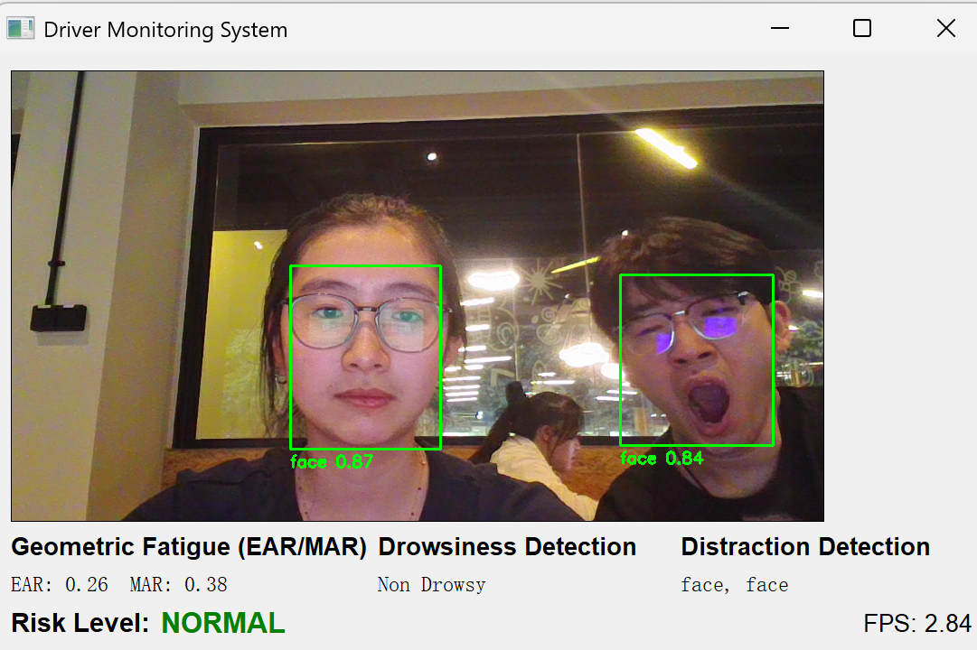
Figure 14 Two faces detected

Chapter 5
Project Results
This chapter presents experimental results and performance evaluation. Comparative analysis of YOLOv5, YOLOv8, and Faster R-CNN is conducted using standard object detection metrics. The effectiveness of the proposed risk fusion strategy and real-time performance are quantitatively analysed.

5.1 Performance of Drowsiness Detection Model

5.1.1 Driver Drowsiness Dataset Overview
Driver Drowsiness Dataset (DDD) is a public dataset for driver fatigue detection research, which is widely used in driver status monitoring system based on computer vision (Driver Monitoring System, DMS) research. The dataset collects the driver's facial video or image frames through the front camera on the car, focussing on fatigue-related behavioural characteristics, such as long-term eye closure, frequent blinking, yawning and head posture changes.
The DDD dataset contains two types of tags: Non-Drowsy and Drowsy. Its annotation structure can meet the needs of a variety of research tasks, including image classification, target detection, and timing modelling. For methods based on deep learning (YOLO series target detection models), DDD can be used to train fatigue behaviour recognition models; at the same time, the dataset also supports the study of geometric feature methods, such as calculating indicators such as eye ratio (EAR) and eye closure percentage (PERCLOS). So as to realise multi-modal fusion analysis.
At the same time, DDD also includes a certain degree of light changes (such as normal light and low-light environment), as well as differences in the appearance of different drivers (such as wearing or not wearing glasses).
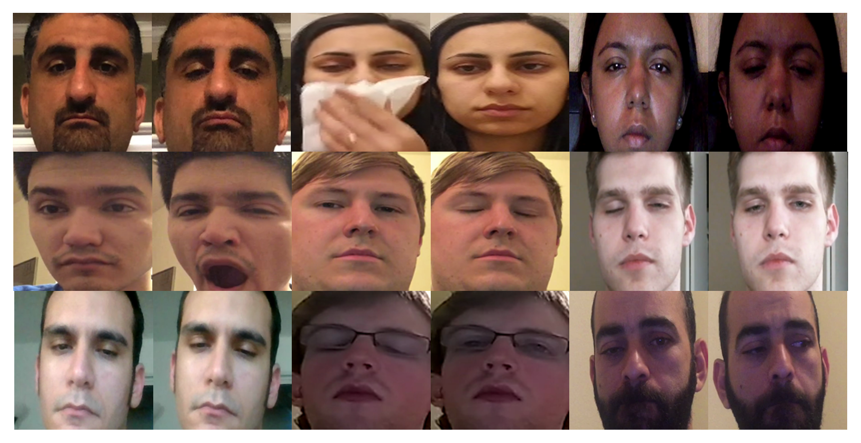
Figure 15 Pictures in Driver Drowsiness Dataset

5.1.2 Training Performance Analysis of YOLOv5
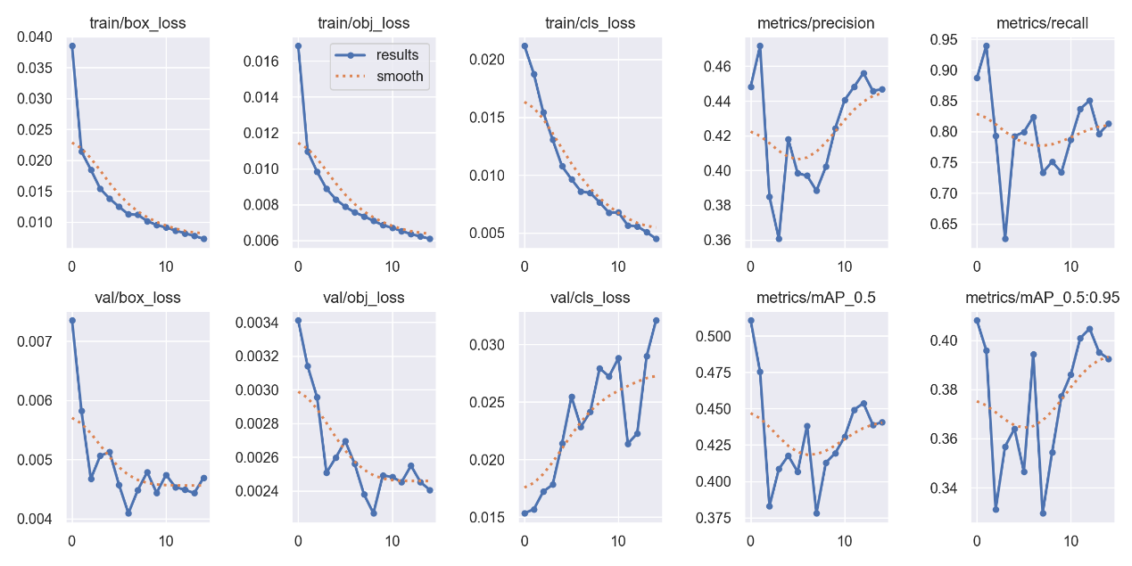
Figure 16 Training result curve of YOLOv5
It can be seen from the training result curve of YOLOv5 that the overall convergence process of the model is stable, and there is no obvious divergence or violent oscillation. During the training stage, box_loss, obj_loss and cls_loss all show a continuous downward trend, indicating that the model is gradually optimised in terms of boundary box regression, target confidence prediction and category discrimination, and the parameter update process is effective. In particular, train/box_loss and train/obj_loss declined rapidly in the first few epochs, and then tended to be flat, reflecting the typical gradient convergence characteristics.
In the verification stage, val/box_loss and val/obj_loss maintain a low level and a limited fluctuation, indicating that the model has a good generalisation ability in positioning and target confidence prediction. However, val/cls_loss shows a slow upward trend, indicating that there may be a certain degree of overfitting or category imbalance in category discrimination, which needs to be further analysed in combination with the distribution of category samples.
Judging from the changes in performance indicators, Recall is maintained at an important level, indicating that the model has a strong detection ability for the target and a low leakage rate, which is consistent with the safety goal of high recall rate emphasised by this study. Although there are certain fluctuations in the Precision curve, it shows an upward trend in the later stage, indicating that the model gradually improves the mischecking problem in the later stage of training. mAP@0.5 and mAP@0.5:0.95 gradually rebounded and stabilised after fluctuations in the medium term, indicating that the model has reached a balanced state in terms of comprehensive detection performance.
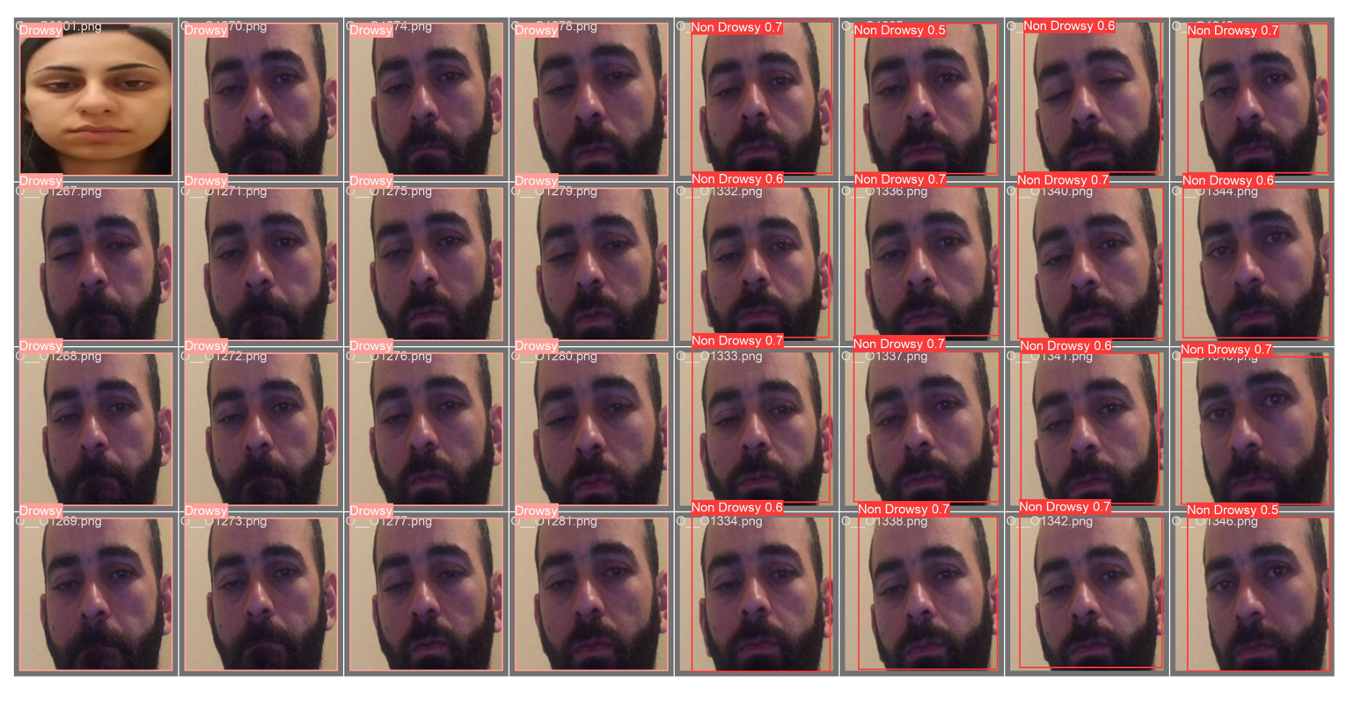
Figure 17 Prediction result of YOLOv5
It can be seen from the prediction result diagram of the verification set that the model can accurately locate the face area and identify the fatigue state. Although there is still a misjudgement between Drowsy and Non-Drowsy in some samples, most drowsiness samples can be successfully detected, indicating that the model performs well in maintaining a high recall rate.

5.1.3 Training Performance Analysis of YOLOv8
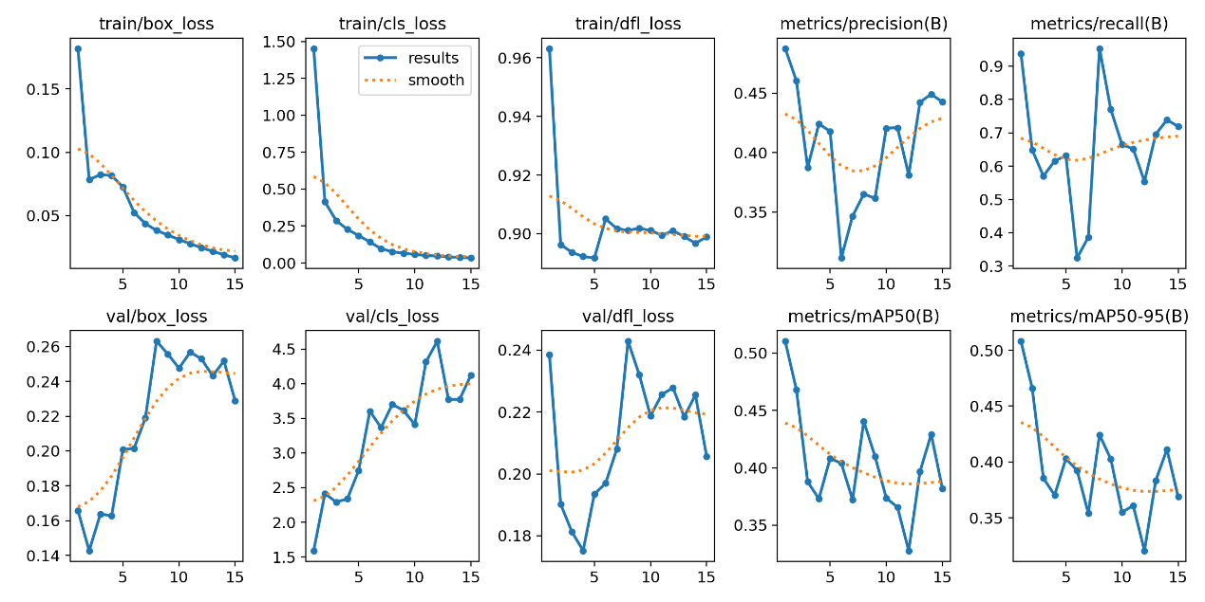
Figure 18 Training result curve of YOLOv8
It can be seen from the training result curve of YOLOv8 that the model converges rapidly in the early stage of training, and train/box_loss, train/cls_loss and train/dfl_loss all shows a significant downward trend and tend to stabilise in the later stage. It shows that the model can effectively learn feature representation in boundary box regression, category discrimination, and distributed focus loss (DFL) optimisation. However, unlike the continuous decline in training losses, val/box_loss, val/cls_loss and val/dfl_loss in the verification stage show an upward trend of fluctuations as a whole, especially the increase of val/cls_loss is more obvious, indicating that the model There may be a certain degree of over-mitting phenomenon in category discrimination, and the generalisation ability is affected to a certain extent.
Judging from the changes in performance indicators, Precision and Recall fluctuate during the training process. Recall can reach an important level (close to 0.95) in some epoch, but the overall trend is unstable, and there is a significant decline in the medium term and then gradually rebounds; Precision is at a medium level as a whole and slightly improved in the later stage. At the same time, mAP@0.5 and mAP@0.5:0.95 were high at the beginning of training, but then there was a decline and accompanied by shock, and there was no continuous upward trend, indicating that the model has not yet reached a stable and optimal state in terms of comprehensive positioning accuracy.
To conclude, YOLOv8 showed a faster convergence rate in this experiment, but the increase in verification loss and the fluctuation of mAP indicator indicate that its generalisation performance is limited. Although a high recall rate can be obtained at individual stages, it is not stable enough, which may bring uncertainty in the safety-sensitive task of drowsiness detection.
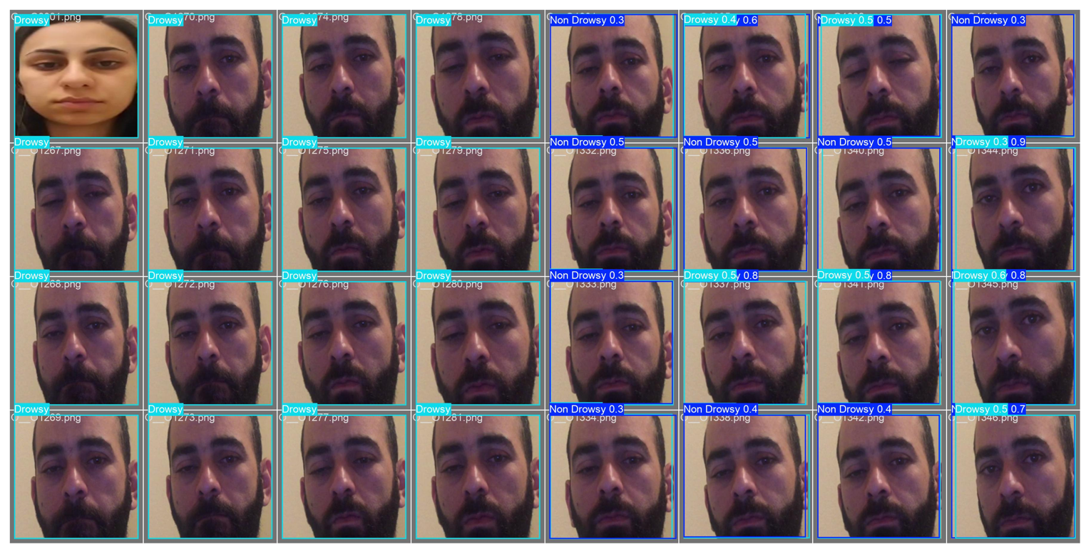
Figure 19 Prediction result of YOLOv8
In addition, YOLOv8 also provides a visual result chart of the verification set. By comparing the prediction box with the real annotation, the detection performance of the model in different fatigue states can be intuitively observed. The visualisation results show that the model can better complete the face area positioning, but there is category confusion or confidence fluctuation in samples.

5.1.4 Training Performance Analysis of Faster R-CNN
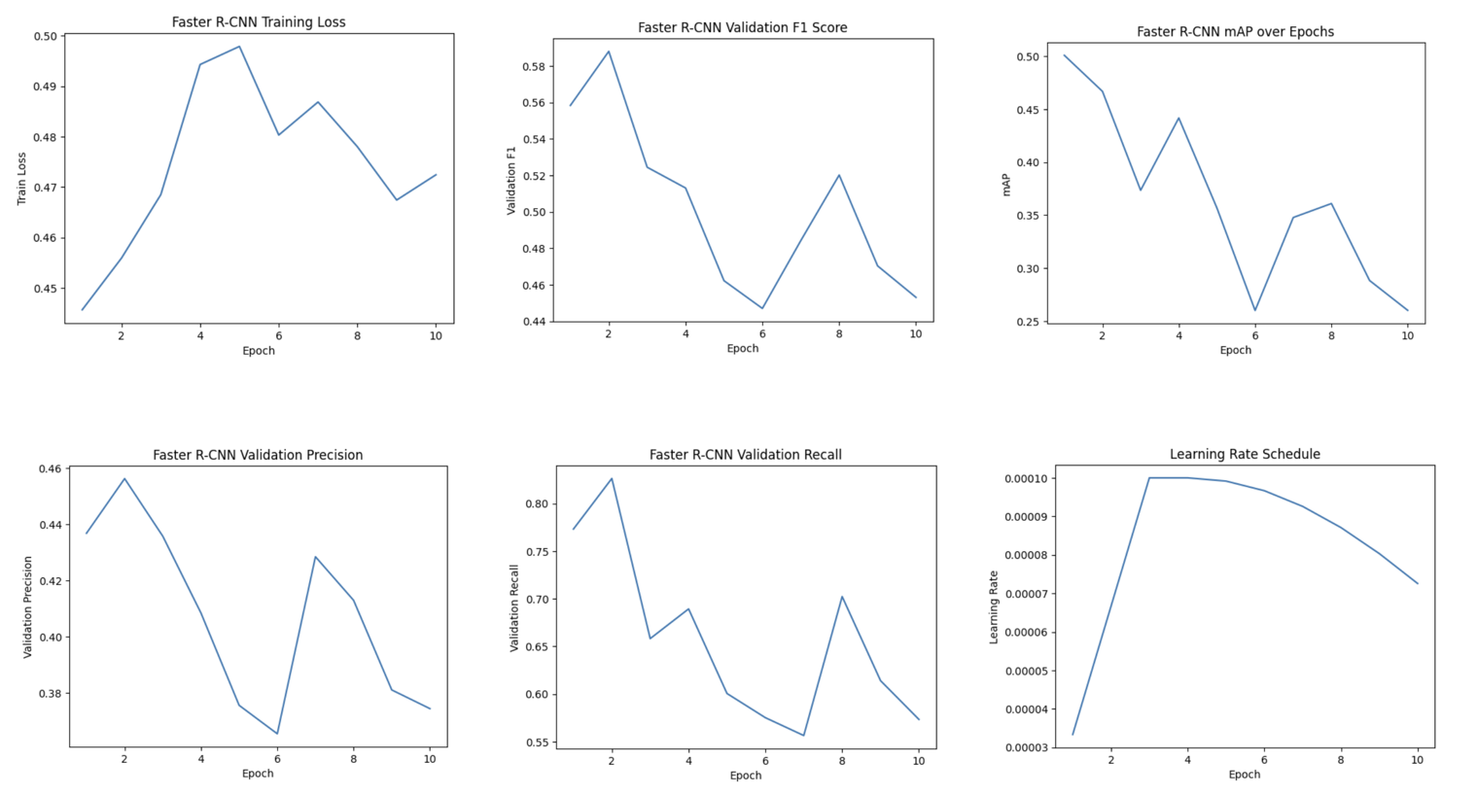
Figure 20 Training result curve of Faster R-CNN
It can be seen from the Train Loss curve that the model showed a slight upward trend in the early stage and reached a peak in the 4th–5th epoch, and then gradually declined and stabilised. This phenomenon is usually related to the learning rate warm-up and the initial instability of the parameters. It can be seen from the learning rate change curve that the learning rate of the first three epoch gradually rose to 0.0001, followed by a gradual attenuation strategy, so the early loss fluctuation has a certain rationality. On the whole, there is no continuous downward trend in training loss, which shows that there is some instability in the process of feature optimisation of the model.
In terms of verification performance, Val F1-score reached the highest value in the second epoch, and then the overall downward trend was accompanied by obvious fluctuations, and finally stabilised at about 0.45. Val Precision gradually decreased from 0.456 to about 0.37, indicating a gradual increase in the number of mischecks; Val Recall reached a peak of 0.826 in the second epoch, but then decreased and fluctuated at 0.55–0.70. The interval shows that the detection ability of the model cannot continue to maintain an important level.
The change trend of mAP indicators is more obvious. mAP@0.5 reached a higher value of 0.50 in the first epoch, but then the overall decline and remained in the 0.26–0.36 range in the later stage, showing no stable upward trend. This shows that there is a certain generalisation problem in the comprehensive performance of target positioning and classification of the model. Combined with the verification loss and mAP curve, it can be inferred that Faster R-CNN may have overfitting or insufficient feature expression ability under the current data scale and training configuration.
In general, Faster R-CNN can obtain high Recall and mAP in the early stage of training, but the performance stability is poor. With the in-depth verification of training, the performance gradually declines, and there is no continuous optimisation trend.

5.1.5 Model Compare
On the Driver Drowsiness Dataset, these three models were evaluated separately. The results are as follows:
Table 5 Test results of YOLOv5, YOLOv8 and Faster R-CNN
Model | Precision | Recall | mAP@0.5 | mAP@0.5:0.95
YOLOv5 | 0.439 | 0.95 | 0.597 | 0.471
YOLOv8 | 0.755 | 0.733 | 0.858 | 0.846
Faster R-CNN | 0.456 | 0.826 | 0.467 | 0.467
It can be seen that YOLOv8 has achieved excellent overall detection performance on the verification set. Its Precision is 0.7548, Recall is 0.7331, mAP@0.5 reaches 0.8585, and mAP@0.5:0.95 It is 0.8460, indicating that the model is stable in terms of target positioning accuracy and category discrimination ability, and the overall detection accuracy is the highest. However, judging from the application objective of this study, the system pays more attention to the "missing detection control ability" of the fatigue state. From the perspective of safety system design, the risk of False Negative is much higher than False Positive, so the recall rate is a more critical evaluation indicator.
The overall Recall of YOLOv5 reaches 0.95 (category level: Drowsy category Recall is 0.90, Non-Drowsy category Recall is 1.00), which is significantly higher than the 0 of YOLOv8. 7331, which is also higher than Faster R-CNN's 0.8263. Although the Precision and mAP indicators of YOLOv5 are lower than YOLOv8, its high recall rate means that it is safe in actual driving. The scene can minimise the risk of missed inspection of fatigue driving.
Faster R-CNN Recall in this experiment is 0.8263, and the overall performance is between YOLOv5 and YOLOv8, but its mAP@0.5 is only 0.4673, and the comprehensive performance does not reflect obvious advantages. At the same time, the two-stage structure is low in terms of reasoning efficiency, which is not conducive to the deployment of real-time driving monitoring system.
As shown in Figure 21, YOLOv5 demonstrates a stable and continuously increasing recall trend throughout the training process. In contrast, YOLOv8 exhibits noticeable fluctuations after mid-training, while Faster R-CNN shows performance instability and gradual decline. This stability advantage further supports the selection of YOLOv5 for safety-critical driver monitoring applications.
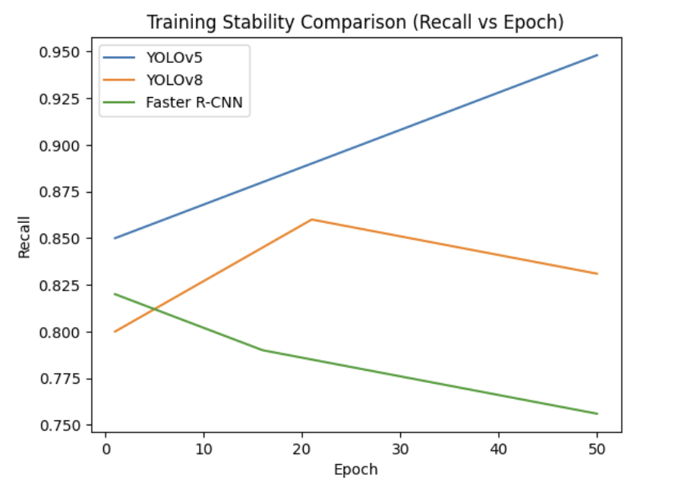
Figure 21 Training Stability Comparison
Figure 22 shows the trade-off between computational complexity and recall performance. YOLOv5 achieves the highest recall with the lowest GFLOPs, demonstrating superior efficiency-performance balance. Although Faster R-CNN provides moderate recall, its computational cost is significantly higher. YOLOv8 offers competitive complexity but does not outperform YOLOv5 in recall under the current task setting.
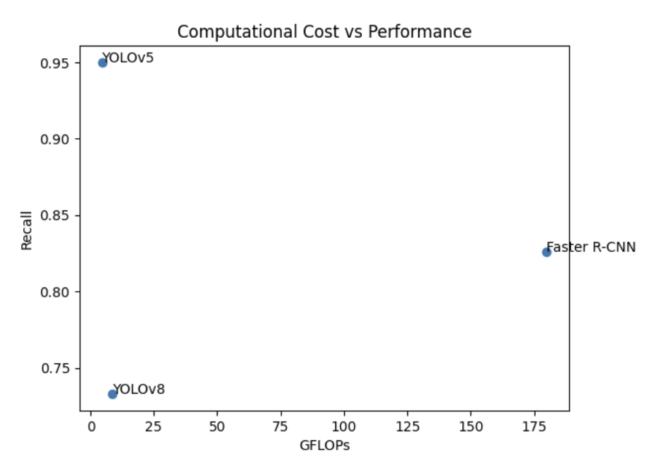
Figure 22 Computational Cost vs Performance
In summary, although YOLOv8 performs best in terms of overall accuracy and mAP indicators, considering that this study aims to improve the detection rate of fatigue behaviour and reduce the risk of missed inspection, the remarkable advantages of YOLOv5 in recall rate are more in line with the design requirements of the driving safety system. Therefore, YOLOv5 was finally selected as the basic model of the fatigue detection module of this study.

5.2 Performance of Distraction Detection Model

5.2.1 StateFarm Distracted Driver Detection Dataset Overview
State Farm Distracted Driver Detection Dataset is an open competition data set launched by State Farm, an American insurance company, on the Kaggle platform, which aims to promote computer vision-based Driver's distracted behaviour identification research. This dataset is specifically used for driver status classification tasks, focussing on several types of distracted behaviour, so it is widely used in driving behaviour analysis and Driver Monitoring System (DMS) research.
The data set contains driver images collected from the front camera in the car, covering a total of 10 categories (c0–c9), corresponding to different driving states, including: safe driving, using mobile phones (calling or texting), adjusting on-board equipment, diet, whole Hairdressing, or makeup, talking to passengers and other behaviours. The image resolution is high, and the driver's face, upper body and part of the in-car environment are clearly visible, which is conducive to the model learning characteristic information such as posture, hand movements, and head direction. The dataset contains different drivers, which has a certain diversity in terms of lighting conditions, shooting angles and appearance characteristics, thus enhancing the generalisation ability of the model.
In this study, normal driving, mobile phone use and eating behaviour in the data set are selected for training the distracted behaviour detection module, and functional integration with the drowsiness detection dataset to build a driver safety monitoring system with multi-behaviour recognition.
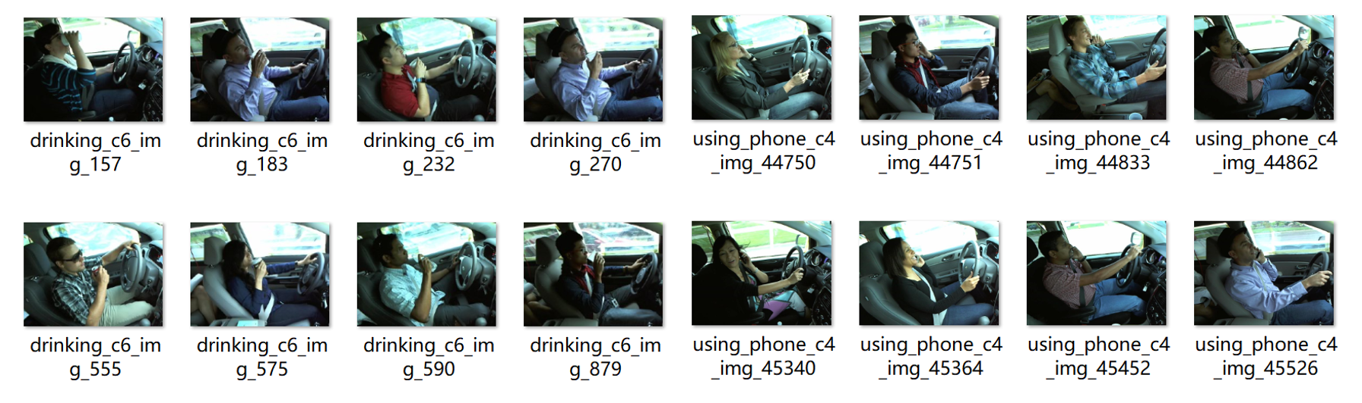
Figure 23 Pictures in StateFarm Distracted Driver Detection Dataset

5.2.2 Results and Performance Evaluation

5.2.2.1 Training and Validation Performance Analysis
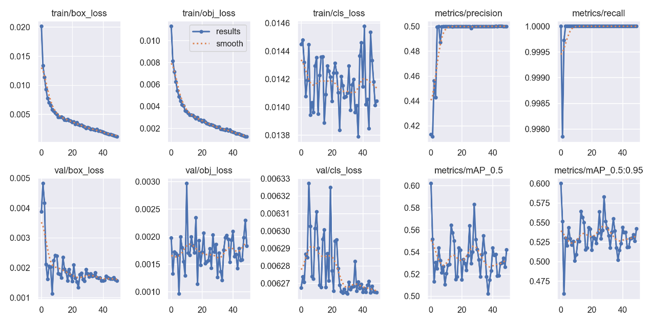
Figure 24 Training result curve of distraction detection model
It can be seen from the curve of the training results that the overall convergence process of the model is stable and enters a stable stage in the later stage.
First of all, in the training stage, train/box_loss and train/obj_loss both show a continuous downward trend and converge to a lower level after about 40 epochs, indicating that the model is gradually optimised in terms of boundary box regression and target confidence prediction. The learning of characteristics is sufficient. Although there are slight fluctuations in train/cls_loss, the overall change is small, indicating that the classification task is stable during the training process.
In the verification stage, val/box_loss tends to stabilise after a rapid decline in the early stage, indicating that the model has a certain generalisation ability; val/cls_loss declines slightly and remains stable in the middle and late stages, and there is no obvious upward trend, indicating that there is no serious over-fitting problem. However, there is a certain fluctuation in val/obj_loss, indicating that the model still has room for improvement in the judgement of target confidence.
Judging from the performance index, Precision has rapidly improved and stabilised at about 0.50 in the previous epoch; Recall is almost close to 1.00, indicating that the model's detection ability to the target is extremely strong and the omission rate is extremely low. This high recall characteristic is of great significance to the safety-sensitive driving monitoring system. At the same time, the overall stability of mAP@0.5 and mAP@0.5:0.95 is in the range of 0.52–0.55. Although there is a slight oscillation, there is no obvious deterioration, indicating that the model has reached a stable level in terms of comprehensive positioning and classification performance.
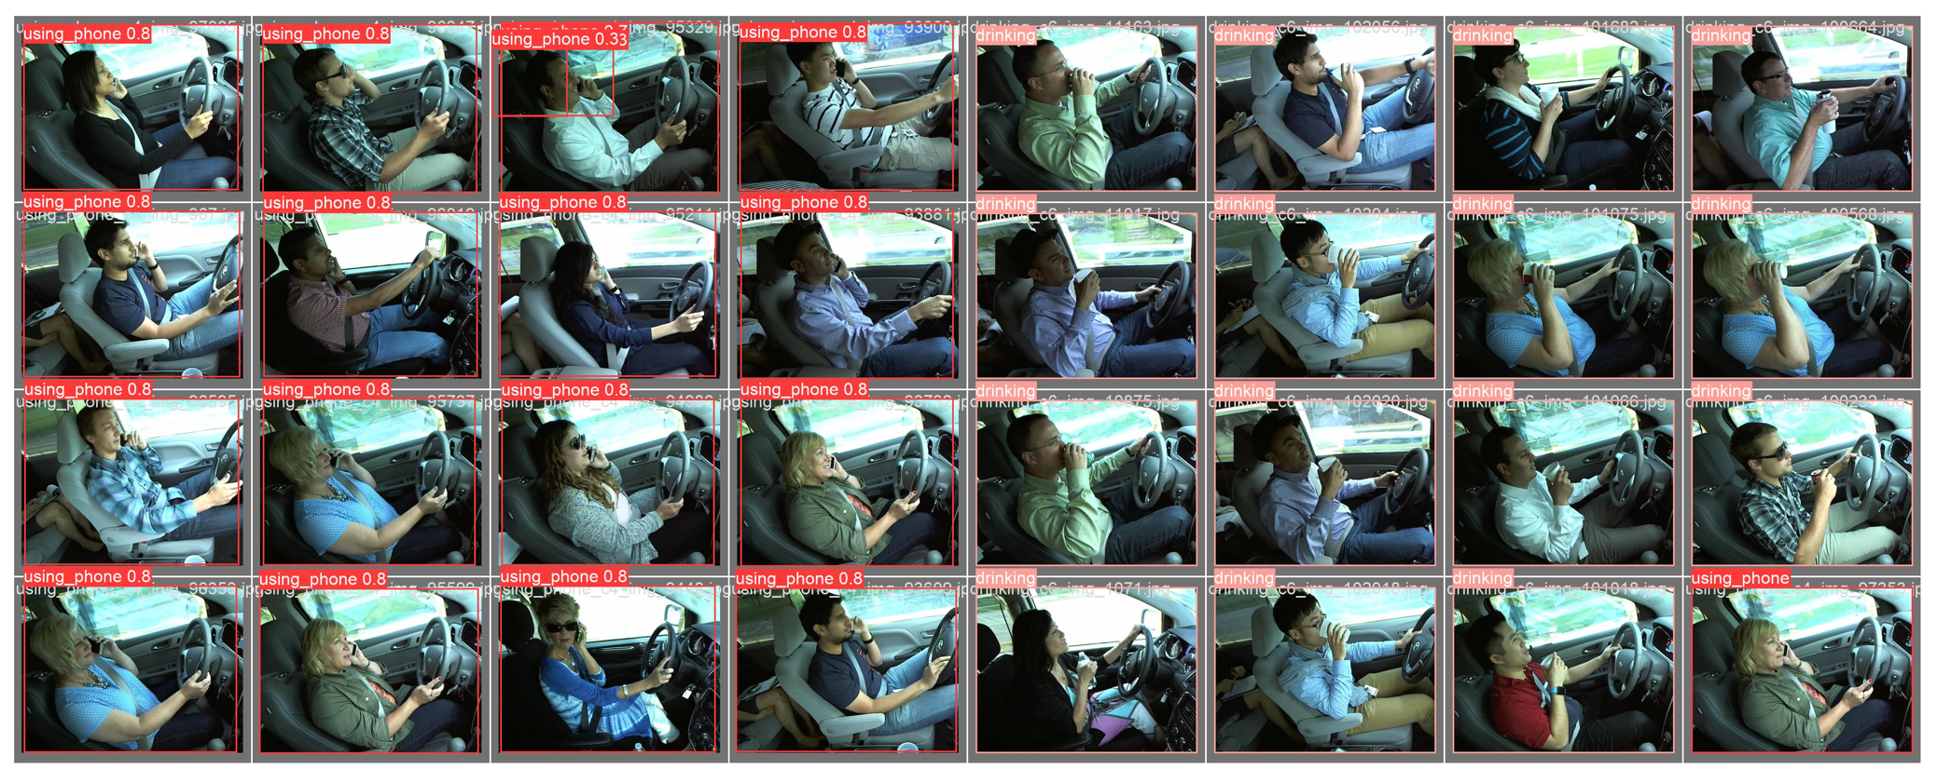
Figure 25 Prediction result of distraction detection model

5.2.2.2 Final Detection Performance Evaluation
Table 6 Test results of distraction detection
Class | Instances | Precision | Recall | mAP@0.5 | mAP@0.5:0.95
All | 2316 | 0.413 | 1 | 0.602 | 0.6
Using phone | 1851 | 0.625 | 1 | 0.841 | 0.839
Drinking | 465 | 0.201 | 1 | 0.363 | 0.361
According to the final test results, it can be seen that the model shows obvious characteristics of "high recall and low accuracy" in the overall detection task. The Precision of the overall (all) category is 0.413, while the Recall reaches 1.000, indicating that the model can detect all target instances, and there is no missed inspection, but at the same time, there are more misdetections, thus lowering the overall accuracy. In terms of comprehensive positioning performance, mAP@0.5 is 0.602, and mAP@0.5:0.95 is 0.600, indicating that the model still maintains a stable detection ability under different IoU thresholds.
From the category level, the detection effect of the using phone category is obviously better than that of the drinking category. For using phone, Precision is 0.625, Recall is 1.000, mAP@0.5 reaches 0.841, and mAP@0.5:0.95 is 0.839, indicating that the model can identify the line more accurately. The positioning and classification performance are ideal. This may be related to the enormous number of samples in this category (1851 instances) and the more obvious behavioural characteristics.
In contrast, the Precision of the drinking category is only 0.201. Although the Recall also reaches 1.000, the mAP@0.5 is only 0.363, and the mAP@0.5:0.95 is 0.361, which shows the mischecking of the model in this category is more serious. This phenomenon can be explained from several aspects related to data distribution, visual similarity, and detection characteristics.
First, class imbalance plays a significant role. In the training dataset, the number of “using phone” samples (1851 instances) are substantially higher than that of “drinking” samples (465 instances). The imbalance causes the model to allocate more representational capacity to dominant classes during optimisation. As a result, the feature space learned for the drinking class is relatively under-represented, making its decision boundary less discriminative. Consequently, the detector tends to generate false positive drinking predictions when encountering ambiguous hand-object interactions.
Second, the visual similarity between drinking and other behaviours increases misclassification risk. In both drinking and phone usage scenarios, the driver’s hand is typically raised toward the face region. The object (bottle or phone) is often partially occluded by the hand, face, or motion blur. Under such conditions, the geometric configuration of the hand-arm posture becomes a dominant feature, while the object-specific texture cues may be weak. This similarity leads the detector to confuse generic “hand-to-face” actions with drinking behaviour, thereby increasing false positives.
Third, small object detection difficulty further contributes to reduced precision. Bottles are typically smaller and less visually distinctive than mobile phones in the dataset. Smaller objects occupy fewer pixels and may lack clear contour or texture information, especially under varying lighting conditions. The detector therefore relies more heavily on contextual features, which may not always be sufficiently discriminative.
Fourth, the system is intentionally optimised for recall-oriented performance due to safety considerations. The confidence threshold is set relatively low to minimise false negatives. While this strategy ensures that no drinking instance is missed, it inevitably increases the number of false positives, thereby lowering precision. This trade-off aligns with the safety-first design principle of the driver monitoring system, where missed detection poses greater risk than occasional false alarms.
The model has achieved an extremely high recall rate in the distracted behaviour detection task, which can avoid the missed inspection of dangerous behaviour to the greatest extent, which is in line with the design principle of "priority guaranteeing the detection rate" of the safety-sensitive driving monitoring system. However, there is still room for improvement in its accuracy rate, especially in categories with a small number of samples or low feature distinction. In the future, the misdetection problem can be further improved through data enhancement, category balance strategy, or threshold optimisation.

5.3 Real-time Performance Analysis
The system conducts a reasoning test in the CPU environment and calculates the average processing speed through multiple forward propagation. The experimental results show that in the case of dual model parallel operation, the system can achieve close to real-time frame rate performance.
Although the dual-model structure increases the computing load, due to the lightweight YOLOv5n model and lower input resolution, the overall reasoning time is controlled within an acceptable range. If deployed to the GPU environment, the frame rate can be further improved.

Chapter 6
Conclusions and future work

6.1 Conclusion
This study designs and implements a driver drowsiness detection system based on the integration of dual YOLOv5 model and EAR/MAR geometric features around the detection of driver drowsiness and distracted behaviour. In response to the problem that it is difficult for a single detection model to comprehensively describe the driving risk state, this project proposes a system architecture that integrates functional decoupling and decision-making layer, which improves the detection stability and risk judgement accuracy under the premise of ensuring real-time.
At the method level, this project first builds a dual YOLOv5 parallel detection framework. Among them, the drowsiness detection model undertakes the task of face area positioning and improves the generalisation ability by strengthening regularisation and freezing layer training strategies; the distracted detection model is responsible for identifying high-risk behaviours such as using phones and drinking water and adopts the standard migration learning method for training and optimisation. Dual-model independent training and reasoning can effectively avoid the problem of multi-task interference and improve the concentration and stability of their respective tasks.
In terms of drowsiness modelling, this project introduces the geometric characteristics of EAR (Eye Aspect Ratio) and MAR (Mouth Aspect Ratio) to quantitatively describe the degree of eye closure and yawning behaviour. Combine the sliding time window mechanism to calculate the PERCLOS index to realise the time accumulation modelling of the fatigue state and reduce the risk of single-frame misjudgement.
At the decision-making level, this project designs a unified risk scoring function to weight and integrate the duration of PERCLOS and MAR and the confidence of distracted behaviour to realise the integrated judgement of multi-source information.
In terms of engineering implementation, the system adopts a lightweight YOLOv5n model and 416×416 input resolution design and optimises the reasoning process through multi-threaded mechanism to achieve near-real-time detection performance in the CPU environment and verify the deploy ability of the system.
To conclude, this project achieves a good balance between detection accuracy, system stability and real-time, providing a feasible solution for the practical application of the driver drowsiness detection system.

6.2 Limitations
Although this project has achieved certain results, there are still the following limitations:
- At present, the system is only based on visual information and does not integrate physiological signals or vehicle behaviour data.
- The weight parameters of risk scoring are determined by empirical parameter adjustment, and there is a lack of automatic optimisation mechanism.
- The system is evaluated in the CPU environment, and the long-term stability verification has not been conducted on the embedded hardware platform.

6.3 Future Work
Future research can be further expanded and optimised from the following directions:
  - Multimodal information fusion
It can introduce steering wheel corner, lane offset data or heart rate signals to realise the multi-modal integration of visual and physiological signals and improve the accuracy of fatigue recognition.
  - Introduce the timing deep learning model
On the basis of the current sliding window statistics, timing modelling methods such as LSTM or Transformer can be further introduced to dynamically model long-term driving behaviour and improve the ability to predict fatigue trends.
  - Lightweighting and embedded deployment
In the future, model pruning, quantisation or TensorRT acceleration technology can be used to deploy the system to embedded devices (such as the NVIDIA Jetson platform) to verify the long-term operating performance in the on-board environment.
  - Automated weight optimisation mechanism
Risk scoring weight parameters can be automatically optimised through Bayesian optimisation or grid search methods to reduce dependence on manual experience and improve model adaptability.
  - Expanded detection categories
It can further increase the categories of distracted behaviour, such as talking to passengers, adjusting the central control screen, etc., and improve the system's coverage of complex driving environments.

References
- World Health Organization, Global Status Report on Road Safety 2023, Geneva, Switzerland, 2023.
- P. Philip et al., “Fatigue, sleep restriction and driving performance,” Accident Analysis & Prevention, vol. 37, no. 3, pp. 473–478, 2005.
- National Highway Traffic Safety Administration, “Drowsy Driving and Automobile Crashes,” NHTSA Traffic Safety Facts, 2021.
- S. K. Lal and A. Craig, “A critical review of the psychophysiology of driver fatigue,” Biological Psychology, vol. 55, no. 3, pp. 173–194, 2001.
- D. Dawson and K. Reid, “Fatigue, alcohol and performance impairment,” Nature, vol. 388, pp. 235, 1997.
- W. Wierwille and L. Ellsworth, “Evaluation of driver drowsiness by trained raters,” Accident Analysis & Prevention, vol. 26, no. 5, pp. 571–581, 1994.
- J. Akerstedt, “Sleepiness as a consequence of shift work,” Sleep, vol. 11, no. 1, pp. 17–34, 1988.
- H. Abtahi et al., “Driver drowsiness monitoring based on yawning detection,” IEEE Intelligent Vehicles Symposium, 2011.
- A. Dasgupta et al., “Real-time driver fatigue detection,” IEEE Transactions on Intelligent Transportation Systems, 2013.
- A. K. Sriranga, Q. Lu, and S. A. Birrell, “A deep learning-based contactless driver state monitoring radar system for in-vehicle physiological applications,” IEEE Transactions on Intelligent Transportation Systems, vol. 26, no. 7, pp. 9491–9499, Jul. 2025.
- T. Soukupová and J. Čech, “Real-time eye blink detection using facial landmarks,” CVWW, 2016.
- A. Baheti et al., “Detecting distracted driver using deep learning,” CVPR Workshop, 2018.
- European Commission, “General Safety Regulation (EU) 2019/2144,” 2019.
- R. Sahayadhas, K. Sundaraj, and M. Murugappan, “Detecting driver drowsiness based on sensors: a review,” Sensors, 2012.
- M. Eriksson and N. P. Papanikolopoulos, “Eye-tracking for detection of driver fatigue,” IEEE ITS, 1997.
- W. Wierwille, “Overview of research on driver drowsiness,” Transportation Research Record, 1994.
- L. M. Bergasa, J. Nuevo, M. A. Sotelo, R. Barea and M. E. López, “Real-Time System for Monitoring Driver Vigilance,” IEEE Trans. Intelligent Transportation Systems, vol. 7, no. 1, pp. 63–77, Mar. 2006.
- T. Nguyen et al., “Driver drowsiness detection using wearable sensors,” IEEE Sensors Journal, 2018.
- B. T. Jap, S. Lal, P. Fischer and E. Bekiaris, “Using EEG spectral components to assess algorithms for detecting fatigue,” Expert Systems with Applications, vol. 36, no. 2, pp. 2352–2359, 2009.
- M. Patel and S. Lal, “Applying neural network analysis on heart rate variability data to assess driver fatigue,” Expert Systems with Applications / Engineering Applications of Artificial Intelligence (see publisher page), 2011.
- C.-T. Lin, R.-C. Wu, S.-F. Liang, W.-H. Chao, Y.-J. Chen and T.-P. Jung, “EEG-Based Drowsiness Estimation for Safety Driving using Independent Component Analysis,” IEEE Transactions on Circuits and Systems I: Regular Papers, vol. 52, no. 12, pp. 2726–2738, Dec. 2005.
- X. Jiang, et al., “Removal of Artifacts from EEG Signals: A Review,” Sensors (Basel), 2019.
- Y. Zhang et al., “Driver fatigue detection based on eye state recognition,” IEEE Access, 2019.
- D. Dinges and R. Grace, “PERCLOS: A Valid Psychophysiological Measure of Alertness. As Assessed by Psychomotor Vigilance,” NHTSA Tech. Brief, 1998.
- S. Park, F. Pan, S. Kang and C. D. Yoo, “Driver Drowsiness Detection System Based on Feature Representation Learning Using Various Deep Networks,” (Deep Drowsiness Detection — DDD), Proc. (KAIST / conference page), 2017.
- B. Baheti, S. Gajre and S. Talbar, “Detection of Distracted Driver Using Convolutional Neural Network,” in Proc. CVPR Workshops, 2018.
- Q. Ji, Z. Zhu and P. Lan, “Real-Time Nonintrusive Monitoring and Prediction of Driver Fatigue,” IEEE Transactions on Vehicular Technology, vol. 53, no. 4, pp. 1052–1068, Jul. 2004.
- Y. Albadawi, M. Takruri and M. Awad, “A review of recent developments in driver drowsiness detection systems,” Sensors, vol. 22, no. 5, 2022.
- J. Redmon et al., “You Only Look Once: Unified, Real-Time Object Detection,” CVPR, 2016.
- A. Bochkovskiy et al., “YOLOv4: Optimal Speed and Accuracy of Object Detection,” 2020.
- G. Jocher et al., “YOLOv8 Architecture Overview,” Ultralytics Technical Report, 2023.
- S. Ren et al., “Faster R-CNN: Towards Real-Time Object Detection,” NIPS, 2015.
- S. Ren, K. He, R. Girshick, and J. Sun, “Faster R-CNN: Towards real-time object detection with region proposal networks,” IEEE Transactions on Pattern Analysis and Machine Intelligence, vol. 39, no. 6, pp. 1137–1149, Jun. 2017.
- J. Dong et al., “Driver inattention monitoring system for intelligent vehicles,” IEEE T-ITS, 2011.
- T. Everingham et al., “The Pascal Visual Object Classes Challenge,” IJCV, 2010.
- COCO Consortium, “Common Objects in Context Dataset Evaluation Metrics,” 2017.

