A Guide to QFN/MLF Footprint Design in Kicad
Suggestions for designing trouble-free footprints

The Problem
QFN and MLF packages use identical footprints. Both have a thermal pad on the bottom for the purpose of heatsinking, but if the copper pattern provided for it on the PCB isn't carefully designed the footprint can cause problems during manufacture. This is because if a single large area of copper is used the chip will float on a central blob of solder, causing some or all of the circumferential pins to lift clear of the board, and/or causing the chip to rotate or move off centre. Alternatively the solder can wick through the thermal vias, which not only has the potential to cause the chip to move due to asymmetric soldering, but also it can result in a dry joint. Reported failure rates are a few percent.

A few footprints designed to solve the difficulties soldering QFN and MLF packages may be found on the internet, but not all are simple to achieve in Kicad.

A Design Methodology for Kicad
Although the pad is for heatsinking, unless the chip is required to source or sink a lot of current the greater issue will be ensuring reliable manufacture. When the solder paste melts it will form a hill-shaped blob, so the first step is to divide a single pad large enough for the thermal pad into smaller pads so that the chip rests on several small hills and not one large hill. This is more stable and will stop the chip from tilting and/or spinning. The second issue is providing thermal vias. There are two approaches to this.

One approach is to use tented vias (ie vias covered with solder resist). This is simple, reliable, and easy to achieve in Kicad, but each via will make poor thermal contact with the thermal pad, so it is important not to use too many. However, you can at least make the drill hole relatively large to ensure it has good heat transfer capacity.

An alternative approach is to use untented vias with holes that are too small to allow solder wicking. You would either need to know how small the holes must be, or have the knowledge to calculate their maximum size. You would also have to check that the reduced diameter doesn't in fact result in less heat transfer capacity than is provided by a single large diameter via hole. Since the vias would need a solder paste mask they would have to be pads rather than vias, which would mean you would have to ensure that the pads are not connected to the ground plane via thermal reliefs (true vias never have thermal reliefs). Thus you can see that this second approach requires a lot more work and may result in problems if you get your calculations wrong.

To aid reliable soldering it is worth shrinking the solder paste mask. The optimum shrink is determined by the manufacturing process (in particular the solder paste used), but failing hard information try 0.04mm (ie the distance from the paste mask edge to the pad edge will be 0.02mm all round).

Examples
The design shown here is tried and tested for various low power applications, having been used for Atmel AVR microcontrollers and FTDI USB chips:

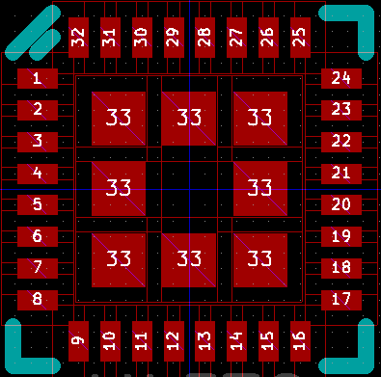
This is a 0.5mm pitch QFN32 (the grid pitch is 0.25mm). The hole in the middle is for a Kicad default via. Note that the thermal pads are all pin number 33 (so a corresponding pin is required on the schematic symbol), and are therefore all on the same net. When routing the pads are connected using thick horizontal and vertical tracks. The following image shows how this footprint was routed for a real board design. Note that the uninterrupted heatsinking area on this two layer board is in fact very small, but as there were no thermal problems resulting from this it demonstrates that heatsinking was indeed the least of the designer's problems.

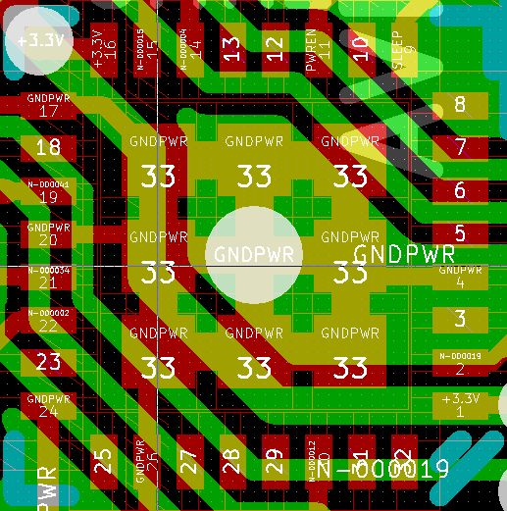
If your calculations show that untented small hole diameter vias would be beneficial and necessary, you would replace the square pads and the central via with untented vias.

With larger QFN packages there is more space for providing pads and vias. The design shown below (which at the time of writing has not been tested on a board) allows for nine tented Kicad default vias, so it should be thermally much more effective.


Note also that in this later design the circumferential pads have been made oval so that the pads at the corners don't conflict, a problem that is even more significant with smaller pitch QFN footprints:

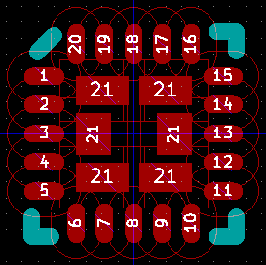
For convenience these module designs have been included in the zip file. Don't forget that at the time of writing only the QFN50P500X500-33N module is used in production. QFN50P500X500-29N has been used sucessfully in a prototype and will be used if and when the board goes into production. Feedback on other designs used in production would be helpful to the Kicad community.

