Use Case Specification

DMT/RM01/TMP

|  |  |
| --- | --- |
| Project Code | PRJ_BankingExam_001 |
| Project Name | Banking Exam Portal |

|  |  |  |
| --- | --- | --- |
| Prepared/Modified by | Role | Date of Preparation |
| Puttaparthi Noor Mohammed | Analyst | 18th May, 2018 |
| Reviewed by | Role | Date of Review |
|  |  |  |
| Approved by | Role | Date of Approval |
|  |  |  |
| Circulation List |  | Version Number of the template:1.1 |
| Version Number | 1.1 |  |

<<Customer>> REVIEW HISTORY

<<Customer comments on the Use case along with the signed off is tracked here>>

|  |  |  |  |  |  |  |
| --- | --- | --- | --- | --- | --- | --- |
| Version | <<Version number>> |  |  |  |  |  |
| Date | <<Date of Review>> |  |  |  |  |  |
| Reviewed by | << Reviewer Name>> |  |  |  |  |  |
| Reviewed UI Specification doc | << Whether UI Specification doc is reviewed >> |  |  |  |  |  |
| All Open Queries/issues closed | << Whether all the open queries and issues resolved>> |  |  |  |  |  |
| Agreement on Assumptions | <<Whether all the assumptions have been agreed upon by the customer>> |  |  |  |  |  |
| Sign Off | <<Signature>> |  |  |  |  |  |

Disclaimer:

The scope of the project ‘University Admission System’ is restricted to the contents of this signed off use case.

TABLE OF CONTENTS

1. Use Case Name: Adding a new exam to the website 5

2. Actor(s): 5

3. Preconditions 5

4. Flow of Events 5

4.1 Basic Flow 5

4.2 Alternative Flows 6

4.2.1 Alternate Flow 1 6

4.2.2 Alternate Flow 2 6

4.2.3 Alternate Flow 3 7

Exception Flow 1: Exceeded Login Attempts 7

Exception Flow 2: Web Server Down 7

Exception Flow 3: Database Connectivity Error 7

Exception Flow 4: Network Connectivity Error 7

5. Post Conditions 7

6. Special Requirements 8

Performance 8

Availability 8

User Interface 9

Security 9

7. Extension Points 9

Extension in Alternate Flow 1: 9

Extension in Alternate Flow x: 9

8. Business Rules 9

9. Diagrams 10

Use Case Diagram for User 10

Activity Diagram 11

10. Scenarios 12

Success Scenarios 12

Failure Scenarios 12

11. Issues 12

12. UI Specifications 12

13. Inter System Dependencies 13

14. Integration with an already existing System of the <<Customer>><<Not Applicable>> 13

15. Assumptions 13

1. Use Case Name: Login to the University Admission System

Use Case ID: BEP.ADD.EXAM_001

Brief Description:

This Use Case describes the process to Add a new exam to the website .For adding a new exam the user must be administrator i.e. a employee of banking portal company and should be logged in as a Admin.

1. Actor(s):

1. User

Administrator (An employee of Banking Exam Portal)

1. Preconditions
2. User is an employee of a Banking Exam Portal company
3. User has an acces to the Banking Exam Portal Website
4. User has a valid user id and the password
5. User has already logged in to the banking exam portal

1. Flow of Events

4.1 Basic Flow

Name: Successfully Adding Exam Details

1. User clicks on the Add Exam Details link available on the Admin Home page.
2. User will be navigated to the add an exam web page.
3. User fills all the required details to add a new exam to the banking exam database.
4. User Clicks on the submit button to complete the process of adding a new exam.
5. New Exam is added to the website.
   1. Alternative Flows
      1. Alternate Flow 1
6. User clickson the Add Exam Details link available on the Admin Home page.
7. User will be navigated to the add an exam web page.
8. User fills all the required details to add a new exam to the banking exam database.
9. User Clicks on Reset button all the fields entered are cleared.
10. User againfills all the required details to add a new exam to the banking exam database.
11. User Clicks on the submit button to complete the process of adding a new exam.
12. New Exam is added to the website.

4.2.2 Alternate Flow 2

1. User clicks on the Add Exam Details link available on the Admin Home page.
2. User will be navigated to the add an exam web page.
3. User fills all the required details to add a new exam to the banking exam database.
4. User changes the name of the exam.
5. User Clicks on the submit button to complete the process of adding a new exam.
6. New Exam is added to the website.

4.2.3 Alternate Flow 3

Exception Flow 1: Leaving the Fields Empty

1. User clicks on the Add Exam Details link available on the Admin Home page.
2. User will be navigated to the add an exam web page.
3. User leaves the fields empty.
4. User Clicks on the submit button to complete the process of adding a new exam.
5. Adding a new exam is failed.

Exception Flow 2: Giving the Same Excisting Name

1. User clicks on the Add Exam Details link available on the Admin Home page.
2. User will be navigated to the add an exam web page.
3. User gives the excisting name in the name fields and fills the remaining fields correctly.
4. User Clicks on the submit button to complete the process of adding a new exam.
5. The system displays message saying same name cannot be used for different exam.

Exception Flow 3: Closure date is less than 30 days from exam date

1. User clicks on the Add Exam Details link available on the Admin Home page.
2. User will be navigated to the add an exam web page.
3. User gives the closuredate less than 30 days and fills the remaining fields correctly.
4. User Clicks on the submit button to complete the process of adding a new exam.
5. Invalid closure date.
6. Post Conditions

| Flow Name | Post Condition |
| --- | --- |
| Successfully adding the exam | Exam is Added Successfully and is available to the applicants |
| Reset and fill the data and adding the exam | Exam is Added Successfully and is available to the applicants |
| Name is changed Before submitting the exam | Exam is Added Successfully and is available to the applicants |
| Leaving the fields empty | Failed to add exam |
| Giving the same excisting name | Same name cannot be given to two exams |
| Closure date is less than 30 days from comencementof the exam | Closure date cannot be less than 30 days |

1. Special Requirements

Performance

1. On Adding the new exam it should be available to the applicant in 1hr.

Availability

* 1. The admin should be able to add exam 24*7.

User Interface

* 1. The letters on Menus shall be bold
  2. The active links shoul be displayed in red color
  3. The visisted links should be displayed in purpule color
  4. The Unvisited links should be displayed in blue
  5. The logout and back button should be available on every page of the application
  6. Look and feel and color of application should be proper.
  7. In case of Field level validation error messages should be displayed in red color.

Security

1. After clicking on back on browser it should takes you back to the previous page in the list
2. After clicking on Forward on browser it should takes you forward to the next page in the list.
3. Extension Points

Extension in Alternate Flow 3 Exception 1:

In step 3, if the user has left fields empty :

1. The system prompts the user to fill the mandatory fields.

1. Business Rules

| Business Rule Name | Business Rule Description | System action (if BR fails) |
| --- | --- | --- |
| BR01 | User must be Administrator | Display “Access denied” |
| BR02 | Administrator should not be able to apply for the exam | Displayes error message “Only applicants are eligible to apply” |

1. Diagrams

Use Case Diagram for User

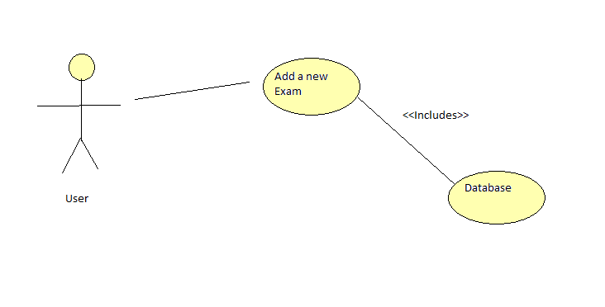

Activity Diagram<<Not Applicable>>

1. Scenarios

Success Scenarios

* User is able to add the exam succesfully
* User can reset and again fill the data to add exam successfully

Failure Scenarios

* Giving the same name for different exams
* Database Connectivity Error
* Network Connectivity Error

1. Issues
2. UI Specifications
3. Inter System Dependencies
4. Integration with an already existing System of the <<Customer>><<Not Applicable>>
5. Assumptions

<< List down all the assumptions considered by this use case>>

1. The User should be authenticate.
2. User should know the valid URL of Banking Exam Portal
3. User should have Google chrome browser for best view of site.

REVISION HISTORY OF THE WORK PRODUCT

<to be maintained by projects>

|  |  |  |  |  |  |
| --- | --- | --- | --- | --- | --- |
| # | Date | Version # | Section Changed | Details of changes made | Approved By |
| 1 |  |  |  |  |  |
| 2 |  |  |  |  |  |