Use Case Specification

DMT/RM01/TMP

|  |  |
| --- | --- |
| Project Code | PRJ_hotel_booking_management_01 |
| Project Name | Hotel Booking Management |

|  |  |  |
| --- | --- | --- |
| Prepared/Modified by | Role | Date of Preparation |
|  | Analyst | 24/05/2018 |
| Reviewed by | Role | Date of Review |
|  |  |  |
| Approved by | Role | Date of Approval |
|  |  |  |
| Circulation List |  | Version Number of the template:1.0 |
| Version Number | 1.0 |  |

<<Customer>> REVIEW HISTORY

<<Customer comments on the Use case along with the signed off is tracked here>>

|  |  |  |  |  |  |  |
| --- | --- | --- | --- | --- | --- | --- |
| Version | <<Version number>> |  |  |  |  |  |
| Date | <<Date of Review>> |  |  |  |  |  |
| Reviewed by | << Reviewer Name>> |  |  |  |  |  |
| Reviewed UI Specification doc | << Whether UI Specification doc is reviewed >> |  |  |  |  |  |
| All Open Queries/issues closed | << Whether all the open queries and issues resolved>> |  |  |  |  |  |
| Agreement on Assumptions | <<Whether all the assumptions have been agreed upon by the customer>> |  |  |  |  |  |
| Sign Off | <<Signature>> |  |  |  |  |  |

Disclaimer:

The scope of the project ‘<<Project Name>>’ is restricted to the contents of this signed off use case.

TABLE OF CONTENTS

1.Use Case Name: <<Use Case Name>> 4

2.Actor(s) 4

3.Preconditions 4

4.Flow of Events 4

4.1 Basic Flow 4

4.2 Alternative Flows 5

4.2.1 Alternate Flow 1 5

4.3 Sub Flows 6

4.3.1 Sub Flow 1 6

5.Post Conditions 6

6.Special Requirements 7

7.Extension Points 7

<Name of extension point> 7

8.Business Rules 7

9.Diagrams 8

Use Case Diagram 8

Activity Diagram 9

10.Scenarios 10

Success Scenarios 10

Failure Scenarios 10

11.Issues 10

12.UI Specifications 10

13.Inter System Dependencies 11

14.Integration with an already existing System of the <<Customer>> 11

15.Assumptions 11

REVISION HISTORY OF THE WORK PRODUCT…………………………….. .. 12

1. Use Case Name: Adding Hotel in HBMS

**Use Case ID:**  admin.adding_hotel_001

**Brief Description:** This use case describes the process by which admin can add hotel and view hotel reports.

1. Actor(s)

Admin

1. Preconditions

Admin has valid username and password.

Admin is aware of all the fields in adding hotel page.

1. Flow of Events

4.1 Basic Flow

**Name:** Successful addition of hotel

1.Admin enters the url on the browser and system navigates admin to login page

2.Admin enters valid credentials

3.System validates credentials and navigates admin to main option screen.

4.Admin clicks manage hotels and selects add hotel option.

5.Admin enters hotel locality

6.Admin enters hotel Name

7.Admin enters Address

8.Admin enters description

9.Admin enters average fare per night

10.Admin enters phone number1& phone number2

11.Admin selects rating

12.Admin enters email

13. Admin enters tax and clicks on add hotel button.

13.System displays message regarding successful addition of hotel.

* 1. Alternative Flows

4.2.1 Alternate Flow 1:Entering Into The Application Throgh HBMS App

1.Admin clicks on HBMS app icon and system navigates admin to login page

2.Admin enters valid credentials

3.System validates credentials and navigates admin to main option screen.

4.Admin clicks manage hotels and selects add hotel option.

5.Admin enters hotel locality

6.Admin enters hotel Name

7.Admin enters Address

8.Admin enters description

9.Admin enters average fare per night

10.Admin enters phone number1& phone number2

11.Admin selects rating

12.Admin enters email

13.Admin enters tax and clicks on add hotel button.

14.System displays message regarding successful addition of hotel.

4.2.1 Alternate Flow 2:View Hotel Report,delete hotel and Adding Hotel

1.Admin clicks on HBMS app icon and system navigates admin to login page

2.Admin enters valid credentials

3.System validates credentials and navigates admin to main option screen.

4.Admin clicks view reports and selects list of hotels.

5.System displays report which contains list of hotels

6.Admin checks for Sri Sai Seven Hills hotel and clicks delete button.

7.system displays a message regarding successful deletion of the hotel.

8.Admin clicks on back button.

9.system navigates the admin to main option screen.

10.Admin clicks manage hotels and selects add hotel option.

11.Admin enters hotel locality

12.Admin enters hotel Name

13.Admin enters Address

14.Admin enters description

15.Admin enters average fare per night

16.Admin enters phone number1& phone number2

17.Admin selects rating

18.Admin enters email

19.Admin enters tax and clicks on add hotel button.

20.System displays message regarding successful addition of hotel.

4.2.2 Alternate Flow 3: update hotel details and adding hotel

1.Admin clicks on HBMS login in bookmark and system navigates admin to login page

2.Admin enters valid credentials

3.System validates credentials and navigates admin to main option screen.

4.Admin clicks view reports and selects list of hotels.

5.System displays report which contains list of hotels

6.Admin checks for Princess hotel and clicks update button.

7.System navigates the admin to update hotel webpage.

8.Admin updates average fare per night field and phone number1 field

9.Admin clicks on Update Hotel button

10.System displays message regarding successful updation of hotel.

11.Admin clicks on back button.

12.System navigates the admin to main option screen.

13..Admin clicks manage hotels and selects add hotel option.

14.Admin enters hotel locality

15.Admin enters hotel Name

16.Admin enters Address

17.Admin enters description

18.Admin enters average fare per night

19.Admin enters phone number1& phone number2

20.Admin selects rating

21.Admin enters email

22.Admin enters tax and clicks on add hotel button

23.System displays message regarding successful addition of hotel.

4.2.3 Alternate Flow 4

Exception Flow 1: Entering Into Application With Invalid Credentials.

1.Admin enters the url on the browser and system navigates admin to login page

2.Admin enters invalid username

3.Admin enters password

4.Admin clicks on login button

5.System validates credentials and displays error message.

Exception Flow 2: Adding Hotel Without Hotel Name.

1.Admin enters the url on the browser and system navigates admin to login page

2.Admin enters valid credentials

3.System validates credentials and navigates admin to main option screen.

4.Admin clicks manage hotels and selects add hotel option.

5.Admin enters hotel locality

6.Admin enters Address

7.Admin enters description

8.Admin enters average fare per night

9.Admin enters phone number1& phone number2

10.Admin selects rating

11.Admin enters email

12.Admin enters tax and clicks on add hotel button

13.System displays error message regarding invalid hotel name.

Exception Flow 3: Data Connectivity Problem

1.Admin enters the url on the browser.

2.System displays error message regarding data connectivity

Exception Flow 4: Database Connectivity Error

1.Admin enters the url on the browser and system navigates admin to login page

2.Admin enters username

3.Admin enters password

4.Admin clicks on login button

5.The system validates Username & Password

6.The system displays an error message regarding database connectivity problem.

POST CONDITION

| Flow Name | Post Condition |
| --- | --- |
| Successful addition of hotel | System displays message regarding successful addition of hotel. |
| Entering into application through HBMS APP | System displays message regarding successful addition of hotel. |
| View Hotel Report,delete hotel and Adding Hotel | System displays message regarding successful addition of hotel. |
| update hotel details and adding hotel | System displays message regarding successful addition of hotel. |
| Entering Into Application With Invalid Credentials | System validates credentials and displays error message. |
| Adding hotel without hotel name. | System displays error message regarding invalid hotel name. |
| Database Connectivity Error | System displays an error message regarding database connectivity problem. |
| Data connectivity problem | System displays error message regarding data connectivity |

1. Special Requirements

Performance

1.Clicks on add hotel option will displays add hotel page within 15 seconds of user request

Availability

**1.** Admin can add hotel 24x7.

2. Application is up and running 24*7

User Interface

1.The letters on Menus shall be bold

2.The active links shoul be displayed in red color

3.The visisted links should be displayed in purpule color

4.The Unvisited links should be displayed in blue

5.The logout and back button should be available on every page of the application

6.Look and feel and color of application should be proper.

7.In case of Field level validation error messages should be displayed in red color.

Security

1.Admin with valid credentials can only login.

2.If Admin enters the URL of the main option screen the system redirects the admin to login page.

3.If HBMS remains inactive for 15 mins it asks to login again.

4.Admin can only add,update,delete hotel

7.Extension Points

Entering Into Application With Invalid Credentials.

In step 2 i if the admin has entered wrong user credentials :

1. The system prompts the admin to re-enter the credentials

2. Admin enters valid credential

3. The system takes admin to the Step 3 of Basic Flow

Entering Into Application With Invalid hotel name.

In step 6 i if the admin has not entered hotel name :

1. The system prompts the admin to re-enter the hotel name

2. Admin enters hotel name

3. The system takes admin to the Step 7 of Basic Flow

1. Business Rules

| Business Rule Name | Business Rule Description | System action (if BR fails) |
| --- | --- | --- |
| BR01 | All field are mandatory in add hotel page | System will display error message |
| BR02 | Average fare per night should be in RS | System will display error message regarding invalid average fare per night |
| BR03 | Admin should login before adding exam | System will navigate admin to login page |

1. Diagrams

Use Case Diagram

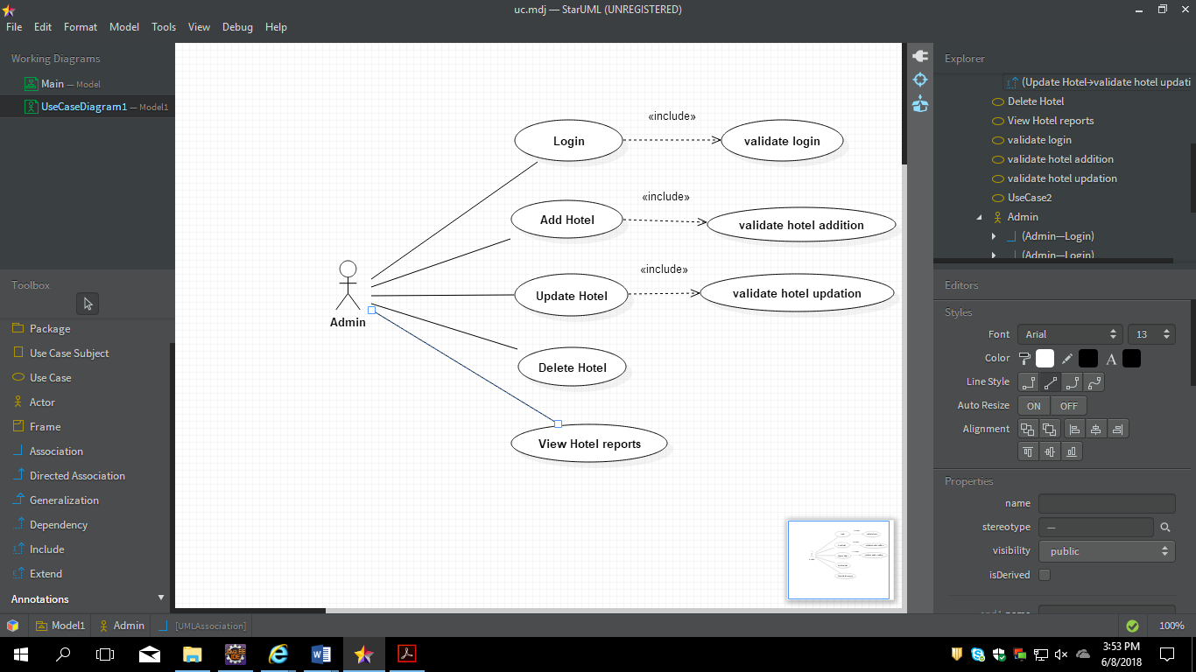

1. Scenarios

Success Scenarios

* Successful addition of hotel
* Entering into application through HBMS APP
* View Hotel Report,delete hotel and Adding Hotel
* update hotel details and adding hotel

Failure Scenarios

* Entering into application with invalid credentials.
* Adding hotel without hotel name.
* Data connectivity problem
* Database Connectivity Error

1. Issues
2. What is the maximum size of username and password that Admin can have ?
3. What if the Admin is blocked after invalid login attempts for three times ?
4. UI Specifications
5. Inter System Dependencies

**Module: ‘**Add room’ gets impacted due to :

Use case name: Adding Hotel in HBMS

**Impact**: Adding room cannot be done if hotel is not added

1. Assumptions
2. The Admin should be authenticate.
3. Admin should know the valid URL of HBMS
4. Admin should have Google chrome browser for best view of site.

REVISION HISTORY OF THE WORK PRODUCT

<to be maintained by projects>

|  |  |  |  |  |  |
| --- | --- | --- | --- | --- | --- |
| # | Date | Version # | Section Changed | Details of changes made | Approved By |
| 1 |  |  |  |  |  |
| 2 |  |  |  |  |  |