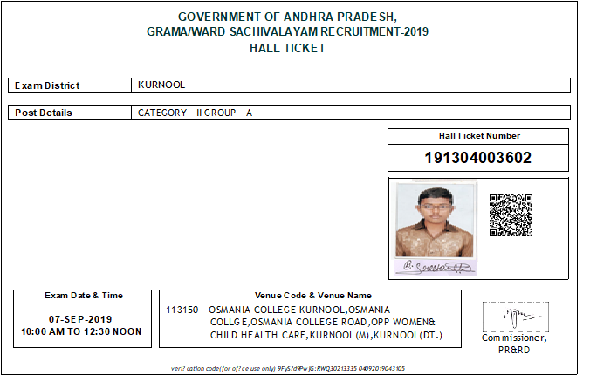

**Candidate Name :** Dandu Sreekanth

**Father Name :** Dandu Ramesh

**Mother Name :** Dandu Sowbhagya Lakshmi

**OTPRID :** VSWS509274486

**Application ID :** 30212223

**Date of Birth :** 06-Jun-1998

**Special Category :** PH: No, Sports: No, NCC: No, Ex-Servicemen: No

**Social category :** OC-General

**Address :** H.no – 8/695, near Railway station, B.C Colony,

Ulindakoda, Kallur, Kurnool-518218

# IMPORTANT INSTRUCTIONS TO THE CANDIDATE

1. Candidates will be permitted to appear for the examination only after their credentials are veriﬁed by centre ofﬁcials and after frisking to ensure that no prohibited articles are carried (writing pads & hand bags are also not allowed). DSC will not make any arrangements for safe custody of prohibited devices and candidates shall make their own arrangements.
2. All the information pertaining to the candidate given above is as submitted by the candidate through online application. Hence, candidate alone is responsible for the entries made by her / him.
3. The Hall Ticket must be presented for entry into the examination hall along with at least one original valid Photo identiﬁcation card issued by Government i.e., Passport, PAN Card, Voter ID, Aadhar Card, Government Employee ID or Driving License, etc.
4. If you have downloaded the Hall Ticket without photo/blurred photo / too small photo / photo without signature, you should bring 3 Passport size Photos duly attested by Gazetted Ofﬁcer and hand over the same to the Invigilator in the examination hall, failing which you will not be admitted to the examination.

# Candidates will be allowed inside the exam centre from 9.30 am / 2.00 pm. No candidate will be allowed after

**10.00 am / 2.30 pm Candidates are advised to check the location of exam centre in advance and also reach the examination centre early to avoid last minute rush.**

1. Candidates are suggested to visit the examination venue, a day in advance, so that they can reach the venue on time on the day of examination.
2. Candidates are not allowed to bring any Electronic devices such as Mobile/Cell Phones, Calculators, Tablets, I-Pad, Bluetooth, Pagers or any other device capable of interacting/Programming to the examination Centre. Any violation of the above leads to disqualiﬁcation of candidature.