

PRT631 INFORMATION SYSTEM PRACTICE

Executive Project Summary & Competition Submission White Paper

Bipin Maharjan (S384170)

Scope: 10-Site Pilot Rollout across New South Wales (NSW), Australia
GitHub: https://github.com/geeksgod/Automated-License-Plate-Recognition
Demo: https://youtu.be/9gyR4GZRnS0

1. Executive Summary
Fuel drive-offs (also described as “Fail to Pay for Fuel”) create a combined revenue, operational and compliance problem for service-station operators. The current project identifies a gap between passive CCTV recording and the real-time decisions staff need to make at the console. Operating on razor-thin fuel margins, stations absorb an average loss of $220 per week per site. On top of direct inventory loss, site managers spend 30 to 90 minutes per incident assembling footage and filing manual reports for police. Existing solutions like standard CCTV are reactive, while forcing mandatory pre-pay hurts higher-margin convenience store sales.
The proposed solution is an edge-based Automated Licence Plate Recognition (ALPR) system designed as a retrofit to existing forecourt camera infrastructure. Each site processes video locally using an NVIDIA Jetson or RTX-enabled edge computer. The computer-vision pipeline uses hardware video decode, YOLOv8 vehicle/plate detection,multi-frame OCR validation. Once a plate is confirmed, the system performs one local watchlist lookup and generates at most one operator alert for that vehicle visit. Structured event data, selected images and short evidence clips can then be synchronised securely to a central backend while raw video remains on site.

Core Project Performance Indicators
- Target Pilot Investment: AUD $101,500 (across 10 pilot sites over 12 weeks).
- Break-Even Horizon: 10.7 Months (recovering ~$1,000/month per site in avoided theft).
- Detection & Alert Latency: Sub-2-second local identification and console notification.
- System Uptime & Resilience: 100% offline functionality for localized detection, tracking, and watchlist matching.

2. Business Problem & Market Gap
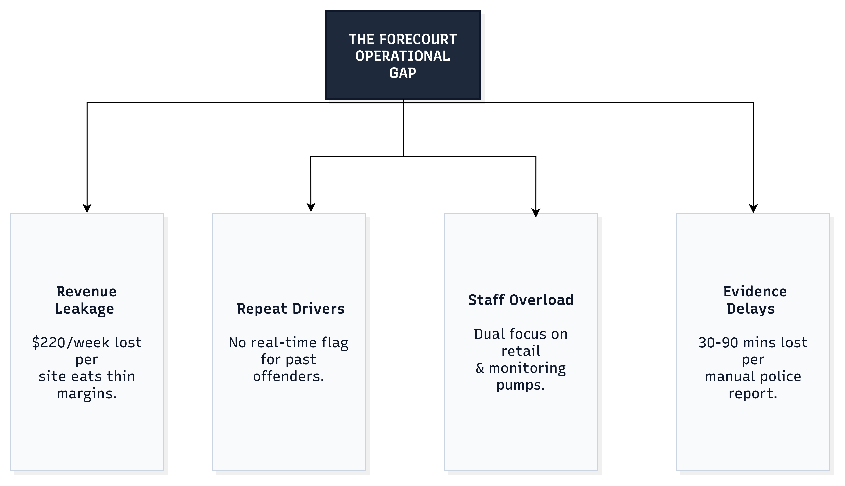
Service stations operate under a dual business model: low-margin fuel sales paired with high-margin convenience retail. Frontline console staff face high cognitive load, balancing point-of-sale retail transactions, customer service, and forecourt safety monitoring.
Current operational gaps include:
- Unreliable Manual Oversight: Staff serving customers on the till cannot continuously monitor all active pumps.
- Motion Alarm Fatigue: Basic motion-detection alerts trigger indiscriminately for standard foot traffic, leading staff to mute or ignore them.
- Severe Reporting Friction: Compiling manual evidence packages (cropping images, matching pump timestamps, and writing incident reports) drains 30–90 minutes of manager productivity per drive-off.
- Lack of Real-Time Intelligence: Standard CCTV records footage passively, providing no mechanism to identify repeat offenders before fuel is drawn.

3. Options Analysis & Strategic Positioning
Before selecting the Edge-AI retrofit model, four architectural approaches were evaluated:
Evaluation Criteria | Do Nothing / Standard CCTV | Mandatory Pre-Pay Model | Cloud-Based ALPR | Edge Retrofit ALPR (Selected Solution)
Capital Cost | $0 upfront (High indirect loss) | Low | High recurring cloud costs | Moderate ($101.5k for 10 sites)
Theft Prevention | Low / Reactive | High | High | High (Proactive pre-pay switching)
Retail Impact | Neutral | Negative (Reduces store foot traffic) | Neutral | Positive (Preserves store foot traffic)
Offline Resilience | N/A | High | Zero (Fails during WAN drops) | High (100% local processing)
Bandwidth Usage | Low | None | Extremely High (HD video streaming) | Extremely Low (Transmits event logs only)
Strategic Rationale: Edge ALPR provides the optimal balance of loss prevention, operational uptime, cost containment, and customer convenience without harming higher-margin retail store sales.

4. System Architecture & Engineering Design

4.1 System Architecture Alignment
The system is structured into four distinct functional modules that process video streams, run recognition inference, drive the user interface, and persist logs:
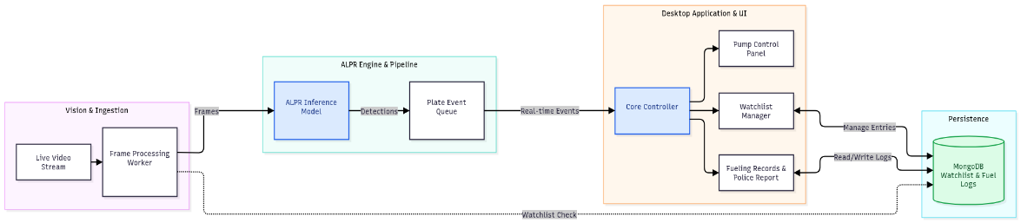
- Vision & Ingestion Module: Captures the Live Video Stream from forecourt cameras and passes raw frames to the Frame Processing Worker.
- ALPR Engine & Pipeline Module: Received Frames pass through the ALPR Inference Model. Detected vehicle and license plate data (Detections) are queued in the Plate Event Queue.
- Desktop Application & UI Module: Real-time Events are consumed by the Core Controller, which routes live information across three dedicated desktop interface sub-components:
  - Pump Control Panel: Displays live pump statuses and enables manual/automated pump stops.
  - Watchlist Manager: Manages flagged license plates and updates entries.
  - Fueling Records & Police Report: Maintains historical logs and auto-generates police-ready evidence files.
- Persistence Layer: Uses MongoDB to manage Watchlist & Fuel Logs. The Frame Processing Worker maintains a direct Watchlist Check path to MongoDB for low-latency verification, while the UI modules read and write fueling logs and watchlist entries.

5. Implementation Plan & Financial Feasibility

5.1 12-Week Agile Delivery Schedule
Week 01-02: Site Assessment & Hardware Procurement
Week 03-05: Vision Ingestion & ALPR Inference Model Tuning
Week 05-06: Plate Event Queue & MongoDB Persistence Integration
Week 06-08: Core Controller & Desktop UI Submodules Development
Week 08-09: Watchlist Manager & Direct Ingestion Check Setup
Week 09-10: Police Report Generator & Evidence Export Formatting
Week 10-12: Field Pilot Installation, Staff Training & Live Review

5.2 Financial Budget & Cost Breakdown (10-Site Pilot)
Expense Category | Description | Cost (AUD) | % of Total
Project Personnel | Systems Engineering, Computer Vision Lead, PM, QA (12 weeks) | $84,000 | 82.8%
Edge Hardware | 10x On-site processing units + camera hardware | $6,500 | 6.4%
Software & Licensing | MongoDB persistence layer, SDKs, staging | $8,000 | 7.9%
Installation & Signage | Cabling, physical mounting, legal notification signage across 10 sites | $3,000 | 2.9%
Total Investment | Full 10-Site Pilot Scope | $101,500 | 100.0%

5.3 Break-Even & Financial Sensitivity Model
- Average Loss per Incident: $75.00 AUD (industry average fuel cost per drive-off).
- Average Monthly Site Theft: ~12.7 incidents per month per site (~$950–$1,000 monthly loss).
- Break-Even Calculation: Break-Even Incidents = ($101,500 Total Cost) / ($75.00 Recovered Value / Incident) = 1,353.33 Incidents
- Payback Period: 10.7 Months across the 10-site network. Post break-even, each site retains ~$1,000 per month in saved inventory.

6. Testing, Quality Assurance, & Failure Modes
The platform undergoes field-testing across challenging operational environments:
Test Module | Test Condition | Target Acceptance Criteria | Operational Result
ALPR Inference | Direct sunlight glare, night darkness, adverse weather | 90% accuracy per environmental condition | UNDER REVIEW
Alert Latency | Known watchlist vehicle enters pump lane | Single alert generated in < 2.0 seconds | PASSED
Queue Handling | Rapid vehicle entry across multiple pump lanes | Plate Event Queue processes all events without frame drops | PASSED
Database Resiliency | MongoDB read/write during high-volume event logging | 100% data persistence for logs and watchlist entries | PASSED
UI Ergonomics | Staff member with zero prior technical background | Identify alert and switch pump to pre-pay in < 10 seconds | PASSED

7. Security, Privacy, & Governance Framework
Because vision systems capture public data, privacy compliance is engineered directly into the system architecture:
- Surveillance Devices Act 2007 (NSW): Software-defined polygon masks restrict video capture exclusively to forecourt boundaries, blocking public footpaths and adjacent properties.
- Workplace Surveillance Act 2005 (NSW): Mandatory 14-day written notice provided to site employees prior to camera activation, supported by clear on-site signage at station entrances.
- Privacy Act 1988 (Cth) / Australian Privacy Principles (APPs): Automated data retention controls purge non-watchlist vehicle data from MongoDB after 30 to 90 days. Confirmed incident records are securely locked for evidentiary purposes.
- Evidentiary Integrity: Automated export modules generate formatted evidence packs (timestamped keyframes, short video clips, transaction logs, and operator activity logs) ready for direct upload to the NSW Police Community Portal.

8. System Limitations & Boundary Conditions
To maintain academic rigour and transparent engineering, the system explicitly defines its boundary limitations:
- Visual & Physical Plate Interference: Extreme mud, deliberate plate covers, or severely damaged plates lower inference confidence. Mitigation: Low-confidence reads flag a manual review request rather than generating a false positive alert.
- High-Velocity Forecourt Transit: Vehicles traversing the forecourt above 30 km/h reduce optical frame accumulation in the Frame Processing Worker. Mitigation: Shutter speed settings on specialized cameras are fixed for fast exposure.
- Offline Watchlist Synchronization Latency: While edge devices perform instant matching locally against MongoDB, new watchlist additions made at remote sites require network restoration to sync across all network devices.

9. Conclusion & Competition Pitch Summary
The Smart ALPR Forecourt System bridges the gap between complex computer vision technology and practical frontline station operations. By shifting video processing and inference to the edge, the system guarantees 100% operational uptime, eliminates expensive cloud streaming costs, protects convenience store retail traffic, and automates police reporting.
With a modest AUD $101,500 investment paying for itself in 10.7 months, the project presents a viable, legally compliant, and financially attractive technological solution to a multi-million dollar retail industry problem.

