Ben Abrams – blabram – Recitation 1

Part1

1. I am relatively familiar with c++ I would say about a 4. It’s been a little bit of time since I’ve used it.
2. I have never programmed in openGL before
3. I have a very small amount of linear algebra knowledge.
4. I really want to be able to program an image from my childhood, the Kingdom hearts keyblades, “oathkeeper” and “oblivion”. I have attached the image below:

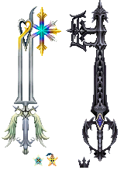

Part 2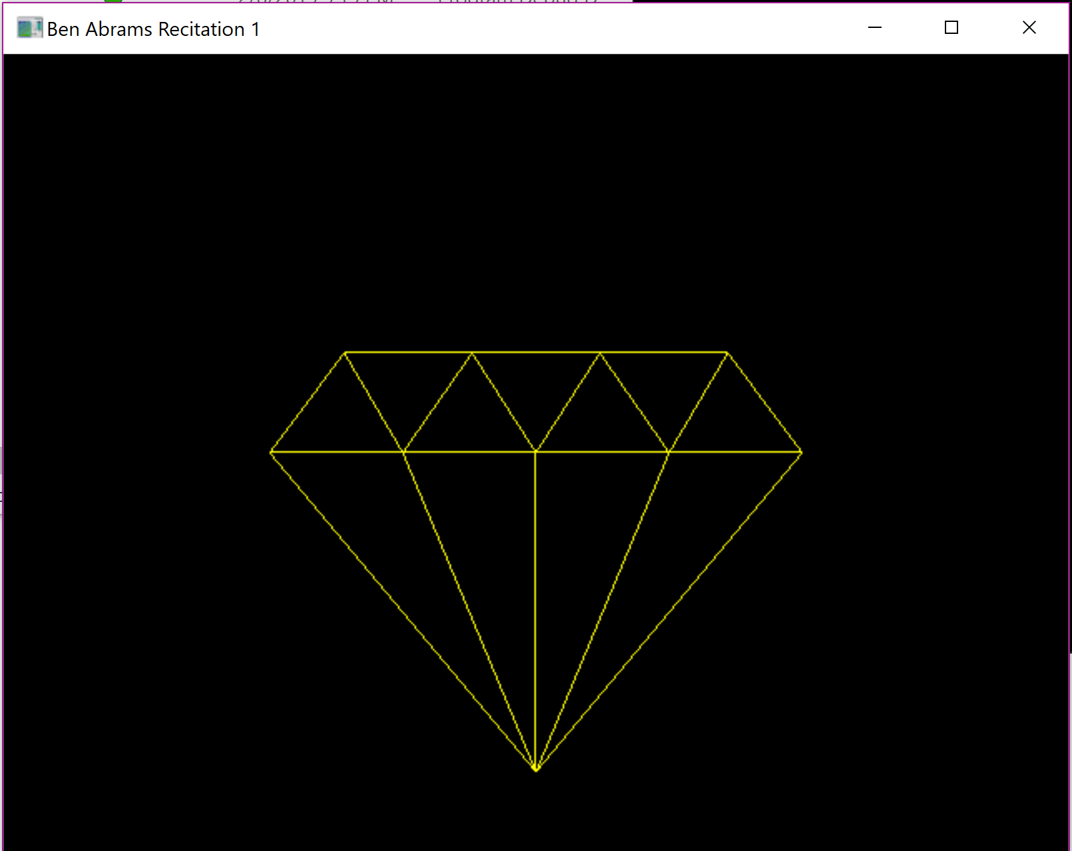

Part 3

