Ben Abrams

Blabram

Recitation 2

Question 1:

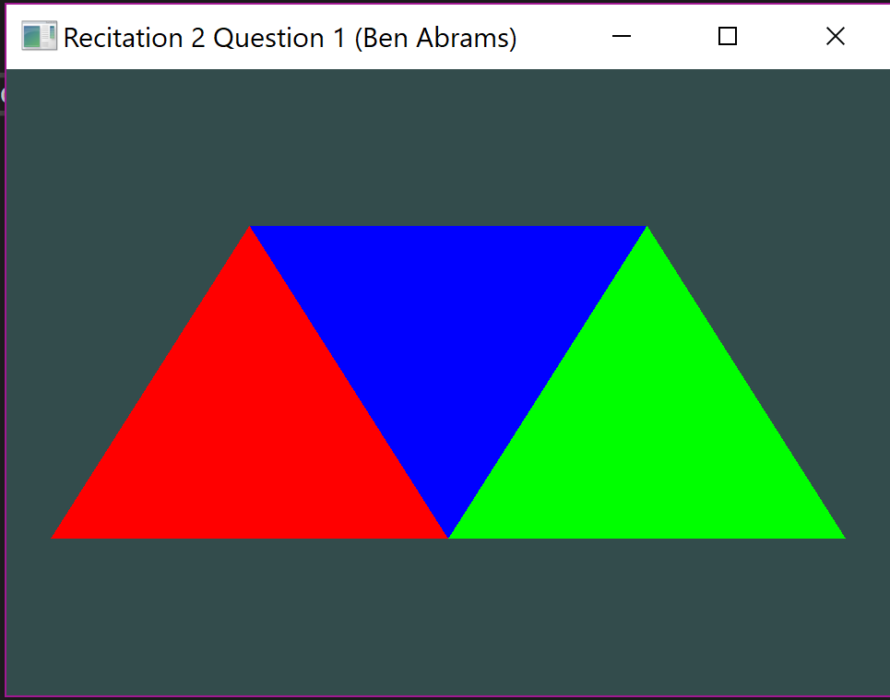

Question 2:

