**1(a) System Calls**

**Aim:** To write programs to perform following operations in UNIX:

**a) Process Creation**

Command:

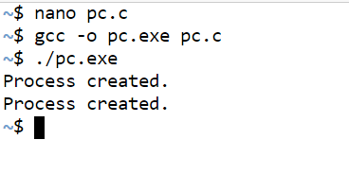

Code:

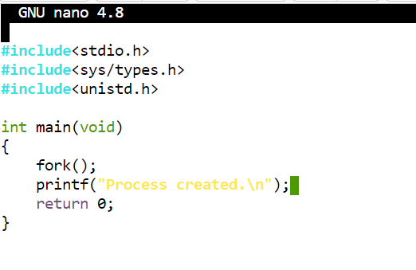

**b) Executing a command**

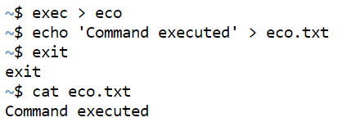

**c) Sleep command**

Command:

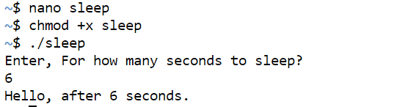

Code:

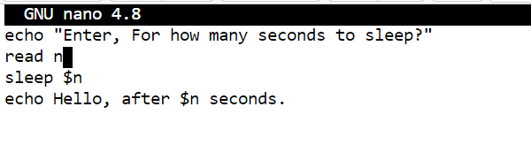

**d) Sleep command using get pid**

Command:

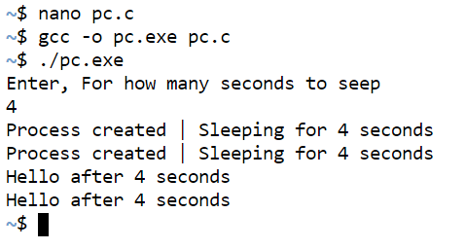

Code:

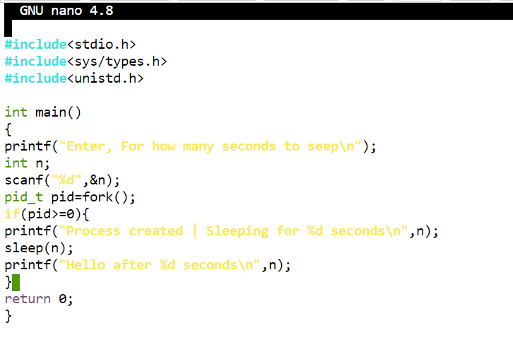

**e) Signal handling using kill**

Command:

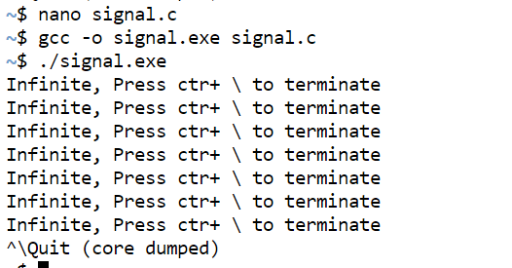

Code:

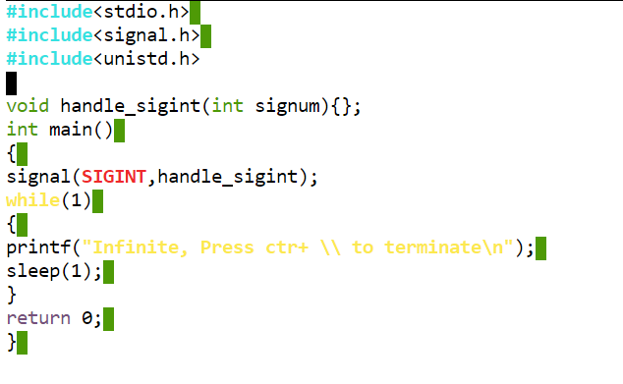

**f) Wait command**

Command:

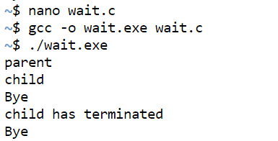

Code:

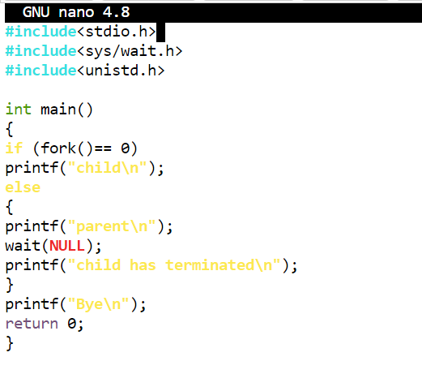

**1(b) (I/O System calls)**

**Aim:** To write programs to perform following operations in UNIX:

**a) Reading from a file**

Command:

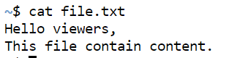

File:

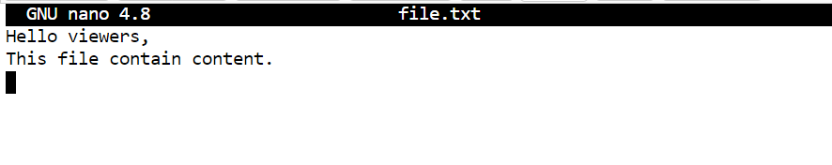

**b) Writing into a file**

Command:



File:

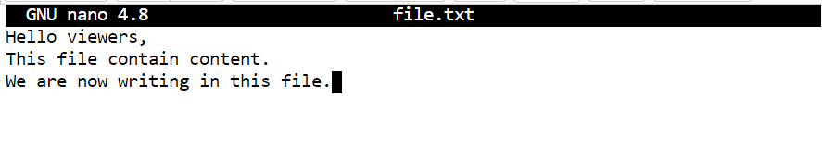

**c) File Creation**

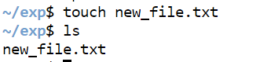

**d) Implementation of ls command**

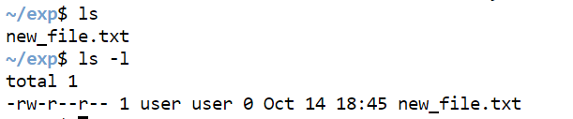

**e) Implementation of grep command.**

Command:

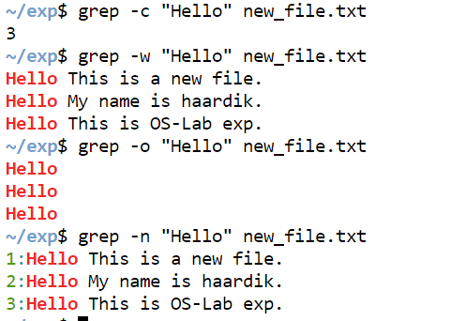

File:

