**Experiment 2**

**(Scheduling)**

**2) (a)**

**(FIRST COME FIRST SERVE)**

**Aim:** To write a C program to implement the CPU scheduling algorithm for FIRST COME FIRST SERVE.

*Command:*

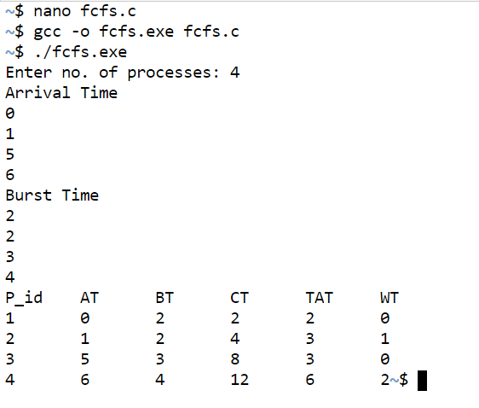

*Code:*

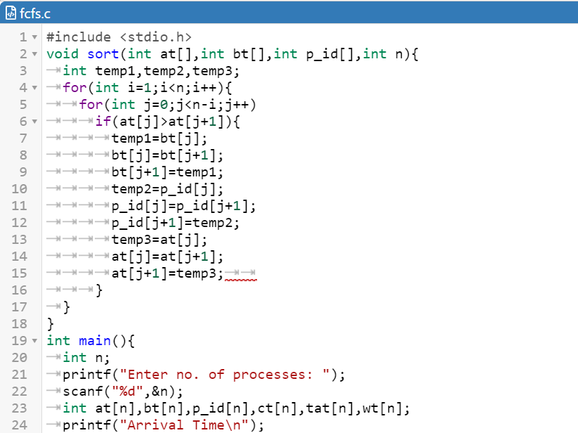

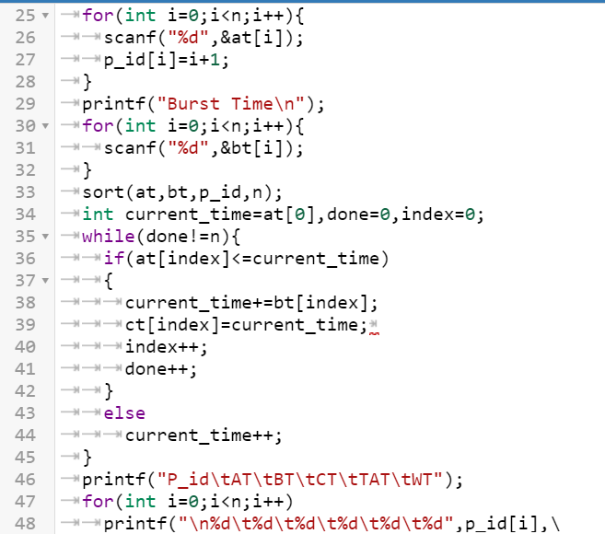

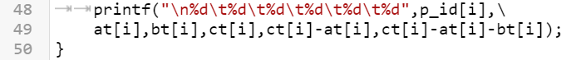

**(b)**

**(SHORTEST JOB FIRST-Non-Preamptive)**

**Aim:** To write a C program to implement the CPU scheduling algorithm for shortest job first.

*Command:*

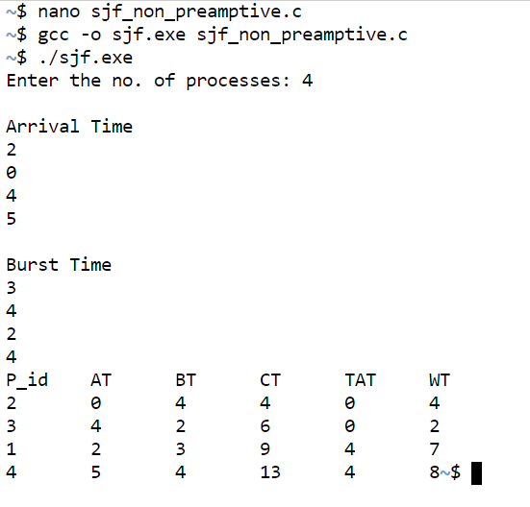

*Code:*

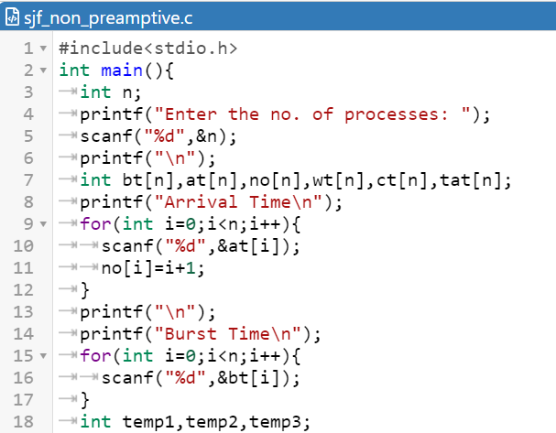

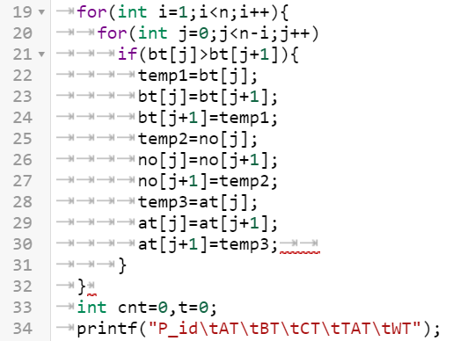

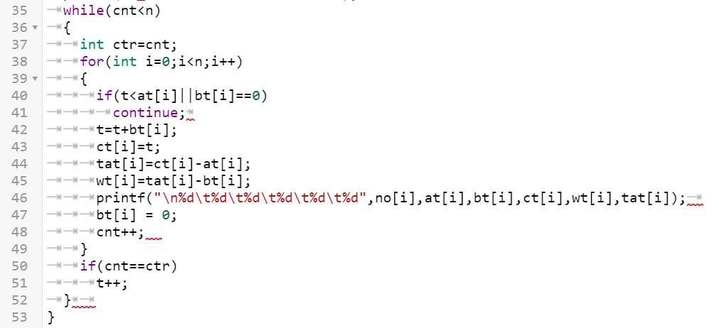

**(SHORTEST JOB FIRST-Preamptive)**

*Command:*

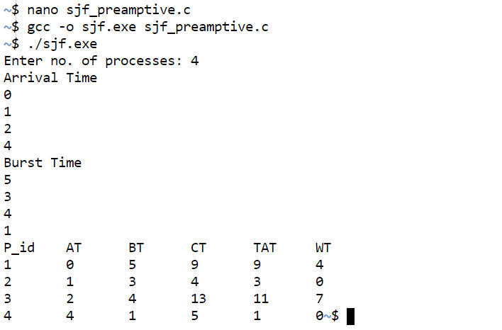

*Code:*

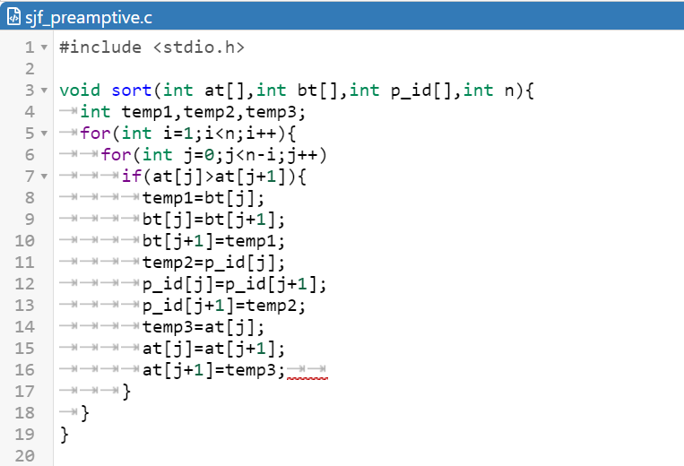

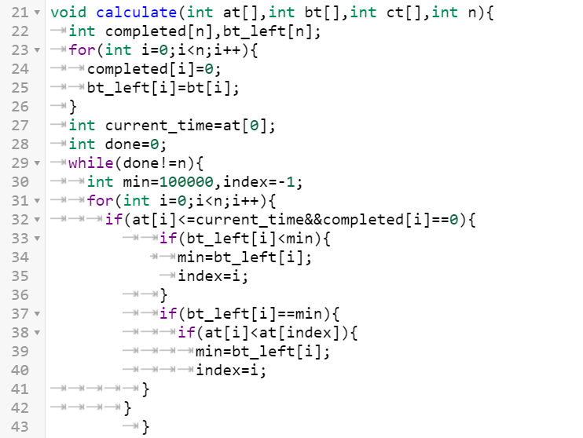

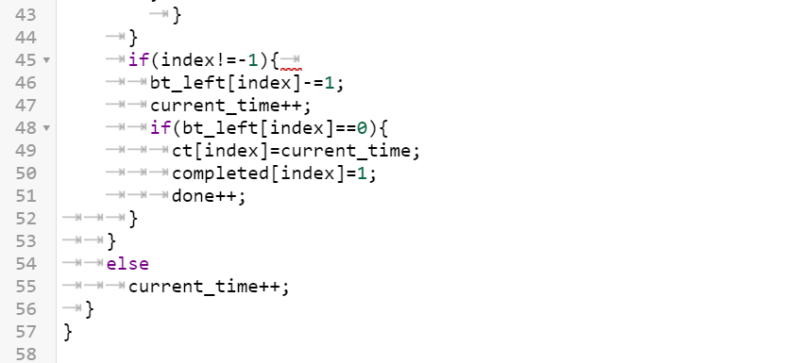

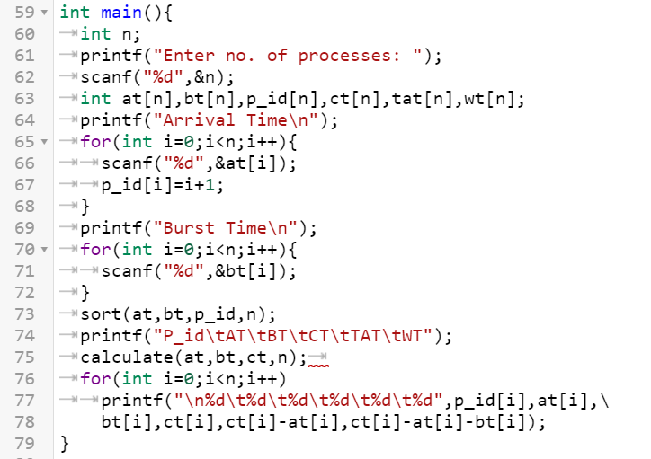

**(c)**

**(ROUND ROBIN)**

**Aim:** To write a C program to simulate the CPU scheduling algorithm for round robin.

*Command:*

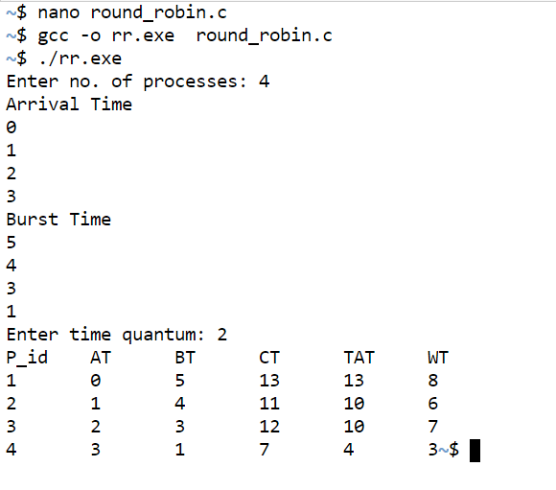

*Code:*

