**Experiment 3**

(Inter process communication)

**Aim:** Write a program that creates a child process. Parent process writes data to pipe and child process reads the data from pipe and prints it on the screen.

*Command:*

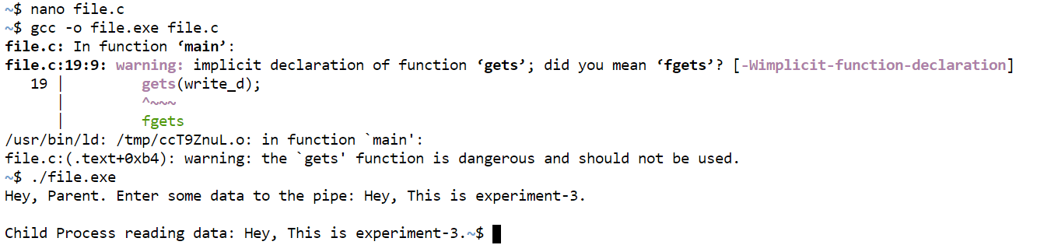

*Code:*

