**Experiment:-5**

**(Memory management-1)**

Aim: To write a C program to implement memory management using paging technique.

*CODE:*

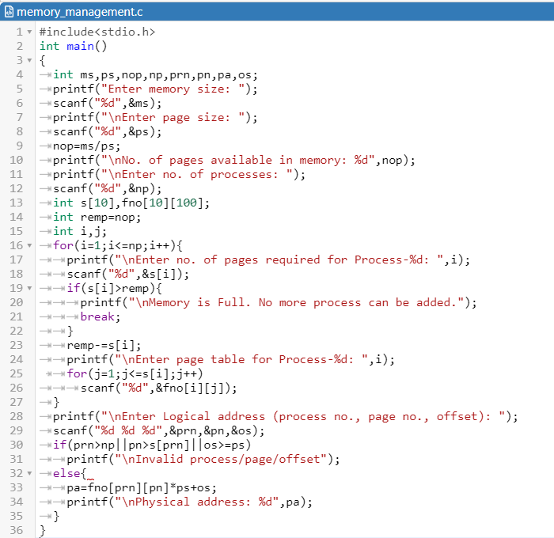

*OUTPUT:*

