**Experiment:-6**

(Memory management-II)

Aim: To write a C program to implement memory management using segmentation.

*CODE*

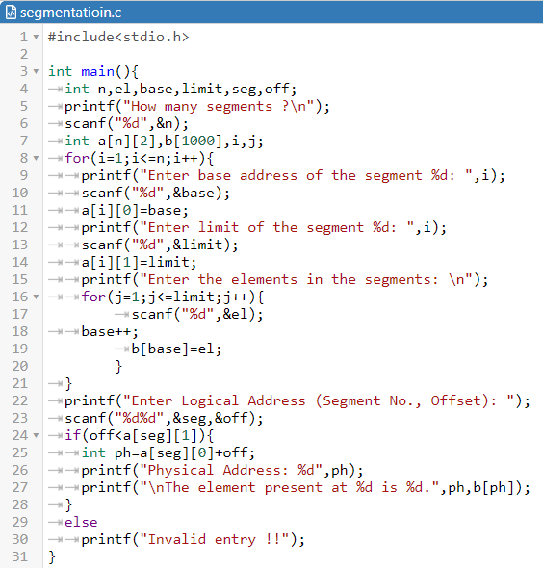

*OUTPUT*

