**Experiment:-7**

(File Manipulation)

7(a) (Displays the file and Directory)

Aim: To write a program for file manipulation to display the file and directory in UNIX.

*CODE*

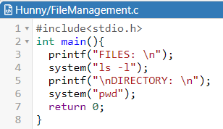

*OUTPUT*

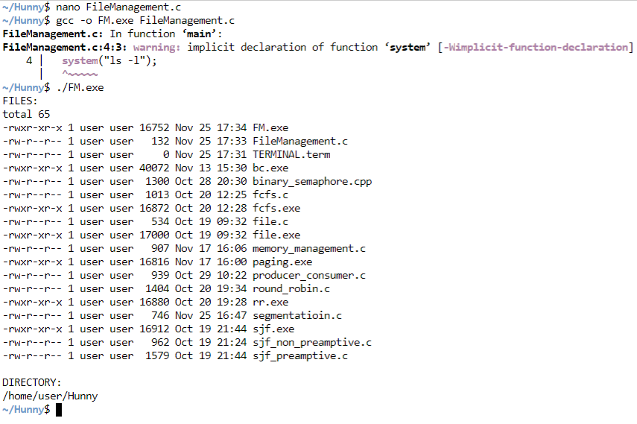

7(b) (Creating new Directory)

Aim: To write a program to perform file manipulation for creating a new directory

*CODE*

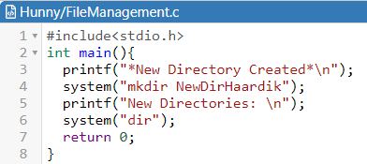

*OUTPUT*

