**Experiment 8**

**(Fork Execution)**

**8 (a) (Simple fork execution)**

**Aim:** To write a program to show the FORK Execution.

*CODE*

*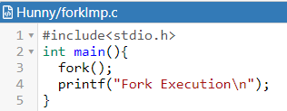  
OUTPUT*

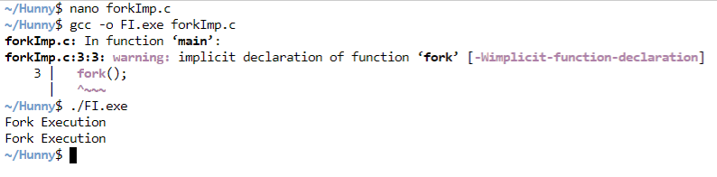

**8 (b) (fork system call)**

**Aim:** To write a program for implement the Fork System calls in UNIX.

*CODE*

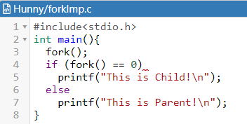

*OUTPUT*

