**Experiment:-9**

(Deadlock Avoidance)

10(a) Banker's Algorithm

Aim: To implement Banker's algorithm for a multiple resources.

*CODE*

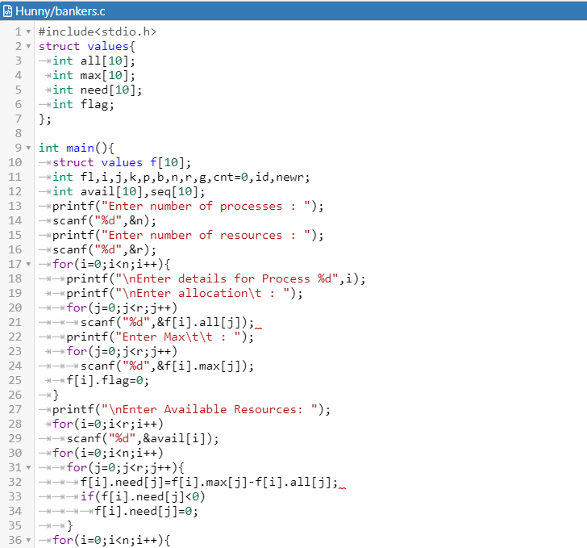

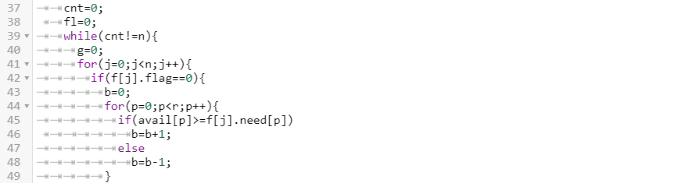

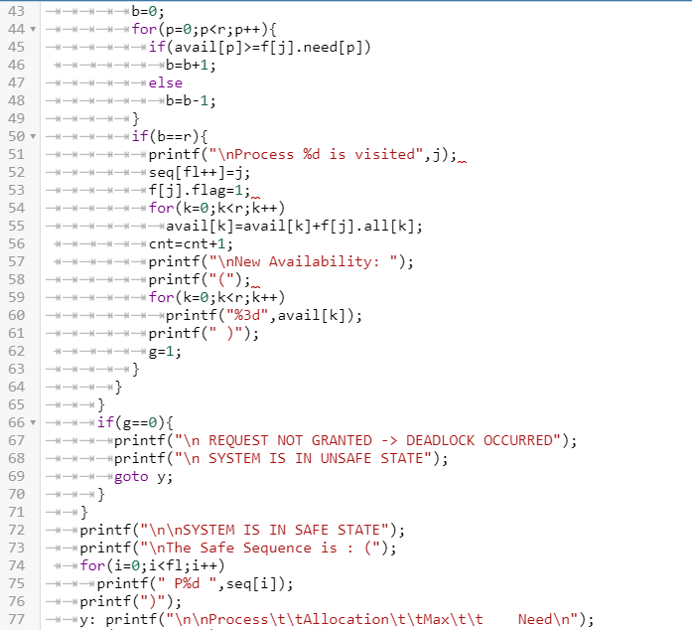

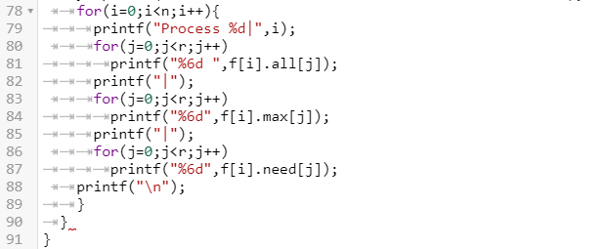

*OUTPUT*

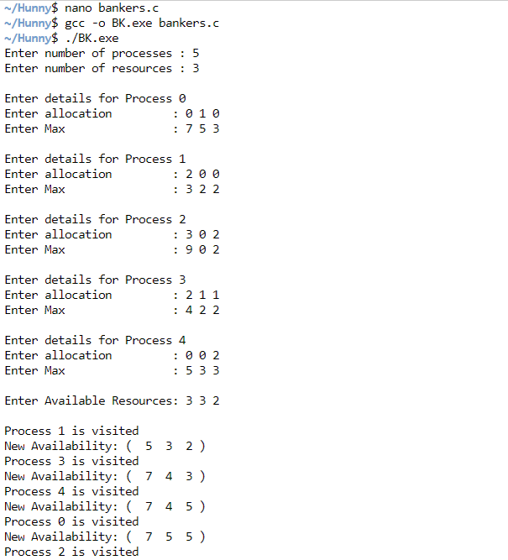

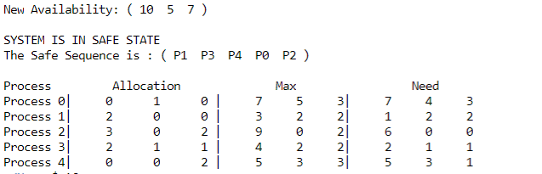

10(b) Dinning Philosopher's problem

Aim: To implement dinning philosopher’s problem.

*CODE*

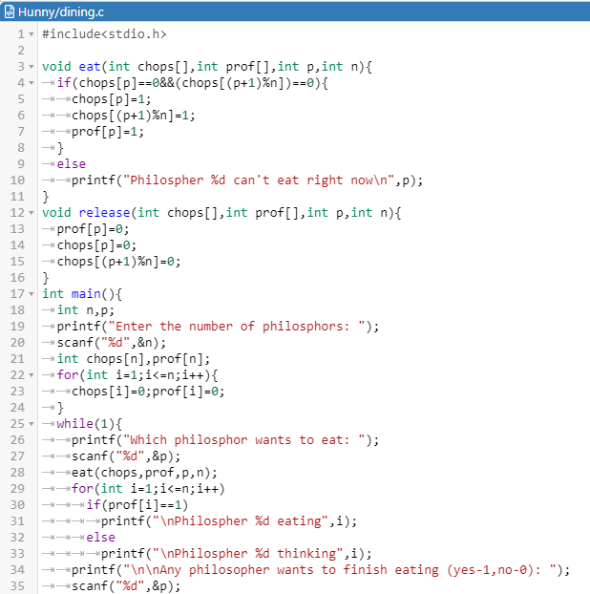

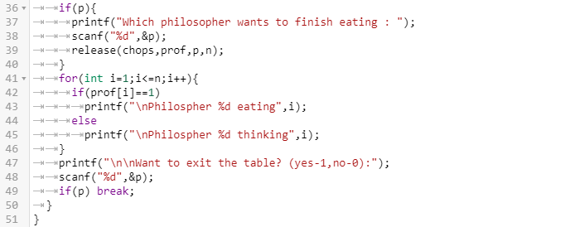

*OUTPUT*

