This is a two part assignment. In the first part of the assignment you will configure a Python 2.7 environment that gets Twitter data. In the second part of the assignment you will derive “sentiments” for tweets.

**Part 1: Get Twitter Data**

Depending on if you are running Windows or Mac this part may be a little different.

Windows users see step 1 here:

1. Install oauth2 library (See <https://pypi.python.org/pypi/oauth2/>.) To install the oauth2 library you will first need to install “pip”.
   1. Get the file get-pip.py from <https://bootstrap.pypa.io/get-pip.py>
   2. Execute – python get-pip.py (This will create a directory C:\Python27\Scripts\ that contains the pip executable. You may want to append this directory to your PATH environment variable.)
   3. Execute “pip install ouath2” or “\Python27\Scripts\pip install oauth2”

This is a screen shot from Dr. Hart’s computer for step 1.

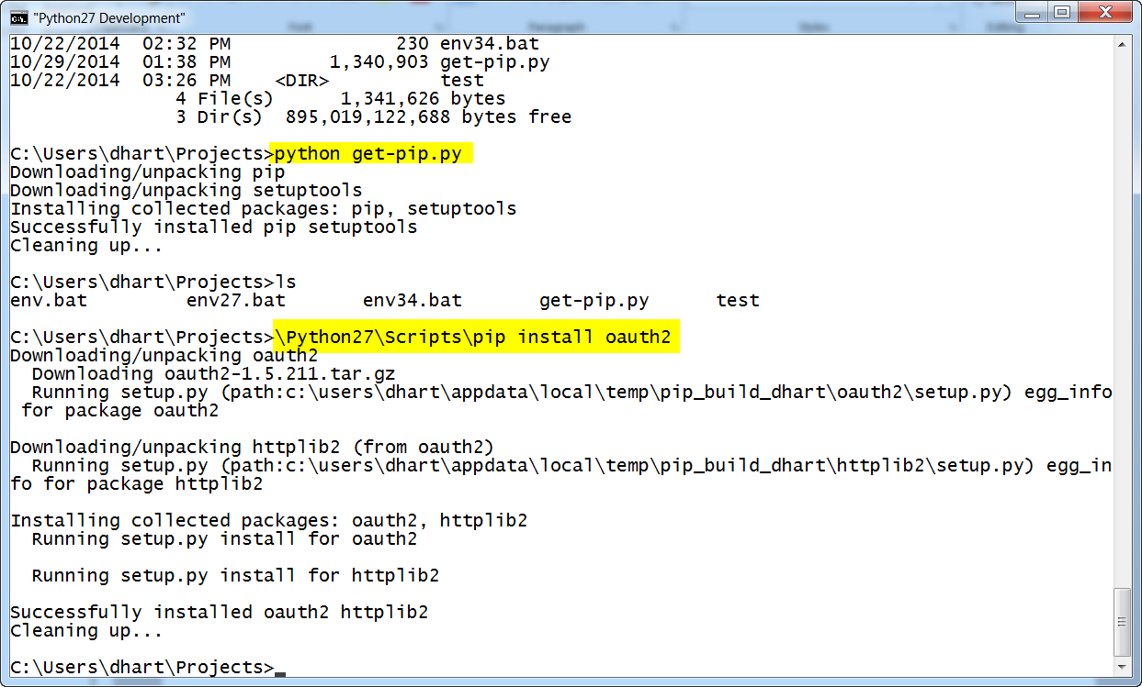

Mac users see step 1 here:

1. If you are running OS X you should have pip installed already, if not follow the outline above.

a. Open your terminal window, do not prompt python yet, but type the following command *pip install oauth2* and hit enter. You should see something similar to Dr. Harts screenshot above, since I already have oauth2 installed my window looks as follows:

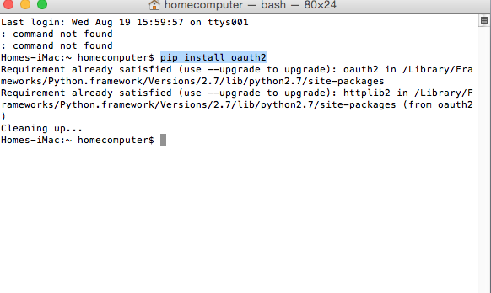

1. These steps will help you set up your twitter account to be able to access the live 1% stream
   1. Create a twitter account if you do not already have one.
   2. Go to <https://dev.twitter.com/apps> and log in with your twitter credentials
   3. Click “Create New App”
   4. Fill out the form and agree to the terms. Put in a dummy website if you don’t have one that you want to use.
   5. On the next page, click the “API Keys” tab along the top[, the scroll all the way down until you see the section “Your Access Token”

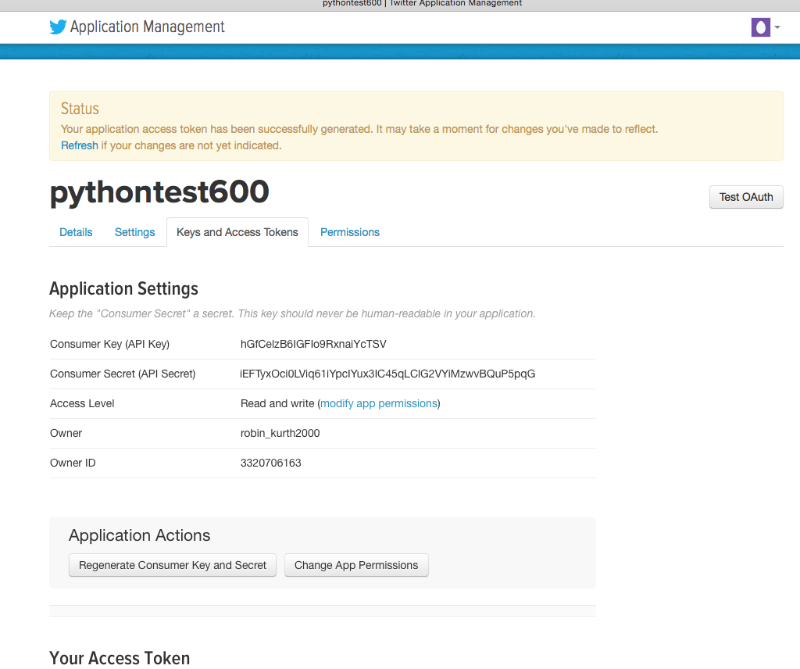

* 1. Using your editor, copy the four values into twitterstream.py (on lines 6, 7, 8, and 9)
     1. API Key
     2. API secret
     3. Access token
     4. Access token secret

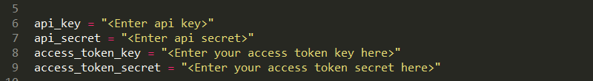

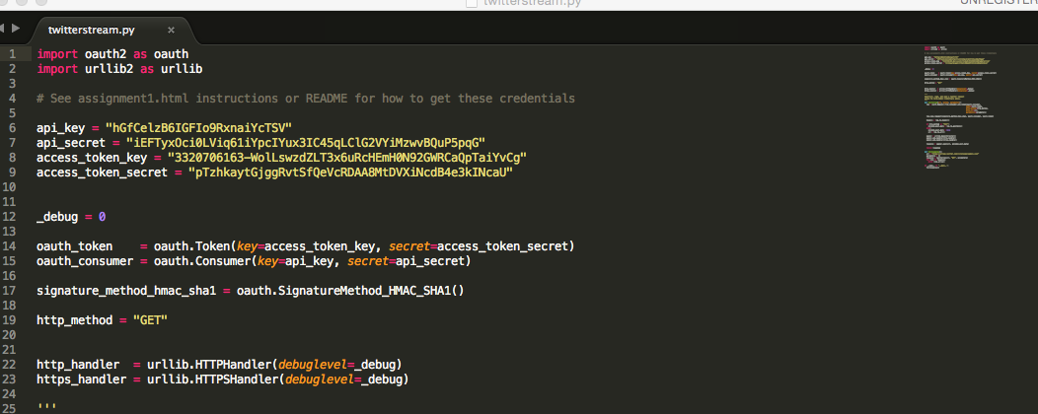

* 1. Run the following and make sure that you see data flowing and that no errors occur.

python twitterstream.py > output.txt

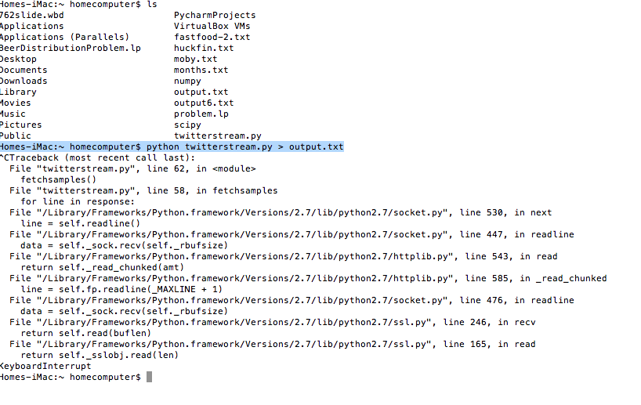

This commend pipes the output to a file. Stop the program with **Ctrl C**, but wait for three mines for data to accumulate. Keep the file output.txt for the remaining parts of the assignment.

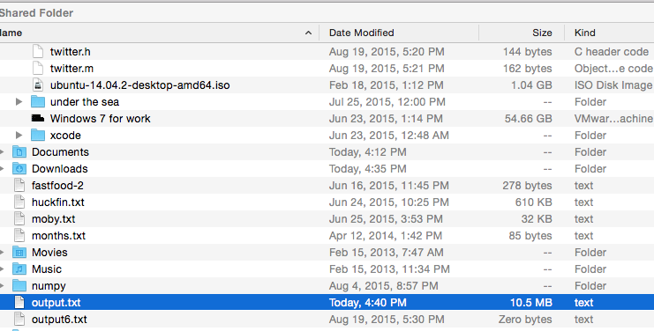

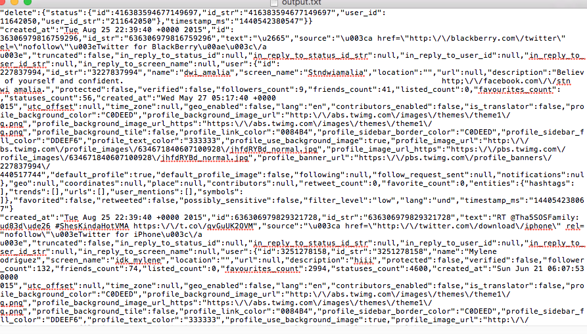

# Part 2: Derive the sentiment of each tweet

This will be provided in week 3.