* Cover Page with ID No., Name, Course Number, Course Title and Dissertation Title, Broad Academic Area of Work:
* Background (Relevance of the project to the current work environment in the employing organization)
* Objectives
* Scope of Work (to be done by the student independently)
* Plan of Work (Work to be done during the semester)
* Literature References
* Particulars of the Supervisor and Examiner
* Remarks of the Supervisor

Background (Relevance of the project to the current work environment in the employing organization)

Here are the Five Key Automation and Orchestration Layers:

* It’s no longer about 1-to-1 application server mapping. Now, with high-density computing and the need for greater levels of multi-tenancy, servers are hosting more users and more workloads. Data center administrators don’t have the time to configure individual blades. Now, hardware and server profiles are built in seconds. Admins only need to insert a new blade and allow the server layer automation to take over. New technologies allow administrators to create powerful “follow-the-sun” data center models where hardware automatically re-provisions itself for the appropriate set of new users. These policies can then scale cross-data center. When coupled with a load-balancing solution, you can dynamically port users to a data site that is most efficient for the workload and has the available resources. All of this is done through orchestration and automation policy.
* Software/Application: New technologies are able to look at applications running within the data center or within the cloud and help automate and control them. Power physical and virtual load balancers, for example, can see that a certain type of application is receiving too many connections. From there, an automated process will allow the administrator to provision another instance of the application or a new server which will host the app. Furthermore, a few examples of automation include technologies like provisioning services. Application layering and provisioning services are able to connect directly into virtualization brokers to help the delivery and control of both desktops and applications. Other platforms like CloudPlatfom, OpenStack and Eucalyptus further help automate and create true cloud orchestration. From there organizations are able to granularly control hosts, clusters, various zones, and even core virtual machine resources.
* The virtualization and hypervisor layer is more important than ever. Today, they sit as the bridge to both your data center and the cloud. Automation and orchestration tools aim to directly integrate with the virtual layer to better control resources, virtual services delivery, and the virtual workloads themselves. Automation has become such an integral piece that you have direct plug-ins into the hypervisor platform. For example, you can send VMs from one data center to another. Or, you can push entire repositories from an on-premise data center to a cloud facility all from the virtual layer. You can even integrate security policy, user control, and application automation into your hypervisor. With all of this in mind, the virtualization layer is a critical (and powerful) piece when creating your orchestration and automation strategy
* Although still emerging, there are already very large organizations deploying technologies like CloudStack, OpenStack, and even OpenNebula for their cloud automation and extension layers. Furthermore, many cloud automation and orchestration tools now place governance and advanced policy control directly into their products. Some technologies allow cloud admins to control security aspects of their cloud. Aside from being able to control costs around resource utilization, utilizing these cloud controls creates a very dynamic automated cloud platform. Finally, automation solutions like Puppet help create a unified management and automation approach to sometimes very heterogeneous data centers. Puppet is capable of controlling environments – cloud, virtual, and physical – and allows you to automate the management of compute, storage, and network resources. To support a diverse cloud model, you can use a VMware platform, CloudStack, OpenStack, Eucalyptus, Amazon, or even your own bare-metal data center.
* Data Center: Some services bridge the gap between IT and control engineers for connecting, managing, and automating industrial networks and control systems. Today's industrial organizations are driven to increase production and reduce costs while maintaining quality and safety. As networks converge, the physical infrastructure becomes even more critical to support the demands of real-time control, data collection, and device configuration. In a recent article, we discussed the concept of a “lights-out” data center. Although we’re not quite at that sort of advanced-robotics data center automation level, many large data center providers are looking at ways to align data center power, cooling, environmental, and overall management all together to create one intelligent control layer. The future may very well aim to directly unify cloud automation with data center resources control and delivery.

When creating any sort of data center automation or orchestration architecture, remember to design around your use case and your business. The whole idea here is to simplify business process and create new levels of efficiency. New solutions spanning the entire data center allow you to proactively manage very dynamic workloads and a diverse set of users. You’ll create better visibility into the distributed data center and be able to truly utilize the capacity of the cloud. Through it all, you’ll allow your content to flow more efficiently and allow the user to be much more productive.

**Data center orchestration** software uses the automation of tasks to implement processes, such as deploying new servers. Automation solutions which orchestrate data center operations enable an agile DevOps approach for continual improvements to applications running in the data center.

Orchestration outlines how individual tasks can come together for a larger purpose. It organizes all the tasks of various services and creates a highly functioning and responsive data center.

The massive amount of data move to cloud computing has put more pressure on the data center. Data center needs to be a central management platform and be able to provide the same agility as public clouds. Data center automation and orchestration creates the efficiencies needed to meet that demand.

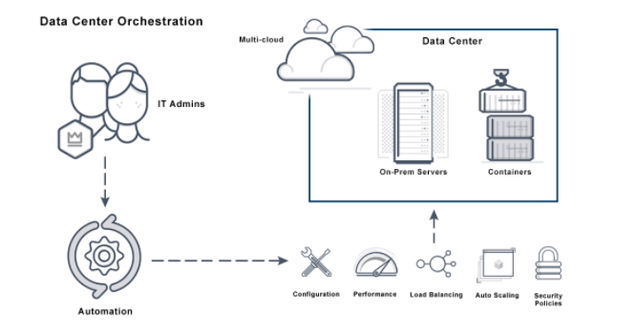

**Function of Data center orchestration** is a process-driven workflow that helps make data centers more efficient. Repetitive, slow and error-prone manual tasks are replaced by the automation of tasks and the orchestration of processes.

Data center orchestration systems automate the configuration of L2-L7 network services, compute and storage for physical, virtual and hybrid networks. New applications can be quickly deployed.

Benefits of data center orchestration systems include:

* Streamlined provisioning of private and public cloud resources.
* Less time to value between a business need and when the infrastructure can meet the need.
* Less time for IT department to deliver a domain specific environment.

Data center orchestration systems are a framework for managing data exchanged between a business process and application. They use the following functions:

* Scheduling and coordination of data services.
* Leveraging of distributed data repository for large data sets.
* Tracking and publishing APIs for automatic updates of metadata management.
* Updating policy enforcement and providing alerts for corrupted data.
* Integrating data services with cloud services.