Department of Computer Application

LAB MANUAL
Session 2021-2022

Subject Name : - Computer Graphics and Multimedia
Application Lab

Subject Code : - CA- 312

Branch : - BCA

Year : - 3rd

Semester : - 6th



INTEGRAL UNIVERSITY LUCKNOW
Dsauli, Kursi Road, PO Basha-226026
Revision History

Revision History
Revision # | Author(s) | Reviewer(s) | Date of Release | Owner | Summary of Changes
Revision - 1 | Mr. Tabrez Khan  Mr. Faizan Ahmad | Internal Reviewers | 08/01/2019 | HOD - CA | Initial Release
Revision -2 |  | Departmental QAC | 30/01/2016 | HOD - CA | Major revisions made. Incorporated review comments from departmental QAC into Revision-2
Revision -3 |  | External Reviewers | 26/02/2016 | HOD - CA

List of Lab Exercises
Week | Experiment No. | Name of the Experiments | Page No.
Week -1 | 1 | Introduction Of Basic Functions | 4
Week-3 | 2 | DDA LINE Drawing Algorithm | 9
Week-4 | 3 | Bresenham’s Algorithm For Line Drawing | 12
Week-5 | 4 | Mid Point Circle Drawing Algorithm | 15
Week-6 | 5 | Rotation in 2D | 18
 | 5.1 | Line
 | 5.2 | Rectangle
 | 5.3 | Triangle
Week-7 | 6 | Translation in 2D | 23
 | 6.1 | Line
 | 6.2 | Rectangle
 | 6.3 | Triangle
Week-9 | 7 | Scaling in 2D | 27
 | 7.1 | Line
 | 7.2 | Rectangle
 | 7.3 | Triangle
Week-11 | 8 | Cohen Sutherland Line Clipping Algorithm | 31
Week-12 | 9 | 3D Projection | 37
 | 9.1 | Parallel
 | 9.2 | Perspective
Week-13 | 10 | Introduction Macromedia Flash | 41
 | 10.1 | Drawing Geometric shapes in Flash
 | 10.2 | Frame by frame animation
 | 10.3 | Working Animation with Shapes and Text
 | 10.4 | Timeline Animation
Week-15 | 11 | Introduction Maya | 52
 | 11.1 | Drawing Geometric shapes in Maya
 | 11.2 | Basic Animation
 | 11.3 | Character Animation

Introduction Of Basic Function

INITGRAPH
•Initializes the graphics system

Declaration
• initgraph(int *graphdriver, int *graphmode, char * pathtodriver);

Remarks
To start the graphic system, you must first call initgraph
• Initgraph initializes the graphic system by loading a graphics driver from disk (or validating a registered driver) then putting the system into graphics mode.
Integer that specifies the initial graphics mode (unless *graphdriver = DETECT). If *graphdriver = DETECT, initgraph sets *graphmode to the highest resolution available for the detected driver. You can give *graphmode a value using a constant of the graphics_modes enumeration type.
Initgraph also resets all graphics settings (color, palette, current position, viewport, etc) to
their defaults then resets graph

CLOSE GRAPH

Decleration
• closegraph(void);

Remarks
Close graph deallocates all memory allocated by the graphic system.
It then restores the screen to the mode it was in before you called initgraph

Return value
None

GETPIXEL, PUTPIXEL

• getpixel gets the color of a specified pixel
• putpixel places a pixel at a specified point

Decleration
getpixel(int x, int y
putpixel(int x, int y, int color)
Return value
• getpixel returns the color of the given pixel
• putpixel does not return

CLEARDEVICE

Declaration
void cleardevice();
cleardevice function clears the screen in graphics mode and sets the current position to (0,0). Clearing the screen consists of filling the screen with current background color.

ARC, CIRCLE, PIESLICE

• arc draws a circular arc
• circle draws a circle
• pieslice draws and fills a circular pieslice

Decleration
• arc(int x, int y, int stangle, int endangle, int radius);
• far circle(int x, int y, int radius);
• pieslice(int x, int y, int stangle, int endangle, int radius);

Remarks

Arc draws a circular arc in the current drawing color
• Circle draws a circle in the current drawing color
• Pieslice draws a pieslice in the current drawing color, then fills it using the current fill
pattern and fill color

ELLIPSE, FILLELIPSE, SECTOR

• ellipse draws an elliptical arc
• fillellipse draws and fills ellipse

Sector draws and fills an elliptical pie slice.

Declaration
ellipse(int x, int y, int stangle, int endangle, int xradius, int yradius);
fillellipse(int x, int y, int xradius, int yradius);
farsectoe(int x, int y, int stangle, int endangle, int xradius, int yradius);

Remarks
Ellipse draws an elliptical arc in the current drawing color
• Fillellipse draws an elliptical arc in the current drawing color and than fills it with fill color and fill pattern.
Sector draws an elliptical pie slice in the current drawing color and than fills it using the pattern and color defined by setfillstyle or setfillpattern

FLOODFILL

Flood-fills a bounded region

Declaration
• floodfill(int x, int y, int border)

Remarks
• Floodfills an enclosed area on bitmap device.
• The area bounded by the color border is flooded with the current fill pattern and fill color
(x,y) is a “seed point
If the seed is within an enclosed area, the inside will be filled
If the seed is outside the enclosed area, the exterior will be filled
Use fillpoly instead of floodfill wherever possible so you can maintain code compatibility
with future versions
• Floodfill doesnot work with the IBM-8514 driver

Return value
If an error occurs while flooding a region, graph result returns ‘1’

GETCOLOR, SETCOLOR

Getcolor returns the current drawing color
Setcolor returns the current drawing color

Declaration
• getcolor(void);
• setcolor(int color);

Remarks
Getcolor returns the current drawing color.
• Setcolor sets the current drawing color to color, which can range from 0 to getmaxcolor
• To set a drawing color with setcolor , you can pass either the color number or the
equivalent color name.

LINE,LINEREL,LINETO
Line draws a line between two specified pints
Linrto draws a line from the current position (CP) to(x,y).

Declaration
•line(int x1, int y1,x2,y2);
•lineto(int x, int y);

Remarks
• Line draws a line from (x1, y1) to (x2, y2) using the current color, line style and thickness
It does not update the current position (CP)
• Lineto draws a line from the CP to (x, y), then moves the CP to (x,y)

Return value
None

RECTANGLE
• Draws a rectangle in graphics mode

Declaration
•rectangle(int left, int top, int right, int bottom);

Remarks
• It draws a rectangle in the current line style, thickness and drawing color
(left, top) is the upper left corner of the rectangle, and (right, bottom) is its lower right
corner

Return value
None
TEXTHEIGHT
textheight function returns the height of a string in pixels.
Declaration
int textheight(char *string);

TEXTWIDTH
textwidth function returns the width of a string in pixels.
Declaration
int textwidth(char *string);

OUTTEXT
outtext function displays text at current position.
Declaration
void outtext(char *string);

OUTTEXTXY
outtextxy function display text or string at a specified point(x,y) on the screen.

Declaration
void outtextxy(int x, int y, char *string);
x, y are coordinates of the point and third argument contains the address of string to be displayed.

GETMAXX
getmaxx function returns the maximum X coordinate for current graphics mode and driver.
Declaration
int getmaxx();

GETMAXY
getmaxy function returns the maximum Y coordinate for current graphics mode and driver.
Declaration
int getmaxy();

MOVETO
moveto function changes the current position (CP) to (x, y)
Declaration
void moveto(int x, int y);

SETBKCOLOR
Declaration
void setbkcolor (int color);

SETCOLOR
Declaration
void setcolor (int color);
ALGORITHM TO DRAW A LINE USING DDA ALGORITHM

- Start.
- Declare variables x,y,x1,y1,x2,y2,k,dx,dy,s,xi,yi and also declare
gdriver=DETECT,gmode.
- Initialise the graphic mode with the path location in TC folder.
- Input the two line end-points and store the left end-points in (x1,y1)
- Load (x1,y1) into the frame buffer;that is,plot the first point.put x=x1,y=y1.
- Calculate dx=x2-x1 and dy=y2-y1.
- If abs(dx) > abs(dy), do s=abs(dx).
- Otherwise s= abs(dy).
- Then xi=dx/s and yi=dy/s.
- Start from k=0 and continuing till k<s,the points will be
x=x+xi.
y=y+yi.
11.Place pixels using putpixel at points (x,y) in specified colour.
12.Close Graph.
13.Stop.

DDA Line Drawing Programme

# include <stdio.h>
# include <graphics.h>
# include <math.h>

void main()
{
int gmode , gdrive = DETECT , errorcode , i ;
float x1 , x2 , y1 , y2 , dy , dx ;
float x , y , xinc , yinc , l ;
initgraph ( &gdrive , &gmode ,"C:\\TC\\BGI" ) ;
printf ( "DDA Line Drawing Algorithm \n" ) ;
printf ( "Enter x1 : " ) ;
scanf ( "%f" , &x1 ) ;
printf ( "Enter y1 : " ) ;
scanf ( "%f" , &y1 ) ;
printf ( "Enter x2 : " );
scanf ( "%f" , &x2 ) ;
printf ( "Enter y2 : " );
scanf ( "%f" , &y2 ) ;
dy = y2 - y1 ;
dx = x2 - x1 ;

if ( abs ( dy ) >= abs ( dx ) )
l = abs ( dy ) ;
else
l = abs ( dx ) ;
xinc = dx / l ;
yinc = dy / l ;
x = x1 ;
y = y1 ;
for( i = 1 ; i < l ; i++ )
{
x = x + xinc ;
y = y + yinc ;
putpixel ( x , y , 6 ) ;
}
getch ( ) ;
closegraph ( ) ;
}

Output :

DDA Line Drawing Algorithm

Enter x1 : 100
Enter y1 : 100
Enter x2 : 200
Enter y2 : 200

BRESENHAM’S ALGORITHM FOR LINE DRAWING

- Start.
- 2. Declare variables x,y,x1,y1,x2,y2,p,dx,dy and also declare gdriver=DETECT,gmode.
- . Initialize the graphic mode with the path location in TC folder.
- 4. Input the two line end-points and store the left end-points in (x1,y1).
- Load (x1,y1) into the frame buffer; that is, plot the first point put x=x1,y=y1.
- Calculate dx=x2-x1 and dy=y2-y1,and obtain the initial value of decision parameter p as:
- p=(2dy-dx).
- Starting from first point (x,y) perform the following test:
- Repeat step 9 while(x<=x2).
- If p<0,next point is (x+1,y) and p=(p+2dy).
- Otherwise, the next point to plot is (x+1,y+1) and p=(p+2dy-2dx).
- Place pixels using putpixel at points (x,y) in specified colour.
- Close Graph
- Stop.
Bresenham Line Drawing Programme

# include <stdio.h>
# include <graphics.h>
# include <math.h>

void main()
{
int gmode , gdrive = DETECT ;
float x1 , x2 , y1 , y2 , dx , dy , temp , p ;
float x , y , xend , yend ;

initgraph ( &gdrive , &gmode ,"C:\\TC\\BGI" ) ;

printf ( "Bresenham's Line Drawing Algorithm\n\n" ) ;

printf ( "Enter x1 : " ) ;
scanf ( "%f" , &x1 ) ;
printf ( "Enter y1 : " ) ;
scanf ( "%f" , &y1 ) ;
printf ( "Enter x2 : " ) ;
scanf ( "%f" , &x2 ) ;
printf ( "Enter y2 : " ) ;
scanf ( "%f" , &y2 ) ;

dx = abs ( x2 - x1 ) ;
dy = abs ( y2 - y1 ) ;

if( dy > dx )
{
temp = dy ;
dy = dx ;
dx = temp ;
}

p = dx - ( 2 * dy ) ;

if ( x1 < x2 )
{
x = x1 ;
y = y1 ;
xend = x2 ;
}

else
{
x = x2 ;
y = y2 ;
xend = x1 ;
}

while( x < xend )
{
x++ ;
if( p < 0 )
{
p = p + 2 * dx - 2 * dy ;
y++;
}

else
{
p = p - 2 * dy ;
putpixel ( ceil ( x ) , ceil ( y ) , 5 ) ;

}
}
getch ( ) ;
}

Output :

Bresenham’s Line Drawing Programme

Enter x1 : 100
Enter y1 : 100
Enter x2 : 200
Enter y2 : 200

Midpoint Circle Generating Algorithm

1.Start.
2.Declare variables x,y,p and also declare gdriver=DETECT,gmode.
3.Initialise the graphic mode with the path location in TC folder.
4.Input the radius of the circle r.
5.Load x-0,y=r,initial decision parameter p=1-r.so the first point is (0,r).
6.Repeat Step 7 while (x<y) and increment x-value simultaneously.
7. If (p>0),do p=p+2*(x-y)+1.
8. Otherwise p=p+2*x+1 and y is decremented simultaneously.
9. Then calculate the value of the function circlepoints() with p.arameters (x,y).
10. Place pixels using putpixel at points (x+300,y+300) in specified colour in circlepoints()
function shifting the origin to 300 on both x-axis and y-axis.
11 Close Graph.
12.Stop.
Midpoint Circle Generating Programme

#include<stdio.h>
#include<graphics.h>
#include<math.h>

void main()
{
int gmode,gdrive=DETECT;
int p , x , y , r ;
int xcenter = 0 , ycenter = 0 ;

initgraph ( &gdrive , &gmode ,"C:\\TC\\bgi" ) ;

printf ( "Midpoint Circle Drawing Algorithm \n\n" ) ;
printf("Enter the radius : ");
scanf ( "%d" , &r ) ;
printf("Enter Center coordinates : ");
scanf ( "%d %d" , &xcenter , &ycenter ) ;

x = 0 ;
y = r ;
p = 1 - r ;

while ( x < y )
{
if ( p < 0 )
{
x = x + 1 ;
p = p + 2 * x + 1 ;
}
else
{
x = x + 1 ;
y = y - 1 ;
p = p + 2 * ( x - y ) + 1 ;
}

putpixel ( xcenter + x , ycenter + y ,6 ) ;
putpixel ( xcenter - x , ycenter + y ,6 ) ;
putpixel ( xcenter + x , ycenter - y ,6 ) ;
putpixel ( xcenter - x , ycenter - y ,6 ) ;
putpixel ( xcenter + y , ycenter + x ,6 ) ;
putpixel ( xcenter - y , ycenter + x ,6 ) ;
putpixel ( xcenter + y , ycenter - x ,6 ) ;
putpixel ( xcenter - y , ycenter - x ,6 ) ;
}
getch();
}
Output :

Midpoint Circle Drawing Algorithm

Enter radius : 50

Enter Center coordinates : 200 200
Rotation of 2D

#include <graphics.h>
#include <stdlib.h>
#include <stdio.h>
#include <conio.h>
#include <math.h>

float x1 , y1 , x2 , y2 , x3 , y3 , a ;
float x1,x2,x3,y1,y2,y3,xt,yt,a;
float x4,y4,x12,x21,x22,y12,y22,y21;

int ch ;

void main ( )
{
int gdriver = DETECT, gmode, errorcode;
clrscr ( ) ;
do
{
closegraph ( ) ;
gotoxy ( 10 , 2 ) ;
printf ( "Rotation of 2D\n" ) ;
printf ( "\n1.Rotaton of line " ) ;
printf ( "\n2.Rotaton of rectangle " ) ;
printf ( "\n3.Rotation of Triangle " ) ;
printf ( "\n4.Exit" ) ;
printf ( "\n\nEnter your choice : " ) ;
scanf ( "%d" , &ch ) ;

initgraph ( &gdriver , &gmode , "C:\\TC\\BGI" ) ;

switch ( ch )
{
case 1 : printf ( "Enter value of Line Coordinates \n\n" ) ;
printf ( "Enter x1 : " ) ;
scanf ( "%f" , &x1 ) ;
printf ( "Enter y1 : " ) ;
scanf ( "%f" , &y1 ) ;
printf ( "Enter x2 : " ) ;
scanf ( "%f" , &x2 ) ;
printf ( "Enter y2 : " ) ;
scanf ( "%f" , &y2 ) ;

printf ( "\n\nEnter angle of rotation : " ) ;
scanf ( "%f" , &a ) ;

cleardevice ( ) ;
setcolor ( 7 ) ;

xt=x1;
yt=y1;
x1-=xt;
y1-=yt;
x2=x2-xt;
y2=y2-yt;
line(x1+xt,y1+yt,x2+xt,y2+yt);
a=a*3.14/180;
x3=(x2*cos(a))-(y2*sin(a));
y3=(x2*sin(a))+(y2*cos(a));
printf ( "Press any key to rotate .... " ) ;
getch ( ) ;

setcolor(GREEN);
line(x1+xt,y1+yt,x3+xt,y3+yt);

getch ( ) ;
break ;

case 2 : printf ( "Enter value of Rectangle Coordinates \n\n" ) ;
printf ( "\n\nEnter Top Left Coordinates \n" ) ;
printf ( "Enter x1 : " ) ;
scanf ( "%f" , &x1 ) ;
printf ( "Enter y1 : " ) ;
scanf ( "%f" , &y1 ) ;

printf ( "\n\nEnter Bottom Right Coordinates \n" ) ;
printf ( "Enter x2 : " ) ;
scanf ( "%f" , &x2 ) ;
printf ( "Enter y2 : " ) ;
scanf ( "%f" , &y2 ) ;

printf ( "\n\nEnter angle of rotation : " ) ;
scanf ( "%f" , &a ) ;
cleardevice ( ) ;
setcolor ( 7 ) ;

rectangle ( x1 , y1 , x2 , y2 ) ;

xt=x1;
yt=y1;
x1-=xt;
y1-=yt;
x2=x2-xt;
y2=y2-yt;
a=float(a*(3.14/180));
x22=(x2*cos(a))-(y2*sin(a));
y22=(x2*sin(a))+(y2*cos(a));
x21=(x2*cos(a))-(y1*sin(a));
y21=(x2*sin(a))+(y1*cos(a));
x12=(x1*cos(a))-(y2*sin(a));
y12=(x1*sin(a))+(y2*cos(a));

printf ( "Press any key to rotate .... " ) ;
getch ( ) ;

setcolor ( 5 ) ;
setcolor(YELLOW);
line(x1+xt,y1+yt,x12+xt,y12+yt);
getch();
setcolor(RED);
moveto(x12+xt,y12+yt);
lineto(x22+xt,y22+yt);
getch();
setcolor(GREEN);
moveto(x22+xt,y22+yt);
lineto(x21+xt,y21+yt);
getch();
setcolor(CYAN);
moveto(x21+xt,y21+yt);
lineto(x1+xt,y1+yt);
getch ( ) ;
break ;

case 3 : printf ( "Enter value of Trinagle Coordinates \n\n" ) ;
printf ( "\nEnter Coordinates of a side \n" ) ;
printf ( "Enter x1 : " ) ;
scanf ( "%f" , &x1 ) ;
printf ( "Enter y1 : " ) ;
scanf ( "%f" , &y1 ) ;
printf ( "\nEnter x2 : " ) ;
scanf ( "%f" , &x2 ) ;
printf ( "Enter y2 : " ) ;
scanf ( "%f" , &y2 ) ;

printf ( "\n\nEnter Coordinates for third vertex \n" ) ;
printf ( "Enter x3 : " ) ;
scanf ( "%f" , &x3 ) ;
printf ( "Enter y3 : " ) ;
scanf ( "%f" , &y3 ) ;

printf ( "\n\nEnter angle of rotation : " ) ;
scanf ( "%f" , &a ) ;
cleardevice ( ) ;
setcolor ( 7 ) ;

line ( x1 , y1 , x2 , y2 ) ;
moveto ( x2 , y2 ) ;
lineto ( x3 , y3 ) ;
moveto ( x3 , y3 ) ;
lineto ( x1 , y1 ) ;

xt=x1;
yt=y1;
x2=x2-xt;
y2=y2-yt;
x3=x3-xt;
y3=y3-yt;

printf ( "Press any key to rotate .... " ) ;
getch ( ) ;

setcolor(GREEN);
x21=(x2*cos(a))-(y2*sin(a));
y21=(x2*sin(a))+(y2*cos(a));
x31=(x3*cos(a))-(y3*sin(a));
y31=(x3*sin(a))+(y3*cos(a));
setcolor(RED);
line(x1,y1,x21+xt,y21+yt);
line(x21+xt,y21+yt,x31+xt,y31+yt);
line(x31+xt,y31+yt,x1,y1);
getch();
break ;

case 4 : closegraph ( ) ;
exit ( 1 ) ;
default : printf ( "\n\nWrong choice " ) ;
break ;
}
} while ( ch != 4 ) ;

getch ( ) ;
closegraph ( ) ;
}

Output:

Rotation of 2D

1. Rotation of Line
2. Rotation of Rectangle
3. Rotation of Triangle

Enter your choice : 1

Enter value of Line coordinates

Enter x1 : 50
Enter y1 : 50
Enter x2 : 200
Enter y2 : 200

Enter angle of rotation : 40

Translation of 2D

#include <graphics.h>
#include <stdlib.h>
#include <stdio.h>
#include <conio.h>
#include <math.h>

int x1 , y1 , x2 , y2 , x3 , y3 , ch , x , y ;

void main( )
{
int gdriver = DETECT, gmode, errorcode;
clrscr ( ) ;
do
{
closegraph ( ) ;
gotoxy ( 25 , 2 ) ;
printf ( "Translation of 2D\n\n\n" ) ;
printf ( "\n1.Translation of Line " ) ;
printf ( "\n2.Translation of Rectangle " ) ;
printf ( "\n3.Translation of Triangle " ) ;
printf ( "\n4.Exit" ) ;
printf ( "\n\nEnter your choice : " ) ;
scanf ( "%d" , &ch ) ;

initgraph ( &gdriver , &gmode , "C:\\TC\\BGI" ) ;
cleardevice ( ) ;

switch ( ch )
{
case 1 : printf ( "Enter value of Line Coordinates \n\n" ) ;
printf ( "Enter x1 : " ) ;
scanf ( "%d" , &x1 ) ;
printf ( "Enter y1 : " ) ;
scanf ( "%d" , &y1 ) ;
printf ( "Enter x2 : " ) ;
scanf ( "%d" , &x2 ) ;
printf ( "Enter y2 : " ) ;
scanf ( "%d" , &y2 ) ;

printf ( "\n\nEnter translation factor for X - Axis : " ) ;
scanf ( "%d" , &x ) ;
printf ( "Enter translation factor for Y - Axis : " ) ;
scanf ( "%d" , &y ) ;

cleardevice ( ) ;
setcolor ( 7 ) ;

line ( x1 , y1 , x2 , y2 ) ;

printf ( "Press any key to translate .... " ) ;
getch ( ) ;

setcolor ( 5 ) ;
line ( x1 + x , y1 + y , x2 + x , y2 + y ) ;
getch ( ) ;
break ;

case 2 : printf ( "Enter value of Rectangle Coordinates\n" ) ;
printf ( "\nEnter Top Left Coordinates \n" ) ;
printf ( "Enter x1 : " ) ;
scanf ( "%d" , &x1 ) ;
printf ( "Enter y1 : " ) ;
scanf ( "%d" , &y1 ) ;

printf ( "\n\nEnter Bottom Right Coordinates\n" ) ;
printf ( "Enter x2 : " ) ;
scanf ( "%d" , &x2 ) ;
printf ( "Enter y2 : " ) ;
scanf ( "%d" , &y2 ) ;

printf ( "\n\nEnter translation factor for X - Axis " ) ;
scanf ( "%d" , &x ) ;
printf ( "Enter translation factor for Y - Axis : " ) ;
scanf ( "%d" , &y ) ;

cleardevice ( ) ;
setcolor ( 7 ) ;

rectangle ( x1 , y1 , x2 , y2 ) ;

printf ( "Press any key to translate .... " ) ;
getch ( ) ;

setcolor ( 5 ) ;
rectangle ( x1 + x , y1 + y , x2 + x , y2 + y ) ;
getch ( ) ;
break ;

case 3 : printf ( "Enter value of Trinagle Coordinates \n\n" ) ;
printf ( "\nEnter Coordinates of a side \n" ) ;
printf ( "Enter x1 : " ) ;
scanf ( "%d" , &x1 ) ;
printf ( "Enter y1 : " ) ;
scanf ( "%d" , &y1 ) ;
printf ( "\nEnter x2 : " ) ;
scanf ( "%d" , &x2 ) ;
printf ( "Enter y2 : " ) ;
scanf ( "%d" , &y2 ) ;

printf ( "\n\nEnter Coordinates for third vertex \n" ) ;
printf ( "Enter x3 : " ) ;
scanf ( "%d" , &x3 ) ;
printf ( "Enter y3 : " ) ;
scanf ( "%d" , &y3 ) ;

printf ( "\n\nEnter translation factor for X -Axis: " ) ;
scanf ( "%d" , &x ) ;
printf ( "Enter translation factor for Y - Axis: " ) ;
scanf ( "%d" , &y ) ;

cleardevice ( ) ;
setcolor ( 7 ) ;

line ( x1 , y1 , x2 , y2 ) ;
moveto ( x2 , y2 ) ;
lineto ( x3 , y3 ) ;
moveto ( x3 , y3 ) ;
lineto ( x1 , y1 ) ;

printf ( "Press any key to translate .... " ) ;
getch ( ) ;

setcolor ( 5 ) ;
moveto ( x1 + x , y1 + y ) ;
lineto ( x2 + x , y2 + y ) ;
moveto ( x2 + x , y2 + y ) ;
lineto ( x3 + x , y3 + y ) ;
moveto ( x3 + x , y3 + y ) ;
lineto ( x1 + x , y1 + y ) ;
getch ( ) ;
break ;

case 4 : closegraph ( ) ;
exit ( 1 ) ;

default : printf ( "\n\nWrong choice " ) ;
break ;
}
} while ( ch != 4 ) ;

getch ( ) ;
closegraph ( ) ;
}
Output:

Translation of 2D

1. Translation of Line
2. Translation of Rectangle
3. Translation of Triangle

Enter your choice : 1

Enter value of Line coordinates

Enter x1 : 50
Enter y1 : 50
Enter x2 : 200
Enter y2 : 200

Enter translation factor for X - Axis : 50

Enter translation factor for Y - Axis : 50

Press any key to translate ...

Scaling of 2D

#include <graphics.h>
#include <stdlib.h>
#include <stdio.h>
#include <conio.h>
#include <math.h>

int x1 , y1 , x2 , y2 , x3 , y3 , x4 , y4 , ch , x , y ;

int main(void)
{
int gdriver = DETECT, gmode, errorcode;
clrscr ( ) ;
do
{
closegraph ( ) ;
gotoxy ( 25 , 2 ) ;
printf ( "Scaling of 2D\n\n\n" ) ;
printf ( "\n1.Scaling of Line " ) ;
printf ( "\n2.Scaling of Rectangle " ) ;
printf ( "\n3.Scaling of Triangle " ) ;
printf ( "\n4.Exit" ) ;
printf ( "\n\nEnter your choice : " ) ;
scanf ( "%d" , &ch ) ;

initgraph ( &gdriver , &gmode , "c:\\tc-300\\bgi" ) ;

errorcode = graphresult();
if (errorcode != grOk)
{
printf("Graphics error: %s\n", grapherrormsg(errorcode));
printf("Press any key to halt:");
getch();
exit(1);
}

cleardevice ( ) ;
switch ( ch )
{
case 1 : printf ( "Enter value of Line Coordinates \n\n" ) ;
printf ( "Enter x1 : " ) ;
scanf ( "%d" , &x1 ) ;
printf ( "Enter y1 : " ) ;
scanf ( "%d" , &y1 ) ;
printf ( "Enter x2 : " ) ;
scanf ( "%d" , &x2 ) ;
printf ( "Enter y2 : " ) ;
scanf ( "%d" , &y2 ) ;

printf ( "\n\nEnter scaling factor of X - Axis : " ) ;
scanf ( "%d" , &x ) ;
printf ( "Enter scaling factor of Y - Axis : " ) ;
scanf ( "%d" , &y ) ;

cleardevice ( ) ;
setcolor ( 7 ) ;

printf ( "Press any key to Scale in X axis .... " ) ;
getch ( ) ;

line ( x1 , y1 , x2 , y2 ) ;

setcolor ( 5 ) ;
line ( x1 , y1 , x2 * x , y2 ) ;

printf ( "\nPress any key to Scale in Y axis .... " ) ;
getch ( ) ;

setcolor ( 5 ) ;
line ( x1 , y1 , x2 , y2 * y ) ;
getch ( ) ;
break ;

case 2 : printf ( "Enter value of Rectangle Coordinates \n\n" ) ;
printf ( "\n\nEnter Top Left Coordinates \n" ) ;
printf ( "Enter x1 : " ) ;
scanf ( "%d" , &x1 ) ;
printf ( "Enter y1 : " ) ;
scanf ( "%d" , &y1 ) ;

printf ( "\n\nEnter Bottom Right Coordinates \n" ) ;
printf ( "Enter x2 : " ) ;
scanf ( "%d" , &x2 ) ;
printf ( "Enter y2 : " ) ;
scanf ( "%d" , &y2 ) ;

printf ( "\n\nEnter scaling factor of X - Axis: " ) ;
scanf ( "%d" , &x ) ;
printf ( "\nEnter scaling of Y - Axis : " ) ;
scanf ( "%d" , &y ) ;

cleardevice ( ) ;
setcolor ( 7 ) ;

rectangle ( x1 , y1 , x2 , y2 ) ;
printf ( "Press any key to Scale in X axis ... " ) ;
getch ( ) ;

setcolor ( 5 ) ;
rectangle ( x1 , y1 , x2 * x , y2 ) ;

printf ( "\nPress any key to Scale in Y axis ... " ) ;
getch ( ) ;
setcolor ( 5 ) ;
rectangle ( x1 , y1 , x2 , y2 * y ) ;

getch ( ) ;
break ;

case 3 : printf ( "Enter value of Trinagle Coordinates \n\n" ) ;
printf ( "\n\nEnter Coordinates of a side \n" ) ;
printf ( "Enter x1 : " ) ;
scanf ( "%d" , &x1 ) ;
printf ( "Enter y1 : " ) ;
scanf ( "%d" , &y1 ) ;
printf ( "\nEnter x2 : " ) ;
scanf ( "%d" , &x2 ) ;
printf ( "Enter y2 : " ) ;
scanf ( "%d" , &y2 ) ;

printf ( "\n\nEnter Coordinates for third vertex \n" ) ;
printf ( "Enter x3 : " ) ;
scanf ( "%d" , &x3 ) ;
printf ( "Enter y3 : " ) ;
scanf ( "%d" , &y3 ) ;

printf ( "\n\nEnter scaling factor of X - Axis : " ) ;
scanf ( "%d" , &x ) ;
printf ( "Enter scaling factor of Y - Axis : " ) ;
scanf ( "%d" , &y ) ;

cleardevice ( ) ;
setcolor ( 7 ) ;

line ( x1 , y1 , x2 , y2 ) ;
moveto ( x2 , y2 ) ;
lineto ( x3 , y3 ) ;
moveto ( x3 , y3 ) ;
lineto ( x1 , y1 ) ;

printf ( "Press any key to Scale in X axis .... " ) ;
getch ( ) ;
setcolor ( 5 ) ;
moveto ( x1 , y1 ) ;
lineto ( x2 * x , y2 ) ;
moveto ( x2 * x , y2 ) ;
lineto ( x3 * x , y3 ) ;
moveto ( x3 * x , y3 ) ;
lineto ( x1 , y1 ) ;
getch ( ) ;

printf ( "\nPress any key to Scale in Y axis .... " ) ;
getch ( ) ;

setcolor ( 5 ) ;
moveto ( x1 , y1 ) ;
lineto ( x2 , y2 * y ) ;
moveto ( x2 , y2 * y ) ;
lineto ( x3 , y3 * y ) ;
moveto ( x3 , y3 * y ) ;
lineto ( x1 , y1 ) ;
getch ( ) ;
break ;

case 4 : closegraph ( ) ;
exit ( 1 ) ;

default : printf ( "\n\nWrong choice " ) ;
break ;
}
} while ( ch != 4 ) ;

getch ( ) ;
closegraph ( ) ;
}
Output:
Scaling of 2D
1. Scaling of Line
2. Scaling of Rectangle
3. Scaling of Triangle
Enter your choice : 1
Enter value of Line coordinates
Enter x1 : 2
Enter y1 : 2
Enter x2 : 100
Enter y2 : 100

Enter scaling factor for X - Axis : 2

Enter scaling factor for Y - Axis : 2

Press any key to Scale in X – axis . . . .

Press any key to Scale in Y - axis . . . .
ALGORITHM TO CLIP A LINE

- Start.
- Initialize the graphic system using initgraph function.
- Get the input of window co ordinates from the user and draw a window.
- Get the input of line co ordinates from user and draw the line.
- Calculate the region code of each end point of line using relation given in steps 6 to step
- Let (x,y) be the co ordinates of end point of line and (xmin,ymin), (xmax,ymax) be co ordinates of world window
- If y –ymax = +ve
- MSB region code = 1.
- Else MSB region code = 0.
- If ymin – y = +ve
- Region code = 1.
- Else Region code = 0.
- If x – xmax = +ve
- Region code = 1.
- . Else Region code = 0.
- If xmin – x = +ve
- LSB Region code = 1.
- Else LSB Region code = 0.
- Calculate region code of both end points.
- Logically and both region code.
- If Logically anded result is = 0
- Line is not a clipping candidate.
- Else.
- Line is a clipping candidate.
- Calculate slope of line using formula slope=(y2-y1)/(x2-x1).
- If line is to be horizontally clipped.
- New y = ymin or ymax.
- New x = x1 + ((new y - y1)/slope).
- If line is to be vertically clipped
- New x = xmin or xmax.
- New y = y1+slope*(new x –x1).
- Clip the lines from these intersection points.
- Display the new line.
- Close the graphic system.
- Stop
Cohen Sutherland Line Clipping Algorithm

# include <stdio.h>
# include <conio.h>
# include <graphics.h>
# include <stdlib.h>

int xmax , ymax , xmin , ymin , code [ 2 ][ 4 ] ;
char * msg ;

// Returns the intersection point of a line with clipping window
int intersect ( int x11 , int y11 , int x22 , int y22 , int ch )
{
int val ;
float m ;
m = ( y22 - y11 ) / ( x22 - x11 ) ;

switch ( ch )
{
case 0 : val = y11 + ( m * ( xmin - x11 ) ) ;
break ;

case 1 : val = x11 + ( ( ymin - y11 ) / m ) ;
break ;

case 2 : val = y11 + ( m * ( xmax - x11 ) ) ;
break ;

case 3 : val = x11 + ( ( ymax - x11 ) / m ) ;
break ;
}

return ( val ) ;
}

// Generates code Identity | left (0) | top (1) | right(2) | below (3)
void ptCode ( int idx , int xx , int yy )
{
code [idx][0] = code [idx][1] = code [idx][2] = code [idx][3] =
0 ;

if ( xx < xmin )
code [idx][0] = 1 ;
if ( yy < ymin )
code [idx][1] = 1 ;
if ( xx > xmax )
code [idx][2] = 1 ;
if ( yy > ymax )
code [idx][3] = 1 ;
}

void main ( )
{
int gdriver = DETECT , gmode ;
int x1 , y1 , x2 , y2 , xo1 , yo1 , xo2 , yo2 , i ;
initgraph ( &gdriver , &gmode , "C:\\TC\\BGI" ) ;

printf ( "Cohen Sutherland Line Clipping Algorithm \n\n" ) ;
printf ( "Enter Values for \nClipping WindowCoordinates\n" ) ;
printf ( "Xwmin : " ) ;
scanf ( "%d" , &xmin ) ;
printf ( "Ywmin : " ) ;
scanf ( "%d" , &ymin ) ;
printf ( "Xwmax : " ) ;
scanf ( "%d" , &xmax ) ;
printf ( "Ywmax : " ) ;
scanf ( "%d" , &ymax ) ;

printf ( "\n\nCoordinates of Line " ) ;
printf ( "\nX1 : " ) ;
scanf ( "%d" , &x1 ) ;
printf ( "Y1 : " ) ;
scanf ( "%d" , &y1 ) ;
printf ( "X2 : " ) ;
scanf ( "%d" , &x2 ) ;
printf ( "Y2 : " ) ;
scanf ( "%d" , &y2 ) ;

cleardevice ( ) ;
setcolor ( getmaxcolor ( ) ) ;

line ( x1 , y1 , x2 , y2 ) ;
rectangle ( xmax , ymax , xmin , ymin ) ;
sprintf ( msg , "( %d , %d ) " , x1 , y1 ) ;
outtextxy ( x1 , y1 , msg ) ;
sprintf ( msg , "( %d , %d ) " , x2 , y2 ) ;
outtextxy ( x2 , y2 , msg ) ;
getch ( ) ;

ptCode ( 1 , x1 , y1 ) ;
ptCode ( 2 , x2 , y2 ) ;
printf ( "Left | Top | Right | Below\n" ) ;
printf ( "Code of point ( %d , %d ) : " , x1 , y1 ) ;
printf ( "%d%d%d%d\n" , code[1][0] , code[1][1] , code[1][2] ,
code[1][3] ) ;
printf ( "Code of point ( %d , %d ) : " , x2 , y2 ) ;
printf ( "%d%d%d%d\n" , code[2][0] , code[2][1] , code[2][2] ,
code[2][3] ) ;

getch ( ) ;
gotoxy ( 10 , 10 ) ;
printf ( "Press any key to continue .... " ) ;
cleardevice ( ) ;
rectangle ( xmax , ymax , xmin , ymin ) ;

for ( i = 0 ; i < 4 ; i++ )
{
if ( code[1][i] == 1 && code[2][i] == 1 )
{
printf ( "Line is outside clipping region " ) ;
getch ( ) ;
exit ( 1 ) ;
}
}

xo1 = x1 ; xo2 = x2 ; yo1 = y1 ; yo2 = y2 ;
for ( i = 0 ; i < 4 ; i++ )
{
if ( i % 2 == 0 )
{
if ( code [1][i] == 1 )
{
yo1 = intersect ( x1 , y1 , x2 , y2 , i ) ;
if ( i == 0 )
xo1 = xmin ;
if ( i == 2 )
xo1 = xmax ;
}

if ( code [2][i] == 1 )
{
yo2 = intersect ( x2 , y2 , x1 , y1 , i ) ;
if ( i == 0 )
xo2 = xmin ;
if ( i == 2 )
xo2 = xmax ;
}
}
else
{
if ( code [1][i] == 1 )
{
xo1 = intersect ( x1 , y1 , x2 , y2 , i ) ;
if ( i == 1 )
yo1 = ymin ;
if ( i == 3 )
yo1 = ymax ;
}

if ( code [2][i] == 1 )
{
xo2 = intersect ( x2 , y2 , x1 , y1 , i ) ;
if ( i == 1 )
yo2 = ymin ;
if ( i == 3 )
yo2 = ymax ;
}
}
}

line ( xo1 , yo1 , xo2 , yo2 ) ;
sprintf ( msg , " ( %d , %d ) " , xo1 , yo1 ) ;
outtextxy ( xo1 , yo1 , msg ) ;
sprintf ( msg , " ( %d , %d ) " , xo2 , yo2 ) ;
outtextxy ( xo2 , yo2 , msg ) ;
getch ( );
closegraph ( ) ;
}

Output :

Cohen Sutherland Line Clipping Algorithm

Enter Values for

Clipping Window Coordinates
Xwmin : 100
Ywmin : 100
Xwmax : 300
Ywmax : 300

Clipping Window Coordinates
X1 : 50
Y1 : 50
X2 : 400
Y2 : 400

( 50 , 50 )

Left | Top | Right | Below

Code of Point ( 50 , 50 ) : 1100
Code of Point ( 400 , 400 ) : 0011

( 400 , 400 )

( 100 , 100 )

( 300 , 300 )

3D Projection

# include <stdio.h>
# include <conio.h>
# include <graphics.h>
# include <stdlib.h>
# include <math.h>

int n ;
float proj [ 50 ][ 3 ] ;

void main ( )
{
int gdriver = DETECT , gmode , ch = 0 , i ;
char msg [ 80 ] ;
float xc = 0.0 , yc = 0.0 , zc = 0.0 ;

initgraph ( &gdriver , &gmode , "C:\\TC\\BGI" ) ;
clrscr ( ) ;

printf ( "3D Projection \n" ) ;
printf ( "Enter no of vertices : " ) ;
scanf ( "%d" , &n ) ;

for ( i = 0 ; i < n ; i++ )
{
printf ( "Enter value for ( X%d , Y%d , Z%d ) " , i + 1 , i +
1 , i + 1 ) ;
scanf ( "%f %f %f" , &proj[i][0] ,&proj[i][1],&proj[i][2] ) ;
}

for ( i = 0 ; i < n ; i++ )
printf ( "P%d ( %f , %f , %f )" , i , proj[i][0] , proj[i]
[1], proj[i][2] ) ;

clrscr ( ) ;
cleardevice ( ) ;

printf ( "1.Parallel Projection \n2.Perspective Projection\n”) ;
printf ( "Enter your choice : " ) ;
scanf ( "%d" , &ch ) ;

if ( ch == 1 )
{
printf ( "Enter coordinates for point of projection \n" ) ;
printf ( "Xc : " ) ;
scanf ( "%f" , &xc ) ;
printf ( "Yc : " ) ;
scanf ( "%f" , &yc ) ;
printf ( "Zc : " ) ;
scanf ( "%f" , &zc ) ;

for ( i = 0 ; i < n ; i++ )
{
proj[i][0] = proj[i][0] - ( proj[i][2] * ( xc / zc ) ) ;
proj[i][1] = proj[i][1] - ( proj[i][2] * ( yc / zc ) ) ;
proj [i][2] = 0.0 ;
}

for ( i = 0 ; i < n ; i++ )
{
printf ( "P%d ( %f , %f , %f ) " , i+1 ,proj[i][0] ,
proj[i][1] , proj[i][2] ) ;
}
cleardevice ( ) ;

for ( i = 0 ; i < n ; i++ )
{
putpixel ( proj[i][0] , proj[i][1] , 6 ) ;
sprintf ( msg , "( %d , %d ) " , ( int ) proj [i][0] ,
( int ) proj [i][1] ) ;
outtextxy ( proj [i][0] , proj [i][1] , msg ) ;
}
}

if ( ch == 2 )
{
printf ( "Enter coordinates for center of projection \n" ) ;
printf ( "Xc : " ) ;
scanf ( "%f" , &xc ) ;
printf ( "Yc : " ) ;
scanf ( "%f" , &yc ) ;
printf ( "Zc : " ) ;
scanf ( "%f" , &zc ) ;

for ( i = 0 ; i < n ; i++ )
{
proj[i][0] = xc -( zc * proj[i][0] - xc )/( proj[i][2]
- zc ) ;
proj [i][0] = yc - ( zc * proj[i][1] - yc ) / ( proj[i]
[2] - zc ) ;
proj [i][2] = 0.0 ;
}

for ( i = 0 ; i < n ; i++ )
{
printf ( "P%d ( %f , %f , %f ) " , i+1 , proj [i][0] ,
proj[i][1] , proj[i][2] ) ;
}
cleardevice ( ) ;

for ( i = 0 ; i < n ; i++ )
{
putpixel ( proj[i][0] , proj[i][1] , 6 ) ;
sprintf ( msg , "( %d , %d ) " , ( int )proj [i][0] ,
( int )proj [i][1] ) ;
outtextxy ( proj [i][0] , proj [i][1] , msg ) ;
}
}

getch ( ) ;
closegraph ( ) ;
}

Output :
3D Projection
Enter no. of vertices: 8

Enter Value for ( Xo , Yo , Zo ) : 50 50 50
Enter Value for ( X1 , Y1 , Z1 ) : 50 250 50
Enter Value for ( X2 , Y2 , Z2 ) : 250 250 50
Enter Value for ( X3 , Y3 , Z3 ) : 250 50 50
Enter Value for ( X4 , Y4 , Z4 ) : 30 30 100
Enter Value for ( X5 , Y5 , Z5 ) : 30 200 100
Enter Value for ( X6 , Y6 , Z6 ) : 200 200 50
Enter Value for ( X7 , Y7 , Z7 ) : 200 30 100

1. Parallel Projection
2. Perspective Projection

Enter your choice : 1

Enter coordinates for point of projection :
Xp : 100
Yp : 200
Zp : 300

( 17 , 3 ) ( 107 , 5 )

( 43 , 37 ) ( 243 , 37 )

( 17 , 175 ) ( 107 , 175 )

( 43 , 237 ) ( 243 , 237 )

Enter your choice: 2

Enter coordinates for center of projection:
Xp: 100
Yp: 400
Zp: 800

( 46 , 26 ) ( 260 , 26 )

( 20 , 171 ) ( 214 , 171 )

( 46 , 240 ) ( 260 , 240 )

Macromedia Flash

Flash 5.0 is a vector-based technology that supports animation, sound and interactivity. It evolved from a product “Splash” in the mid 90s and aims at delivering scalable and high quality web content over the Internet.
Features of Flash 5
Flash 5 features a user-friendly interface that provides a powerful development tool for creating artwork, streamlining workflow and creating interactivity.

User-friendly Interface
Flash 5 provides an easy to access environment for creating and editing Flash movies (animation with sound and interactivity). A user typically works with the key features as follows (Figure1):
The Stage ⎯ the rectangular area where the movie plays
The Timeline ⎯ where graphics are animated over time
Symbols ⎯ the reusable media assets of a movie
The Library window ⎯ where symbols are organized
The Movie Explorer ⎯ providing an overview of a movie and its structure
Floating, dockable panels ⎯ elements properties and authoring environment setting
Floating, dockable Panels
Timeline

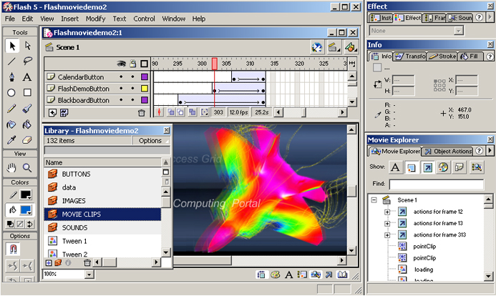
Stage
Symbol
Library Window

Movie Explorer

Flash 5 Toolbar

Subselection Rectangle Paint Bucket Stroke color
Lasso Text Brush Eraser Zoom Fill color
Arrow Pen Pencil Eyedropper Tool modifiers
Line Oval Ink Bottle Hand
Figure : Drawing and Painting Tools

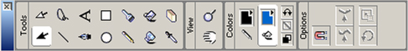

Flash 5 can import different file formats (such as .ai, .dxf, .bmp, .emf, .fh9, .spl, .gif, .jpg, .png, .swf, and .wmf for windows system). The following are basic concepts to deal with in Flash

Drawing ⎯ provides various tools for drawing freeform or precise lines, shapes, and paths, and painting filled objects.
Symbol ⎯ a symbol is a reusable image, animation, or button

Instance ⎯ an instance is an occurrence of a symbol on the Stage. Symbols help to create sophisticated interactivity, reduce a file’s size and simplify editing a movie

Layers ⎯ structure as transparent stacked sheets on top of each other and it helps to organize the artwork in a movie by separating objects on different level

Type ⎯ the text block object where properties such as size, typeface, style, spacing, color and alignment can be set. Sophisticated transform can be applied like shape object.

Buttons ⎯ the objects (with four statuses: Up, Over, Down and Hit) trap mouse clicks and trigger the interaction with Flash movie.

Sound ⎯ the object can be integrated into a Flash layer. There are two types: event sounds (a complete pre-download before playing and independent to the Timeline) and stream sounds (synchronized to the Timeline)

Animation ⎯ Tweening is an essential technique for creating animation. It defines starting and ending states of an instance, group, or text block and use transformation matrix to do the calculation and interpolates the values or shapes for the frames (cells on the Timeline) in between. There are two types of tweened animation in Flash: tweening motion (position and shape) and tweening color. Here is an example of a tweening motion along a straight path .

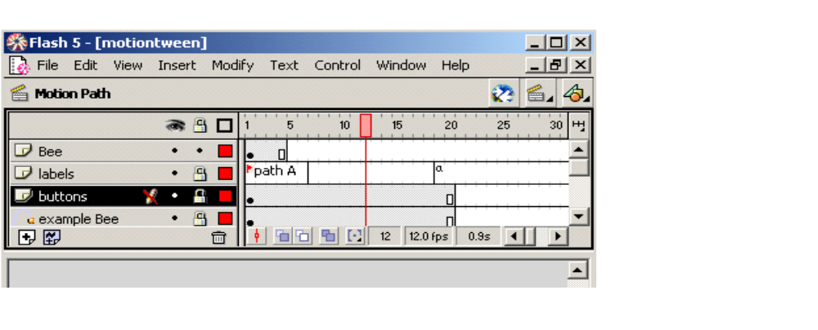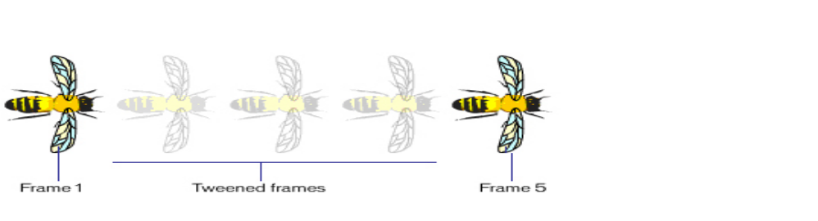
Frame 1 and 5 are the starting and ending points. Frame 2 to 4 are interpolated.
Bee object is put on the top layer
Frame 1 Frame 5
Playhead

list by dragging and dropping or fill in parameters in the argument fields. In Expert Mode, one can enter ActionScript code directly into the text editor on the right side area of the panel

Key technologies of Flash 5
Vector graphics

Vector graphics is perhaps the most important technique used by Flash 5. Although there is other leading designing tools that build up on vector graphics, such as CorelDRAW 10 graphics suite, Macromedia Flash is the very first one who uses vector based graphic design in generating web contents and delivering them over the Internet.

Compared with bitmapped images (GIF and JPEG), which are optimized for a single resolution, the scalability of vector images is more ideal for displaying web contents uniformly on PDA, set-top boxes, or PCs. Vector images can be more compacted, thus make the file size small for delivering. Therefore, the product benefits from this designing feature both in terms of bandwidth efficiency and device independence.
Flash file format (SWF)

The Macromedia Flash (SWF) file format was designed to deliver vector graphics and animation over the Internet. It features with extensibility (a tagged format), efficiency (a binary format), simplicity (a simple format) and scalability (vector based graphics). SWF structure is consists of a Header and a series of tagged data blocks .There are two types of tag ⎯ definition tag (defining the content of a Flash movie) and control tag (manipulating characters and controlling the flow of the movie).

•••
Header Tag Tag Tag
Macromedia Flash (SWF) File Structure
End Tag

File Compression

Flash interactive movie needs frequent data exchange over a network connection. For high quality rendering, Flash is structured in separating the contents from its displaying system (Flash player). The Flash (SWF) file, a tagged format, is compressed to be small and rendered through binary code. Several compression techniques are used to reduce the file size:
Compression ⎯ Shapes are using delta encoding scheme, which assumes the first coordinate of a line to be the last coordinate of the previous one and distances are expressed by relative position to the previous one
Shape Data Structure ⎯ uses a unique structure to minimize the size of shapes and to efficiently render anti-aliased shapes on the screen
Change Encoding ⎯ SWF files only store the changes between states.
Default values ⎯ some structures, like matrices and color transforms, share common field with default values
Reuse ⎯ by the character dictionary, a font, bitmap, shape, or button element can be stored once and referenced multiple times.

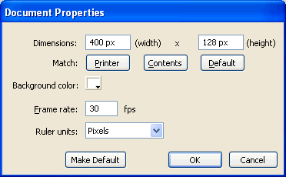
First Steps

Okay, you have a document to work on. Next we’re going to change the size and add some content to the document.
In the Properties panel at the bottom of the window, click on the “Size” button and change the width to 400, the height to 128 and the frame rate to 30.
This has the effect of making the document into a “letterbox” shaped rectangle which will play animations back at 30 steps per second.

Background Colours

Next we will change the background to have a graded blue look.
Click on the Rectangle Tool in the toolbox (upper left) but don’t draw a rectangle on the document yet.
Change the fill colour (Properties panel, bottom of the window) to a blended colour (not a single colour) like the circular graded blue. It can be found at the very bottom of the colour picker.
Later you may want to try a few colours out and experiment a bit. For now, draw a rectangle almost as big as the document.
Click on the Selection Tool (upper left) and click once on your rectangle. This selects the filled part of the rectangle (to select the filled part and the line around the edge, you would double-click).
In the properties, you can see the width, height and position of the rectangle. You can change these figures to position an object exactly where you want.
Try to change the rectangle’s properties so that it is 400 pixels wide, 128 pixels high and positioned at x=0, y=0. Odd isn’t it? The shape of the rectangle is locked, so click on the little padlock icon in the properties area. Now you can change the size easily. Lock the shape when you have finished, then save your work with a
File|Save.

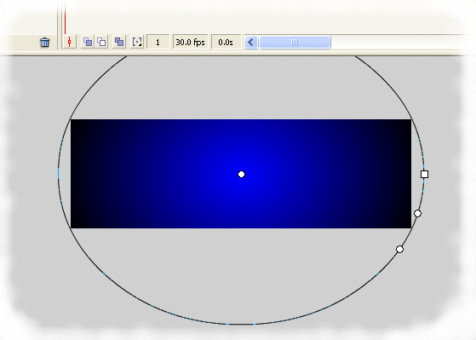
Tweaking the fill colours
Click on the Fill Transform Tool and then click on your blue shaded rectangle. You should see something like this image. If you have a simple plain colour it will not work.
Play with all four of the control points to make a pleasing graded background.
If you accidentally click on the grey background you will deselect the rectangle – just click on it to continue editing.

Pause for thought
Did you think Flash was an animation program? Yet it seems like a drawing program! The current version of Flash is a versatile tool with many capabilities.
Was that easier to do than to describe? If you got stuck, persevere. You will find lots of tutorials use the same style and language, so get used to getting the most out of them.

More Layers
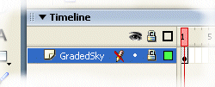
In the Timeline panel (top of the window) you will see that we have something called “Layer 1”. To change the name of the layer, double-click on the name (or right-click and select Properties). Change the name to say GradedSky.
Now look at the symbols to the right of the name – an eye, representing visibility, a padlock representing the lock status, and a square representing a highlight colour. Click on the circular dot under the padlock.
You have protected the layer against accidental editing, which is surprisingly easy to do.
Now we will add a layer and name it Text.
Right-click on the GradedSky name and select Insert Layer from the context menu.
Now change the name of the new layer from “Layer 2” to “Text”.
This second layer sits over the first. Anything in this new layer appears to be on top of the GradedSky layer. We’re going to put some text in it.

Adding Text
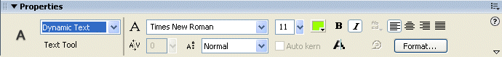
Click on the Text Tool. Don’t create any text yet – just like the rectangle tool, we need to set some properties first.

In the Properties panel, make sure the selection box is set to Static Text. If you have an empty properties panel, make sure the new layer is selected and not locked.
Set the font to Lucida Sans, 72 point, yellow, not bold, not italic.
Now click on the Text layer and type in “This is a long message”.
Note that the text extends off the visible area. This is not a problem!
Save your work. Use Ctrl-S or File|Save.

Animation
Click on the Selection Tool and click on our new text message. It will be selected and you will be able to see the properties at the bottom of the window.
If you have all of the properties visible, you will see the width, height and position of the text object. If not, click on the tiny downwards-facing arrow in the far lower-right corner of the panel.
You can drag the text block around or type in new coordinates to change the position of the text in the layer.
In the timeline (top of the window), on the layer (row) named Text, right-click in the little square under the number 60 – in other words, right click in frame 60 of our animation. From the menu, select Insert Keyframe.
Now we have a two-second animation (remember, we have 30 frames per second) that does nothing at all!
In frame 60, select the text block and move it across to the left. Move it so the end of the text is just off the left edge of our 400-pixel wide area.
Have you noticed that the background has changed? We’ve lost our lovely blue rectangle. Right click in frame 60 on the GradedSky layer row and Insert Frame. This spreads the background over all 60 frames.
Now double-click on any frame from 1 to 59 on the Text layer row. You should see that all the frames from 1 to 59 are selected as one big block. Now look at the properties panel – you should be able to select a Motion tween from a drop-down list box. Tweening is the process of getting the computer to work out all the stages “in between”.
Excellent – you have an animation! Now save your work.

Testing
Obviously we need to be able to test our animation, and Flash provides us with the tools for the job.
One way to test is to press the Enter key; this gives a simple idea of how things will look.
Another way to test is to press the Control and the Enter keys at the same time (Ctrl-Enter). Press Enter again to stop, and then navigate back to your document. You may want to use the Window menu, or click on the name of your document at the top left of the window area.
Another way is to simply press the F12 key to preview your work in a browser. If this is set up, it gives a more accurate feel for how your animation will really look when you publish it.
Application
To create a movie in Flash
Procedure
The most important thing to understand when working with flash is the timeline:

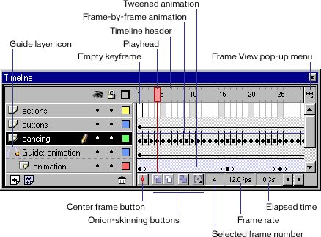

- Make sure you have a “keyframe” in the first frame. Use F6.

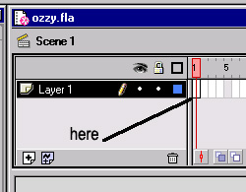

- Import your Ozzy picture from a file. File → Import.

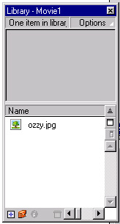

- Now we want to make another keyframe on the 20th frame. Using F6 again.
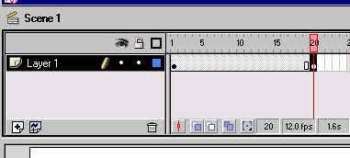

- Right-Click in the gray area, and select “Create Motion Tween”. Then you should see:
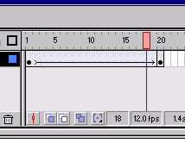
Repeat step 4 for the 20th frame so you have no gray, it should all be blue.

5. Select the first frame in the Timeline, and position Ozzy completely out of the left screen. You can hold the Shift key, and use the arrow keys to position him more accurately. Drag-and-drop works fine too.
Now if you grab the red box shown in the picture above, slide the bar through the frames…Ozzy should be moving in a smooth fashion from frame 1 to frame 20!
NOW YOU CAN DO MOTION TWEEN!!

- From here we are going to head to another scene. A scene acts like a webpage. You normally have several pages in your personal website, well you have several scenes in Flash too! Things would get pretty confusing if we tried to make motion tweens 1000+ frames long (only about 1min20sec).

6. To add a new scene. Insert → Scene
After doing this, Flash should take you directly to that scene, and you should have a blank, fresh new space to work in.

- Click “Scene 1” on the upper right of the screen.

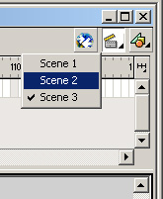

- Ok now that we are back to our first scene. Right-Click in the 20th frame to get the “Actions” pop-up. Then single click on “actions” then double click “goto” within actions.
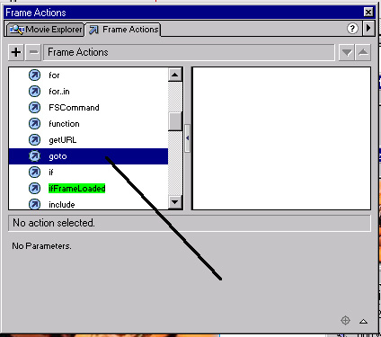

Use these settings for the goto options.

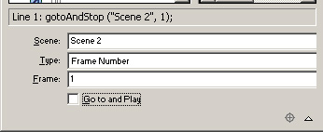

- Now go back to Scene 2 you just created.

- Now we are going to make the red text fly in. Instead of having the text all on the same layer, to make things more interesting we will put sections on different layers. First thing then…. Add 4 new layers.

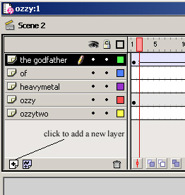
Each layer above has only one text box, or picture within itself.
Since you have already created a motion tween with Ozzy. We will make another tween with text.
Type in the text “The Godfather” on the top frame labeled the godfather.

- Now create a motion tween for “The Godfather” text. Just make the tween, it shouldn’t move at all.
For the Ozzy tween, we made him move from left to right. This time we will make the text appear to fly down from large to small. Click on the first frame of the tween. You should notice that your text automatically is selected.
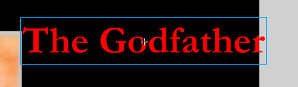

- Now instead of moving the text, right-click inside the blue box above and select Scale. Make the text VERY LARGE. Anywhere from 200% to 300% works awesome!

13.Ok, you should have a motion tween the makes the text appear to fly down from large to small. Our next step is to make sure that after the movie runs to the 20th frame, your Godfather text stays there and doesn’t go away. So….. go way down to the 105th frame and hit F6 again. Should look like this.
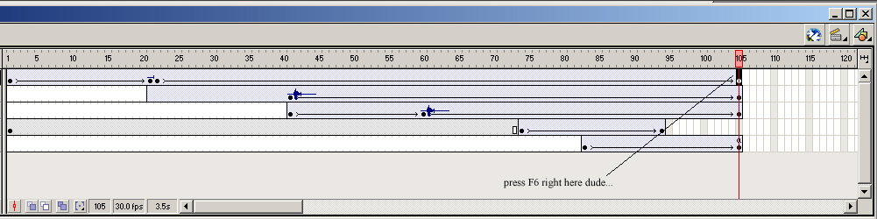

- We now can forget about “the godfather” layer, no more messin’ with it.

- So yer a pro now eh? Well the same steps are done for the text “of” and “heavy metal.”

- Insert your other “ozzy” picture. File → Import. (we won’t mess with it just yet)
- Make sure on the ozzy layer, that your frames continue on until frame 94.
You should make a key frame on frame 73 using F6, and again on frame 94, then make the motion tween.
The picture below shows what it should look like.
- Click on frame 94.
- Now from the Instances panel, we need to select Alpha.
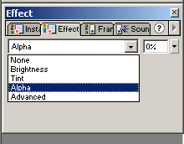
Then make the % zero.
See what happens? Ozzy disappears!! Well that’s what we want.

- On the ozzytwo layer, put your new ozzy picture on there, and make a motion tween from frames 82 to 105.

- Alright now same thing with alpha, make him zero % from the start, then 100% at the end.

From the timeline picture above, you can see that everything you see in the “ozzy” movie takes place within frame 1 to frame 105. Also some tasks on different layers, overlap other tasks….

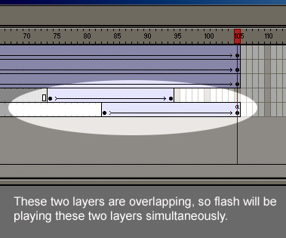
Now, the movie is done. Double click on the ozzytwo layer on frame 105.
We are going to use another action…

Pick Stop. And then you are finally done.
If you weren’t to do this step, the flash movie would just loop over and over again forever. There are some cases you would want this effect.
Autodesk Maya
Autodesk Maya is a software application used for 3D animation, 3D modeling, simulation, visual effects, rendering, matchmoving, and compositing. It is developed in Toronto by Autodesk's Media and Entertainment Division (formerly Alias).Maya is used in the film and TV industry, as well as for computer and video games, architectural visualisation and design.

Overview

Maya is a popular, integrated node-based 3D software suite, evolved from Wavefront Explorer and Alias PowerAnimator using technologies from both. The software used to be released in two versions: Maya Complete and Maya Unlimited; but is now sold as one software.
Maya was originally released for the IRIX operating system, and subsequently ported to the Microsoft Windows, Linux, and Mac OS X operating systems. IRIX support was discontinued after the release of version 6.5. When Autodesk acquired Alias in October 2005, they continued Maya development. The latest version, 2011 (13.0), was released in April 2010.
An important feature of Maya is its openness to third-party software, which can strip the software completely of its standard appearance and, using only the kernel, transform it into a highly customized version of the software. This feature in itself made Maya appealing to large studios, which tend to write custom code for their productions using the provided software development kit.
A Tcl-like cross-platform scripting language called Maya Embedded Language (MEL) is provided not only as a scripting language, but as means to customize Maya's core functionality (much of the environment, commands, and tools are written in the language). Additionally, user interactions are implemented and recorded as MEL scripting code which users can store on a custom toolbar, allowing animators to add functionality without experience in C or C++, though that option is provided with the software development kit. Support for Python scripting was added in version 8.5.
The core of Maya itself is written in C++.
In addition to standard Maya Binary (.mb extension) scenes, project files can be stored as sequences of MEL operations saved as a human-readable file (.ma, for "Maya ASCII"). Containing all geometry and animation data, these files are editable in any text editor outside of the Maya environment, thus allowing for a high level of flexibility when working with external tools.
A marking menu is built into larger menu system called Hotbox that provides instant access to a majority of features in Maya at the press of a key.

Modeling

An example render of a Maya scene.
NURBS, polygons and subdivision surfaces (or SubDivs or SubD's) are available in Maya.
Polygons are a widely used model medium due to its relative stability and functionality. Polygons are also the visualization bridge between NURBS and SubDivs. NURBS are used for their ready-smooth appearance and respond well to deformations in the Dynamics Workbench. SubDivs resemble a combination of both NURBS and polygons, but they are actually just a smoothed mesh. They are ready-smooth and can be manipulated like polygons, resulting in a model of many objects including hands, faces, and other multi-topological constructions. Maya hair tools cannot be applied to subdivision polygons.

Dynamics and Simulation
Maya features a particle system for handling masses like steam and water drops. Dynamic fields allow adding gravity, wind and vortexes, allowing for effects such as blowing leaves or even tornadoes. Special tools give artists the ability to brush and style particles like hair and fur. This module is a direct evolution of Wavefront Dynamation.
An artist may create rigid body geometric objects which collide automatically without explicit animation, as well as soft body objects which can ripple and bend, like flags and cloth.
Maya effects are built-in programs that make it easy for users to create complex animation effects such as smoke, fire and realistic water effects, with many options and attributes for tuning the results.
In version 8.5 a powerful cloth simulator called "nCloth" was added, allowing users to simulate cloth with control over aspects such as self-collision and interpenetration. The cloth objects can be modified to behave as rigid or soft bodies.
In version 2009, "nParticles" were added, offering a new particle simulation system (based around the same system running 'nCloth'), in addition to the original particle system available in Maya. This addition was similar to the inclusion of "nCloth" alongside "Maya Cloth", insofar as it did not take the place of any existing dynamic tools, despite being newer.

Maya Software
Maya now comes in one version (replacing Maya Unlimited). Maya Complete has been discontinued. The new Maya contains all the features of Maya Unlimited 2009:
Maya Fluid Effects
A realistic fluid simulator (effective for smoke, fire, clouds and explosions, added in Maya 4.5)
Maya Classic Cloth
Cloth simulation to automatically simulate clothing and fabrics moving realistically over an animated character. The Maya Cloth toolset has been upgraded in every version of Maya released after Spider-Man 2. Alias worked with Sony Pictures Imageworks to get Maya Cloth up to scratch for that production, and all those changes have been implemented, although the big studios opted to use third party plugins such as Syflex instead of the (relatively) cumbersome Maya Cloth.
Maya Fur
Animal fur simulation similar to Maya Hair. It can be used to simulate other fur-like objects, such as grass.
Maya Hair
A simulator for realistic-looking human hair implemented using curves and Paint Effects. These are also known as dynamic curves.
Maya Live
A set of motion tracking tools for CG matching to clean plate footage.
Maya nCloth
Added in version 8.5, nCloth is the first implementation of Maya Nucleus, Autodesk's simulation framework. nCloth gives the artist further control of cloth and material simulations.
Maya nParticle
Added in version 2009, nParticle is addendum to Maya Nucleus toolset. nParticle gives artists an intuitive, efficient workflow for simulating a wide range of complex 3D effects, including liquids, clouds, smoke, spray, and dust.
MatchMover
Added to Maya 2010, this enables compositing of CGI elements with motion data from video and film sequences.

Scripting and Plugins
In Maya, all attributes are parametric, meaning anything can be connected to anything (e.g. a color intensity of a shader can be used to control the movement of a door opening and closing). To control the node-based system of Maya, its fully reconfigurable user interface can be scripted with MEL script code which can be dropped onto a shelf to create a new icon that executes that code.
With the release of Maya 8.5 support for the Python scripting language has been included. The current implementation of Python in Maya is not fully object oriented though.
- List of Maya plugins

MEL Scripting
Maya has an embedded script language called MEL, Maya Embedded Language, which is similar to TCL and Perl programming. Code written in MEL can be executed from the script editor, shelves, and drop down menus.
MEL affords more access and control than what was designed in the User Interface; some functions of the software and advanced options are only available by using MEL programming. All Maya preferences, commands, toolbars, and drop down menus are MEL code. By recording from the Script Editor History Window or scanning the Maya Program Files directory, it is possible to retrieve the original MEL procedures and functions.
MEL is not object oriented, so it is impossible to create custom classes and methods as you would in C++ or Python. The advantage of this is that it gives MEL a strong structure making it accessible and easier to understand to Maya users and to first time programmers. Also the linear scripting nature of the language would assist the user in making the most of the Maya nodes instead of tempting him/her to make their own objects, as in case of object oriented languages.

Learning Tools
Along with the history of Maya the company has produced Maya learning tools which date back to the earlier Alias days. Beginning with an internally produced newsletter on Maya software techniques and workflows, the company continued with the internally produced Art of Maya book and training videos and tutorials. In response to strong user demand the company's education department further developed instructional books and video-based learning content referred to as learning tools. Autodesk continues to develop learning tools with content developed both by internal product specialists as well as industry professionals. The company's video-based learning tools have recently moved away from physical production and are now available as digital downloads.

Use in Films
Many popular computer-animated films have been made with Maya software, including Ice Age, its sequel Ice Age: The Meltdown, Geng: The Adventure Begins, Monsters vs. Aliens, James Cameron's Avatar, and others.

