Q1. Console "Hello Word" in document.ready function.

Ans

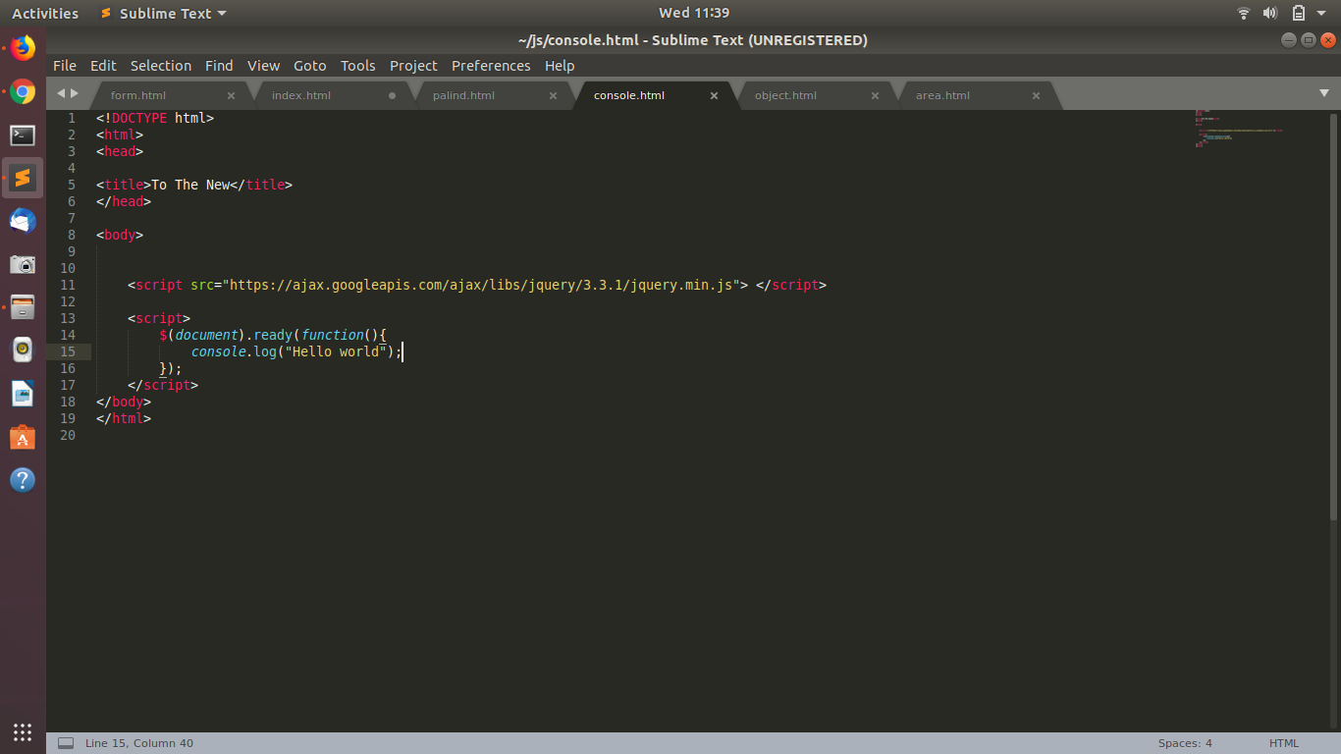

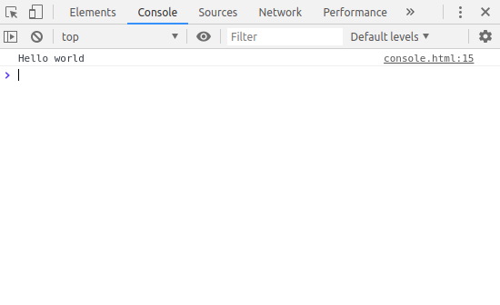

Q2 Select a ID name "#test" and add class "load" when DOM is loaded

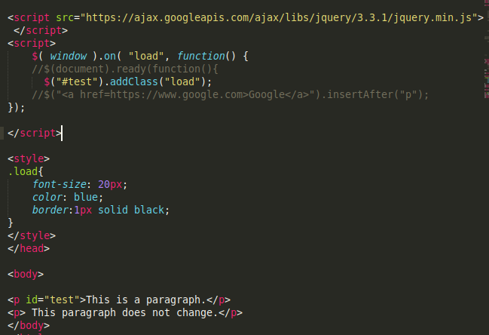

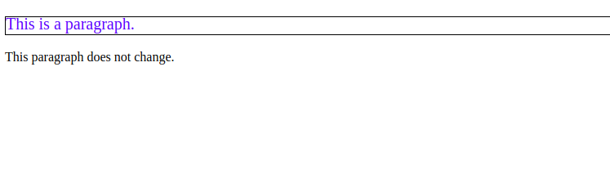

Q3 .Change the color of element which class name end with "-new”

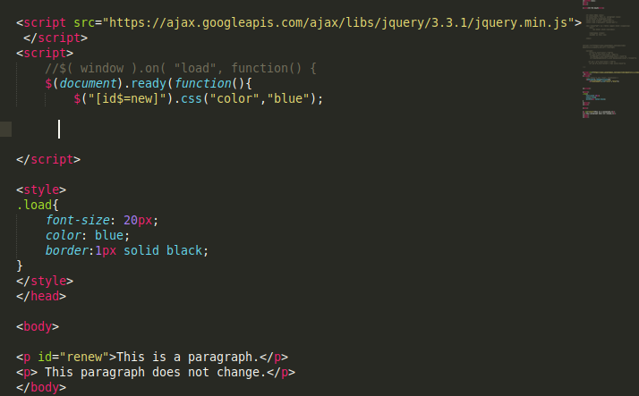

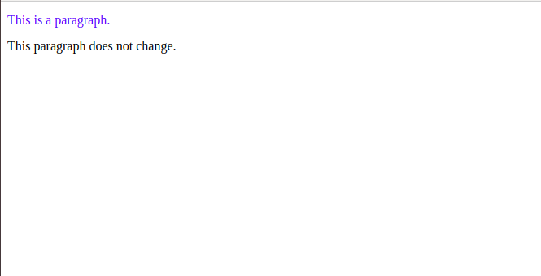

4 . Disable submit button using jquery attr method

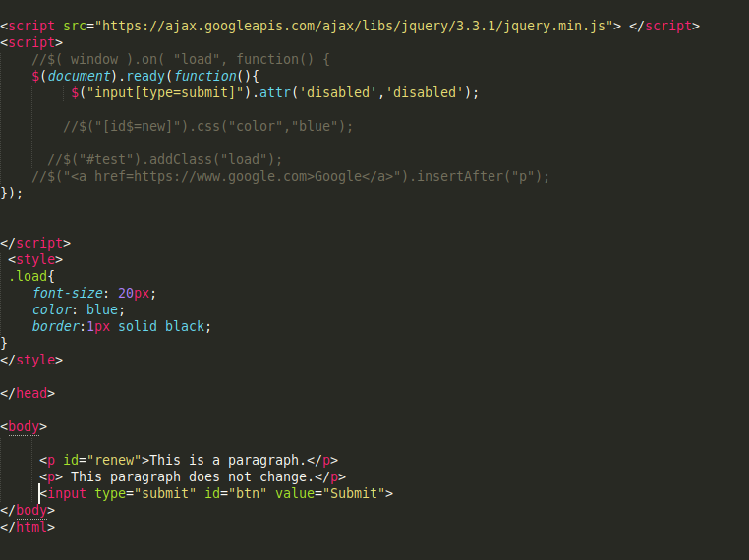

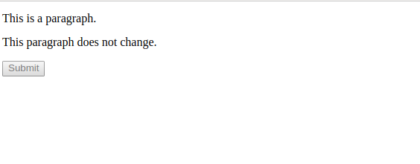

Q5 Change the font size of ".target" which has parent element with id name "#main".

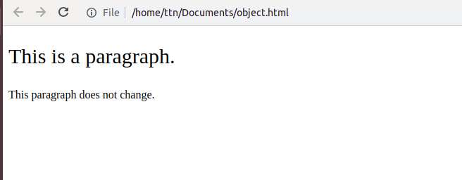

Q6. After page load change the HTML of div element with "p" element

<!DOCTYPE html>

<html>

<head>

<title>To The New</title>

</head>

<body>

<div id="result"> This is a div</div>

<script src="https://ajax.googleapis.com/ajax/libs/jquery/3.3.1/jquery.min.js"> </script>

<script>

$( window ).on( "load", function(){

{

$("#result").replaceWith("<p>This is a paragraph</p>"); }

});

</script>

</body>

</html>

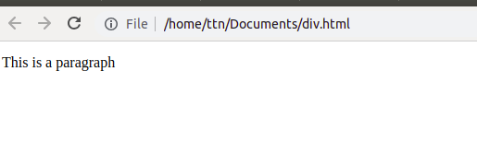

Q7 Bind a click function to an "click" element and append next "click" next to it.

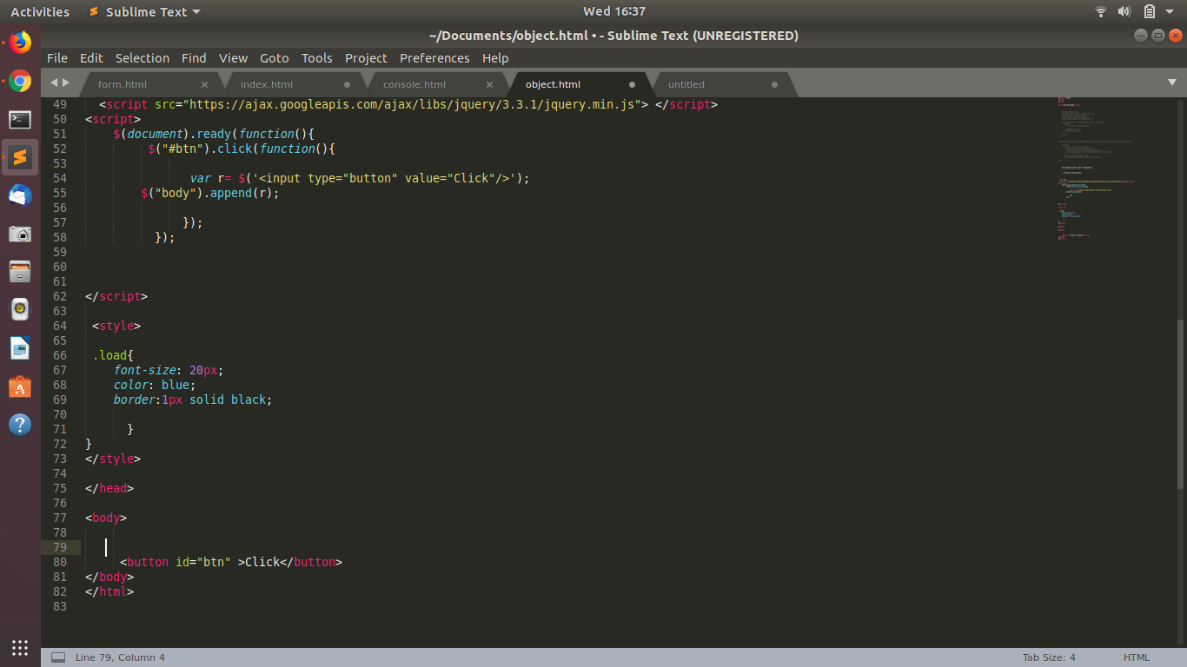

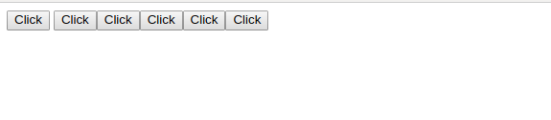

8 .Click event not working on element which added dynamicly or via script, make it work using .on method

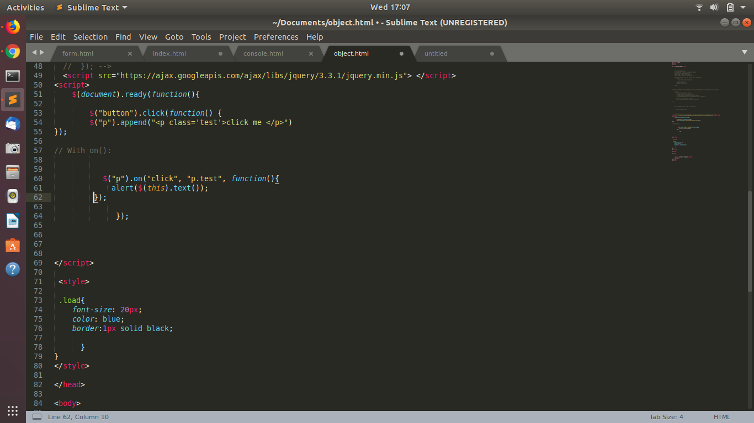

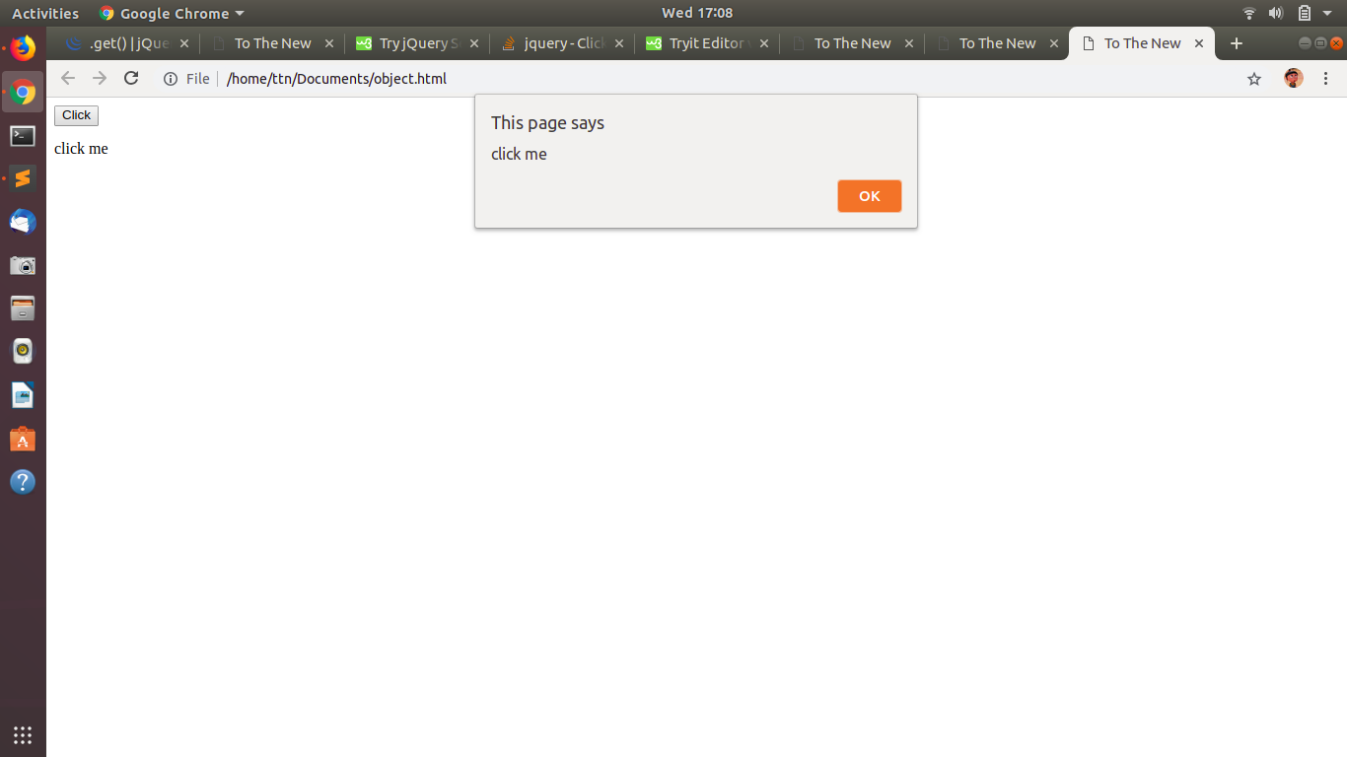

9. Get dropdown selected value on on change event and append in div container.

Ans

jQuery change event occurs when the value of an element is changed. It works only on form fields.

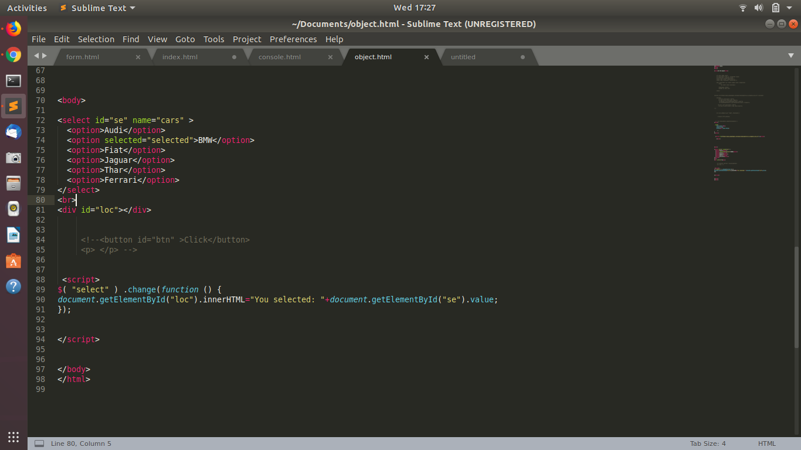

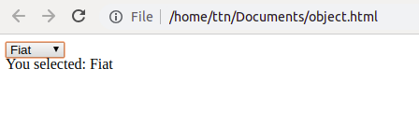

10.Create a dropdown menu using hover method in jquery

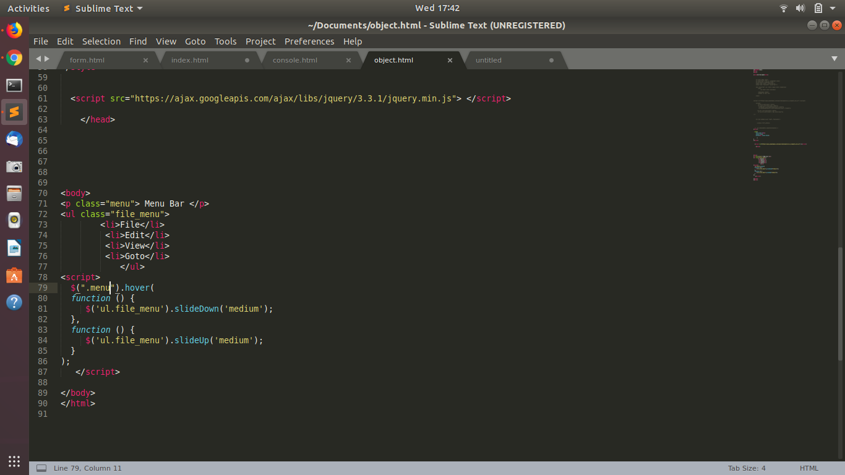

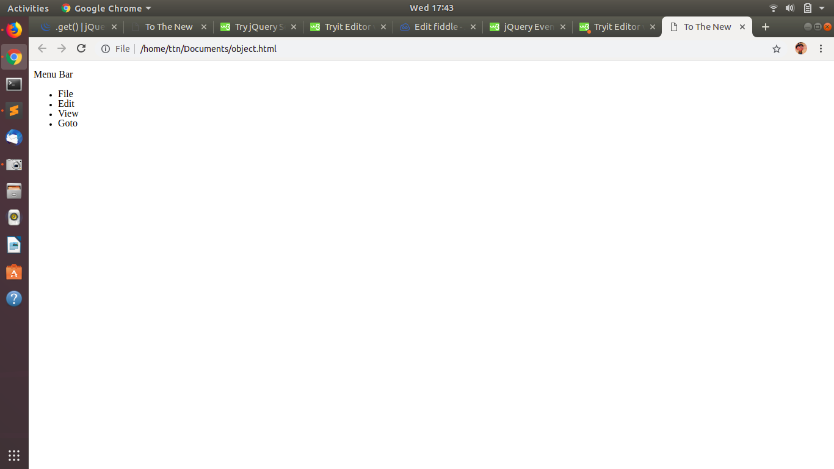

11. On clicking on "[google](https://www.google.com)" tag. It is taking us to google home page. Stop it from happening.

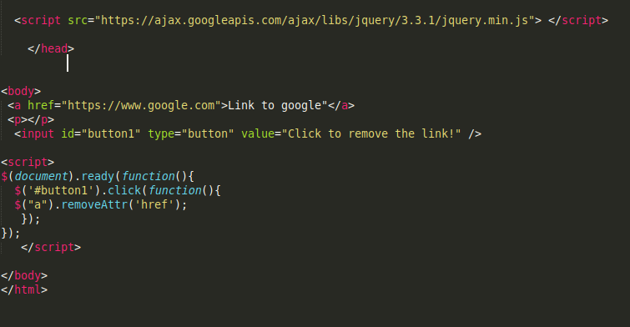

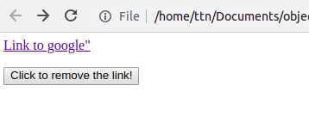

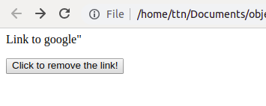

12. We have bind a click funtion to parent div but we want stop it from performing when user clicks on its child li

<body>

<div id="parent">

<p>Click this to show alert</p>

<div id="child">

<ul>

<li>Click here to stop the link </li> </ul>

</div>

</div>

<script>

$(document).ready(function(){

$('#parent').on("click",function(e){

alert("You entered parent!");

//e.stopPropagation();

});

$('#child').click(function(){

$("#parent").unbind("click");

//$("li").css("color","blue");

});

});

</script>

</body>

</html>

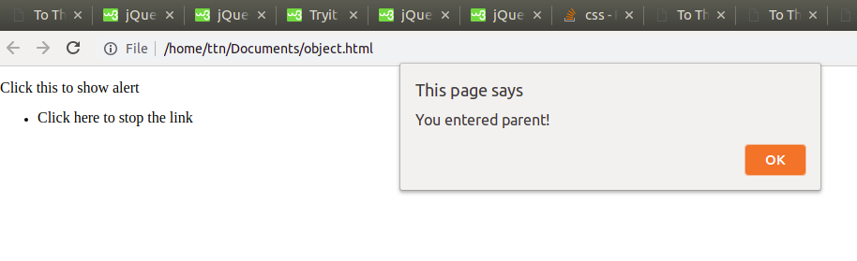

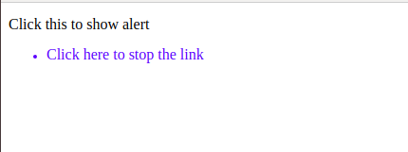

13. Get the max height of elements using jquery each method

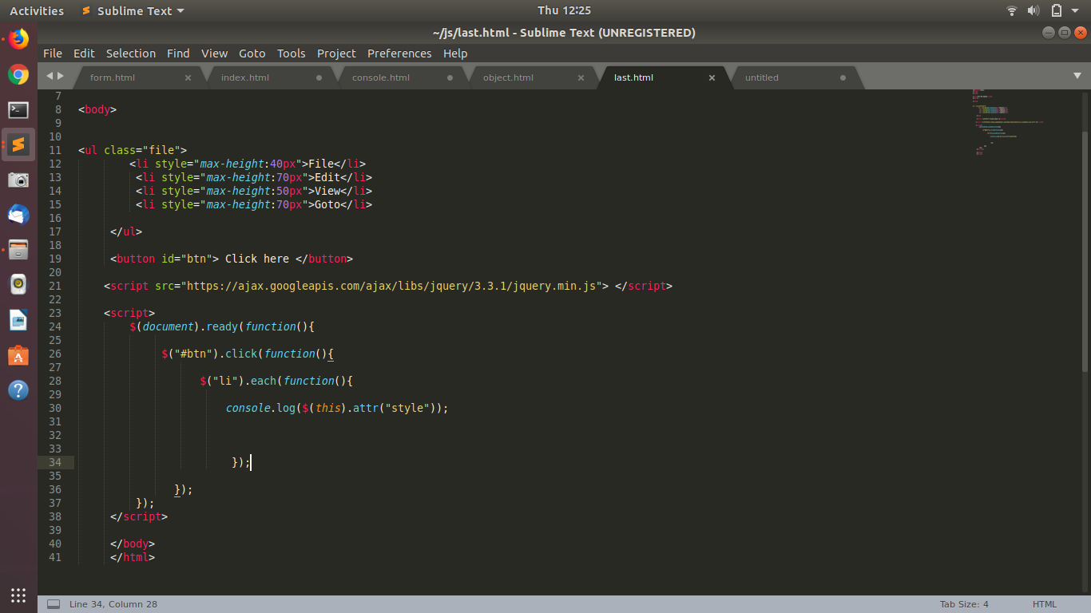

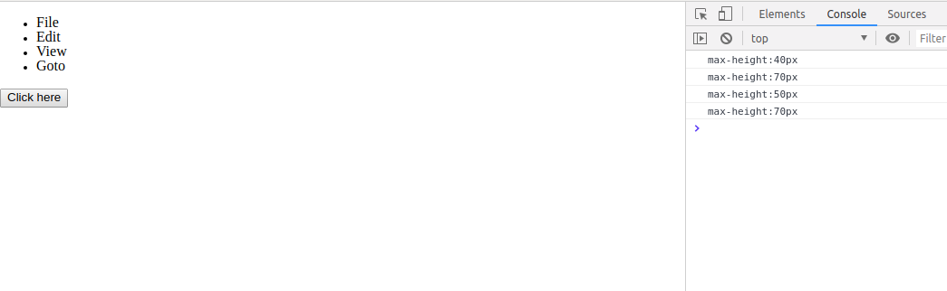

14. Change color of every cell which has number larger than 10

<!DOCTYPE html>

<html>

<head>

<title>To The New</title>

<style>

table,th,td {

border:1px solid black;

}

</style>

</head>

<body>

<table >

<th>Numbers </th>

<tr> <td>20 </td></tr>

<tr> <td>25</td></tr>

<tr> <td>09</td></tr>

<tr> <td>06</td></tr>

<tr> <td>11</td></tr>

</table>

<button id="btn"> Click here </button>

<script src="https://ajax.googleapis.com/ajax/libs/jquery/3.3.1/jquery.min.js"> </script>

<script>

$(document).ready(function(){

$("#btn").click(function(){

$("td").each(function(){

if ($(this).text()>10){

$(this).css("background-color","pink");

}

});

});

});

</script>

</body>

</html>

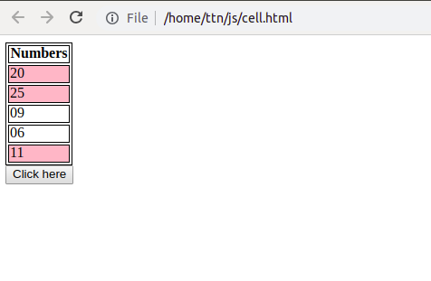

15. Retrive the data from server using ajax get call

<body>

<button id="btn">Send an HTTP GET request to a page and get the result back</button>

<div id="result"> </div>

<script src="https://ajax.googleapis.com/ajax/libs/jquery/3.3.1/jquery.min.js"> </script>

<script>

$(document).ready(function(){

$("#btn").click(function(){

$.ajax({url:"https://jsonplaceholder.typicode.com/posts/1",

success:function( data ) {

console.log(data);

//$( "body" ).append( data );

$("#result").text(JSON.stringify(data));;

alert( "Load was performed." );

},

error:function(error){

alert(error.message)

}

}

);

// get Result

});

});

</script>

