Performance Analysis of Vision Transformers for Multi-Task Autonomous Vehicle Perception
Capstone Project Technical Report
Report scope: literature-grounded project plan and completed BDD100K image-quality characterization, with Phase 1 model experiments and Phase 2 multi-task implementation described as proposed work where results are not yet available.

1. Abstract
This project investigates the use of Vision Transformer (ViT) architectures for multi-task perception in autonomous vehicles, with emphasis on the relationship between perception accuracy, data scale, architectural choice, sensor configuration, and computational cost. The work is structured in two phases. Phase 1 is designed as a systematic performance-analysis study covering five experimental dimensions: task performance, dataset scale, model architecture, sensor configuration, and computational efficiency. Phase 2 is intended to use the findings of Phase 1 to implement a multi-task Vision Transformer perception system trained using the combined BDD100K and A2D2 datasets. The target perception functions include object detection, semantic segmentation, instance segmentation, and related road-scene understanding tasks supported by the selected annotations. The central motivation is that autonomous-vehicle perception must operate across heterogeneous visual conditions while balancing predictive quality with practical computational constraints.
The attached implementation currently provides a substantial dataset-characterization component for Phase 1. It processes 8,027 BDD100K images and extracts five image-quality properties: mean luminance, luminance standard deviation, variance of the Laplacian, underexposed-pixel percentage, and overexposed-pixel percentage. The extraction pipeline converts images to grayscale luminance using OpenCV, computes the selected measures, resolves environmental metadata, and stores the resulting records in structured CSV form. The statistical-analysis pipeline subsequently derives distributional summaries and performs Mann–Whitney U tests, Kolmogorov–Smirnov tests, and Cohen’s d effect-size calculations for day-versus-night and clear-versus-rain comparisons. The supplied visualization code produces correlation heatmaps, histograms with kernel-density estimates, cumulative luminance distribution functions, environmental benchmark plots, and an integrated presentation dashboard.
The resulting BDD100K characterization shows substantial environmental variation in image formation. Across the analysed images, mean luminance is 102.13 ± 24.82, while the underexposure and overexposure measures exhibit strongly right-skewed distributions. The day-versus-night comparison shows marked shifts in brightness, contrast, sharpness, and underexposure, while the clear-versus-rain comparison indicates a distinct increase in overexposed pixels under rainy conditions. These observations provide an empirical basis for selecting robustness conditions and balancing training subsets in later perception experiments. The report therefore treats image quality analysis as a methodological foundation rather than as a substitute for the planned ViT model benchmarks. Model-accuracy values, latency measurements, and final Phase 2 results are not presented as completed findings because the attached material does not contain those experimental outputs.

2. Introduction & Motivation for the Work
Autonomous vehicles require perception systems that can convert raw sensor observations into structured representations of the driving environment. Camera-based perception is particularly important because RGB imagery contains semantic and geometric cues about road users, lane markings, road surfaces, traffic controls, and scene context. In practical driving environments, however, the visual input distribution is not stationary. The same perception system may encounter high illumination, low illumination, rain, glare, blur, partial occlusion, and heterogeneous scene composition. A model that performs well under a narrow operating distribution can consequently exhibit degraded behaviour when the incoming imagery differs from the conditions represented during training. The problem becomes more demanding when multiple perception tasks are required simultaneously, because different tasks rely on different aspects of the shared visual representation.
Vision Transformers provide a relevant basis for studying this problem because they replace the strictly convolutional feature-extraction paradigm with tokenized image representations and self-attention. The original ViT formulation demonstrated that a pure Transformer can operate directly on image patches, while later hierarchical designs such as Swin Transformer were developed to improve multi-scale visual representation and computational practicality for dense prediction. ConvNeXt is also relevant as a modern convolutional baseline because it revisits convolutional design choices using insights from Transformer architectures. These developments make it possible to perform a controlled comparison between established CNN backbones and Transformer-based backbones rather than treating a Transformer result in isolation. [7]–[10]
The selection of BDD100K and A2D2 is motivated by their complementary characteristics. BDD100K was introduced specifically as a diverse driving dataset for heterogeneous multitask learning and provides broad environmental, geographical, and task diversity. A2D2 complements this emphasis through synchronized camera and LiDAR data together with 3D bounding-box, semantic-segmentation, and instance-segmentation annotations. [1], [2] The two datasets therefore offer a basis for studying not only task diversity but also differences in sensing configuration. The present project further introduces explicit image-quality characterization so that environmental variation is measured rather than described only qualitatively.
The attached BDD100K analysis demonstrates why such characterization is relevant. In the analysed subset, daytime images have a mean luminance of 104.04 compared with 46.07 for nighttime images, while median luminance changes from 103.29 to 34.39. The median Laplacian variance decreases from 399.77 during daytime to 74.40 at night, and the average underexposed-pixel fraction increases from 1.39% to 24.65%. The clear-versus-rain analysis shows a different pattern: mean luminance increases from 96.47 to 103.31, but median sharpness falls from 359.25 to 285.69 and median overexposure rises from 0.52% to 2.81%. These distributions motivate the later robustness experiments and support the broader objective of determining how perception architectures behave under heterogeneous real-world visual inputs.

3. Objective / Problem Statement
The core problem addressed by the project is the absence of a single, controlled evaluation framework that simultaneously considers perception-task performance, training-data scale, architectural design, sensing configuration, and computational efficiency for Vision Transformer-based autonomous-vehicle perception. Autonomous-driving models are frequently evaluated using a task-specific accuracy metric, but such an evaluation does not by itself reveal whether a model remains effective when the data distribution changes, whether the observed performance is sensitive to training-set size, or whether the computational burden is compatible with real-time deployment. The project therefore frames performance as a multidimensional property rather than as a single accuracy value.
The first objective is to establish a reproducible baseline for multiple road-scene perception tasks. The planned Task Performance experiment compares models on object detection, semantic segmentation, and instance segmentation, with task-appropriate evaluation measures such as mean Average Precision for detection and mean Intersection over Union for segmentation. The second objective is to quantify data efficiency by training models on progressively larger subsets, represented in the current project plan by 5K, 10K, 20K, and 40K samples. The third objective is to compare architectural families, specifically ResNet, ConvNeXt, ViT, and Swin Transformer, under controlled experimental conditions. These comparisons are intended to isolate the contribution of backbone design as far as practical.
The fourth objective is to investigate sensor configuration by comparing camera-only input with camera-plus-LiDAR input where the required synchronized data and fusion pipeline are implemented. This experiment is especially relevant to A2D2 because the dataset provides synchronized camera and LiDAR observations. The fifth objective is to quantify computational efficiency using inference latency, frames per second, GPU memory usage, parameter count, floating-point operations, and training time. The intended outcome is not simply to identify the model with the highest task score, but to establish the accuracy–efficiency trade-off associated with each architecture and sensor setting.
The final objective is to use the evidence obtained in Phase 1 to guide the Phase 2 implementation of a multi-task Vision Transformer using combined BDD100K and A2D2 data. This phase is intended to use a shared visual representation with task-specific prediction heads. The attached codebase, however, presently documents image-quality analysis rather than completed model-training results; consequently, numerical claims concerning ViT accuracy, latency, GPU memory, or multimodal fusion performance remain future experimental outputs. The problem statement is therefore operationalized as a sequence of measurable questions: how perception performance changes across tasks, how it scales with data volume, how CNN and Transformer backbones compare, whether additional sensor information changes the outcome, and what computational cost accompanies the observed performance.

4. Literature Review & Existing Approaches/Methods
The BDD100K dataset was introduced by Yu et al. as a large-scale driving dataset designed for heterogeneous multitask learning. Its motivation is particularly aligned with this project because autonomous-driving perception involves tasks of different complexity and existing datasets often constrain researchers to narrower problem settings. BDD100K was constructed from 100K driving videos and provides diversity in geography, environment, and weather, together with multiple task annotations. [2] This makes it suitable as the primary RGB dataset for evaluating how a common perception framework behaves across multiple road-scene tasks.
Geyer et al. introduced A2D2 as a multimodal autonomous-driving dataset containing simultaneously recorded images and 3D point clouds, together with 3D bounding boxes, semantic segmentation, instance segmentation, and automotive-bus information. The sensor suite consists of six cameras and five LiDAR units, and the released annotations include 41,277 frames with semantic segmentation labels and 12,497 frames with 3D bounding-box annotations. [1] A2D2 is consequently valuable for the sensor-configuration dimension of the present study because it makes camera-only and multimodal investigations technically plausible within the same sensing environment.
At the model level, ResNet remains a standard convolutional baseline because residual connections enable the construction of deep networks while preserving effective optimization behaviour. ConvNeXt later revisited the design space of modern ConvNets and showed that carefully modernized convolutional architectures can remain competitive with Transformer-based models. [7], [8] These works motivate the inclusion of both a conventional residual network and a contemporary convolutional backbone in the experimental comparison. They provide a reference point against which any claimed advantage of Vision Transformers can be interpreted.
Dosovitskiy et al. established the original Vision Transformer framework in which an image is divided into fixed-size patches that are embedded as a token sequence and processed with Transformer layers. [9] The strength of this approach is its ability to model long-range relationships through self-attention, but its direct application to dense visual tasks introduces challenges associated with spatial resolution and multi-scale structure. Swin Transformer addresses these challenges through hierarchical representations and shifted local windows, producing a more scalable backbone for tasks such as detection and segmentation. [10] The project therefore compares both a conventional ViT and a hierarchical Transformer rather than assuming that all Transformer designs behave identically.
For external validation and segmentation-oriented comparison, the project may draw on Cityscapes, which was designed for semantic urban-scene understanding and contains imagery from 50 cities with dense annotations for pixel-level and instance-level labelling. [5] The present report does not claim that such cross-dataset experiments have already been performed; it identifies them as a suitable external benchmark once the primary Phase 1 models are operational. Overall, the literature indicates a progression from specialized convolutional perception models toward Transformer-based unified representations, while the proposed study focuses on a controlled empirical question that cuts across architecture, task, data scale, sensing, and computation.

5. Proposed Work: Block Diagram / Architectural Diagram with Description
The proposed system is organized as a two-phase pipeline. Phase 1 begins with BDD100K and A2D2 data preparation, followed by five evaluation modules that independently vary task, data volume, architecture, sensor configuration, and computational measurement. The intention is to preserve consistent preprocessing and evaluation protocols while changing one principal factor at a time so that observed performance differences can be interpreted more directly. The integrated Phase 1 workflow is represented conceptually by the supplied master dashboard and related experimental illustrations. The current implementation evidence supports the data-characterization portion of this pipeline; the model-comparison components remain planned until the corresponding training and evaluation code is implemented.
The first stage is dataset preparation. BDD100K supplies RGB road-scene imagery and multitask annotations, while A2D2 supplies camera and LiDAR observations with complementary segmentation and 3D annotations. The preprocessing stage is intended to establish synchronized and reproducible samples, normalize input resolution, perform data cleaning, and create training, validation, and test subsets. Particular care is required to preserve environmental diversity and to avoid information leakage between related frames or sequences. The image-quality scripts already establish a consistent data-processing pattern: images are read from split-specific directories, environmental metadata are resolved from the associated annotation JSON files, and a structured record is created for each successfully processed image.
Within Phase 1, the Task Performance module provides the task-level benchmark, the Dataset Scale module produces performance-versus-data learning curves, the Model Architecture module compares ResNet, ConvNeXt, ViT, and Swin Transformer, the Sensor Configuration module compares camera-only and camera-plus-LiDAR settings where supported, and the Computational Efficiency module records the resource cost of each model. The experiments converge on a common performance-analysis stage that considers accuracy, efficiency, robustness, and generalization. The supplied visualization design uses a five-module horizontal evaluation structure rather than a conventional mind map, which is suitable for representing the experimental logic in the final report and presentation.
Phase 2 uses the evidence from Phase 1 to construct the multi-task perception model. The proposed architecture contains a shared Vision Transformer encoder followed by task-specific prediction heads. In the RGB pathway, images from BDD100K and A2D2 are transformed into patch or token representations before being processed by Transformer blocks. Where multimodal fusion is implemented, LiDAR features from A2D2 can be aligned with the camera representation through an explicit fusion mechanism. The shared encoder is intended to learn reusable scene representations, while separate task heads produce outputs for detection, semantic segmentation, instance segmentation, and other finalized tasks. The attached Phase 2 diagram should be treated as an architectural proposal rather than a record of completed training results.

6. Hardware & Software Requirements (Dataset / Hardware / Software)
The dataset requirement is defined primarily by the two selected sources. BDD100K is the principal RGB driving dataset because its design explicitly supports heterogeneous multitask learning, while A2D2 is the complementary dataset for multimodal perception and sensor-configuration analysis. [1], [2] The currently attached BDD100K analysis operates on 8,027 successfully characterized images from the project’s 10K image sample and associates each image with split information and environmental metadata such as weather, time of day, and scene type. The image-quality extraction code reads train, validation, and test directories and produces a structured CSV record containing luminance statistics, exposure indicators, percentile measures, environmental labels, and the resolved metadata match type. The statistical pipeline then generates overall, day-versus-night, and clear-versus-rain summary outputs.
The software environment evident from the attached codebase is Python with NumPy, pandas, OpenCV, SciPy, Matplotlib, JSON handling, filesystem utilities, and Python’s concurrent.futures module. OpenCV is used to read images and convert them to grayscale luminance. NumPy provides array operations and percentile calculations, pandas provides tabular data management and CSV export, SciPy provides the statistical tests and kernel-density calculations, and Matplotlib produces the reported figures. The image-quality extractor also uses a ThreadPoolExecutor with a worker count capped by the implementation at min(12, CPU count), which allows independent images to be processed concurrently. The visualization code exports high-resolution JPG and scalable SVG figures at 300 DPI for presentation and reporting.
The hardware requirement for the completed image-quality analysis is comparatively modest because the pipeline is CPU-oriented and performs image-wise statistical processing. The project materials do not specify a validated minimum or recommended CPU, RAM, storage capacity, or GPU configuration for the later Vision Transformer training stage, so those values should not be represented as measured requirements at this point. For Phase 1 model experiments and Phase 2 Transformer training, a CUDA-capable GPU with sufficient VRAM, adequate system RAM, and fast local storage would ordinarily be required, but the exact hardware threshold depends on the selected image resolution, model variant, batch size, optimizer, and whether LiDAR fusion is enabled. These values should be added after the first controlled training run establishes empirical resource consumption.
For reproducibility, the software environment should be pinned once model development begins, including Python version, PyTorch version, CUDA version where applicable, computer-vision frameworks, and random seeds. The present codebase already provides a reproducible pattern for filesystem organization and structured result generation, including separate CSV files for overall statistics and environmental comparisons and a JSON file for inferential tests. The final implementation should extend the same principle to model checkpoints, configuration files, training logs, metric outputs, and inference benchmarks so that every experiment can be recreated from an explicit configuration rather than relying on undocumented manual settings.

7. List of Modules & Explanation
The first module is Dataset and Metadata Preparation. Its role is to collect images and associated labels, resolve environmental attributes, preserve train/validation/test membership, and provide a consistent representation for downstream analysis. In the supplied image-quality implementation, metadata are resolved first by exact image-name matching and, when that is unavailable, by a video-prefix fallback. Weather, time of day, and scene attributes are then stored alongside image identifiers and split information. This module establishes the context required for later robustness analysis because the image-quality measurements can be stratified by environmental condition rather than treated as an undifferentiated aggregate.
The second module is Image-Quality Characterization. It computes mean luminance as the average grayscale intensity, luminance standard deviation as a contrast measure, Laplacian variance as the sharpness or blur indicator, and the proportions of pixels below or above predefined exposure thresholds. Additional severe-clipping indicators and luminance percentiles are also calculated by the extractor. The implemented pipeline uses the ITU-R BT.601 grayscale conversion exposed through OpenCV, calculates the metrics per image, and stores the values with controlled rounding. This module produced the 8,027-image dataset characterization used in the attached report and figures.
The third module is Statistical and Distributional Analysis. It computes means, standard deviations, medians, interquartile ranges, fifth and ninety-fifth percentiles, extrema, and skewness for each metric. For environmental comparisons, the implementation applies two-sided Mann–Whitney U tests, two-sample Kolmogorov–Smirnov tests, and Cohen’s d effect sizes. The resulting day-versus-night analysis shows very large differences for brightness, contrast, and underexposure, while the clear-versus-rain comparison exhibits a particularly strong difference in overexposure. The associated visualization module expresses these results through histograms with KDE curves, CDFs, correlation plots, and benchmark bar charts, allowing both distributional structure and aggregate differences to be inspected.
The fourth module is the Phase 1 Model Evaluation Framework. This module is planned to train and test ResNet, ConvNeXt, ViT, and Swin Transformer backbones over the selected perception tasks under controlled protocols. Its output is intended to support the Task Performance and Model Architecture experiments and to supply comparable accuracy measures for the later computational-efficiency analysis. The fifth module is Dataset-Scale Evaluation, which repeats the selected model training over the planned 5K, 10K, 20K, and 40K sample regimes. The resulting learning curves are intended to quantify how additional training data influence the performance of each architecture.
The sixth module is Sensor Configuration and Multimodal Fusion. Its purpose is to compare camera-only inference with camera-plus-LiDAR inference using A2D2 data when a validated fusion implementation is available. The seventh module is Computational Efficiency, which records latency, FPS, GPU memory, parameter count, FLOPs, and training time alongside accuracy. The eighth and final module is Phase 2 Multi-Task Implementation. It is planned as a shared Vision Transformer encoder with task-specific heads for the finalized perception tasks, trained using the combined BDD100K and A2D2 datasets. The attached materials establish the data-analysis foundation and the proposed architecture, but the model-training and deployment outputs of these later modules are not yet represented by completed numerical results.

Figures and Analytical Outputs
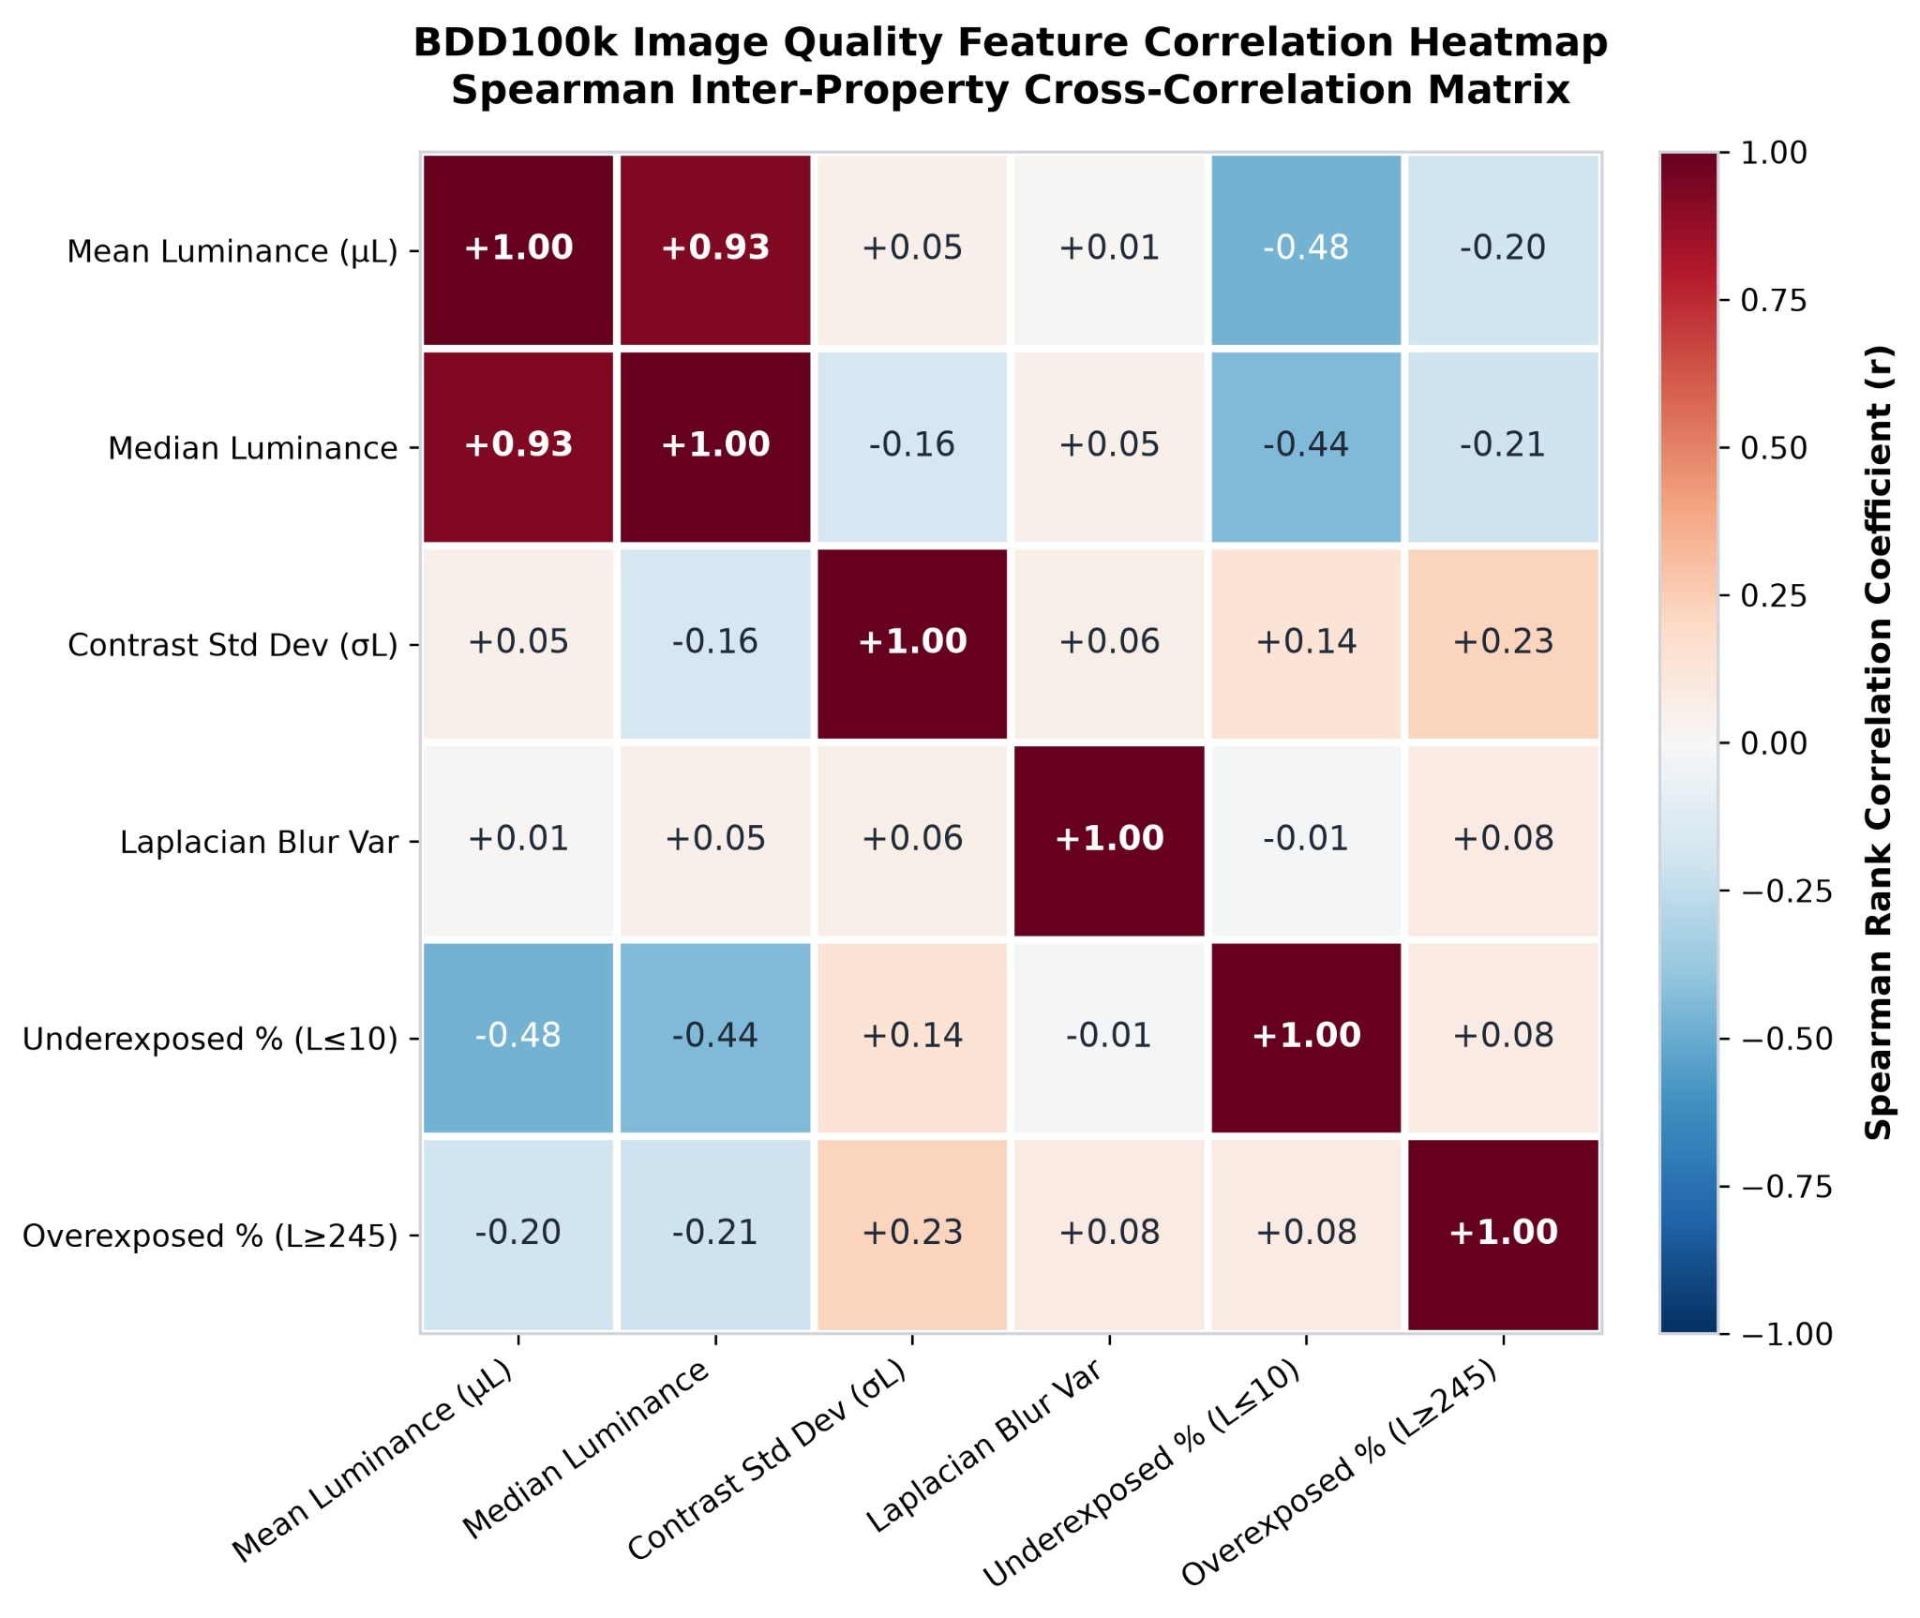
Figure 1. Spearman correlation matrix of BDD100K image-quality properties.
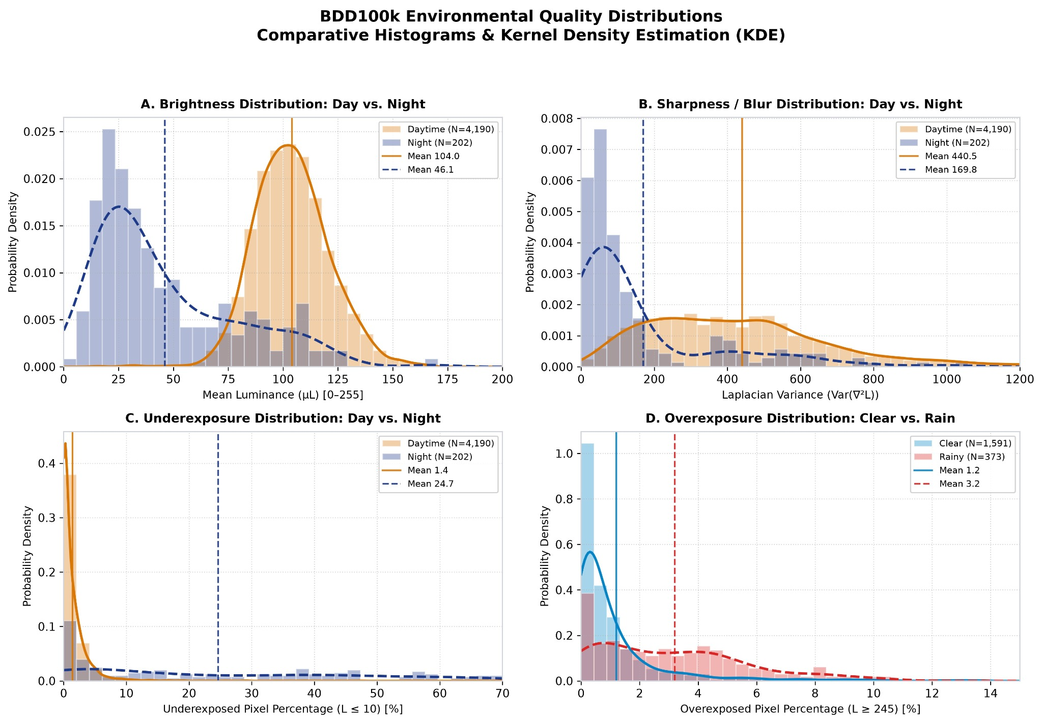
Figure 2. Environmental distributions of brightness, sharpness, underexposure, and overexposure.
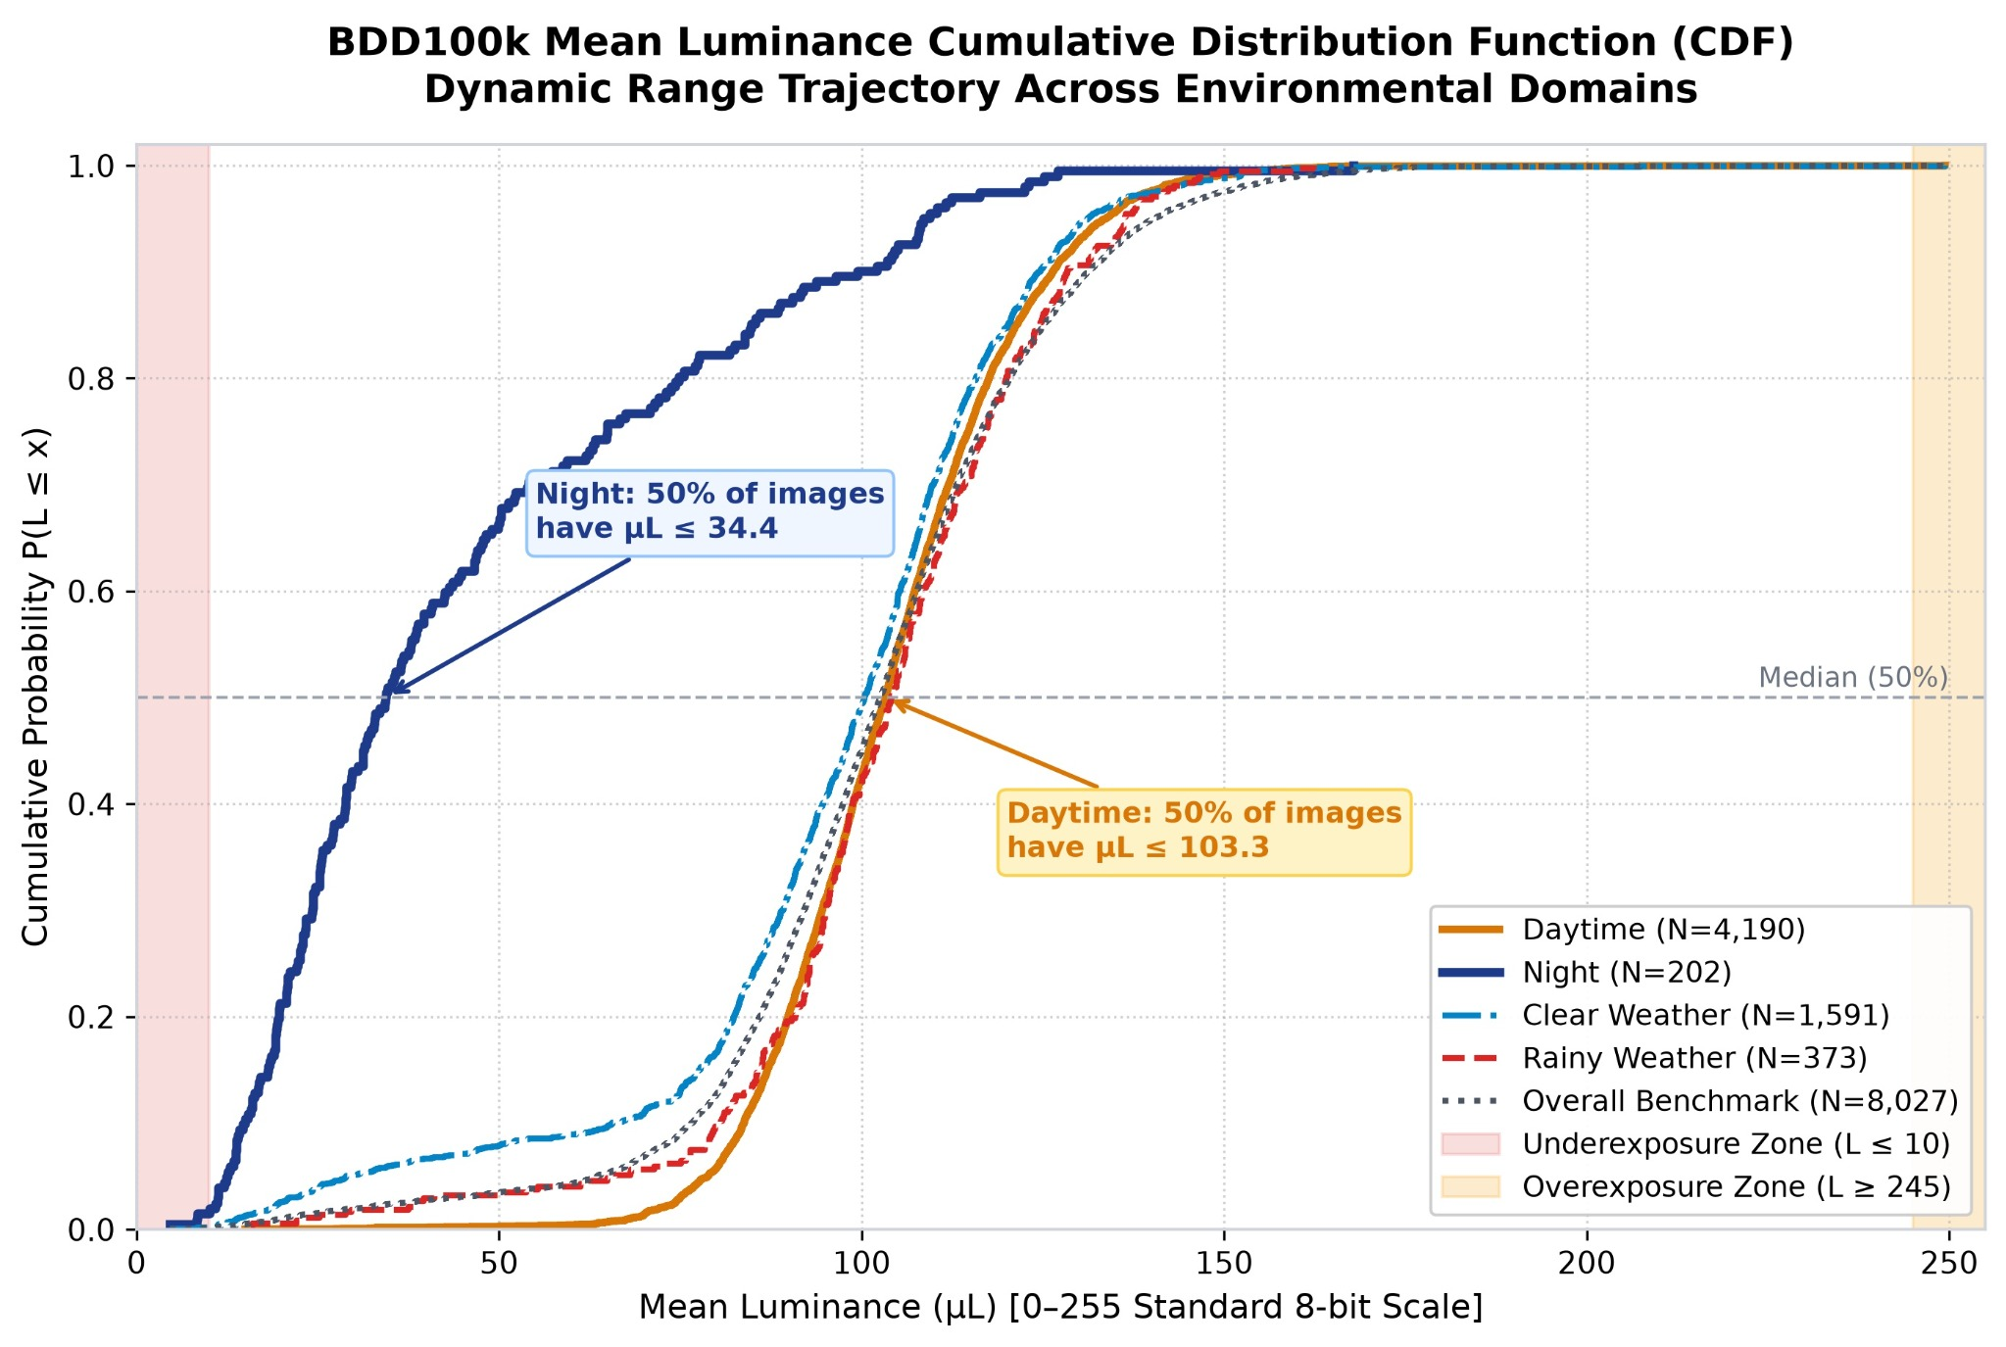
Figure 3. Cumulative distribution of mean luminance across environmental domains.
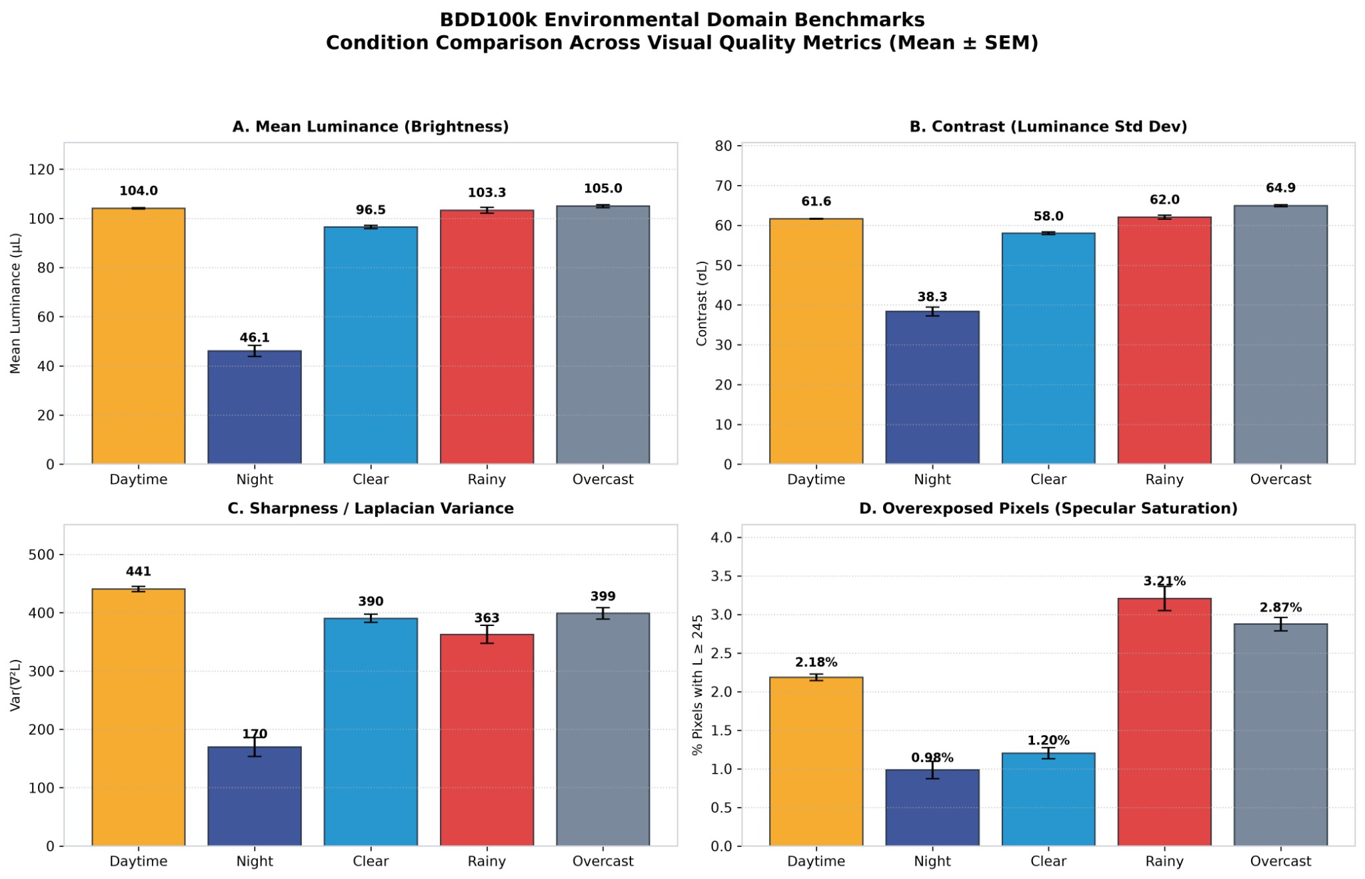
Figure 4. Environmental-domain benchmarks across visual quality metrics.
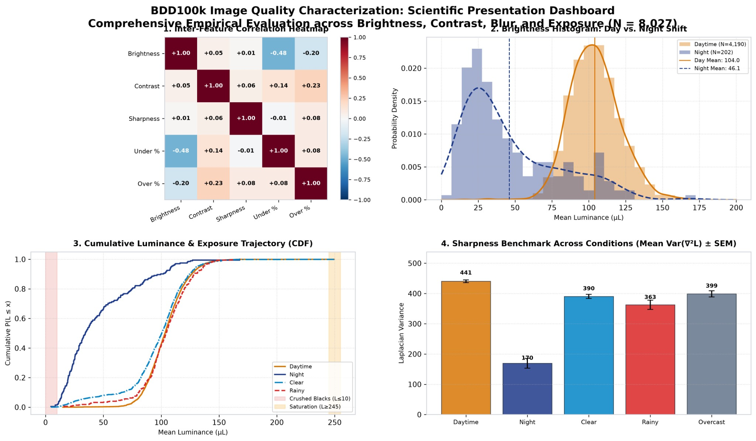
Figure 5. Integrated dashboard summarizing the BDD100K image-quality analysis.

Selected Quantitative Findings from the Attached BDD100K Analysis
For the 8,027 analysed images, the overall mean luminance is 102.13 ± 24.82, with a median of 102.62 and a 5th–95th percentile range of 63.53–140.29. Contrast has a mean of 61.32 ± 10.22 and median 61.90. Laplacian variance has a mean of 362.61 ± 269.78 and median 302.24, indicating a substantially dispersed sharpness distribution. Underexposed pixels account for 2.74% ± 7.92% on average, with a skewness of +6.13, while overexposed pixels average 1.92% ± 2.99% with skewness +7.83. The large positive skew values indicate that the exposure measures contain substantial high-end tails rather than approximately symmetric distributions.
In the day-versus-night comparison, daytime mean luminance is 104.035 and night mean luminance is 46.072, with Cohen’s d = 3.1839 and a two-sided Mann–Whitney p-value of 1.06945 × 10⁻⁸⁸. Contrast changes from 61.634 to 38.345 with Cohen’s d = 2.9296 and p = 1.95136 × 10⁻⁷⁷. Mean Laplacian variance changes from 440.541 to 169.788, with median values of 399.768 and 74.400 respectively; the effect size is d = 0.9721 and p = 1.43315 × 10⁻⁵⁸. Underexposure changes from 1.393% to 24.654%, with Cohen’s d = −4.1964 and p = 8.38979 × 10⁻⁶³. The corresponding Kolmogorov–Smirnov statistics are 0.7774, 0.7251, 0.6180, and 0.6426 for brightness, contrast, sharpness, and underexposure, respectively.
In the clear-versus-rain comparison, mean luminance changes from 96.473 to 103.308, while contrast changes from 58.013 to 62.049. Mean Laplacian variance changes from 390.434 to 362.814 and median variance from 359.251 to 285.689. The most pronounced shift occurs for overexposed pixels: the clear-weather mean is 1.203% compared with 3.205% during rain, the median rises from 0.524% to 2.813%, Cohen’s d is −0.6917, and the Mann–Whitney p-value is 9.67615 × 10⁻⁵⁵. These numerical differences support the use of environmental condition as an explicit stratification factor in subsequent robustness experiments.

References
[1] J. Geyer et al., “A2D2: Audi Autonomous Driving Dataset,” arXiv preprint arXiv:2004.06320, 2020.
[2] F. Yu et al., “BDD100K: A Diverse Driving Dataset for Heterogeneous Multitask Learning,” arXiv preprint arXiv:1805.04687, 2020.
[3] H. Caesar et al., “nuScenes: A Multimodal Dataset for Autonomous Driving,” in Proceedings of the IEEE/CVF Conference on Computer Vision and Pattern Recognition (CVPR), 2020, pp. 11621–11631.
[4] P. Sun et al., “Scalability in Perception for Autonomous Driving: Waymo Open Dataset,” in Proceedings of the IEEE/CVF Conference on Computer Vision and Pattern Recognition (CVPR), 2020, pp. 2446–2454.
[5] M. Cordts et al., “The Cityscapes Dataset for Semantic Urban Scene Understanding,” in Proceedings of the IEEE Conference on Computer Vision and Pattern Recognition (CVPR), 2016, pp. 3213–3223.
[6] A. Geiger, P. Lenz, C. Stiller, and R. Urtasun, “Vision Meets Robotics: The KITTI Dataset,” The International Journal of Robotics Research, 2013.
[7] K. He, X. Zhang, S. Ren, and J. Sun, “Deep Residual Learning for Image Recognition,” in Proceedings of the IEEE Conference on Computer Vision and Pattern Recognition (CVPR), 2016, pp. 770–778.
[8] Z. Liu, H. Mao, C.-Y. Wu, C. Feichtenhofer, T. Darrell, and S. Xie, “A ConvNet for the 2020s,” in Proceedings of the IEEE/CVF Conference on Computer Vision and Pattern Recognition (CVPR), 2022, pp. 11976–11986.
[9] A. Dosovitskiy et al., “An Image Is Worth 16×16 Words: Transformers for Image Recognition at Scale,” in International Conference on Learning Representations (ICLR), 2021.
[10] Z. Liu et al., “Swin Transformer: Hierarchical Vision Transformer Using Shifted Windows,” in Proceedings of the IEEE/CVF International Conference on Computer Vision (ICCV), 2021, pp. 10012–10022.

Source and Reproducibility Note
This report was prepared from the supplied BDD100K analysis report, CSV/JSON result files, Python analysis scripts, presentation figures, and the project plan established in the capstone discussion. The image-quality extraction code defines the five principal image-quality metrics and their thresholds; the statistical-analysis code performs the reported distribution summaries and inferential tests and generates the attached visualizations. Claims about completed model training, model rankings, deployment speed, or multimodal fusion are intentionally not stated as achieved results because those outputs are not present in the supplied implementation materials.

