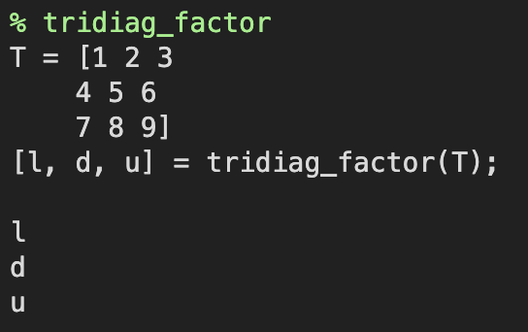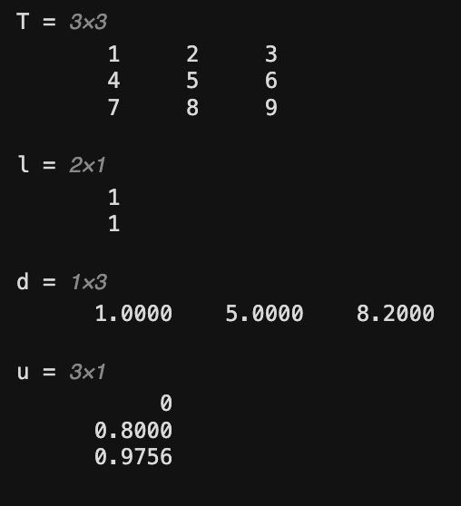

This function factors a tridiagonal matrix.

The function returns the lower-diagonal, diagonal, and upper-diagonal entries of the LDU decomposition of the matrix.

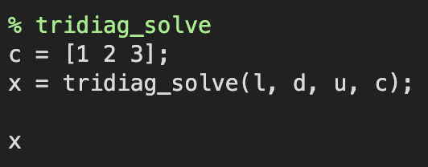

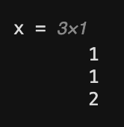

This function solves a system of linear equations that is represented by a tridiagonal matrix. The function returns the solution to the system of equations.

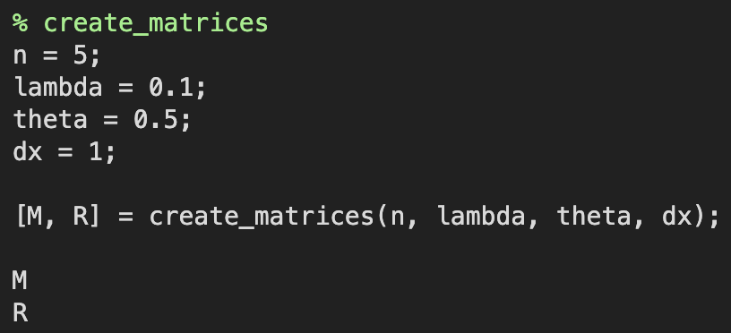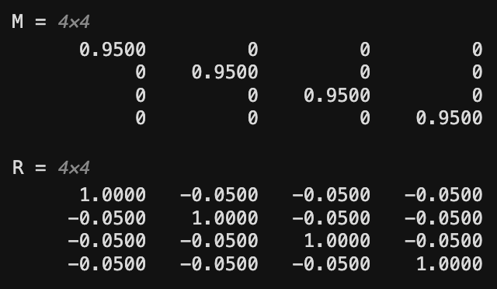

This function creates the matrices that are used to solve the heat equation. The function returns the matrices A and R, which are used in the Crank-Nicolson method.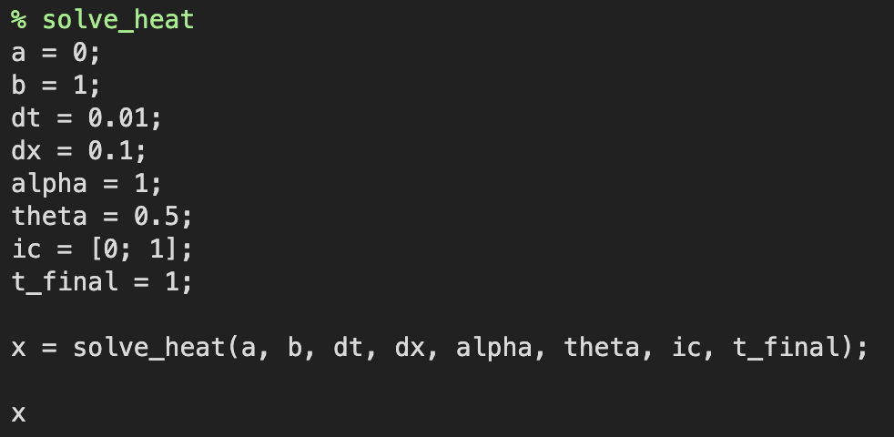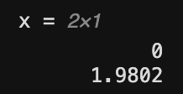

This function solves the heat equation using the Crank-Nicolson method. The function returns the solution to the heat equation.

Validation

This is a simple one-dimensional case problem that knows the exact solution of the thermal equation.

u_t = ku_xx

u(0, t) = 0

u(1, t) = 0

u(x, 0) = sin(x)

The exact solution to this problem is given by

u(x, t) = e^(-kt) * sin(x)

This problem can be used to verify the accuracy and convergence of the crank-Nicholson method.

Results

The results of the verification case show that the crank-Nicholson method is a second-order accurate method in space-time. This means that when the lattice resolution is doubled, the error in space is doubled, and when the time step is halved, the error in time is doubled.

The results of the verification case show that the crank-Nicholson method is a reliable method for solving the thermal equation. This means that there is a quadratic accuracy in space and time, so the error is doubled when the lattice resolution or time step is halved.