University of Canberra

Software Technology 2

2023 Semester 1

Assignment 1 V7 – Updated 22/3/2023

Warning – the test data has been updated on 23/3/2023

This assignment is worth 20 Marks towards your final assessment.

This assignment is 6 different tasks:

* The first task is just to check you have learned Java acceptably (8 marks)
  + To read in the data and store it and then summarise it so we know its read in correctly
* The second task is a computation/formatting problem (2 marks)
  + To compute the electricity bill for the flats (not the tenants- but the body corporate)
* The third task is a sort problem (2 marks)
  + If you do this you must code at least 1 sort routine and 1 search routine (or store meters in an easy to access data structure that you coded); this is to be indicated in the reflection report (kind of sort and where you used it and kind of search and where you used it). The idea is to use this sort/search/datastructure routine to speed up searches for meters
  + To prove the sort you display the first, last and 10th meter of the test dataset (mandatory test task3a), this would be index 9 since data structures start at zero.
* The fourth task is a search problem (2 marks)
  + To compute the bill for one requested flat, showing all tenants in the flat and their adjusted bills
* The fifth task (3marks)
  + To compute the bills and summarise them for all flats total and all adjusted Tenants total.
* The 6th task is your Reflection report (3 marks).

NOTE: Tasks one to five has a mandatory tests to perform on specified datasets – see the tables for mandatory testing.

DUE: Midnight 8th of April (Saturday midnight)

Submitted on Canvas as a single zip file that contains:

* Your reflection report.
* Your source code BlueJ Java solution (typically this is a directory).
* Screen shots of your mandatory testing for each option you claim to have working.

NOTE: I expect the code to compile in BlueJ, if it does not compile and run in that environment, you will not receive a good grade, I have been known to reduce marks to less than 50% for just this alone. I also expect to see screen shots of your testing; again I have been known to reduce marks to less than 50% for failing to evidence your testing.

Notes:

This is based on the kind of data you get in industry, it may surprise you to know that large organisations, with large amounts of legacy data , have often ‘messy data’. This is basically a cut down version of programs I wrote in my career. Electricity billing has changed a lot since then, but problems like it persist any metering utility.

The electricity rate is 0.205 $/Kwh (20.5 cents a kwh)

If the difference between the tenant meters and the body corporate meter is in fact negative (i.e. the body corporate pays less than the total of the tenants) then the adjustment is deemed to be Zero. In this case the tenants pay exactly what on there meters to the body corporate and the body corporate pays its metered amount and pockets the difference 😊 happy, happy, happy.

I have modified the meter files on 22/3/2023 to be more out of order so the sort has more work to do. You must use the news files if you do task 3.

## The Data Supplied

I provide 4 sets of data:

* Development – prefixed with Dev0 or Dev1; these are small versions of the data set for initial testing, this mirrors the data available to the programmer in a development environment.
* Test - prefixed with test; this is a full size dataset with typical problems such as would be found in a companies test data base and would be available to the programming team.
* Production - prefixed with prod; this is a full size dataset with typical problems such as would be found in a companies real data base and would be NOT usually be available to the programming team unless investigating production errors. This is the set of files for most of your mandatory testing.

In each dataset the data is in 2 files comma separated files:

* Blocks of flats and addresses; suffixed with flats
* Meter readings; suffixed with meter

The two files have the following format:

* They are comma separated.
* There may be leading or trailing blanks on any field that should be ignored;
* Lines starting with / should be ignored, or if you want you can edit the file and delete them.
* Lines can have a trailing comma which can be ignored.

Flats File Format

|  |  |  |
| --- | --- | --- |
| Field | Example | Notes |
| Street | Birch Grove | Street name |
| Building number | 12 | Building number |
| Building meter | b240003 | The meter number of the flat |
| current reading | 600146 | Obviously the current meter reading |
| current reading date | 12/3/2023 | current reading date |
| previous reading | 594023 | Obviously the previous meter reading |
| previous reading date | 07/1/2023 | previous reading date |
| Tenant Meter1 | m163962 | The start of a comma separated list of tenant meters, note a flat can have 1 to 99 tenants |
| Tenant meter 2 | m163980 |  |
| Tenant meter 3 | m163986 |  |
| .. repeat  Tenant meters 4,5,6, | m163991, m163996 | Up to a maximum of 99 (for any premise total) |

Meter File Format

|  |  |  |
| --- | --- | --- |
| Field | Example | Notes |
| honorific (name prefix) | Mr | honorific (name prefix) |
| first name | Rupert | first name |
| 2nd name, | McGuffin | 2nd name, |
| Unused | “MT” | Corporation name (not used in this assignment) |
| Tenant meter number | m783451 |  |
| Current Meter reading | 600113 |  |
| Current Meter reading date | 4/5/2022 |  |
| Previous Meter reading | 599012 |  |
| Previous Meter reading date | 6/2/2022 |  |

This is a sample of the Meter file to help you understand the problems.

|  |
| --- |
| Mr,Lewis,Pressman,MT,m163962,223579,08/04/2022,221758,11/01/2022,  Mrs,Diana,Purvis,MT,m163963,536530,08/04/2022,534696,11/01/2022,  Mr,Harvey,Pearce,MT,m163964,157233,06/04/2022,155561,09/01/2022,  Ms,Wendy,Yarwood,MT,m163965,289352,06/04/2022,287997,09/01/2022,  Mr,James,Palmer,MT,m163966,319840,08/04/2022,318156,11/01/2022,  Ms,Dorothy,McBride,MT,m163967,885781,06/04/2022,884413,11/01/2022, |

This is a sample of the Flat file to help you understand the problems.

|  |
| --- |
| Adelaide Street,11,b239863,705007,07/04/2022,703649,11/01/2022,m163965,  Alma Street,7,b239873,986460,06/04/2022,983395,09/01/2022,m163966,m163967,  Alma Street,8,b239883,595049,06/04/2022,589650,09/01/2022,m163962,m163963,m163964, |

I use a menu to control the program, The menu shows the current file being processed, and has the options shown below.

ST2-2023 Assignment 1

E - Exit

F - Read Flats (Task 1)

M - Read Meters (Task 1)

C - Compute BC Bill For one Flat (Task2)

A - Compute BC Bill For All Flats (Task2)

S - Sort the meter file into meter order (Task3)

P – Prove meter file sort and find (task3)

O - Compute Full Bill For One Flat (Task4)

5 - Compute Full Bill For All Flats (Task5)

0 - Set Dev0 environment

1 - Set Dev1 environment

2 - Set Test environment

3 - Set prod environment

Select Option:

## Task 1

8 marks , We need to be able to get data into the Java program so we can work on it, so you need to write a program, to read in both data files and store that data in a suitable structure (i.e. java class), the information needs to be stored in two ArrayLists or Arrays.

To demonstrate you have read the data, it needs to be displayed on a console in summary form and a count and checksum should confirm all the data is read in and stored accurately.

The checksum is literally the total of all current readings.

The report must include the total of meters used eg: Number Of Meters Read in is:6

Mandatory testing for this part is:

|  |  |  |  |
| --- | --- | --- | --- |
| **Test** | **Option** | **File** | **Notes** |
| Task1a | Read Flats | Prod_flat.txt |  |
| Task1b | Read Meters | Prod_Meter.txt |  |

Don’t forget to take and include screenshots.

Sample Screenshots of Task 1 – for the test dataset

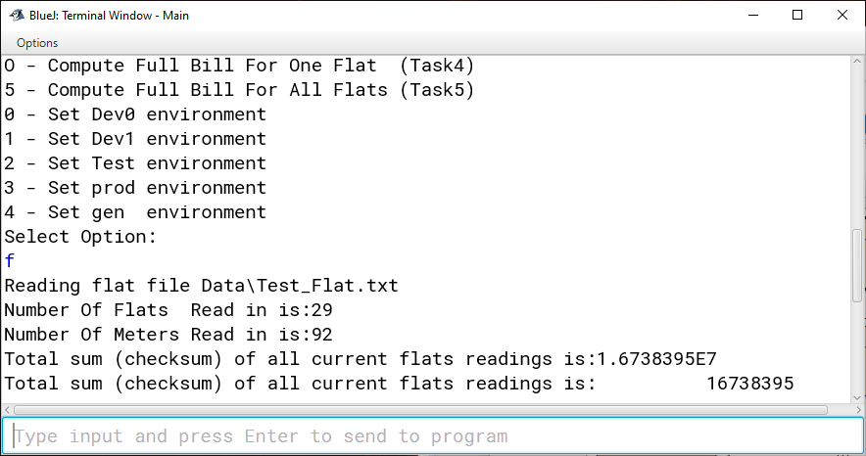

## Task 2

The second task is a computation/formatting problem (2 marks)

To compute the electricity bill for the flats (not the tenants- but the body corporate) this is based entirely on data from the Flat file.

My menu options

C - Compute BC Bill For one Flat (Task2)

A - Compute BC Bill For All Flats (Task2)

Support this task (from test_flat.txt) – Screen shots below:

The number to show for testing is a debug option to help me check that answers are correct I deliberately left it in to demonstrate how I test – a 0 means no details are show.

You should probably do something similar, but perhaps remove it for the final program!

Mandatory testing for this part is:

|  |  |  |  |
| --- | --- | --- | --- |
| **Test** | **Option** | **File** | **Notes** |
| Task2a | Compute BC Bill For one Flat (Task2) | Prod_flat.txt |  |
| Task2b | Compute BC Bill For All Flats (Task2) | Prod_flat.txt |  |

Don’t forget to take and include screenshots.

## Task 3

The third task is a sort problem (2 marks)

If you do this you must code at least 1 sort routine and 1 binary search routine this is to be indicated in the reflection report (kind of sort and where you used it). The idea is to use this sort/search/datastructure routine to speed up searches for meters.

I was hoping that the program would have enough data with 1000 meters to be slow, but it is not, so I have added a prove it menu option in which you need to search for 10000 meters (see code fragment below).

To prove the sort you display the first, last and 10th meter of the test dataset (mandatory test task3a), this would be index 9 since data structures start at zero.

Two menu options are part of this Task:

S - Sort the meter file into meter order (Task3)

P – Prove meter file sort and find (task3)

I have modified all the meter files on 22/3/2023 to be more out of order so the sort has more work to do. You must use the new files if you do task 3.

Note that the dev0 data set can not run with option s because it has less than 10 entries, we wont test task3 on meter files with less than 10 entries.

Mandatory testing for this part is to be added soon:

|  |  |  |  |
| --- | --- | --- | --- |
| **Test** | **Option** | **File** | **Notes** |
| Task3a | S | Prod_Meter.txt |  |
| Task3b | P | Prod_Meter.txt |  |

Don’t forget to take and include screenshots.

Example screenshot option s – dev1 dataset

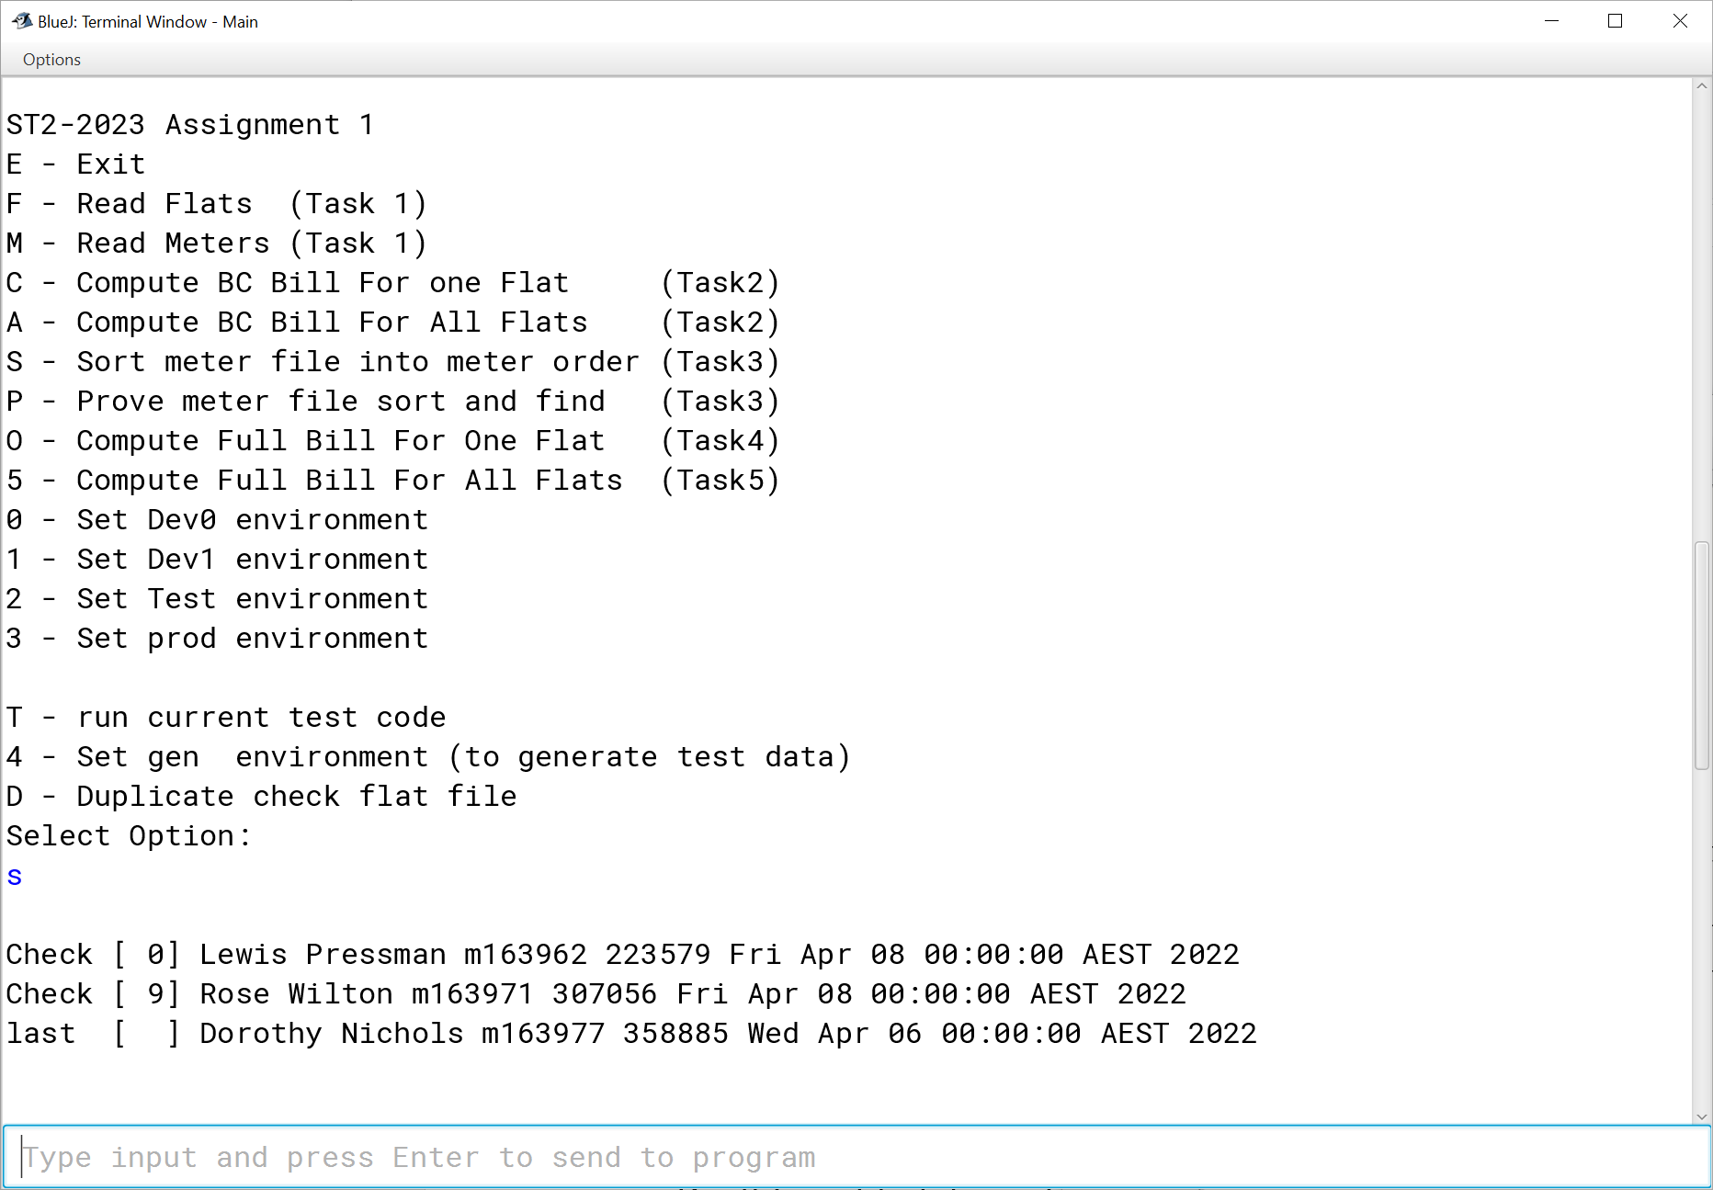

I modified s to show the full sorted meter data for short datasets – this is for the dev1 dataset (this is a good idea for testing)

Example screenshot option p on the test-meter.txt dataset (note my p option runs option s first)

Below is a Code fragment from my p option

## Task 4

The fourth task is a search and computation problem (2 marks)

To compute the bill for one requested flat, showing all tenants in the flat and their adjusted bills this is based on both files the Flat file and the meter file

There are two bill amounts on this Report One is from the main meter the Body Corporate meter read from the flat file and computed accordingly – in the case shown below this is 1866.1 – which is 9103 usage by the cost at 0.205 $ per kwh.

The second bill amount is the sum of each tenant bill based on usage

When these two are computed there is a difference in the case below this difference is 31.57

This difference is the apportioned to the tenants on the basis of usage (show as usage percent in the example below, and then added to the tenant bill.

In rare cases the difference is negative in which case it is ignored and the tenant is billed for usage only.

Second Example Task4

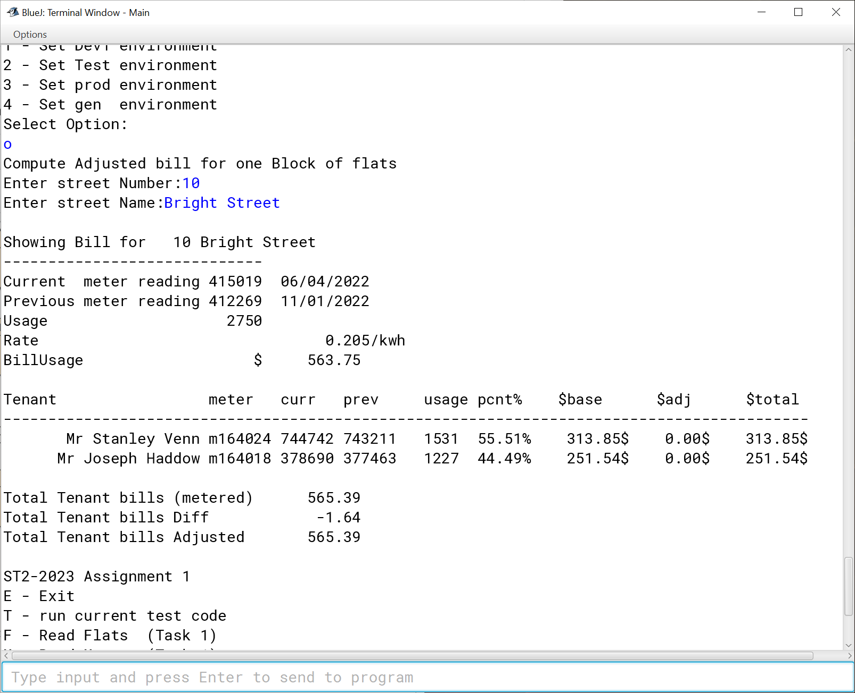

Mandatory testing for this part is:

|  |  |  |  |
| --- | --- | --- | --- |
| **Test** | **Option** | **File** | **Notes** |
| Task4a | Compute Full Bill For One Flat (Task4) | test_flat.txt, test_Meter.txt | Beaconsfield Road,9 |
| Task4b | Compute Full Bill For One Flat (Task4) | Prod_flat.txt, Prod_Meter.txt | The Causeway,12 |

Don’t forget to take and include screenshots.

## Task 5

The fifth task (3marks) To compute the bills and summarise them for all flats total and all adjusted Tenants total.

In the sample below one can see the only case of a negative difference is ignored

The sample run is from Dev1_flat and Dev1_meter

Mandatory testing for this part is:

|  |  |  |  |
| --- | --- | --- | --- |
| **Test** | **Option** | **File** | **Notes** |
| Task5a | Compute Full Bill For All Flats (Task5) | test_flat.txt, test_Meter.txt | Full Screen shot all flats |
| Task5b | Compute Full Bill For All Flats (Task5) | Prod_flat.txt, Prod_Meter.txt | Just Screen shot the totals bit not all the mess |

Don’t forget to take and include screenshots.

## Task 6

The refection report:

You should indicate the following in this report:

1. The problems you faced and how you got around them please address:
   1. How you chose to store the data and why you chose that method;
   2. What sort routines you chose
   3. The search techniques (if you did the 3 point path search)
2. You must identify any source code used that is not your own (except that code that I have supplied);
3. You should try to summarise what you learned doing this assignment.
4. Identify what you would do differently or improve on if you had more time.
5. Remember the majority of the program should be your own work.

## Further Notes:

IF you are unsure what the program should do ask in a tutorial, and please look at the sample runs to clarify what the various requested options do.

HINTS:

This is designed to be done in the following sequence:

1. Option m – read meter file
2. Option f – read flats file
3. Option C – Compute BC bill for 1 flat
4. Option A- Compute BC Bill For All Flats (this is really just a total)
5. Option O - Compute Full Bill For One Flat (Task4)
6. Option 5 - Compute Full Bill For All Flats (Task5)

The other option – S can be done last or can be done – after option a at the students desire

I also used a lot of static variables in a Global class – see tutorial recording Thursday 16/3/2023 for how to do this it help get around the problems of class visibility – but breaks the ‘pure’ oo model.

Students have quite a lot of options as to how they do this assignment:

* Do all of the assignment or just tasks 1, 2 and 6 (or more)
* Is information to be stored in ArrayLists or Arrays;
* Should you use a simple sort like a bubble sort or selection sort or a more complex one like shell Metzner, merge sort or quick sort.
* Will I have coke and pizza while doing it (and can I afford it – perhaps just toast)
* Will I leave it to the last night and fail or hand in really late. (allocate a few days)