CHECKSUM IMPLEMENTATION USING SOCKETS

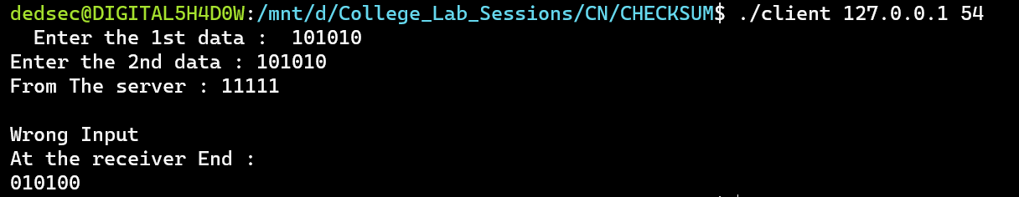

CLIENT SIDE

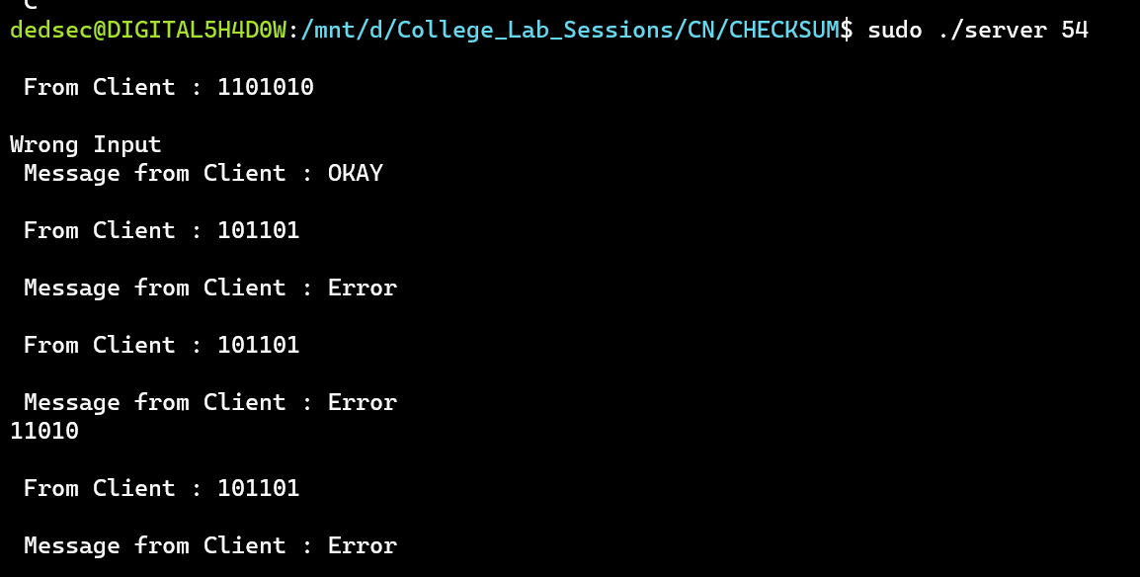

SERVER SIDE