**NAME:** SHUBHAM TAKANKHAR

**CLASS:** SY MCA

**ROLL NO:** 54

**ASSIGNMENT 1:** Write program for "make change problem" using Greedy approach

write program for kruscal/prims algorithm to find minimum spanning tree using greedy approach.

**SOURCE CODE:**

**<<write program for kruscal/prims algorithm to find minimum spanning tree using greedy approach>>**

import java.util.*;

import java.lang.*;

import java.io.*;

class Graph {

    class Edge implements Comparable<Edge>

    {

        int src, dest, weight;

        public int compareTo(Edge compareEdge)

        {

            return this.weight - compareEdge.weight;

        }

    };

    class subset

    {

        int parent, rank;

    };

    int V, E;

    Edge edge[];

    Graph(int v, int e)

    {

        V = v;

        E = e;

        edge = new Edge[E];

        for (int i = 0; i < e; ++i)

            edge[i] = new Edge();

    }

    int find(subset subsets[], int i)

    {

        if (subsets[i].parent != i)

            subsets[i].parent

                = find(subsets, subsets[i].parent);

        return subsets[i].parent;

    }

    void Union(subset subsets[], int x, int y)

    {

        int xroot = find(subsets, x);

        int yroot = find(subsets, y);

        if (subsets[xroot].rank

            < subsets[yroot].rank)

            subsets[xroot].parent = yroot;

        else if (subsets[xroot].rank

                 > subsets[yroot].rank)

            subsets[yroot].parent = xroot;

        else {

            subsets[yroot].parent = xroot;

            subsets[xroot].rank++;

        }

    }

    void KruskalMST()

    {

        Edge result[] = new Edge[V];

        int e = 0;

        int i = 0;

        for (i = 0; i < V; ++i)

            result[i] = new Edge();

        Arrays.sort(edge);

        subset subsets[] = new subset[V];

        for (i = 0; i < V; ++i)

            subsets[i] = new subset();

        for (int v = 0; v < V; ++v)

        {

            subsets[v].parent = v;

            subsets[v].rank = 0;

        }

        i = 0;

        while (e < V - 1)

        {

            Edge next_edge = new Edge();

            next_edge = edge[i++];

            int x = find(subsets, next_edge.src);

            int y = find(subsets, next_edge.dest);

            if (x != y) {

                result[e++] = next_edge;

                Union(subsets, x, y);

            }

        }

        System.out.println("Following are the edges in "

                           + "the constructed MST");

        int minimumCost = 0;

        for (i = 0; i < e; ++i)

        {

            System.out.println(result[i].src + " -- "

                               + result[i].dest

                               + " == " + result[i].weight);

            minimumCost += result[i].weight;

        }

        System.out.println("Minimum Cost Spanning Tree "

                           + minimumCost);

    }

    public static void main(String[] args)

    {

        int V = 4;

        int E = 5;

        Graph graph = new Graph(V, E);

        graph.edge[0].src = 0;

        graph.edge[0].dest = 1;

        graph.edge[0].weight = 10;

        graph.edge[1].src = 0;

        graph.edge[1].dest = 2;

        graph.edge[1].weight = 6;

        graph.edge[2].src = 0;

        graph.edge[2].dest = 3;

        graph.edge[2].weight = 5;

        graph.edge[3].src = 1;

        graph.edge[3].dest = 3;

        graph.edge[3].weight = 15;

        graph.edge[4].src = 2;

        graph.edge[4].dest = 3;

        graph.edge[4].weight = 4;

        graph.KruskalMST();

    }

}

**OUTPUT:**

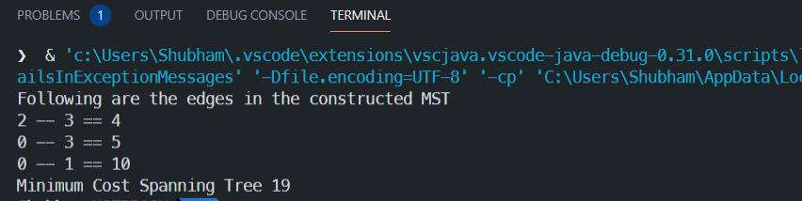

**<<Write program for "make change problem" using Greedy approach>>**

class coin

{

    static int minCoins(int coins[], int m, int V)

    {

       if (V == 0) return 0;

       int res = Integer.MAX_VALUE;

       for (int i=0; i<m; i++)

       {

         if (coins[i] <= V)

         {

             int sub_res = minCoins(coins, m, V-coins[i]);

             if (sub_res != Integer.MAX_VALUE && sub_res + 1 < res)

                res = sub_res + 1;

         }

       }

       return res;

    }

    public static void main(String args[])

    {

       int coins[] =  {9, 6, 5, 1};

       int m = coins.length;

       int V = 11;

       System.out.println("Minimum coins required is "+ minCoins(coins, m, V) );

    }}

Input:

coins[] =  {9, 6, 5, 1};

Value = 11

**Output**

