**NAME: TAKANKHAR SHUBHAM**

**CLASS: SY MCA**

**ROLL NO: 54**

**LAB ASSIGNMENT 5** : Design a java application to demonstrate use of ArrayList Collections.

**<<SOURCE_CODE>>**

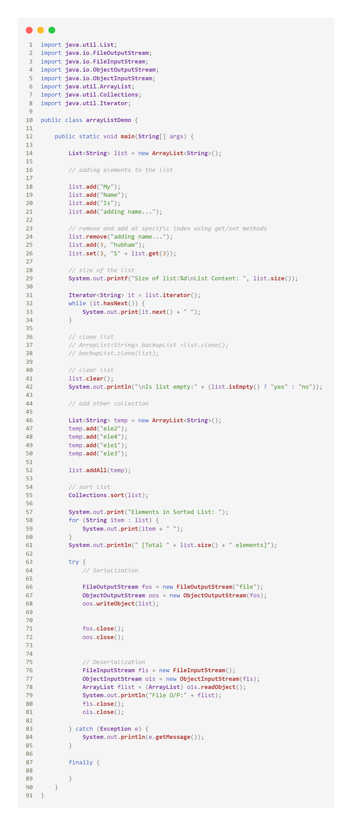

**OUTPUT:**

