**NAME: TAKANKHAR SHUBHAM**

**CLASS: SY MCA**

**ROLL NO: 54**

**LAB ASSIGNMENT 1 : STUDENT RESULT GENERATING SYSTEM**

**Steps To RUN:**

Run studentResult.java

Enter your GR.NO.

Check Working Directory of Project for Result Output File

INPUT FILE:

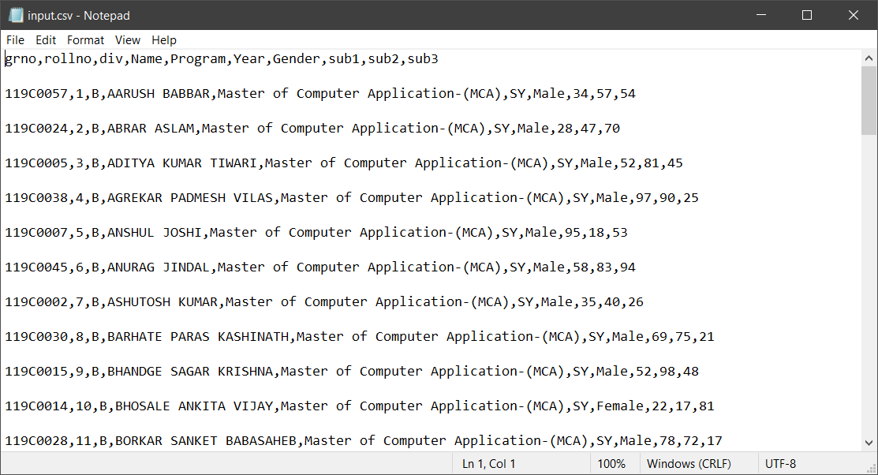

Output Screen:

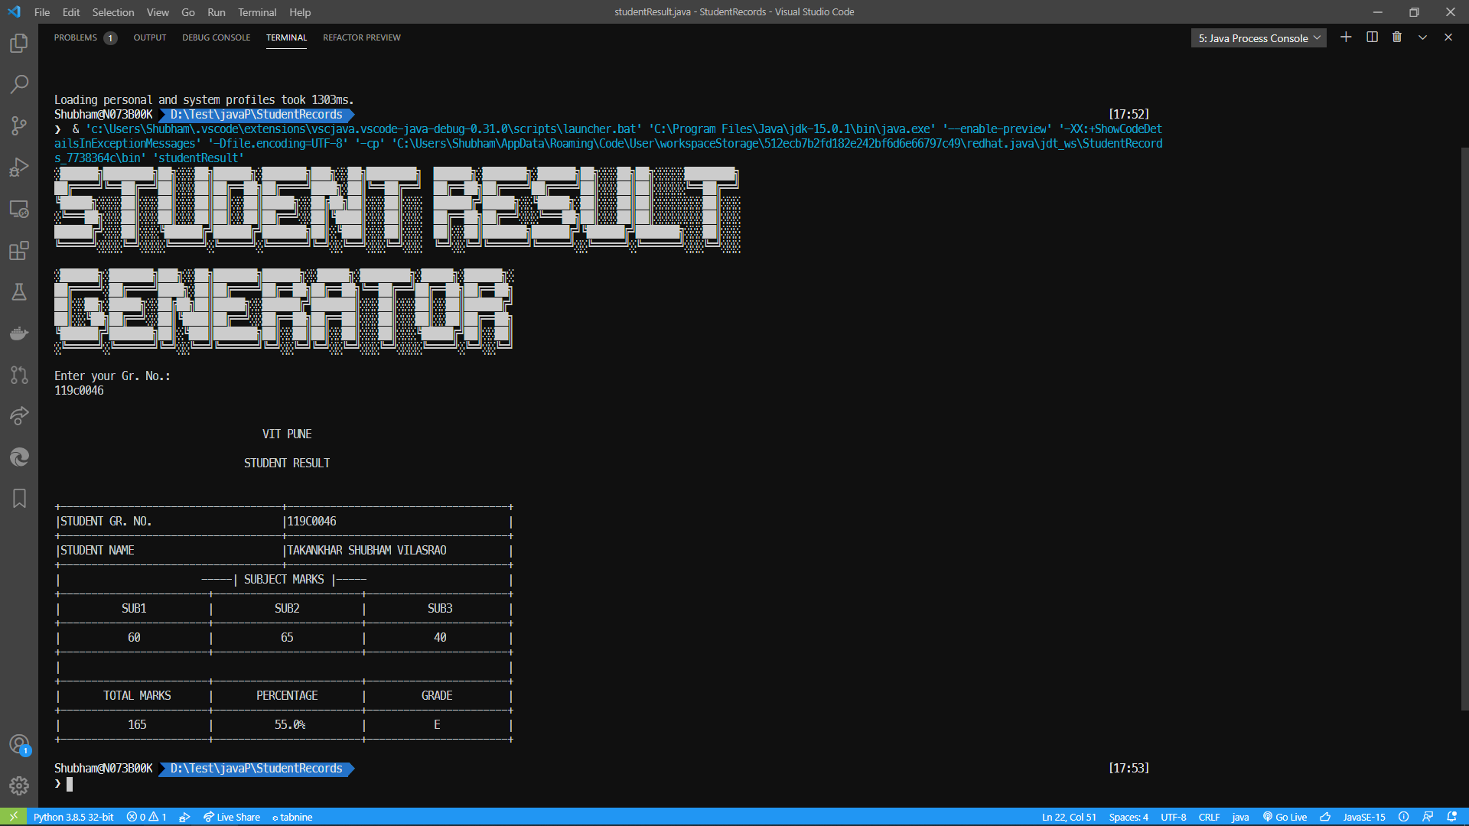

OUTPUT FILE <gr_no>.txt:

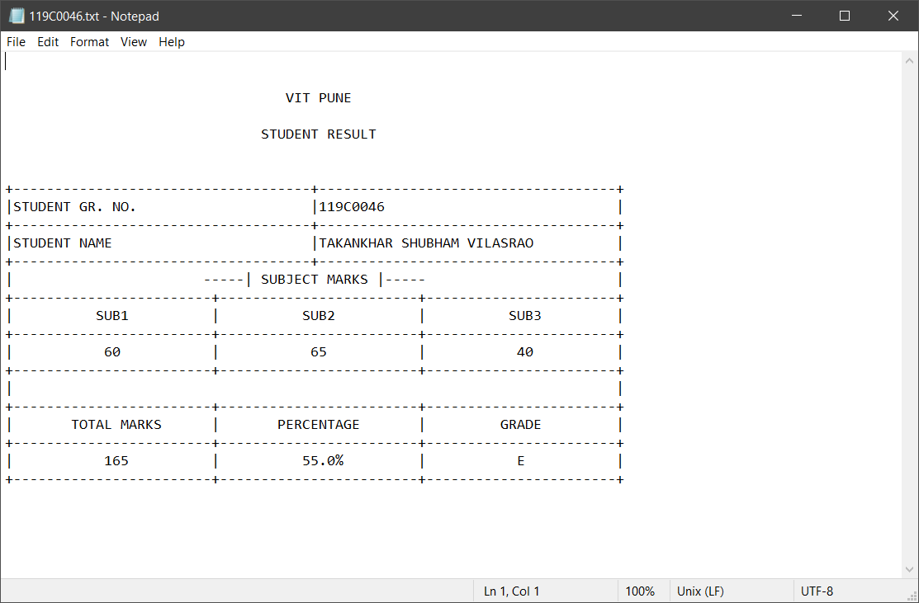

**Source_Code**

**File : <<studentResult.java>>**

import java.io.*;

import java.util.Scanner;

public class studentResult extends studentRecord{

    public static void main(String[] args) throws IOException {

        String art = extracted();

        System.out.println(art);

        Scanner records;

        records = new Scanner(new File("D:\\Test\\javaP\\StudentRecords\\input.csv"));

        records.useDelimiter("[,\n]");

        System.out.println("Enter your Gr. No.:");

        String searchID = (System.console().readLine()).toUpperCase();

        while(records.hasNext()){

            String ID = records.next();

            // System.out.println(records.next());

            if (ID.equals(searchID)){

                // System.out.println("id: " + ID+" searchID: " +searchID);

                //grno,rollno,div,Name,Program,Year,Gender,sub1,sub2,sub3

                studentRecord student = new studentRecord();

                student.grno = searchID;

                student.rollno=Integer.parseInt(records.next());

                student.div=(records.next()).charAt(0);

                student.fname=records.next();

                student.program=records.next();

                student.year=records.next();

                student.gender=records.next();

                student.sub1=Integer.parseInt(records.next());

                student.sub2=Integer.parseInt(records.next());

                student.sub3=Integer.parseInt((records.next()).trim());

                // System.out.println(student.getRollno());

                // System.out.println(student.div);

                // System.out.println(student.getName());

                // System.out.println(student.sub1);

                // System.out.println(student.sub2);

                // System.out.println(student.sub3);

                // System.out.println("Percentage:"+student.getPercent()+"%");

                // System.out.println("Grade:"+student.getGrade());

                student.printRecord();

            }

        }

    }

**File : <<studentRecord.java>>**

import java.io.File;

import java.io.FileWriter;

import java.io.IOException;

import java.util.Arrays;

import java.util.List;

import wagu.Block;

import wagu.Board;

import wagu.Table;

public class studentRecord{

    int rollno;

    String grno;

    String fname;

    String program;

    String year;

    String gender;

    int sub1;

    int sub2;

    int sub3;

    float percent;

    char grade;

    char div;

    String result;

    public float getPercent() {

        percent = (sub1+sub2+sub3)/3;

        return percent;

    }

    public String getName(){

        return fname;

    }

    public String getProgram(){

        return program;

    }

    public String getYear(){

        return year;

    }

    public String getGender(){

        return gender;

    }

    public int getRollno(){

        return rollno;

    }

    public String getGrno(){

        return grno;

    }

    public char getGrade(){

        if ( percent > 0 )

            result = "PASS";

            if ( percent > 90){

                grade = 'A';

            }

            else if ( percent > 80){

                grade = 'B';

            }

            else if ( percent > 70){

                grade = 'C';

            }

            else if ( percent > 60){

                grade = 'D';

            }

            else if ( percent > 50){

                grade = 'E';

            }

            else{

                result = "FAIL";

                grade = 'F';

            }

            return grade;

        }

        public String writeRecord(){

            return grno+","+rollno+","+div+","+fname+","+program+","+year+","+gender+","+sub1+","+sub2+","+sub3+","+percent+","+grade+","+result;

        }

        public void printRecord(){

            List<Integer> colAlign= Arrays.asList(

                    Block.DATA_CENTER,

                    Block.DATA_CENTER,

                    Block.DATA_CENTER

                    );

            String college = ""

                + "VIT PUNE\n"

                + " \n"

                + "STUDENT RESULT\n"

                + " \n";

                List<String> t1Headers = Arrays.asList("STUDENT GR. NO. ", grno);

                List<List<String>> t1Rows = Arrays.asList(Arrays.asList("STUDENT NAME ",fname));

                String t2Desc = "-----| SUBJECT MARKS |-----";

                List<String> t2Headers = Arrays.asList("SUB1", "SUB2", "SUB3");

                List<List<String>> t2Rows = Arrays.asList(

                Arrays.asList(Integer.toString(sub1), Integer.toString(sub2), Integer.toString(sub3)));

                String t3Desc = " ";

                List<String> t3Headers = Arrays.asList("TOTAL MARKS","PERCENTAGE","GRADE");

                List<List<String>> t3Rows = Arrays.asList(Arrays.asList(Integer.toString(sub1+sub2+ sub3),Float.toString(getPercent())+"%",Character.toString(getGrade())));

                Board board = new Board(75);

                Block title = new Block(board, 56, 7, college).allowGrid(false).setBlockAlign(Block.BLOCK_CENTRE).setDataAlign(Block.DATA_CENTER);

                board.setInitialBlock(title);

                board.appendTableTo(0,Board.APPEND_BELOW,new Table(board,75,t1Headers,t1Rows));

                board.getBlock(3).setBelowBlock(new Block(board, 73, 1, t2Desc).setDataAlign(Block.DATA_CENTER));

                board.appendTableTo(5, Board.APPEND_BELOW, new Table(board, 75, t2Headers, t2Rows).setColAlignsList(colAlign));

                board.getBlock(9).setBelowBlock(new Block(board, 73, 1, t3Desc).setDataAlign(Block.DATA_CENTER));

                board.appendTableTo(12, Board.APPEND_BELOW, new Table(board, 75, t3Headers, t3Rows).setColAlignsList(colAlign));

            // b.showBlockIndex(true);

            //     System.out.println(b.invalidate().build().getPreview());

            board.build();

            String tableString = board.getPreview();

            System.out.println(tableString);

            //Printing to file

            try{

            File file = new File(grno+".txt");

            if (!file.exists()){

                file.createNewFile();

            }

            FileWriter writer = new FileWriter(file);

            writer.write(tableString);

            writer.close();

            }

            catch (IOException e){

                System.out.println("Error: " + e.getMessage());

            }

        }

    }