**Name:** Shubham Takankhar

**Class :** SY MCA

**Roll No. :** 54

**Assignment 1:** Solve any 10 problems based on QT topic - Numbers, Average and Percentage.

|  |
| --- |
| **Q1. 397 x 397 + 104 x 104 + 2 x 397 x 104 = ?** |
| |  |  | | --- | --- | | [**A.**](javascript:%20void%200;) | 250001 | | [**B.**](javascript:%20void%200;) | **251001** | | [**C.**](javascript:%20void%200;) | 260101 | | [**D.**](javascript:%20void%200;) | 261001 | |

**🡺**

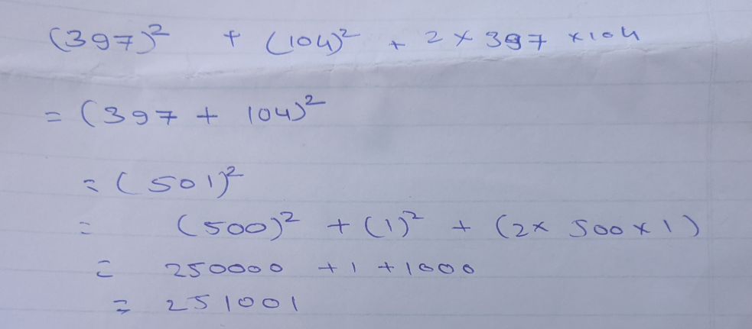

|  |  |
| --- | --- |
| **Q2.** | **(35423 + 7164 + 41720) - (317 x 89) = ?** |
| |  |  | | --- | --- | | [**A.**](javascript:%20void%200;) | 28213 | | [**B.**](javascript:%20void%200;) | 84307 | | [**C.**](javascript:%20void%200;) | 50694 | | [**D.**](javascript:%20void%200;) | **56094** | | [**E.**](javascript:%20void%200;) | None of these | |

🡺

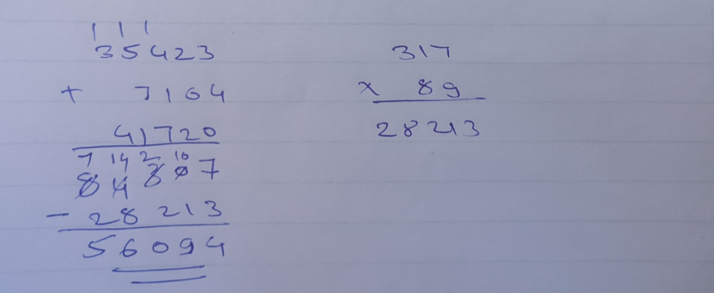

|  |
| --- |
| **Q3.Which of the following numbers will completely divide (325 + 326 + 327 + 328) ?** |
| |  |  | | --- | --- | | [**A.**](javascript:%20void%200;) | 11 | | [**B.**](javascript:%20void%200;) | 16 | | [**C.**](javascript:%20void%200;) | 25 | | [**D.**](javascript:%20void%200;) | **30** | |

🡺

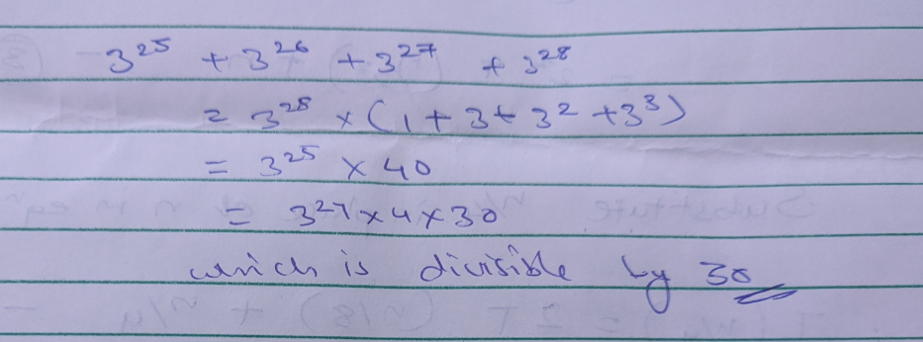

|  |  |
| --- | --- |
| **Q4.** | **(12 + 22 + 32 + ... + 102) = ?** |
| |  |  | | --- | --- | | [**A.**](javascript:%20void%200;) | 330 | | [**B.**](javascript:%20void%200;) | 345 | | [**C.**](javascript:%20void%200;) | 365 | | [**D.**](javascript:%20void%200;) | **385** | |

🡺

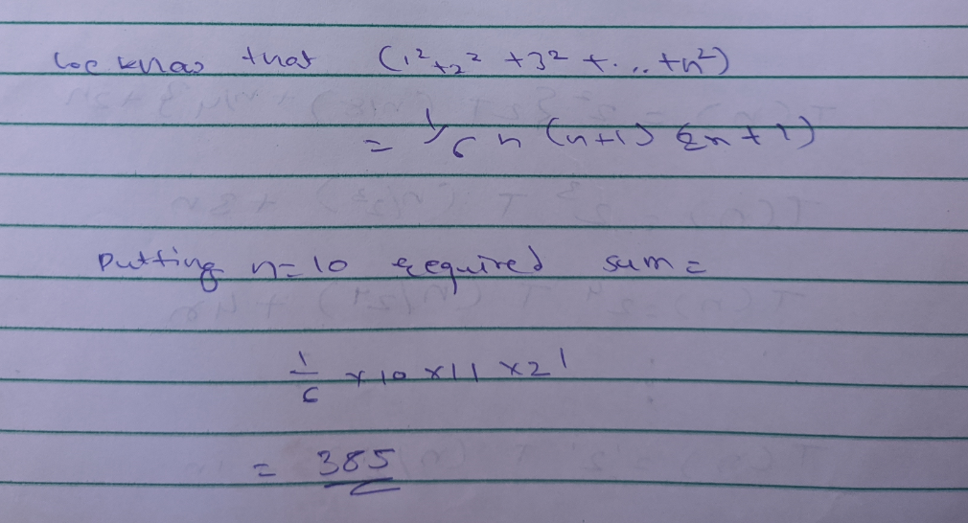

|  |  |
| --- | --- |
|  | **Q5. A library has an average of 510 visitors on Sundays and 240 on other days. The average number of visitors per day in a month of 30 days beginning with a Sunday is:** |
| |  |  | | --- | --- | | [**A.**](javascript:%20void%200;) | 250 | | [**B.**](javascript:%20void%200;) | 276 | | [**C.**](javascript:%20void%200;) | 280 | | [**D.**](javascript:%20void%200;) | **285** | |

🡺

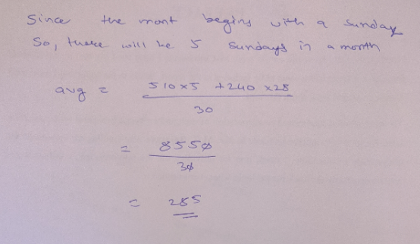

|  |  |
| --- | --- |
| **Q6.** | **If the average marks of three batches of 55, 60 and 45 students respectively is 50, 55, 60, then the average marks of all the students is:** |
| |  |  | | --- | --- | | [**A.**](javascript:%20void%200;) | 53.33 | | [**B.**](javascript:%20void%200;) | **54.68** | | [**C.**](javascript:%20void%200;) | 55 | | [**D.**](javascript:%20void%200;) | None of these | |

🡺

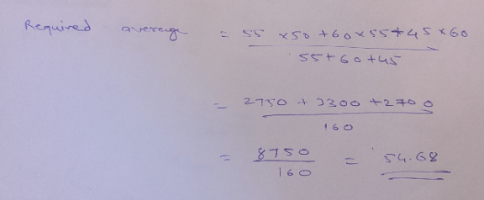

|  |
| --- |
| **Q7.The captain of a cricket team of 11 members is 26 years old and the wicket keeper is 3 years older. If the ages of these two are excluded, the average age of the remaining players is one year less than the average age of the whole team. What is the average age of the team?** |
| |  |  | | --- | --- | | [**A.**](javascript:%20void%200;) | **23 years** | | [**B.**](javascript:%20void%200;) | 24 years | | [**C.**](javascript:%20void%200;) | 25 years | | [**D.**](javascript:%20void%200;) | None of these | |

🡺

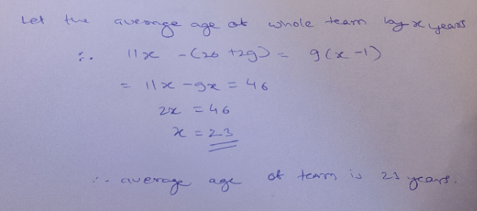

|  |
| --- |
| **Q8.Two students appeared at an examination. One of them secured 9 marks more than the other and his marks was 56% of the sum of their marks. The marks obtained by them are:** |
| |  |  | | --- | --- | | [**A.**](javascript:%20void%200;) | 39, 30 | | [**B.**](javascript:%20void%200;) | 41, 32 | | [**C.**](javascript:%20void%200;) | **42, 33** | | [**D.**](javascript:%20void%200;) | 43, 34 | |

🡺

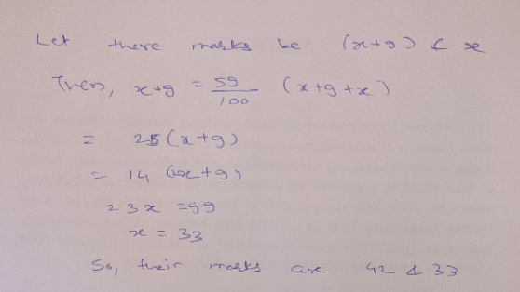

|  |
| --- |
| **Q9.A fruit seller had some apples. He sells 40% apples and still has 420 apples. Originally, he had:** |
| |  |  | | --- | --- | | [**A.**](javascript:%20void%200;) | 588 apples | | [**B.**](javascript:%20void%200;) | 600 apples | | [**C.**](javascript:%20void%200;) | 672 apples | | [**D.**](javascript:%20void%200;) | **700 apples** | |

🡺

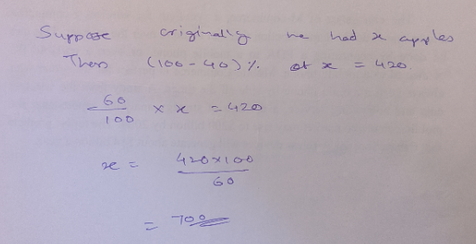

|  |
| --- |
| **Q10.In a certain school, 20% of students are below 8 years of age. The number of students above 8 years of age is  of the number of students of 8 years of age which is 48. What is the total number of students in the school?** |
| |  |  | | --- | --- | | [**A.**](javascript:%20void%200;) | 72 | | [**B.**](javascript:%20void%200;) | 80 | | [**C.**](javascript:%20void%200;) | 120 | | [**D.**](javascript:%20void%200;) | 150 | | [**E.**](javascript:%20void%200;) | 100 | |

🡺

