**Name:** Shubham Takankhar

**Class :** SY MCA

**Roll No. :** 54

**Assignment 2:** Solve 10 problems on - Ratio and Proportion, Simple interest, Compound interest, Partnership, Chain Rule

|  |  |
| --- | --- |
| 1. | If 0.75 : *x* :: 5 : 8, then *x* is equal to: |
| |  |  | | --- | --- | | [**A.**](javascript:%20void%200;) | 1.12 | | [**B.**](javascript:%20void%200;) | **1.2** | | [**C.**](javascript:%20void%200;) | 1.25 | | [**D.**](javascript:%20void%200;) | 1.30 | |

🡺

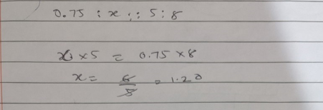

|  |  |
| --- | --- |
| 2. | If 40% of a number is equal to two-third of another number, what is the ratio of first number to the second number? |
| |  |  | | --- | --- | | [**A.**](javascript:%20void%200;) | 2 : 5 | | [**B.**](javascript:%20void%200;) | 3 : 7 | | [**C.**](javascript:%20void%200;) | **5 : 3** | | [**D.**](javascript:%20void%200;) | 7 : 3 | |

🡺

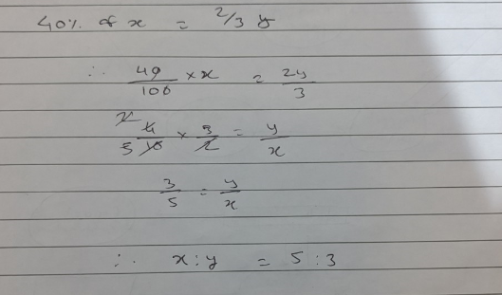

|  |  |
| --- | --- |
| 3. | A sum of money at simple interest amounts to Rs. 815 in 3 years and to Rs. 854 in 4 years. The sum is: |
| |  |  | | --- | --- | | [**A.**](javascript:%20void%200;) | Rs. 650 | | [**B.**](javascript:%20void%200;) | Rs. 690 | | [**C.**](javascript:%20void%200;) | **Rs. 698** | | [**D.**](javascript:%20void%200;) | Rs. 700 | |

🡺

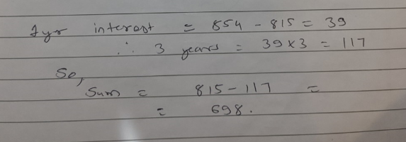

|  |  |
| --- | --- |
| 4. | How much time will it take for an amount of Rs. 450 to yield Rs. 81 as interest at 4.5% per annum of simple interest? |
| |  |  | | --- | --- | | [**A.**](javascript:%20void%200;) | 3.5 years | | [**B.**](javascript:%20void%200;) | **4 years** | | [**C.**](javascript:%20void%200;) | 4.5 years | | [**D.**](javascript:%20void%200;) | 5 years | |

🡺

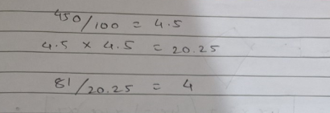

|  |  |
| --- | --- |
| 5. | The compound interest on Rs. 30,000 at 7% per annum is Rs. 4347. The period (in years) is: |
| |  |  | | --- | --- | | [**A.**](javascript:%20void%200;) | **2** | | [**B.**](javascript:%20void%200;) | |  |  | | --- | --- | | 2 | 1 | | 2 | | | [**C.**](javascript:%20void%200;) | 3 | | [**D.**](javascript:%20void%200;) | 4 | |

🡺

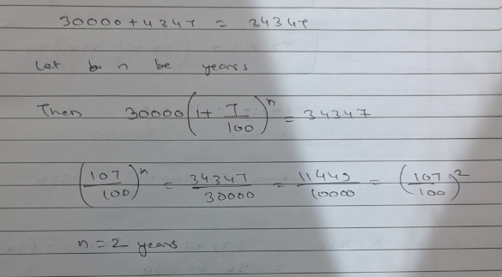

|  |  |
| --- | --- |
| 6. | What will be the compound interest on a sum of Rs. 25,000 after 3 years at the rate of 12 p.c.p.a.? |
| |  |  | | --- | --- | | [**A.**](javascript:%20void%200;) | Rs. 9000.30 | | [**B.**](javascript:%20void%200;) | Rs. 9720 | | [**C.**](javascript:%20void%200;) | **Rs. 10123.20** | | [**D.**](javascript:%20void%200;) | Rs. 10483.20 | | [**E.**](javascript:%20void%200;) | None of these | |

🡺

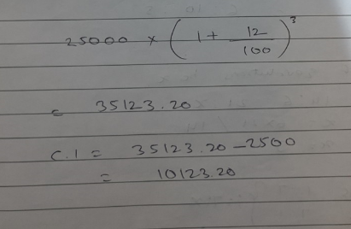

|  |  |
| --- | --- |
| 7. | A and B entered into partnership with capitals in the ratio 4 : 5. After 3 months, A withdrew  of his capital and B withdrew  of his capital. The gain at the end of 10 months was Rs. 760. A's share in this profit is: |
| |  |  | | --- | --- | | [**A.**](javascript:%20void%200;) | Rs. 330 | | [**B.**](javascript:%20void%200;) | Rs. 360 | | [**C.**](javascript:%20void%200;) | **Rs. 380** | | [**D.**](javascript:%20void%200;) | Rs. 430 | |

🡺

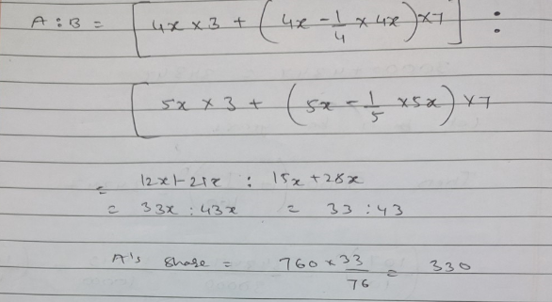

|  |  |
| --- | --- |
| 8. | A and B started a partnership business investing some amount in the ratio of 3 : 5. C joined then after six months with an amount equal to that of B. In what proportion should the profit at the end of one year be distributed among A, B and C? |
| |  |  | | --- | --- | | [**A.**](javascript:%20void%200;) | 3 : 5 : 2 | | [**B.**](javascript:%20void%200;) | 3 : 5 : 5 | | [**C.**](javascript:%20void%200;) | **6 : 10 : 5** | | [**D.**](javascript:%20void%200;) | Data inadequate | |

🡺

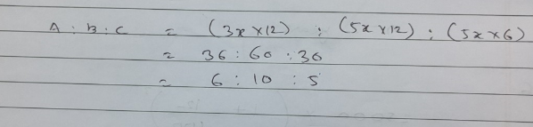

|  |  |
| --- | --- |
| 9. | A wheel that has 6 cogs is meshed with a larger wheel of 14 cogs. When the smaller wheel has made 21 revolutions, then the number of revolutions mad by the larger wheel is: |
| |  |  | | --- | --- | | [**A.**](javascript:%20void%200;) | 4 | | [**B.**](javascript:%20void%200;) | **9** | | [**C.**](javascript:%20void%200;) | 12 | | [**D.**](javascript:%20void%200;) | 49 | |

🡺

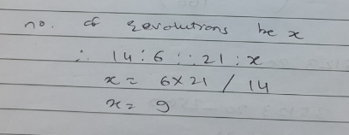

|  |  |
| --- | --- |
| 10. | If 7 spiders make 7 webs in 7 days, then 1 spider will make 1 web in how many days? |
| |  |  | | --- | --- | | [**A.**](javascript:%20void%200;) | 1 | | [**B.**](javascript:%20void%200;) | |  | | --- | | 7 | | 2 | | | [**C.**](javascript:%20void%200;) | **7** | | [**D.**](javascript:%20void%200;) | 49 | |

🡺

