**Name:** Shubham Takankhar

**Class :** SY MCA

**Roll No. :** 54

**Assignment 2:** Solve any 10 problems on- HCF and LCM of Numbers. Time and distance, Problems on trains, Boats and Streams

|  |  |
| --- | --- |
| 1. | Find the greatest number that will divide 43, 91 and 183 so as to leave the same remainder in each case. |
| |  |  | | --- | --- | | [**A.**](javascript:%20void%200;) | 4 | | [**B.**](javascript:%20void%200;) | 7 | | [**C.**](javascript:%20void%200;) | 9 | | [**D.**](javascript:%20void%200;) | 13 | |

🡺

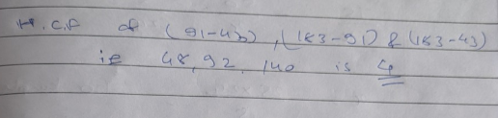

|  |  |
| --- | --- |
| 2. | The H.C.F. of two numbers is 23 and the other two factors of their L.C.M. are 13 and 14. The larger of the two numbers is: |
| |  |  | | --- | --- | | [**A.**](javascript:%20void%200;) | 276 | | [**B.**](javascript:%20void%200;) | 299 | | [**C.**](javascript:%20void%200;) | 322 | | [**D.**](javascript:%20void%200;) | 345 | |

🡺

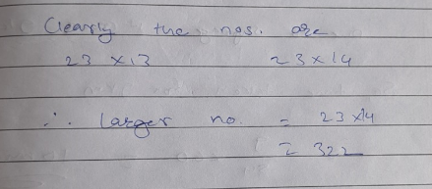

|  |  |
| --- | --- |
| 3. | Six bells commence tolling together and toll at intervals of 2, 4, 6, 8 10 and 12 seconds respectively. In 30 minutes, how many times do they toll together ? |
| |  |  | | --- | --- | | [**A.**](javascript:%20void%200;) | 4 | | [**B.**](javascript:%20void%200;) | 10 | | [**C.**](javascript:%20void%200;) | 15 | | [**D.**](javascript:%20void%200;) | 16 | |

🡺

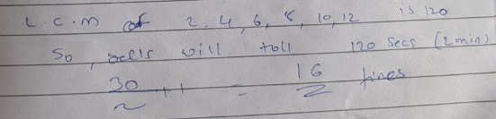

4. A train can travel 50% faster than a car. Both start from point A at the same time and reach point B 75 kms away from A at the same time. On the way, however, the train lost about 12.5 minutes while stopping at the stations. The speed of the car is:

A. 100 kmph

B. 110 kmph

C. 120 kmph

D. 130 kmph

🡺

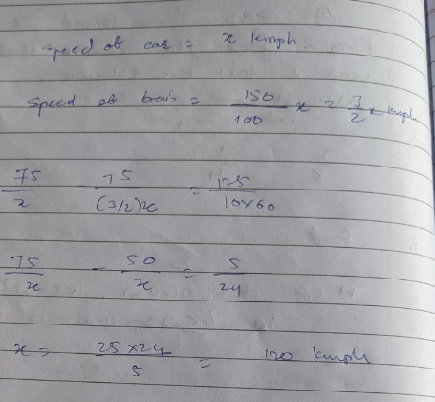

|  |  |
| --- | --- |
| 5. | Excluding stoppages, the speed of a bus is 54 kmph and including stoppages, it is 45 kmph. For how many minutes does the bus stop per hour? |
| |  |  | | --- | --- | | [**A.**](javascript:%20void%200;) | 9 | | [**B.**](javascript:%20void%200;) | 10 | | [**C.**](javascript:%20void%200;) | 12 | | [**D.**](javascript:%20void%200;) | 20 | |

🡺

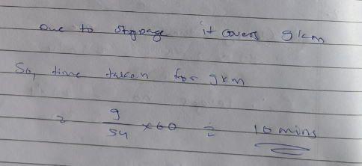

|  |  |
| --- | --- |
| 6. | In a flight of 600 km, an aircraft was slowed down due to bad weather. Its average speed for the trip was reduced by 200 km/hr and the time of flight increased by 30 minutes. The duration of the flight is: |
| |  |  | | --- | --- | | [**A.**](javascript:%20void%200;) | 1 hour | | [**B.**](javascript:%20void%200;) | 2 hours | | [**C.**](javascript:%20void%200;) | 3 hours | | [**D.**](javascript:%20void%200;) | 4 hours | |

🡺

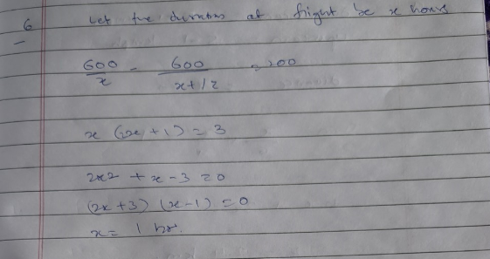

|  |  |
| --- | --- |
| 7. | The speed of a boat in still water in 15 km/hr and the rate of current is 3 km/hr. The distance travelled downstream in 12 minutes is: |
| |  |  | | --- | --- | | [**A.**](javascript:%20void%200;) | 1.2 km | | [**B.**](javascript:%20void%200;) | 1.8 km | | [**C.**](javascript:%20void%200;) | 2.4 km | | [**D.**](javascript:%20void%200;) | 3.6 km | |

🡺

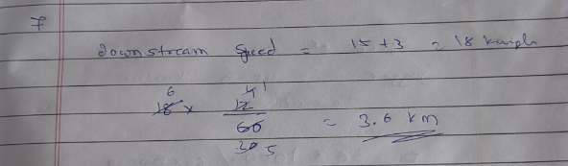

|  |  |
| --- | --- |
| 8. | A boat takes 90 minutes less to travel 36 miles downstream than to travel the same distance upstream. If the speed of the boat in still water is 10 mph, the speed of the stream is: |
| |  |  | | --- | --- | | [**A.**](javascript:%20void%200;) | 2 mph | | [**B.**](javascript:%20void%200;) | 2.5 mph | | [**C.**](javascript:%20void%200;) | 3 mph | | [**D.**](javascript:%20void%200;) | 4 mph | |

🡺

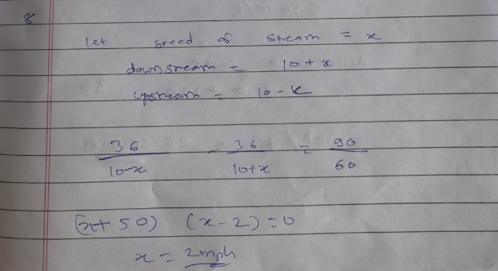

|  |  |
| --- | --- |
| 9. | A man can row at 5 kmph in still water. If the velocity of current is 1 kmph and it takes him 1 hour to row to a place and come back, how far is the place? |
| |  |  | | --- | --- | | [**A.**](javascript:%20void%200;) | 2.4 km | | [**B.**](javascript:%20void%200;) | 2.5 km | | [**C.**](javascript:%20void%200;) | 3 km | | [**D.**](javascript:%20void%200;) | 3.6 km | |

🡺

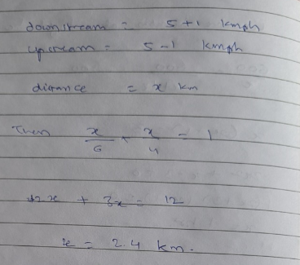

|  |  |
| --- | --- |
| 10. | A jogger running at 9 kmph alongside a railway track in 240 metres ahead of the engine of a 120 metres long train running at 45 kmph in the same direction. In how much time will the train pass the jogger? |
| |  |  | | --- | --- | | [**A.**](javascript:%20void%200;) | 3.6 sec | | [**B.**](javascript:%20void%200;) | 18 sec | | [**C.**](javascript:%20void%200;) | 36 sec | | [**D.**](javascript:%20void%200;) | 72 sec | |

🡺

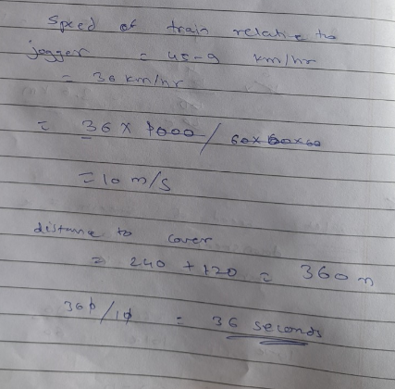

|  |  |
| --- | --- |
| 11. | A 270 metres long train running at the speed of 120 kmph crosses another train running in opposite direction at the speed of 80 kmph in 9 seconds. What is the length of the other train? |
| |  |  | | --- | --- | | [**A.**](javascript:%20void%200;) | 230 m | | [**B.**](javascript:%20void%200;) | 240 m | | [**C.**](javascript:%20void%200;) | 260 m | | [**D.**](javascript:%20void%200;) | 320 m | |

🡺

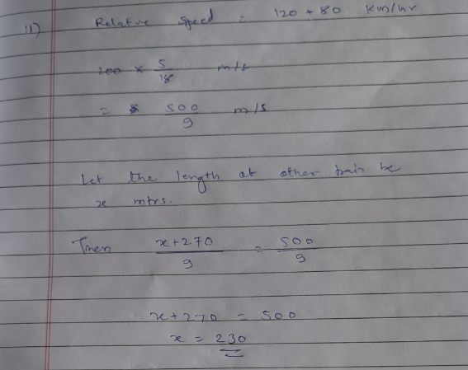

|  |  |
| --- | --- |
| 12. | A goods train runs at the speed of 72 kmph and crosses a 250 m long platform in 26 seconds. What is the length of the goods train? |
| |  |  | | --- | --- | | [**A.**](javascript:%20void%200;) | 230 m | | [**B.**](javascript:%20void%200;) | 240 m | | [**C.**](javascript:%20void%200;) | 260 m | | [**D.**](javascript:%20void%200;) | 270 m | |

🡺

