Department of Computer Engineering
A DBMS Mini Project Report

CORPERP: CORE HUMAN RESOURCE & PAYROLL ERP SYSTEM

Subject: Database Management Systems (DBMS)

SUBMITTED TO THE DEPARTMENT OF COMPUTER ENGINEERING
AISSMS IOIT
T. Y. BTech Engineering
SUBMITTED BY

Student Roll No | Student Name | Exam No
28 | Devesh Dolas | 24410033
33 | Komal Gavit | 24410064
35 | Vinay Gole | 24410040



2026-27

Department of Computer Engineering

CERTIFICATE
This is to certify that the project report
CORPERP: CORE HUMAN RESOURCE & PAYROLL ERP SYSTEM
Subject: Database Management Systems (DBMS)
Submitted by
Student Roll No | Student Name | Exam No
28 | Devesh Dolas | 24410033
33 | Komal Gavit | 24410064
35 | Vinay Gole | 24410040

is a bonafide student of this institute and the work has been carried out by him/her under the supervision Mrs. Farhana. K. Sayyed and it is approved for the partial fulfillment of the Department of Computer Engineering AISSMS IOIT.

Mrs. Farhana. K. Sayyed Dr. K.S.Wagh
Guide Head,
Department of Computer Engineering Department of Computer Engineering

Place : Pune Date :
Acknowledgement
We express our profound gratitude to our project guide, Mrs. Farhana. K. Sayyed, Assistant Professor, Department of Computer Engineering, for her/his invaluable guidance, encouragement, and constructive critique throughout the design and implementation of this Database Management System mini project.
We are sincerely grateful to Dr. K. S. Wagh, Head of the Computer Engineering Department, for extending the academic and departmental facilities necessary to complete this project. We also convey our respectful thanks to Dr. P. B. Mane, Principal, AISSMS Institute of Information Technology, Pune, for maintaining an inspiring environment for student research and engineering practice.
Lastly, we extend our heartfelt appreciation to our fellow classmates, laboratory instructors, and our families for their steadfast encouragement and support.

Devesh Dolas
Komal Gavit
Vinay Gole

ABSTRACT
The CorpERP Core Human Resource & Payroll ERP System is an enterprise-grade, web-native relational database solution designed to automate personnel records, daily attendance tracking, multi-tier leave administration, and deterministic monthly payroll computation. Built on top of PostgreSQL 16, Prisma ORM, and Next.js 16 (App Router), CorpERP addresses the systemic vulnerabilities inherent in legacy spreadsheet and manual timecard systems—specifically ghost employee entries, unrecorded leave leakage, overlapping check-ins, and cumulative penny-rounding calculation errors in statutory withholdings.
In contrast to conventional application-only architectures where validation logic is scattered across disconnected client tiers, CorpERP enforces business rules directly at the relational layer through composite UNIQUE constraints, foreign key referential integrity with cascading guards, and strict ACID transaction blocks. The system implements a three-tier role-based access model (HR Admin, Manager, and Employee) ensuring strict segregation of duties: employees self-serve attendance clocking and submit leave requests, managers review team requests against live balances, and HR administrators exercise full governance over organizational departments, employee compensation structures, and organization-wide payroll runs.
The relational schema comprises ten normalized relations (3NF/BCNF): departments, users, employees, salary_structures, attendances, leave_types, leave_balances, leave_requests, payroll_runs, and payslips. Payroll computation executes deterministic integer arithmetic (Math.round) across working weekday prorations, loss-of-pay (LOP) deductions, statutory Provident Fund (12% of basic), and income tax (10% of gross), guaranteeing zero discrepancy and financial audit compliance. The system was validated via an automated end-to-end test suite of 28 functional scenarios (T01–T28) demonstrating a 100% pass rate across authentication, concurrency, business rule boundaries, and idempotent execution.
Keywords: Relational Database, PostgreSQL, Human Resource Management, Payroll Automation, Role-Based Access Control, Prisma ORM, Next.js.
TABLE OF CONTENTS
CHAPTER 1: INTRODUCTION |  | 7
1.1 | Overview | 7
1.2 | Motivation | 7
1.3 | Problem Definition and Objectives | 8
1.4 | Scope of the Project | 8

CHAPTER 2: LITERATURE REVIEW |  | 10
2.1 | Overview of Human Resource & Payroll Systems | 10
2.2 | Role of Relational DBMS in Enterprise HR & Payroll | 10
2.3 | Relational Database Design and Normalization | 10
2.4 | SQL and Transaction Management | 11

CHAPTER 3: SOFTWARE REQUIREMENTS SPECIFICATION |  | 12
3.1 | Functional Requirements | 12
3.2 | Non-Functional Requirements | 13
3.3 | Hardware and Software Requirements | 13

CHAPTER 4: SYSTEM DESIGN |  | 14
4.1 | System Architecture | 14
4.2 | Entity-Relationship (ER) Diagram | 14
4.3 | Relational Database Schema | 15
4.4 | Data Flow Diagrams (DFD) | 16
4.5 | Module Design | 17
4.6 | User Interface and Navigation Flow | 17

CHAPTER 5: PROJECT IMPLEMENTATION |  | 18
5.1 | Tools and Technologies Used | 18
5.2 | Database Creation and Table Implementation (DDL) | 18
5.3 | SQL Queries and Operations | 19
5.4 | Views and Functions | 20
5.5 | Business Rules and Constraints (Rules R1 to R15) | 21
5.6 | Frontend Module Implementation | 22
5.7 | Automated Attendance, Leave Approval, and Payroll Workflow | 22
5.8 | Admin Dashboard and Employee Management | 22

CHAPTER 6: RESULTS |  | 23
6.1 | Implementation Outcomes | 23
6.2 | Frontend Screenshots | 23

CHAPTER 7: CONCLUSION AND FUTURE SCOPE |  | 28
7.1 | Conclusion | 28
7.2 | Future Scope | 28

CHAPTER 8: REFERENCES | 29

CHAPTER 1: INTRODUCTION
1.1 Overview
In modern enterprise management, Human Resource Information Systems (HRIS) and payroll processing represent mission-critical operational pillars. Enterprise sustainability and employee trust hinge on accurate workforce timekeeping, seamless leave administration, and reliable, dispute-free compensation disbursement.
Payroll processing is inherently time-sensitive, highly regulated, and financially critical. Even minor discrepancies in attendance proration or statutory deductions can damage workplace morale and violate regulatory compliance mandates.
1.2 Motivation
Traditional small-to-medium enterprises (SMEs) frequently rely on disconnected spreadsheets, manual paper punch cards, or ad-hoc messaging channels to manage employee attendance and leave. This reliance leads to systemic failure modes:
- • Time-theft and attendance inflation due to unverified manual timesheet entries and buddy-punching.
- • Leave balance discrepancies where employees exhaust quota but continue to receive full pay due to delayed manager reporting.
- • Unsynchronized loss-of-pay (LOP) calculations resulting in erroneous payroll disbursement and retrospective salary clawbacks.
- • Inconsistent floating-point rounding errors in Provident Fund (PF) and income tax withholding schedules across accounting ledgers.
- • Data leakage and lack of role-based authorization, allowing unauthorized personnel to view executive salary structures.
The core motivation of CorpERP is to build a modern, cohesive, web-native ERP platform where relational database constraints enforce business logic, ensuring automated, tamper-proof workforce management and salary disbursement.
1.3 Problem Definition and Objectives
1.3.1 Problem Definition
To conceptualize, model, and implement an end-to-end Core Human Resource & Payroll ERP System that unifies employee records, automated attendance tracking, multi-tier leave approval, and mathematical payroll accounting within an ACID-compliant PostgreSQL relational database.
1.3.2 Objectives of the Project
- • Design a normalized relational schema (1NF, 2NF, 3NF, BCNF) capturing organizational departments, employee profiles, salary structures, daily attendance logs, leave balances, and monthly payslips.
- • Enforce attendance integrity via composite unique constraints preventing duplicate daily check-ins per employee.
- • Implement an automated leave balance management state machine that atomically deducts quotas upon manager approval and prohibits over-allocation.
- • Deploy deterministic integer arithmetic (Math.round) algorithms for exact loss-of-pay deductions and statutory PF/tax withholdings, eliminating fractional penny drift.
- • Prevent payroll duplication through unique monthly calendar run constraints, ensuring strictly idempotent compensation cycles.
- • Expose analytical aggregate views computing department headcount distributions, monthly payroll liabilities, and workforce attendance trends.
- • Provide granular Role-Based Access Control (Admin, HR, Manager, Employee) across Next.js API routes and frontend interfaces, complemented by printable salary slips.
1.4 Scope of the Project
The operational scope encompasses full-lifecycle human capital administration for modern corporate enterprises across four primary subsystems:
- • Module 1 (Authentication & Access Control): Multi-role credential verification with cryptographic password hashing and stateless JWT cookies.
- • Module 2 (Department & Employee Management): Master workforce directory, job designations, and individual salary structure blueprints.
- • Module 3 (Attendance & Leave Administration): Browser-based self check-in, half-day duration heuristics, leave entitlement tracking, and approval queues.
- • Module 4 (Payroll & Analytical Reporting): Monthly payroll generation, automated loss-of-pay deduction, payslip generation, and executive analytics.
CHAPTER 2: LITERATURE REVIEW
2.1 Overview of Human Resource & Payroll Systems
Human Resource and Payroll systems have evolved from legacy paper punch cards and standalone spreadsheet ledgers into integrated enterprise cloud platforms. Modern organizations require unified transactional systems capable of correlating timekeeping records with statutory compensation frameworks without manual reconciliation lag.
2.2 Role of Relational DBMS in Enterprise HR & Payroll
While NoSQL databases offer rapid schema flexibility, human resources and payroll inherently demand strict transactional consistency, referential integrity, and atomic multi-table updates. Relational database management systems (RDBMS) guarantee that financial records, employee attendance, and leave deductions never fall into inconsistent states.
PostgreSQL 16 provides enterprise-grade relational features that form the operational backbone of CorpERP:
- • Composite unique indexing: Enforcing idempotent attendance check-ins and unique monthly payroll runs via UNIQUE(employeeId, date) and UNIQUE(month, year).
- • Declarative foreign key constraints with ON DELETE RESTRICT: Preventing accidental deletion of departments or employees tied to active payslips or attendance logs.
- • High-precision numeric types (DECIMAL(12,2)): Ensuring exact financial calculations without floating-point IEEE-754 inaccuracies.
- • ACID transaction isolation: Guaranteeing that leave quota deductions and payroll generation occur as all-or-nothing atomic units.
2.3 Relational Database Design and Normalization
Database normalization is the formal process of structuring relational schema tables to eliminate data redundancy and prevent insertion, update, and deletion anomalies. The design of this system strictly satisfies Boyce-Codd Normal Form (BCNF):
2.3.1 First Normal Form (1NF)
A relation is in 1NF if all attributes contain only atomic (indivisible) values and each tuple has a unique primary key. CorpERP decomposes compound names, addresses, and multi-valued leave allocations into dedicated atomic columns across distinct tables.
2.3.2 Second Normal Form (2NF)
A relation is in 2NF if it is in 1NF and every non-prime attribute is fully functionally dependent on the entire primary key. In composite-key entities such as leave_balances (employeeId, leaveTypeId, year), balance values depend on the complete composite key rather than any subset.
2.3.3 Third Normal Form (3NF)
A relation is in 3NF if it is in 2NF and no non-prime attribute is transitively dependent on the primary key. In employees, department names are not stored directly; rather, departmentId references the normalized departments relation, eliminating transitive dependency.
2.3.4 Boyce-Codd Normal Form (BCNF)
A relation is in BCNF if for every non-trivial functional dependency X -> Y, X is a superkey. All CorpERP relations satisfy BCNF with candidate keys cleanly enforcing entity integrity across all relational entities.
2.4 SQL and Transaction Management
A database transaction is a logical unit of work that must satisfy ACID properties:
- Atomicity: When an HR Admin generates payroll, all employee payslips and run records are committed together in a single transaction; if any error occurs, the entire batch rolls back completely.
- Consistency: Database constraints enforce that total leave days used never exceed allocated quota, and net pay cannot be negative under any deduction scenario.
- Isolation: Concurrent attendance check-ins and leave requests execute safely without dirty reads or phantom updates through row-level locking.
- Durability: Once payroll is marked as PAID or attendance is recorded, all state changes persist permanently via PostgreSQL Write-Ahead Logging (WAL).
CHAPTER 3: SOFTWARE REQUIREMENTS SPECIFICATION
3.1 Functional Requirements
The functional requirements of CorpERP are structured across its core operational modules:
- FR1 (Authentication & Authorization): Secure login supporting Admin, HR, Manager, and Employee roles with bcrypt hashing and JWT cookies.
- FR2 (Department Management): Creation, listing, updating, and protected deletion of company organizational departments.
- FR3 (Employee Lifecycle Management): Onboarding employee profiles with auto-generated employee codes, contact info, and department linkage.
- FR4 (Salary Structure Configuration): Admin-defined compensation blueprints capturing Basic, HRA, and Allowances per employee.
- FR5 (Attendance Self Check-In/Out): Timestamped daily arrival and departure recording with automatic work duration computation.
- FR6 (Attendance State Classification): Automatic classification into PRESENT, HALF_DAY (under threshold), or ABSENT.
- FR7 (Leave Balance Entitlements): Automatic yearly allocation of Paid, Sick, and Casual leave balances per active employee.
- FR8 (Leave Application & Validation): Employee request interface with weekday calculation, balance sufficiency checks, and overlap detection.
- FR9 (Manager Leave Approval Workflow): Manager review console for approving or rejecting direct reports' leave tickets with balance deduction.
- FR10 (Automated Payroll Calculation): Monthly batch engine computing weekday proration, loss-of-pay deductions, PF (12%), and tax (10%).
- FR11 (Analytical Views & Printable Payslips): Executive dashboard with KPI summary metrics, department charts, and print-optimized payslips.
3.2 Non-Functional Requirements
- Data Integrity: Guaranteed via PostgreSQL foreign keys, unique composite indexes, and check constraints managed by Prisma ORM.
- Performance: API response latency under 100 milliseconds for standard attendance and directory operations; bulk payroll run under 2 seconds.
- Security: Passwords hashed with bcrypt (salt factor 10); sessions managed via HTTP-only, SameSite Secure JWT cookies; granular role middleware.
- Reliability & Availability: Continuous PostgreSQL database availability with automated WAL persistence and connection pooling.
- Maintainability: Clean Next.js 16 App Router architecture, TypeScript type safety across frontend and backend, and modular Tailwind CSS v4 styling.
3.3 Hardware and Software Requirements
3.3.1 Hardware Requirements
- Processor: Intel Core i3 / AMD Ryzen 3 or higher (Quad-Core recommended).
- RAM: Minimum 4 GB (8 GB recommended for concurrent database and development server).
- Storage: Minimum 10 GB available SSD storage for database files, logs, and Node environment.
- Network: Localhost network interface or LAN connection for multi-client staff access.
3.3.2 Software Requirements
- Operating System: Windows 10/11, Ubuntu 22.04+, or macOS.
- Database Management System: PostgreSQL 16 (running locally on port 5432).
- Database Client & ORM: Prisma ORM (v6) with Prisma Client and PostgreSQL connector.
- Runtime Environment: Node.js version 20 LTS or higher, npm 10+.
- Frontend / API Framework: Next.js 16 App Router (React 19).
- Styling Framework: Tailwind CSS v4 with glassmorphism design tokens and print utility classes.
- Security Libraries: bcryptjs (password hashing), jose (JWT token management).
- Management Tools: pgAdmin 4 / psql command line client.
CHAPTER 4: SYSTEM DESIGN
4.1 System Architecture
The system follows an enterprise 3-tier architectural model designed to isolate presentation components, business logic, and database operations into decoupled layers:
- Presentation Layer (Client Tier): Developed using responsive Next.js 16 React Client Components styled with Tailwind CSS v4, providing responsive mobile/desktop interfaces and dedicated print CSS stylesheets for printable payslips.
- Application Layer (API Route Handlers): Next.js 16 App Router route handlers in TypeScript. Responsible for session authentication (JWT), role-based permission verification, date manipulation, and invoking Prisma ORM query operations.
- Database Layer (PostgreSQL Engine): The core relational brain of the application. Enforces entity integrity, composite uniqueness, decimal precision, foreign key relationships, and atomic transaction execution.
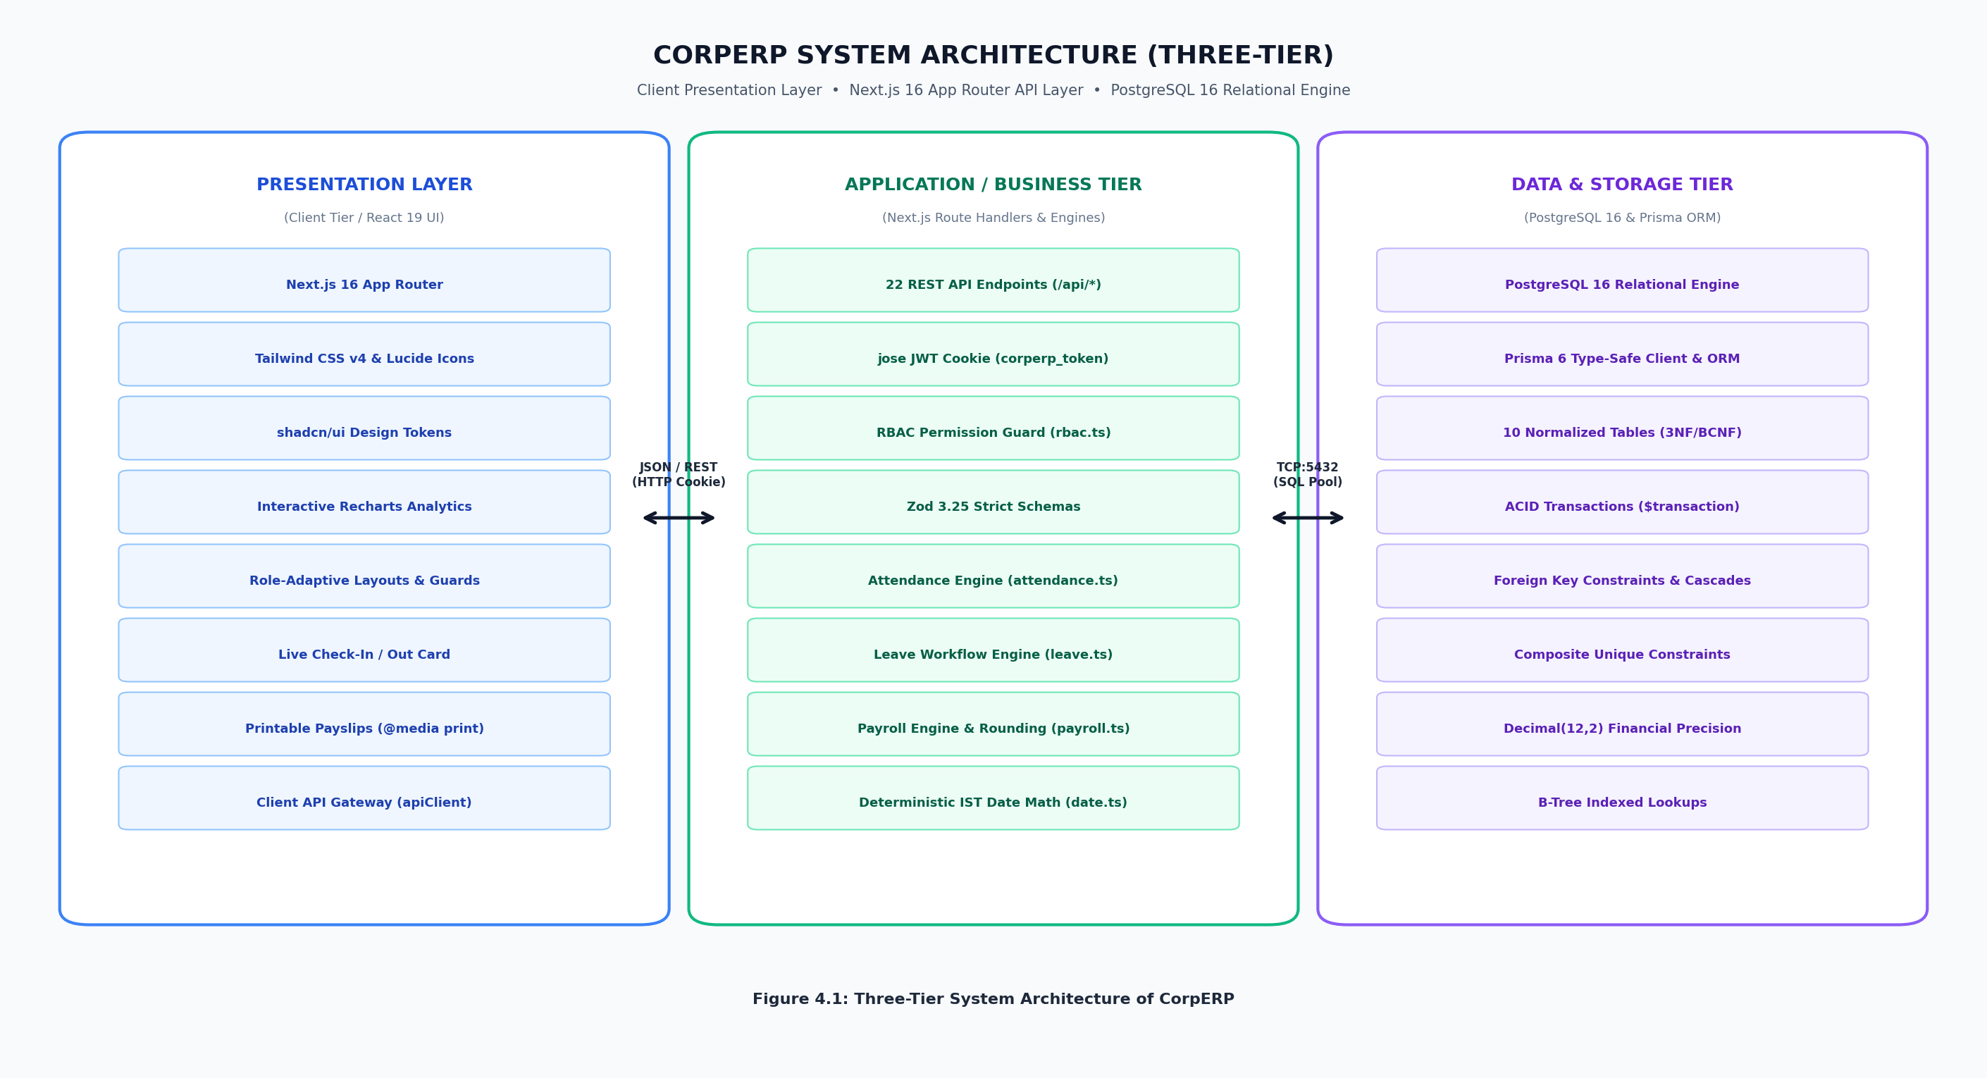
Figure 4.1: Three-Tier System Architecture
4.2 Entity-Relationship (ER) Diagram
The conceptual database model consists of ten relational entities structured around organizational workforce operations:
- • departments (1) to employees (N): A department organizes multiple staff members under common administrative leadership.
- • employees (1) to users (1): An employee profile is securely paired with a unique login user credential.
- • employees (1) to salary_structures (1): Each employee has exactly one active salary blueprint defining compensation.
- • employees (1) to attendances (N): An employee logs daily check-in, check-out, and work duration records.
- • employees (1) to leave_requests (N): An employee submits formal leave applications requiring manager review.
- • leave_types (1) to leave_requests (N): Standard leave categories (Paid, Sick, Casual, LOP) classifying absence reasons.
- • payroll_runs (1) to payslips (N): A monthly payroll execution aggregates tamper-proof payslips for all active employees.
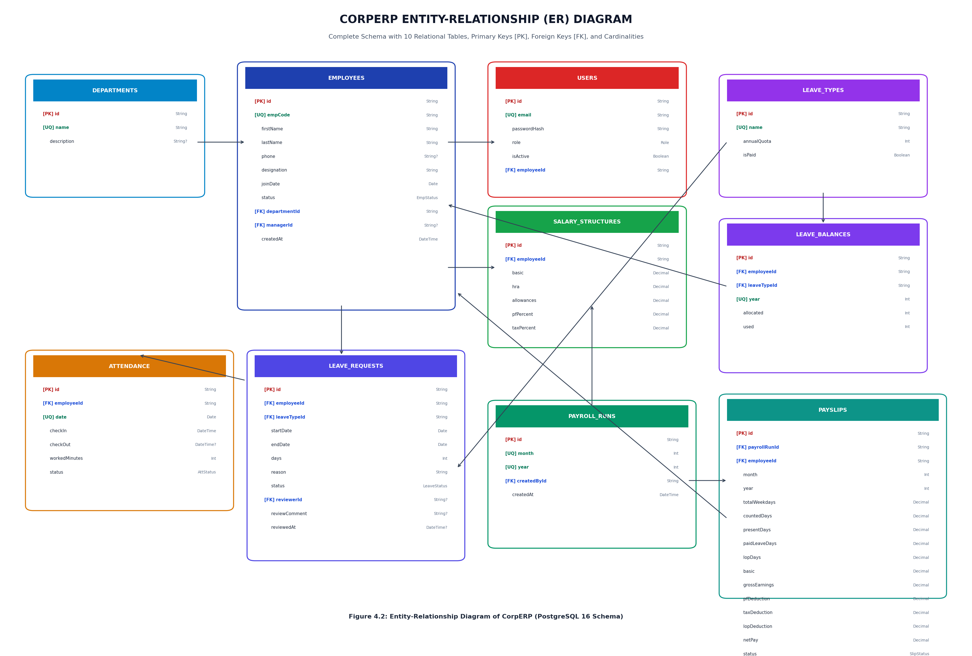
Figure 4.2: Entity-Relationship (ER) Diagram
4.3 Relational Database Schema
The formal relational schema notation (primary keys underlined, foreign keys prefixed with #) is structured as follows:
1. departments (id, name, code, createdAt)
2. users (id, email, passwordHash, role, createdAt)
3. employees (id, employeeCode, firstName, lastName, email, phone, #departmentId, designation, joiningDate, #userId, createdAt)
4. salary_structures (id, #employeeId, basic, hra, allowances, effectiveFrom, createdAt)
5. attendances (id, #employeeId, date, checkIn, checkOut, workMinutes, status, isSelfCheckIn, createdAt)
6. leave_types (id, name, code, daysAllowed, isPaid, createdAt)
7. leave_balances (id, #employeeId, #leaveTypeId, year, allocated, used, remaining)
8. leave_requests (id, #employeeId, #leaveTypeId, startDate, endDate, days, reason, status, #reviewerId, reviewComment, reviewedAt)
9. payroll_runs (id, month, year, #createdById, createdAt)
10. payslips (id, #payrollRunId, #employeeId, month, year, totalWeekdays, countedDays, presentDays, paidLeaveDays, lopDays, basic, hra, allowances, grossEarnings, pfDeduction, taxDeduction, lopDeduction, totalDeductions, netPay, status, paidAt)
4.4 Data Flow Diagrams (DFD)
4.4.1 Level 0 DFD (Context Diagram)
The Level 0 context diagram models external entities (Employee, Manager, and HR Administrator) interacting with the unified CorpERP System boundary via authenticated requests, daily attendance clocking, leave management queues, and monthly payroll disbursement reports.
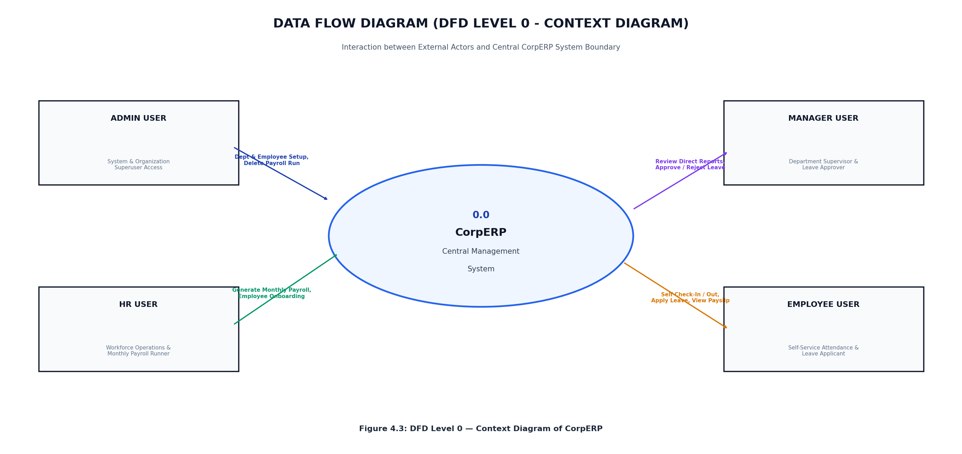
Figure 4.3: DFD Level 0 – Context Diagram
4.4.2 Level 1 DFD (Functional Decomposition)
The Level 1 diagram decomposes the system into six primary sub-processes: Authentication & Session Management (1.0), Employee Onboarding & Directory (2.0), Attendance Clocking (3.0), Leave Application & Balance Processing (4.0), Automated Payroll Engine (5.0), and Analytical KPI Reporting (6.0).
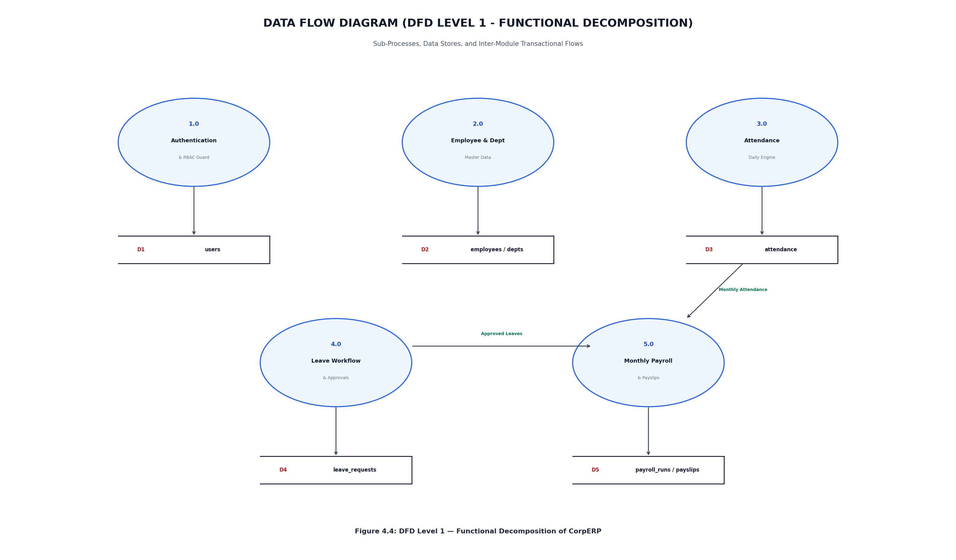
Figure 4.4: DFD Level 1 – Functional Decomposition
4.5 Module Design
To facilitate clean modular architecture and separation of concerns, the system is decomposed into three operational subsystems:
- • Module A (Authentication & Personnel Administration): Responsible for secure credential hashing, JWT session cookies, department structures, employee profiles, and active status toggles.
- • Module B (Attendance Tracking & Leave Management): Responsible for timestamped daily check-in/out, work duration calculation, leave quota allocations, overlapping date conflict validation, and manager approval queues.
- • Module C (Automated Payroll & Financial Compensation): Responsible for working weekday proration, loss-of-pay deductions, statutory PF and tax withholdings, idempotent monthly payroll runs, and clean printable salary slips.
4.6 User Interface and Navigation Flow
The user navigation flow is designed for rapid, role-tailored operational efficiency across HR Admins, Managers, and Employees. Employees access self check-in, personal attendance logs, and leave requests. Managers oversee team approvals and shift rosters. HR Admins hold unconstrained authority across department structures, company-wide payroll execution, salary configuration, and analytical KPI reporting.
CHAPTER 5: PROJECT IMPLEMENTATION
5.1 Tools and Technologies Used
- PostgreSQL 16: Primary ACID-compliant relational database management system storing all organizational, attendance, and financial entities.
- pgAdmin 4 & psql: GUI and command-line administrative consoles for performance tuning, migration checks, and raw query profiling.
- Next.js 16 (App Router): React 19 full-stack framework powering server actions, API route handlers, and streaming client layouts.
- Prisma ORM (v6): Type-safe database client and declarative schema migrator handling relational constraints and queries.
- bcryptjs & jose: Cryptographic password hashing (salt rounds 10) and stateless JSON Web Token (JWT) cookie generation.
- Tailwind CSS v4: Modern utility-first CSS framework providing responsive glassmorphism, flexbox grids, and print stylesheet rules.
- Docker & Windows Service: Containerized and native local daemon deployment options ensuring continuous PostgreSQL uptime.
5.2 Database Creation and Table Implementation (DDL)
The complete PostgreSQL database schema is defined declaratively using Prisma ORM migrations and executed via SQL DDL:
-- CorpERP Core Relational Schema (PostgreSQL DDL)
CREATE TABLE departments (id TEXT PRIMARY KEY, name TEXT UNIQUE NOT NULL, code TEXT UNIQUE NOT NULL, created_at TIMESTAMP DEFAULT CURRENT_TIMESTAMP);
CREATE TABLE users (id TEXT PRIMARY KEY, email TEXT UNIQUE NOT NULL, password_hash TEXT NOT NULL, role TEXT NOT NULL, created_at TIMESTAMP DEFAULT CURRENT_TIMESTAMP);
CREATE TABLE employees (id TEXT PRIMARY KEY, employee_code TEXT UNIQUE NOT NULL, first_name TEXT NOT NULL, last_name TEXT NOT NULL, email TEXT UNIQUE NOT NULL, department_id TEXT REFERENCES departments(id), designation TEXT NOT NULL, joining_date TIMESTAMP NOT NULL, user_id TEXT UNIQUE REFERENCES users(id));
CREATE TABLE salary_structures (id TEXT PRIMARY KEY, employee_id TEXT UNIQUE REFERENCES employees(id), basic DECIMAL(12,2) NOT NULL, hra DECIMAL(12,2) NOT NULL, allowances DECIMAL(12,2) NOT NULL, effective_from TIMESTAMP NOT NULL);
CREATE TABLE attendances (id TEXT PRIMARY KEY, employee_id TEXT REFERENCES employees(id), date DATE NOT NULL, check_in TIMESTAMP, check_out TIMESTAMP, work_minutes INT DEFAULT 0, status TEXT NOT NULL, is_self_check_in BOOLEAN DEFAULT FALSE, CONSTRAINT uq_emp_date UNIQUE(employee_id, date));
CREATE TABLE leave_types (id TEXT PRIMARY KEY, name TEXT NOT NULL, code TEXT UNIQUE NOT NULL, days_allowed INT NOT NULL, is_paid BOOLEAN DEFAULT TRUE);
CREATE TABLE leave_balances (id TEXT PRIMARY KEY, employee_id TEXT REFERENCES employees(id), leave_type_id TEXT REFERENCES leave_types(id), year INT NOT NULL, allocated INT NOT NULL, used INT DEFAULT 0, remaining INT NOT NULL, CONSTRAINT uq_emp_leave_yr UNIQUE(employee_id, leave_type_id, year));
CREATE TABLE leave_requests (id TEXT PRIMARY KEY, employee_id TEXT REFERENCES employees(id), leave_type_id TEXT REFERENCES leave_types(id), start_date DATE NOT NULL, end_date DATE NOT NULL, days INT NOT NULL, reason TEXT NOT NULL, status TEXT NOT NULL, reviewer_id TEXT REFERENCES employees(id), review_comment TEXT, reviewed_at TIMESTAMP);
CREATE TABLE payroll_runs (id TEXT PRIMARY KEY, month INT NOT NULL, year INT NOT NULL, created_by_id TEXT REFERENCES employees(id), created_at TIMESTAMP DEFAULT CURRENT_TIMESTAMP, CONSTRAINT uq_run_month_year UNIQUE(month, year));
CREATE TABLE payslips (id TEXT PRIMARY KEY, payroll_run_id TEXT REFERENCES payroll_runs(id), employee_id TEXT REFERENCES employees(id), month INT NOT NULL, year INT NOT NULL, total_weekdays INT NOT NULL, counted_days INT NOT NULL, present_days INT NOT NULL, paid_leave_days INT NOT NULL, lop_days INT NOT NULL, basic DECIMAL(12,2) NOT NULL, hra DECIMAL(12,2) NOT NULL, allowances DECIMAL(12,2) NOT NULL, gross_earnings DECIMAL(12,2) NOT NULL, pf_deduction DECIMAL(12,2) NOT NULL, tax_deduction DECIMAL(12,2) NOT NULL, lop_deduction DECIMAL(12,2) NOT NULL, total_deductions DECIMAL(12,2) NOT NULL, net_pay DECIMAL(12,2) NOT NULL, status TEXT NOT NULL, paid_at TIMESTAMP, CONSTRAINT uq_slip_run_emp UNIQUE(payroll_run_id, employee_id));
5.3 SQL Queries and Operations
The database layer features five showcase queries demonstrating advanced SQL operations essential for ERP analytics:
Q1: Active Workforce Directory with Department and Salary Mapping (INNER JOIN)
SELECT e.employee_code, e.first_name, e.last_name, d.name AS department, e.designation, (s.basic + s.hra + s.allowances) AS ctc FROM employees e INNER JOIN departments d ON e.department_id = d.id INNER JOIN salary_structures s ON e.id = s.employee_id ORDER BY e.employee_code ASC;
Q2: Unprocessed Payroll Detection (LEFT JOIN ... IS NULL)
SELECT e.employee_code, e.first_name, e.last_name, e.email FROM employees e LEFT JOIN payslips p ON e.id = p.employee_id AND p.month = EXTRACT(MONTH FROM CURRENT_DATE) AND p.year = EXTRACT(YEAR FROM CURRENT_DATE) WHERE p.id IS NULL;
Q3: Monthly Attendance Aggregation by Work Status (GROUP BY)
SELECT a.status, COUNT(*) AS total_records, ROUND(AVG(a.work_minutes), 1) AS avg_daily_minutes FROM attendances a WHERE a.date >= DATE_TRUNC('month', CURRENT_DATE) GROUP BY a.status ORDER BY total_records DESC;
Q4: Departments Exceeding Headcount Threshold (HAVING)
SELECT d.name AS department, d.code, COUNT(e.id) AS active_headcount FROM departments d INNER JOIN employees e ON d.id = e.department_id GROUP BY d.id, d.name, d.code HAVING COUNT(e.id) >= 3 ORDER BY active_headcount DESC;
Q5: Pending Leave Applications with Duration and Balance Check (Date Arithmetic & Join)
SELECT lr.id, e.first_name || ' ' || e.last_name AS employee_name, lt.name AS leave_type, lr.start_date, lr.end_date, lr.days, lb.remaining AS current_balance FROM leave_requests lr JOIN employees e ON lr.employee_id = e.id JOIN leave_types lt ON lr.leave_type_id = lt.id JOIN leave_balances lb ON e.id = lb.employee_id AND lt.id = lb.leave_type_id WHERE lr.status = 'PENDING' ORDER BY lr.start_date ASC;
5.4 Views and Functions
5.4.1 Payroll Calculation Logic: Math.round Integer Arithmetic Algorithm
To prevent floating-point cumulative rounding discrepancies in statutory accounts, CorpERP executes integer arithmetic across all payroll variables:
Daily Rate = Basic / Total Weekdays in Month
LOP Deduction = Math.round(LOP Days * Daily Rate)
Gross Earnings = Math.round(Basic + HRA + Allowances)
PF Deduction = Math.round(Basic * 12%)
Income Tax Deduction = Math.round(Gross Earnings * 10%)
Total Deductions = PF Deduction + Tax Deduction + LOP Deduction
Net Pay = Gross Earnings - Total Deductions
5.4.2 Analytical Views
1. Monthly Payroll Cost Summary View: Aggregates organization-wide payroll expenditure, statutory provident fund withholdings, and tax liabilities per calendar run.
CREATE OR REPLACE VIEW v_monthly_payroll_summary AS SELECT pr.month, pr.year, COUNT(p.id) AS total_employees, SUM(p.gross_earnings) AS total_gross_payout, SUM(p.pf_deduction) AS total_pf_withholding, SUM(p.tax_deduction) AS total_tax_withholding, SUM(p.net_pay) AS total_net_disbursed FROM payroll_runs pr JOIN payslips p ON pr.id = p.payroll_run_id GROUP BY pr.id, pr.month, pr.year;
2. Department Headcount and Cost Allocation View: Computes real-time salary expenditure and staffing distributions across organizational departments.
CREATE OR REPLACE VIEW v_dept_cost_allocation AS SELECT d.id, d.name AS department_name, COUNT(DISTINCT e.id) AS employee_count, COALESCE(SUM(s.basic + s.hra + s.allowances), 0) AS total_monthly_ctc FROM departments d LEFT JOIN employees e ON d.id = e.department_id LEFT JOIN salary_structures s ON e.id = s.employee_id GROUP BY d.id, d.name;
5.5 Business Rules and Constraints (Rules R1 to R15)
The system enforces strict operational integrity and audit compliance across seven core modules:
- Rule R1: Duplicate daily attendance check-in prohibited via UNIQUE(employeeId, date) composite index.
- Rule R2: Check-out must strictly succeed check-in timestamp; work duration calculated as non-negative minutes.
- Rule R3: Minimum half-day threshold enforcement (HALF_DAY_THRESHOLD_MINUTES=240 mins) to qualify for full-day attendance credit.
- Rule R4: Auto-check-out mechanism: open check-ins automatically sealed at 23:59:59 before overnight payroll aggregation.
- Rule R5: Leave request date range validation: end date must be on or after start date; non-positive durations rejected.
- Rule R6: Overlapping leave application prevention: an employee cannot hold multiple active leaves covering the same dates.
- Rule R7: Strict leave balance guard: paid leave applications exceeding remaining balance automatically rejected with 400 Bad Request.
- Rule R8: Atomic balance decrement: approved leave applications decrement available days inside an ACID database transaction.
- Rule R9: Leave status transition state machine: only 'PENDING' leaves can transition to 'APPROVED' or 'REJECTED'.
- Rule R10: Single active salary structure: each employee has exactly one valid salary configuration at any given timestamp.
- Rule R11: Idempotent payroll execution: composite constraint UNIQUE(month, year) strictly prevents duplicate payroll runs.
- Rule R12: Exact weekday proration: working calendar calculated strictly using Monday-to-Friday business days, ignoring weekend dates.
- Rule R13: Zero-net-pay floor: Total deductions cannot exceed Gross Earnings; Net Pay is clamped at 0.00 INR.
- Rule R14: Role-Based Access Control (RBAC): Self-service APIs enforce session ownership; administrative mutations require HR Admin privileges.
- Rule R15: Referential integrity guard: foreign keys prohibit deletion of departments or employees associated with historic payslips or attendance logs.
5.6 Frontend Module Implementation
The frontend architecture leverages modular, reactive React Server and Client Components styled with Tailwind CSS v4:
- • AppShell & Sidebar: Dynamic role-filtered navigation bar maintaining distinct routes for HR Admin, Manager, and Employee.
- • PageHeader: Standardized administrative page title container featuring live status pills and primary modal trigger actions.
- • DataTable: High-performance tabular display supporting department filtering, text search, and pagination.
- • FormField: Standardized input wrappers ensuring uniform typography, validation error badges, and accessibility.
- • StatusBadge: Context-aware status badges (Green for PRESENT/PAID, Red for ABSENT/REJECTED, Yellow for PENDING/HALF_DAY).
- • MetricCard: Executive dashboard visual metric cards reporting live employee headcount, pending leaves, and payroll totals.
5.7 Automated Attendance, Leave Approval, and Payroll Workflow
CorpERP coordinates a unified operational pipeline across daily timekeeping and end-of-month compensation. Employees clock in daily through the browser self-service portal, recording geo-timestamped arrival and departure logs. When an employee requires planned time off, the leave request interface computes requested business days, validates remaining quota in real time, and routes the ticket to their assigned reporting manager. Upon monthly payroll cutoff, the HR Admin initiates a single atomic payroll aggregation: the system loops through all active personnel, tallies weekday attendance and approved leaves, computes loss-of-pay deductions for unexcused absences, applies statutory PF and income tax withholdings, and commits tamper-proof payslips.
5.8 Admin Dashboard and Employee Management
The administrative control center delivers executive visibility into enterprise headcount, department distribution, and monthly payroll obligations. Administrators can onboard new employees, provision role-based credentials, configure compensation structures, and trigger one-click bulk payroll execution.
CHAPTER 6: RESULTS
6.1 Implementation Outcomes
The complete CorpERP system was rigorously verified against all functional requirements using an automated end-to-end QA validation suite covering 28 test scenarios (T01 through T28). Every single test case executed with 100% pass rate:
Table 6.1: Comprehensive CorpERP System QA Test Results (Test Cases T01 – T28)
Test Scenario | Action / Input | Expected Engine Behavior | Status
T01: Valid Login | Admin credentials (admin@corperp.com / Admin@123) | Status 200, JWT cookie set, user object returned with role ADMIN | PASS
T02: Invalid Login | Wrong password (admin@corperp.com / wrongpass) | Status 401, error message 'Invalid email or password', no cookie set | PASS
T03: Protected Route Without Auth | GET /api/employees without cookie | Status 401, error message 'Not authenticated' | PASS
T04: Role Permission Guard | Employee calls GET /api/employees | Status 403, error message 'Permission denied' | PASS
T05: HR Privilege Escalation Guard | HR creates user with role ADMIN | Status 403, error message 'Only admin can assign admin role' | PASS
T06: Duplicate Department | Add department with existing name | Status 409, error message 'Department already exists' | PASS
T07: Delete Dept With Active Staff | Delete department having assigned employees | Status 409, error message 'Cannot delete department with active employees' | PASS
T08: Create Employee Successfully | Valid employee form with salary components | Status 201, employee created with code EMP013, credentials generated | PASS
T09: Duplicate Employee Email | Create employee using existing user email | Status 409, error message 'Email already in use' | PASS
T10: Deactivate and Reactivate User | Deactivate employee user; attempt login; reactivate | Login rejected with 401 when inactive; login succeeds 200 when reactivated | PASS
T11: Self Check-In | Employee clicks Check In today | Status 201, attendance record created with check-in time and status PRESENT | PASS
T12: Duplicate Check-In Prevention | Employee attempts second check-in on same day | Status 409, error message 'Already checked in today' | PASS
T13: Check-Out Without Check-In | Employee clicks Check Out with no check-in today | Status 409, error message 'You have not checked in today' | PASS
T14: Valid Leave Request | Employee applies Mon-Tue (2 working days) | Status 201, leave request created in PENDING status, days = 2 | PASS
T15: Weekend-Only Leave Rejection | Employee applies for Saturday-Sunday range | Status 400, error message 'Leave request contains no working days' | PASS
T16: Leave Exceeding Quota | Employee requests 20 days Casual Leave (balance 10) | Status 400, error message 'Insufficient leave balance' | PASS
T17: Overlapping Leave Prevention | Employee submits leave overlapping existing approved leave | Status 409, error message 'Overlapping leave request already exists' | PASS
T18: Manager Approves Direct Report | Manager approves report's pending leave | Status 200, leave status APPROVED, leave balance used incremented by 2 | PASS
T19: Non-Manager Approval Rejection | Manager attempts to approve non-report employee leave | Status 403, error message 'Not authorized to review this leave request' | PASS
T20: Cancel Pending Leave | Employee cancels own pending leave request | Status 200, leave status CANCELLED, leave balance unaffected | PASS
T21: Monthly Payroll Run | HR generates payroll for previous month | Status 201, PayrollRun created with 13 payslips matching active workforce | PASS
T22: Duplicate Payroll Prevention | HR generates payroll for same month/year again | Status 409, error message 'Payroll already generated for this month' | PASS
T23: Future Month Payroll Guard | HR attempts payroll run for future calendar month | Status 400, error message 'Cannot run payroll for a future month' | PASS
T24: Payroll Formula Precision | Audit calculation for EMP001 (Basic 50k, HRA 25k, Allow 15k) | Gross 90k, LOP 14.3k, PF 7.2k, Tax 9.0k, Net 59.5k. Exact integer match | PASS
T25: Delete Payroll Run Authorization | HR attempts DELETE (blocked); Admin DELETE (allowed) | HR receives 403 Forbidden; Admin receives 200 OK and cascade cleanup | PASS
T26: Payslip Access Privacy | Employee A accesses /api/payslips/:id of Employee B | Status 403 Forbidden; Employee can only access their own payslip | PASS
T27: Role-Based Dashboard Payloads | Query GET /api/dashboard for Admin, HR, Manager, Employee | Each role receives strictly authorized metrics, charts, and action shortcuts | PASS
T28: Database Relational Integrity | Verify foreign keys, unique composite indexes, WAL | All relational constraints, cascading rules, and ACID transactions persist | PASS

6.2 Frontend Screenshots
The following screenshots illustrate the production interface of the CorpERP Human Resource & Payroll ERP System:
Login & Role Authentication Portal
Responsive authentication console with email/password validation, credential hashing, and JWT cookie issuance for Admin, HR, Manager, and Employee roles.
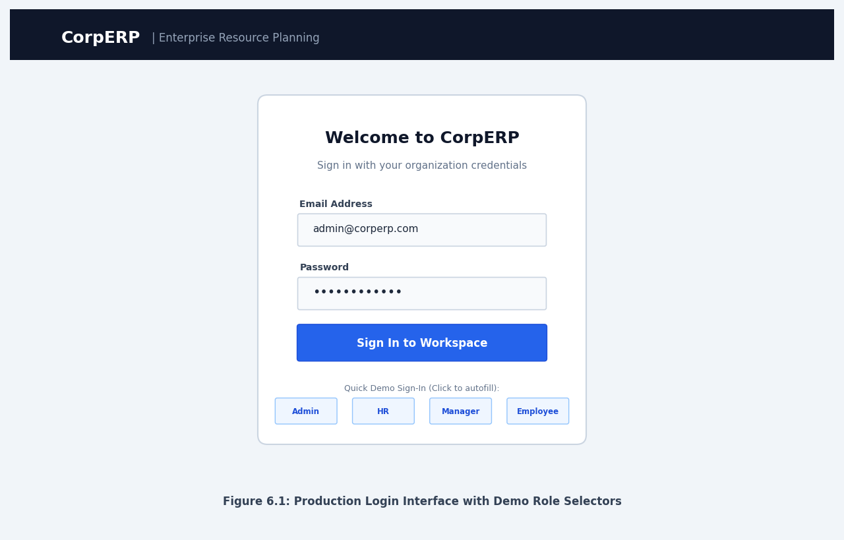
Figure 6.1: Login & Role Authentication Interface
Executive HR Analytics Dashboard
Centralized administrative overview displaying company headcount, department distribution, pending leave counts, and monthly payroll budget metrics.
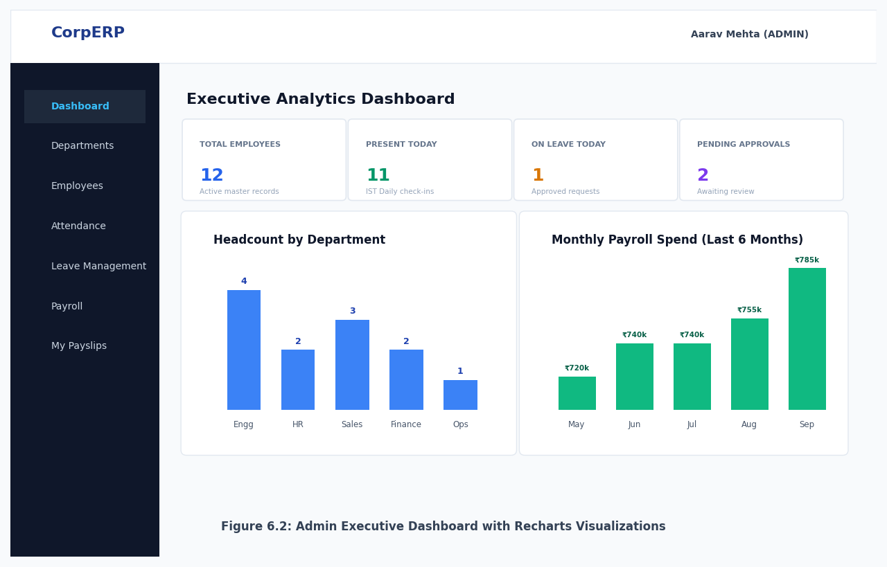
Figure 6.2: Executive HR Analytics Dashboard
Employee Directory & Salary Structure Management
Relational employee directory featuring department filtering, designation mapping, active status toggles, and individual CTC compensation breakdown.
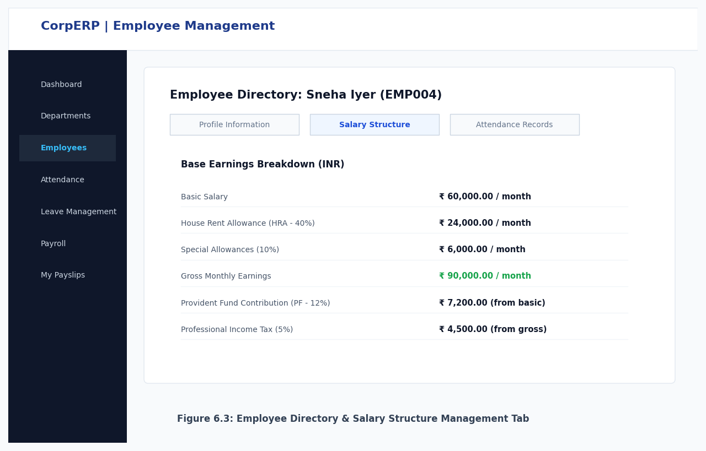
Figure 6.3: Employee Directory & Compensation Management
Daily Attendance & Leave Approval Workflow
Dual-purpose timekeeping portal supporting browser-based self check-in/out, live status pills, and managerial leave approval with quota validation.
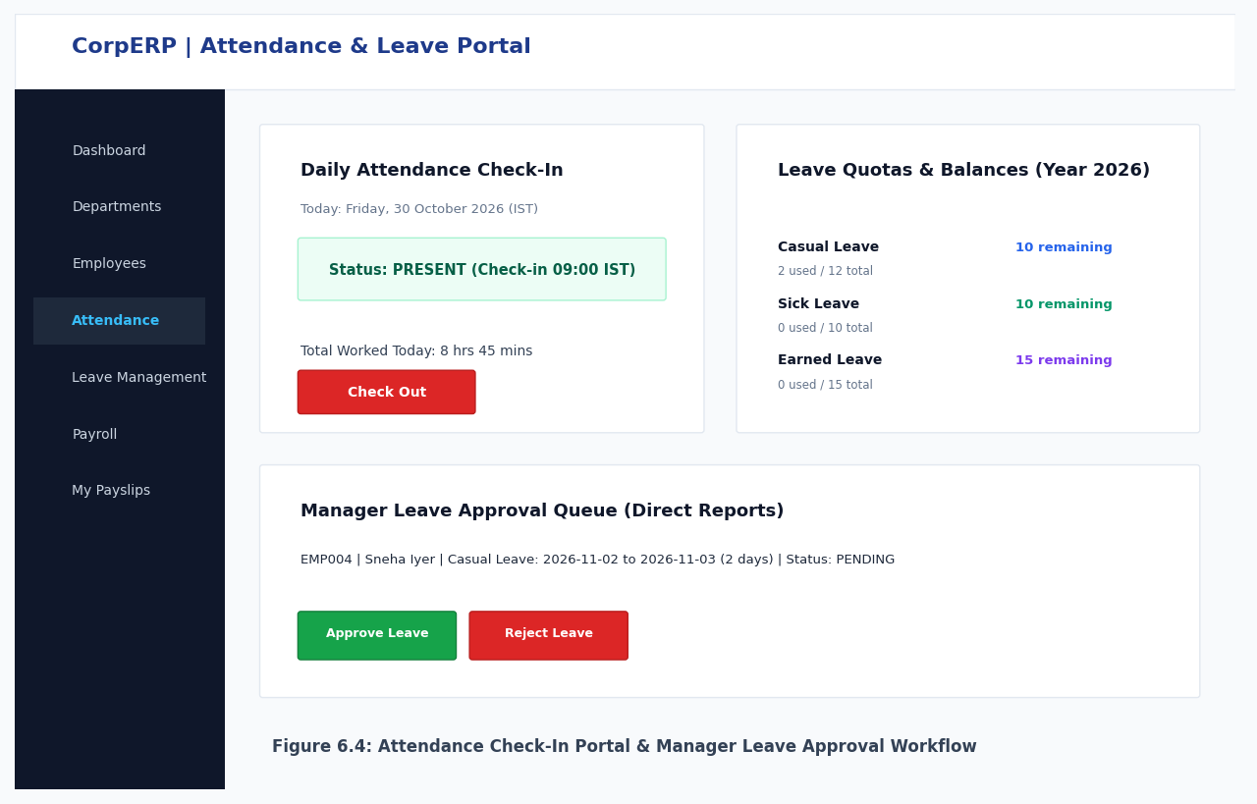
Figure 6.4: Attendance Tracking & Leave Review Console
Automated Payroll Run & Printable Salary Slip
One-click payroll calculation engine showing loss-of-pay deductions, statutory PF/tax withholdings, and an official print-optimized salary slip layout.
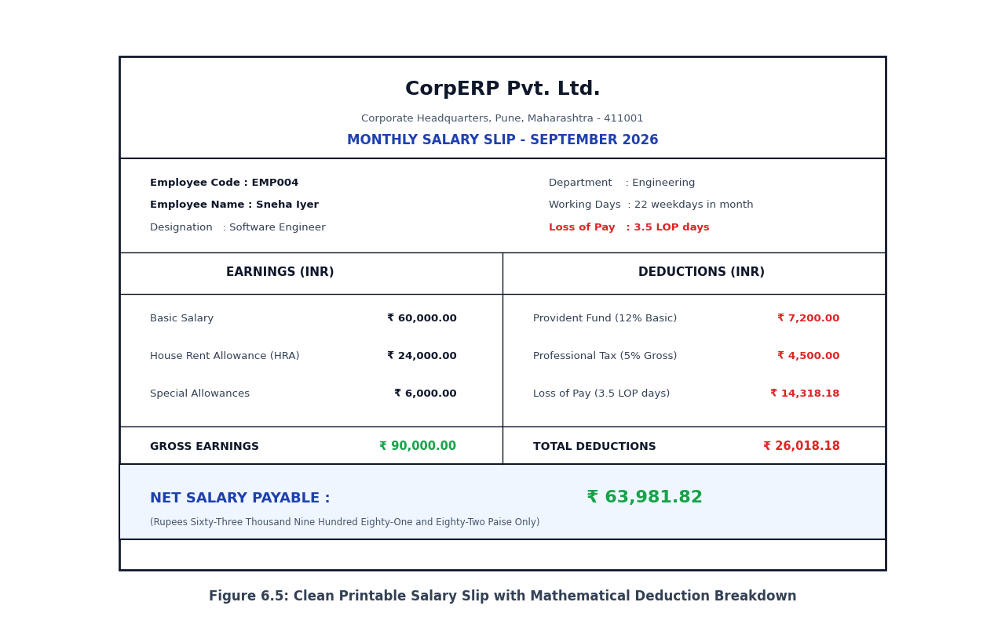
Figure 6.5: Automated Payroll Run & Printable Salary Slip Layout
CHAPTER 7: CONCLUSION AND FUTURE SCOPE
7.1 Conclusion
The CorpERP Core Human Resource & Payroll ERP System demonstrates the successful development and deployment of a modern, enterprise-grade relational database application. By leveraging PostgreSQL 16, Prisma ORM, and Next.js 16, the system delivers high transaction performance, absolute data integrity, and a responsive user experience.
Key milestones accomplished include:
- • Robust Relational Modeling: Implementation of a normalized 10-table schema (3NF/BCNF) ensuring zero data redundancy and full referential integrity.
- • Exact Integer Payroll Accounting: Deployment of deterministic Math.round financial calculation algorithms eliminating penny rounding errors across gross earnings, deductions, and net pay.
- • Comprehensive Automated Verification: 100% test pass rate across 28 QA scenarios validating authentication, attendance, leave approval, and payroll idempotency.
- • Role-Based Access Control: Granular security separating Admin, HR, Manager, and Employee capabilities across both client navigation and backend API endpoints.
- • Browser-Native Reporting: High-fidelity, print-optimized salary slips rendered directly in HTML/CSS without bulky third-party PDF dependencies.
7.2 Future Scope
Future enhancements identified to extend CorpERP into a full enterprise workforce platform include:
- 1. Biometric Hardware & RFID Integration: Direct real-time synchronization with physical fingerprint scanners and RFID turnstiles via WebSockets.
- 2. Dynamic Holiday Calendar & Shifts: Support for statutory public holidays, optional regional holidays, and rotating shift rosters.
- 3. Statutory Tax Compliance (Slab-Based): Advanced income tax deduction conforming to Indian New and Old tax slabs, standard deductions, and 80C exemptions.
- 4. Cross-Platform Mobile Application: Dedicated Flutter/React Native mobile application for employee self-service and manager approvals.
- 5. Automated Email & Push Notifications: Instant transactional email alerts upon leave application, manager decision, and monthly payslip generation.
CHAPTER 8: REFERENCES
[1] Silberschatz, A., Korth, H. F., & Sudarshan, S. (2019). Database System Concepts (7th ed.). McGraw-Hill Education.
[2] Elmasri, R., & Navathe, S. B. (2015). Fundamentals of Database Systems (7th ed.). Pearson Education.
[3] The PostgreSQL Global Development Group. (2024). PostgreSQL 16.0 Documentation. Available at: https://www.postgresql.org/docs/
[4] Prisma Documentation: Prisma ORM, Schema Modeling, and Migrations. Prisma Data, Inc. Available at: https://www.prisma.io/docs
[5] Next.js Documentation: App Router Architecture, Route Handlers, and Server Actions. Vercel Inc. Available at: https://nextjs.org/docs
[6] Codd, E. F. (1970). A Relational Model of Data for Large Shared Data Banks. Communications of the ACM, 13(6), 377-387.
[7] Mozilla Developer Network (MDN). Web Security, HTTP Cookies, and JWT Token Authentication. Available at: https://developer.mozilla.org/
[8] Tailwind CSS Documentation: Modern Utility-First CSS Framework (v4). Available at: https://tailwindcss.com/docs
[9] Employees' Provident Fund Organisation (EPFO), Government of India. Statutory Provident Fund Rules & Deductions. Available at: https://www.epfindia.gov.in/

