Updated, values.yaml

# values.yaml - Option 1: Thanos Sidecar with MinIO S3 + Longhorn + Ingress
# Use with: helm install rancher-monitoring -f values.yaml

## Global Configuration
nameOverride: "rancher-monitoring"
namespaceOverride: "cattle-monitoring-system"

global:
cattle:
systemDefaultRegistry: ""
rbac:
create: true
imageRegistry: ""

## Prometheus Operator Configuration
prometheusOperator:
enabled: true
admissionWebhooks:
enabled: true
patch:
enabled: true
failurePolicy: "Ignore"

# Resources for Operator
resources:
limits:
memory: 500Mi
cpu: 500m
requests:
memory: 200Mi
cpu: 200m

# Service Configuration
service:
type: ClusterIP
port: 8080
targetPort: 8080

## Prometheus with Thanos Sidecar
prometheus:
enabled: true

# --- Thanos Configuration ---
thanosService:
enabled: true # Enable Thanos sidecar service
thanosServiceExternal:
enabled: true # External service for Thanos sidecar
type: ClusterIP
port: 10901 # gRPC port
targetPort: 10901
httpPort: 10902 # HTTP metrics port
targetHttpPort: 10902

# --- Prometheus Ingress ---
ingress:
enabled: true
className: "nginx"
annotations:
kubernetes.io/ingress.class: nginx
nginx.ingress.kubernetes.io/backend-protocol: "HTTP"
nginx.ingress.kubernetes.io/ssl-redirect: "true"
cert-manager.io/cluster-issuer: "letsencrypt-prod"
hosts:
- "prometheus.abc.com"
paths:
- /
tls:
- secretName: prometheus-tls
hosts:
- "prometheus.abc.com"

# --- Service Configuration ---
service:
type: ClusterIP
port: 9090
targetPort: 9090
sessionAffinity: "None"

# --- Prometheus Specification ---
prometheusSpec:
# --- Storage with Longhorn ---
storageSpec:
volumeClaimTemplate:
spec:
storageClassName: "longhorn"
accessModes: ["ReadWriteOnce"]
resources:
requests:
storage: 50Gi

# --- Thanos Sidecar Configuration ---
disableCompaction: true # Let Thanos handle compaction
replicas: 1
retention: 15d # Local retention

thanos:
image:
repository: "rancher/mirrored-thanos-thanos"
tag: "v0.35.1"
sha: ""

# --- MinIO S3 Object Storage Configuration ---
objectStorageConfig:
name: "thanos-objstore-secret"
key: "thanos.yaml"

# Additional Thanos sidecar arguments
additionalArgs:
- name: "shipper.upload-compacted"
value: "true"
- name: "objstore.config-file"
value: "/etc/thanos/objstore.yaml"

# --- Resources ---
resources:
limits:
memory: 4Gi
cpu: 2000m
requests:
memory: 2Gi
cpu: 1000m

# --- Service Monitor Configuration ---
serviceMonitorSelector: {}
serviceMonitorSelectorNilUsesHelmValues: false
podMonitorSelector: {}
podMonitorSelectorNilUsesHelmValues: false

# --- Security Context ---
securityContext:
runAsNonRoot: true
runAsUser: 1000
runAsGroup: 2000
fsGroup: 2000
seccompProfile:
type: "RuntimeDefault"

## Alertmanager Configuration
alertmanager:
enabled: true

# --- Alertmanager Ingress ---
ingress:
enabled: true
className: "nginx"
annotations:
kubernetes.io/ingress.class: nginx
nginx.ingress.kubernetes.io/backend-protocol: "HTTP"
nginx.ingress.kubernetes.io/ssl-redirect: "true"
cert-manager.io/cluster-issuer: "letsencrypt-prod"
hosts:
- "alertmanager.abc.com"
paths:
- /
tls:
- secretName: alertmanager-tls
hosts:
- "alertmanager.abc.com"

# --- Service Configuration ---
service:
type: ClusterIP
port: 9093
targetPort: 9093

# --- Alertmanager Specification ---
alertmanagerSpec:
replicas: 1
retention: 120h

# --- Storage with Longhorn ---
storage:
volumeClaimTemplate:
spec:
storageClassName: "longhorn"
accessModes: ["ReadWriteOnce"]
resources:
requests:
storage: 10Gi

# --- Resources ---
resources:
limits:
memory: 1Gi
cpu: 500m
requests:
memory: 512Mi
cpu: 250m

# --- Security Context ---
securityContext:
runAsNonRoot: true
runAsUser: 1000
runAsGroup: 2000
fsGroup: 2000
seccompProfile:
type: "RuntimeDefault"

# --- Alertmanager Configuration ---
config:
global:
resolve_timeout: "5m"
route:
group_by: ['job']
group_wait: "30s"
group_interval: "5m"
repeat_interval: "12h"
receiver: 'null'
routes:
- match:
alertname: Watchdog
receiver: 'null'
receivers:
- name: 'null'

## Grafana Configuration
grafana:
enabled: true

# --- Grafana Ingress ---
ingress:
enabled: true
className: "nginx"
annotations:
kubernetes.io/ingress.class: nginx
nginx.ingress.kubernetes.io/backend-protocol: "HTTP"
nginx.ingress.kubernetes.io/ssl-redirect: "true"
cert-manager.io/cluster-issuer: "letsencrypt-prod"
hosts:
- "grafana.abc.com"
paths:
- /
tls:
- secretName: grafana-tls
hosts:
- "grafana.abc.com"

# --- Service Configuration ---
service:
type: ClusterIP
port: 80
targetPort: 3000
portName: "http"

# --- Persistence with Longhorn ---
persistence:
enabled: true
storageClassName: "longhorn"
size: 10Gi
accessModes:
- ReadWriteOnce

# --- Admin Configuration ---
adminPassword: "prom-operator" # Change in production!

# --- Grafana Configuration ---
grafana.ini:
users:
allow_sign_up: false
auto_assign_org: true
auto_assign_org_role: "Viewer"
auth:
disable_login_form: false
auth.anonymous:
enabled: false
security:
allow_embedding: true

# --- Sidecar Configuration ---
sidecar:
dashboards:
enabled: true
label: "grafana_dashboard"
datasources:
enabled: true
defaultDatasourceEnabled: true
label: "grafana_datasource"

# --- Resources ---
resources:
limits:
memory: 1Gi
cpu: 500m
requests:
memory: 256Mi
cpu: 100m

## Thanos Sidecar Ingress (Optional - for metrics/debug)
thanosSidecarIngress:
enabled: true
className: "nginx"
annotations:
kubernetes.io/ingress.class: nginx
nginx.ingress.kubernetes.io/backend-protocol: "HTTP"
nginx.ingress.kubernetes.io/ssl-redirect: "true"
cert-manager.io/cluster-issuer: "letsencrypt-prod"
hosts:
- "thanos-sidecar.abc.com"
paths:
- /
tls:
- secretName: thanos-sidecar-tls
hosts:
- "thanos-sidecar.abc.com"

## Core Monitoring Components
kubeStateMetrics:
enabled: true
resources:
limits:
memory: 512Mi
cpu: 300m
requests:
memory: 256Mi
cpu: 100m

nodeExporter:
enabled: true
resources:
limits:
memory: 256Mi
cpu: 200m
requests:
memory: 128Mi
cpu: 100m

## Kubernetes Component Monitoring
kubernetesServiceMonitors:
enabled: true

kubeApiServer:
enabled: true
serviceMonitor:
https: true
insecureSkipVerify: false
serverName: "kubernetes"

kubelet:
enabled: true
serviceMonitor:
https: true
insecureSkipVerify: true
cAdvisor: true
probes: true

coreDns:
enabled: true
service:
port: 9153
targetPort: 9153

kubeControllerManager:
enabled: false # Set to true if exposed

kubeScheduler:
enabled: false # Set to true if exposed

kubeProxy:
enabled: false

kubeEtcd:
enabled: false

## Default Rules Configuration
defaultRules:
create: true
rules:
alertmanager: true
etcd: true
general: true
k8s: true
network: true
node: true
prometheus: true
prometheusOperator: true
kubeApiserverAvailability: true
kubeApiserverBurnrate: true
kubeApiserverHistogram: true
kubeApiserverSlos: true

## Additional Configuration
additionalServiceMonitors: []
additionalPodMonitors: []
additionalPrometheusRules: []

# Network Policy
networkPolicy:
enabled: false

🔑 Required Secret Configuration

1. Create MinIO Secret for Thanos
Create a file named thanos-minio-config.yaml:

# thanos-minio-config.yaml
type: S3
config:
bucket: "thanos"
endpoint: "minio.minio.svc.cluster.local:9000"
access_key: "your-minio-access-key"
secret_key: "your-minio-secret-key"
insecure: true
signature_version2: false
put_user_metadata:
X-Amz-Acl: "bucket-owner-full-control"
http_config:
idle_conn_timeout: "90s"
response_header_timeout: "2m"
trace:
enable: true

Create the secret:

kubectl create secret generic thanos-objstore-secret \
--from-file=thanos.yaml=./thanos-minio-config.yaml \
-n cattle-monitoring-system

2. Optional: Create TLS Secrets
If not using cert-manager, create TLS secrets manually:
# Create self-signed certificates for testing
openssl req -x509 -nodes -days 365 -newkey rsa:2048 \
-keyout prometheus-tls.key -out prometheus-tls.crt \
-subj "/CN=prometheus.abc.com"

kubectl create secret tls prometheus-tls \
--key prometheus-tls.key \
--cert prometheus-tls.crt \
-n cattle-monitoring-system

🚀 Deployment Commands

1. Create Namespace

kubectl create namespace cattle-monitoring-system

2. Deploy Rancher Monitoring

helm repo add rancher-latest https://releases.rancher.com/server-charts/latest
helm repo update

helm upgrade --install rancher-monitoring rancher-latest/rancher-monitoring \
-f values.yaml \
-n cattle-monitoring-system \
--timeout 10m

🌐 Access URLs
Component | URL | Default Credentials
Prometheus | https://prometheus.abc.com | None
Grafana | https://grafana.abc.com | admin / prom-operator
Alertmanager | https://alertmanager.abc.com | None
Thanos Sidecar | https://thanos-sidecar.abc.com | None

💾 Storage Summary
Component | Storage Class | Size | Access Mode | Purpose
Prometheus | Longhorn | 50Gi | ReadWriteOnce | Local TSDB storage
Alertmanager | Longhorn | 10Gi | ReadWriteOnce | Alert data & silences
Grafana | Longhorn | 10Gi | ReadWriteOnce | Dashboards & config
Thanos | MinIO S3 | Configurable | Object Storage | Long-term metrics

🔍 Verification Commands
# Check all pods are running
kubectl get pods -n cattle-monitoring-system

# Check PVC status
kubectl get pvc -n cattle-monitoring-system

# Check services
kubectl get svc -n cattle-monitoring-system

# Check ingresses
kubectl get ingress -n cattle-monitoring-system

# Check Thanos sidecar logs
kubectl logs -n cattle-monitoring-system -l app.kubernetes.io/name=prometheus -c thanos-sidecar

# Verify MinIO connectivity
kubectl exec -n cattle-monitoring-system -it deployment/prometheus-operator -- \
curl http://minio.minio.svc.cluster.local:9000

Here's a comprehensive Mermaid flow diagram showing all connections, ports, and protocols for Option 1:

🔄 Option 1: Thanos Sidecar Architecture
flowchart TD
%% External Users
User[External User] -->|HTTPS:443<br/>DNS: grafana.abc.com| Ingress
User2[External User] -->|HTTPS:443<br/>DNS: prometheus.abc.com| Ingress
User3[External User] -->|HTTPS:443<br/>DNS: alertmanager.abc.com| Ingress

%% Ingress Layer
subgraph IngressLayer [Ingress Controller - nginx]
Ingress[Ingress Controller<br/>nginx:80/443]
end

%% Application Layer
subgraph AppLayer [Application Layer - cattle-monitoring-system]
subgraph PrometheusPod [Prometheus Pod]
Prometheus[Prometheus Container<br/>HTTP:9090]
ThanosSidecar[Thanos Sidecar<br/>gRPC:10901, HTTP:10902]
end

Alertmanager[Alertmanager<br/>HTTP:9093]
Grafana[Grafana<br/>HTTP:3000]
PrometheusOperator[Prometheus Operator<br/>HTTP:8080]

%% Internal connections
Prometheus -->|HTTP:9090| ThanosSidecar
Prometheus -->|HTTP:9093| Alertmanager
Grafana -->|HTTP:9090| Prometheus
PrometheusOperator -->|Watch API| K8sAPI
end

%% Storage Layer
subgraph StorageLayer [Storage Layer]
subgraph LonghornStorage [Longhorn Block Storage]
PrometheusPVC[Prometheus PVC<br/>50Gi RWO]
AlertmanagerPVC[Alertmanager PVC<br/>10Gi RWO]
GrafanaPVC[Grafana PVC<br/>10Gi RWO]
end

MinIO[MinIO Object Storage<br/>S3:9000]

%% Storage connections
Prometheus -->|RWO Block Storage| PrometheusPVC
Alertmanager -->|RWO Block Storage| AlertmanagerPVC
Grafana -->|RWO Block Storage| GrafanaPVC
ThanosSidecar -->|S3 Protocol<br/>HTTP:9000| MinIO
end

%% Data Sources
subgraph DataSources [Data Sources & Targets]
K8sAPI[Kubernetes API<br/>HTTPS:6443]
Kubelet[Kubelet<br/>HTTPS:10250]
NodeExporter[Node Exporter<br/>HTTP:9100]
KubeStateMetrics[Kube State Metrics<br/>HTTP:8080]
CoreDNS[CoreDNS<br/>HTTP:9153]
ServiceMonitors[Service Monitors]
PodMonitors[Pod Monitors]
end

%% Ingress routing
Ingress -->|HTTP:9090| Prometheus
Ingress -->|HTTP:9093| Alertmanager
Ingress -->|HTTP:3000| Grafana
Ingress -->|HTTP:10902| ThanosSidecar

%% Prometheus scraping
Prometheus -->|HTTPS:6443<br/>Service Discovery| K8sAPI
Prometheus -->|HTTPS:10250<br/>Metrics| Kubelet
Prometheus -->|HTTP:9100<br/>Node Metrics| NodeExporter
Prometheus -->|HTTP:8080<br/>K8s Objects| KubeStateMetrics
Prometheus -->|HTTP:9153<br/>DNS Metrics| CoreDNS
Prometheus -->|Service Discovery| ServiceMonitors
Prometheus -->|Service Discovery| PodMonitors

%% Styling
classDef ingress fill:#e1f5fe
classDef app fill:#f3e5f5
classDef storage fill:#e8f5e8
classDef datasource fill:#fff3e0

class IngressLayer ingress
class AppLayer app
class StorageLayer storage
class DataSources datasource

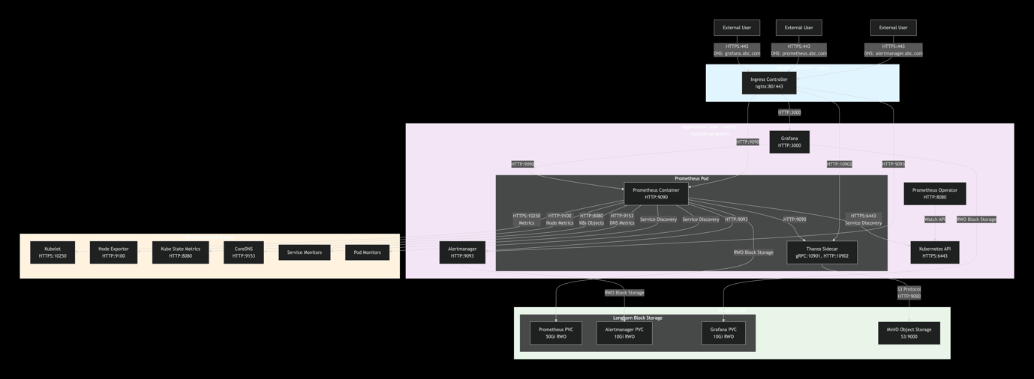

Data Flow Sequence Diagram

sequenceDiagram
participant U as User
participant I as Ingress
participant G as Grafana
participant P as Prometheus
participant TS as Thanos Sidecar
participant M as MinIO
participant AM as Alertmanager
participant KS as Kubelet/NodeExporter
participant PO as Prometheus Operator

%% Metric Collection Flow
Note over KS,P: Continuous Metric Collection
loop Every 30 seconds
KS->>P: HTTP/HTTPS<br/>Scrape Metrics
P->>P: Store in TSDB<br/>Local PVC
end

%% Block Upload Flow
Note over P,M: Block Upload (Every 2 hours)
loop Every 2 hours
P->>TS: New TSDB Block Ready<br/>Internal
TS->>M: S3 PUT<br/>Upload Block<br/>HTTP:9000
M->>TS: S3 Response<br/>Block Stored
end

%% Query Flow
U->>I: HTTPS:443<br/>grafana.abc.com
I->>G: HTTP:3000<br/>Forward Request
G->>P: HTTP:9090<br/>PromQL Query
P->>G: HTTP:200<br/>Query Results
G->>I: HTTP:200<br/>Rendered Dashboard
I->>U: HTTPS:200<br/>Display Dashboard

%% Alerting Flow
Note over P,AM: Alert Evaluation (Every 30s)
loop Every 30 seconds
P->>P: Evaluate Alert Rules
P->>AM: HTTP:9093<br/>Send Alerts
AM->>AM: Process & Route
end

%% Operator Management
Note over PO,P: Continuous Management
PO->>PO: Watch Custom Resources
PO->>P: Reconcile State<br/>Update Configuration

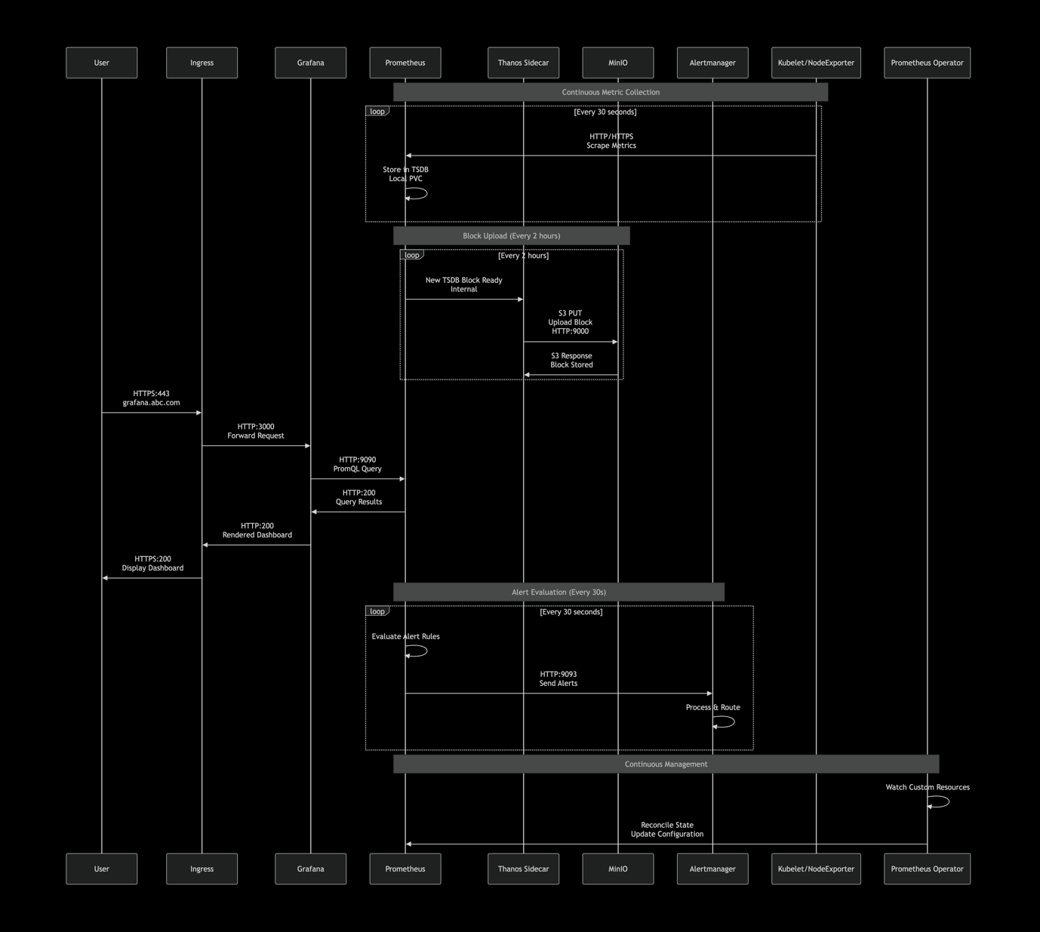

Component Interaction Matrix
flowchart LR
subgraph Source [Data Sources]
K8s[K8s API]
Kube[Kubelet]
Node[Node Exporter]
KSM[Kube State Metrics]
CDNS[CoreDNS]
end

subgraph Core [Core Components]
Prom[Prometheus]
Thanos[Thanos Sidecar]
Alert[Alertmanager]
Graf[Grafana]
Operator[Prometheus Operator]
end

subgraph Storage [Storage]
PVC[Longhorn PVC]
MinIO[MinIO S3]
end

subgraph External [External Access]
Ingress[Ingress]
User[Users]
end

%% Data Source Connections
K8s -->|HTTPS:6443<br/>Watch| Operator
K8s -->|HTTPS:6443<br/>Discovery| Prom
Kube -->|HTTPS:10250<br/>Metrics| Prom
Node -->|HTTP:9100<br/>Metrics| Prom
KSM -->|HTTP:8080<br/>Metrics| Prom
CDNS -->|HTTP:9153<br/>Metrics| Prom

%% Core Component Connections
Prom -->|HTTP:9090<br/>Query| Graf
Prom -->|HTTP:9093<br/>Alerts| Alert
Prom -->|Internal<br/>TSDB Blocks| Thanos
Operator -->|HTTP:8080<br/>Manage| Prom
Operator -->|HTTP:8080<br/>Manage| Alert

%% Storage Connections
Prom -->|RWO Block<br/>Local Storage| PVC
Alert -->|RWO Block<br/>Local Storage| PVC
Graf -->|RWO Block<br/>Local Storage| PVC
Thanos -->|S3 Protocol<br/>HTTP:9000| MinIO

%% External Access
User -->|HTTPS:443<br/>DNS Names| Ingress
Ingress -->|HTTP:9090| Prom
Ingress -->|HTTP:9093| Alert
Ingress -->|HTTP:3000| Graf
Ingress -->|HTTP:10902| Thanos

classDef source fill:#e1f5fe
classDef core fill:#f3e5f5
classDef storage fill:#e8f5e8
classDef external fill:#fff3e0

class Source source
class Core core
class Storage storage
class External external
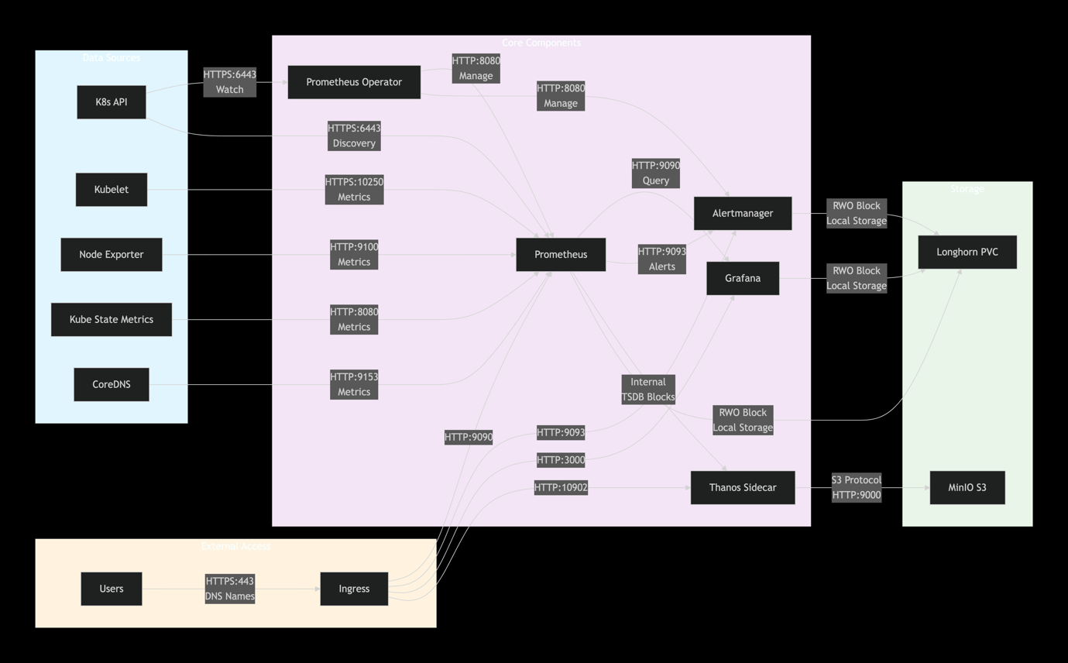

Port & Protocol Summary Table

Component | Port | Protocol | Purpose | External Access
Prometheus | 9090 | HTTP | Web UI, API, Metrics | prometheus.abc.com
Thanos Sidecar | 10901 | gRPC | Internal block access | No
Thanos Sidecar | 10902 | HTTP | Metrics & Debug | thanos-sidecar.abc.com
Alertmanager | 9093 | HTTP | Web UI, Alerts | alertmanager.abc.com
Grafana | 3000 | HTTP | Web UI, Dashboards | grafana.abc.com
Prometheus Operator | 8080 | HTTP | Metrics & Management | No
MinIO | 9000 | HTTP/S3 | Object Storage API | minio.abc.com
Node Exporter | 9100 | HTTP | Node Metrics | No
Kube State Metrics | 8080 | HTTP | K8s Object Metrics | No
CoreDNS | 9153 | HTTP | DNS Metrics | No
Kubelet | 10250 | HTTPS | Container Metrics | No
Kubernetes API | 6443 | HTTPS | Service Discovery | No

Security & Network Policies

flowchart TD
subgraph ExternalTraffic [External Traffic - HTTPS]
User -->|HTTPS:443| Ingress
Ingress -->|HTTP| BackendServices
end

subgraph InternalTraffic [Internal Traffic - HTTP/HTTPS]
BackendServices[Prometheus/Grafana/Alertmanager]
BackendServices -->|HTTP/HTTPS| DataSources[Kubelet/K8sAPI/Metrics]
end

subgraph StorageTraffic [Storage Traffic]
ThanosSidecar -->|S3/HTTP:9000| MinIO
Apps -->|Block Storage| Longhorn
end

subgraph ManagementTraffic [Management Traffic]
PrometheusOperator -->|Watch| K8sAPI
PrometheusOperator -->|Reconcile| ManagedResources
end

%% Security Zones
subgraph Internet [Internet Zone]
User
end

subgraph DMZ [DMZ Zone - Ingress]
Ingress
end

subgraph AppZone [Application Zone]
BackendServices
ManagedResources[Prometheus/Alertmanager]
PrometheusOperator
end

subgraph DataZone [Data Zone]
DataSources
MinIO
Longhorn
end

classDef internet fill:#ffebee
classDef dmz fill:#f3e5f5
classDef app fill:#e8f5e8
classDef data fill:#e1f5fe

class Internet internet
class DMZ dmz
class AppZone app
class DataZone data

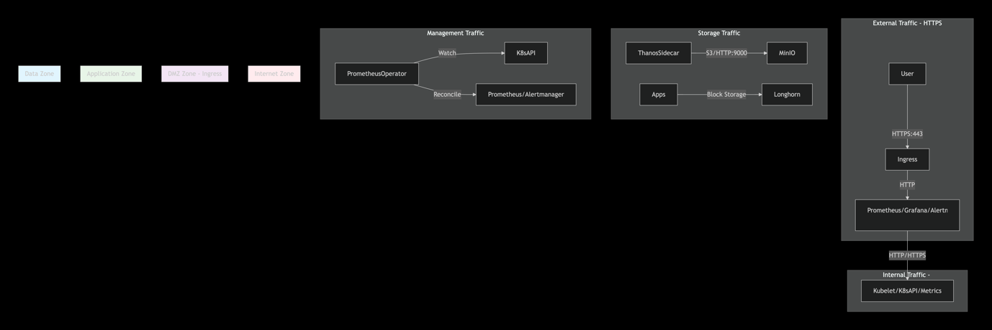

🔄 Option 1 Architecture Flow Diagram

┌─────────────────────────────────────────────────────────────────┐
│ EXTERNAL ACCESS LAYER │
├─────────────────────────────────────────────────────────────────┤
│ https://grafana.abc.com https://prometheus.abc.com │
│ https://alertmanager.abc.com https://thanos-sidecar.abc.com │
│ ↑ │
│ │ Ingress (nginx) │
└────────────────────┼─────────────────────────────────────────────┘
│
┌────────────────────┼─────────────────────────────────────────────┐
│ KUBERNETES CLUSTER │
├─────────────────────────────────────────────────────────────────┤
│ │
│ ┌─────────────────┐ ┌─────────────────┐ ┌─────────────┐ │
│ │ Prometheus │ │ Alertmanager │ │ Grafana │ │
│ │ StatefulSet │ │ StatefulSet │ │ Deployment │ │
│ │ │ │ │ │ │ │
│ │ ┌─────────────┐ │ │ ┌─────────────┐ │ │ ┌─────────┐ │ │
│ │ │ Prometheus │ │ │ │Alertmanager │ │ │ │ Grafana │ │ │
│ │ │ Container │◄┼────┼─┤ Container │ │ │ │ Container│ │ │
│ │ └─────────────┘ │ │ └─────────────┘ │ │ └─────────┘ │ │
│ │ │ │ │ │ │ │
│ │ ┌─────────────┐ │ │ │ │ │ │
│ │ │ Thanos │ │ │ │ │ │ │
│ │ │ Sidecar │ │ │ │ │ │ │
│ │ │ Container │ │ │ │ │ │ │
│ │ └─────────────┘ │ │ │ │ │ │
│ │ │ │ │ │ │ │ │
│ └───────┼─────────┘ └─────────────────┘ └─────────────┘ │
│ │ Uploads blocks every 2h │
│ ▼ │
│ ┌─────────────────┐ │
│ │ MinIO S3 │ │
│ │ Object Storage│ │
│ │ │ │
│ │ • thanos bucket │ │
│ │ • Long-term │ │
│ │ retention │ │
│ └─────────────────┘ │
│ │
├─────────────────────────────────────────────────────────────────┤
│ STORAGE LAYER (Longhorn) │
├─────────────────────────────────────────────────────────────────┤
│ │
│ ┌─────────────┐ ┌─────────────┐ ┌─────────────┐ │
│ │ Prometheus │ │Alertmanager │ │ Grafana │ │
│ │ PVC │ │ PVC │ │ PVC │ │
│ │ 50Gi RWO │ │ 10Gi RWO │ │ 10Gi RWO │ │
│ │ Local TSDB │ │ Silences │ │ Dashboards │ │
│ └─────────────┘ └─────────────┘ └─────────────┘ │
│ │

🔄 Data Flow Description

1. Metric Collection Flow
Application Pods → ServiceMonitor/PodMonitor → Prometheus Operator → Prometheus Container
↓
Kubernetes API → kube-state-metrics → Prometheus Container
↓
Nodes → node-exporter → Prometheus Container

2. Storage & Retention Flow

Prometheus Container → Local TSDB (Longhorn PVC - 50Gi RWO)
↓ (Every 2 hours)
Thanos Sidecar → Compresses & Uploads → MinIO S3 Bucket
↓
Long-term Storage (Object Storage - Cost Effective)

3. Alerting Flow
Prometheus Container → Evaluates Rules → Alertmanager Container
↓
Alertmanager → Routes & Sends → Email/Slack/PagerDuty

4. Visualization Flow
Grafana Container → Queries → Prometheus Container
↓
Renders → Dashboards & Graphs → Web UI (https://grafana.abc.com)

⚙️ Component Interactions

Prometheus Operator Role:
Watch CRDs → Reconcile State → Manage Lifecycle
↓
Create/Update → Prometheus StatefulSet + Thanos Sidecar
↓
Configure → Storage, ServiceMonitors, Rules

Thanos Sidecar Operations:
Monitor → Prometheus TSDB for new blocks
↓
Compress → Blocks for efficient storage
↓
Upload → To MinIO S3 every 2 hours
↓
Serve → gRPC API for potential Thanos Query

🔗 Service Connections

Timing & Intervals
┌─────────────────┬─────────────────┬─────────────────────────────┐
│ Component │ Interval │ Action │
├─────────────────┼─────────────────┼─────────────────────────────┤
│ Prometheus │ 30s │ Scrape metrics │
│ Prometheus │ 30s │ Evaluate alerting rules │
│ Thanos Sidecar │ 2h │ Upload blocks to MinIO │
│ Local Retention │ 7-15 days │ Keep data in PVC │
│ Object Storage │ Years │ Long-term retention in MinIO│

Here is the complete documentation for implementing Rancher Monitoring with Thanos Sidecar and MinIO, which you can use to create your wiki.

Architecture Overview
This setup enhances the standard Rancher Monitoring stack by integrating a Thanos Sidecar with each Prometheus pod. The sidecar continuously uploads Prometheus' metric blocks to MinIO object storage, providing a durable, long-term storage solution independent of the cluster's local disk.
The table below outlines the core components and their roles in this architecture:
Component | Role & Responsibility
Prometheus | Primary monitoring tool that scrapes and stores metrics time-series data.
Thanos Sidecar | Runs alongside Prometheus, uploading metric blocks to MinIO for long-term retention.
MinIO | S3-compatible object storage that serves as the cost-effective, long-term data store.
Grafana | Analytics platform for querying and visualizing metrics (can query via Prometheus or Thanos Query).
Alertmanager | Handles alerts sent by Prometheus, managing routing and notifications.

Prerequisites
Before deployment, ensure your environment meets the following requirements:
- A Running RKE2 Cluster: The cluster should be operational and accessible via kubectl.
- Longhorn StorageClass: Verify that the longhorn StorageClass is available and working in the cluster.
- MinIO Bucket: A MinIO bucket named thanos must be created, and you should have the access key and secret key.
- Ingress Controller: An Ingress controller (like nginx) is required to access the web UIs via the defined hosts.
- Helm: Helm must be installed and configured to manage chart repositories.

Deployment Guide

Step 1: Create the MinIO Configuration Secret
The Thanos sidecar requires a secret to connect to the MinIO bucket. First, create a file named thanos-minio-config.yaml with the following content, replacing the placeholder values with your MinIO information:
yaml
type: S3
config:
bucket: "thanos" # Your MinIO bucket name
endpoint: "minio.minio.svc.cluster.local:9000" # Your MinIO service endpoint
access_key: "your-access-key" # Your MinIO access key
secret_key: "your-secret-key" # Your MinIO secret key
insecure: true # Set to 'false' and configure TLS for production
signature_version2: false
Create the secret in the target namespace using kubectl:
bash
kubectl create secret generic thanos-objstore-secret \
--from-file=thanos.yaml=./thanos-minio-config.yaml \
-n cattle-monitoring-system

Step 2: Create the values.yaml Configuration File
Create a values.yaml file to customize the Rancher Monitoring Helm chart. This configuration enables Thanos, sets up Longhorn storage, and configures Ingress URLs.
yaml
# values.yaml - Option 1 (Thanos Sidecar) with MinIO and Longhorn Storage

## Global Configuration
nameOverride: "rancher-monitoring"
namespaceOverride: "cattle-monitoring-system"

global:
cattle:
systemDefaultRegistry: ""

## Prometheus Configuration with Thanos and MinIO
prometheus:
enabled: true
# --- THANOS CONFIGURATION ---
thanosService:
enabled: true # Enables the Thanos sidecar
thanosServiceMonitor:
enabled: false # Often disabled due to known template issues[citation:2]

# --- INGRESS FOR PROMETHEUS ---
ingress:
enabled: true
className: "nginx"
annotations:
kubernetes.io/ingress.class: nginx
# cert-manager.io/cluster-issuer: "letsencrypt-prod" # Uncomment for TLS
hosts:
- "prometheus.abc.com"
paths:
- /
# tls: # Uncomment for TLS
# - secretName: prometheus-tls
# hosts:
# - "prometheus.abc.com"

# --- PROMETHEUS SPECIFICATION WITH MINIO OBJECT STORAGE ---
prometheusSpec:
# --- LONGHORN STORAGE FOR PROMETHEUS DATA ---
storageSpec:
volumeClaimTemplate:
spec:
storageClassName: longhorn
accessModes: ["ReadWriteOnce"]
resources:
requests:
storage: 50Gi # Adjust based on needs[citation:9]

# --- THANOS SIDECAR CONFIGURATION FOR MINIO ---
disableCompaction: true # Let Thanos handle compaction for object storage[citation:2]
thanos:
image:
repository: rancher/mirrored-thanos-thanos
tag: v0.35.1
# --- MINIO OBJECT STORAGE CONFIGURATION ---
objectStorageConfig:
name: thanos-objstore-secret
key: thanos.yaml
# Upload already compacted historical data[citation:2]
additionalArgs:
- --shipper.upload-compacted=true

## Alertmanager Configuration
alertmanager:
enabled: true
# --- INGRESS FOR ALERTMANAGER ---
ingress:
enabled: true
className: "nginx"
annotations:
kubernetes.io/ingress.class: nginx
hosts:
- "alertmanager.abc.com"
paths:
- /

# --- ALERTMANAGER SPECIFICATION WITH LONGHORN STORAGE ---
alertmanagerSpec:
storage:
volumeClaimTemplate:
spec:
storageClassName: longhorn
accessModes: ["ReadWriteOnce"]
resources:
requests:
storage: 10Gi

## Grafana Configuration
grafana:
enabled: true
# --- INGRESS FOR GRAFANA ---
ingress:
enabled: true
className: "nginx"
annotations:
kubernetes.io/ingress.class: nginx
hosts:
- "grafana.abc.com"
paths:
- /

# --- GRAFANA PERSISTENCE WITH LONGHORN ---
persistence:
enabled: true
storageClassName: longhorn
size: 10Gi
accessModes:
- ReadWriteOnce

adminPassword: "prom-operator" # Change this in production

## Enable other core components
kubeStateMetrics:
enabled: true

nodeExporter:
enabled: true

prometheusOperator:
enabled: true

Step 3: Deploy Rancher Monitoring
Use Helm to deploy the chart with your configuration file.
- Add the Rancher Chart Repository:
bash
helm repo add rancher-latest https://releases.rancher.com/server-charts/latest
helm repo update
- Install the Chart:
bash
helm upgrade --install rancher-monitoring rancher-latest/rancher-monitoring \
-f values.yaml \
-n cattle-monitoring-system \
--create-namespace

Verification and Operation

Post-Installation Verification
- Check Pod Status: Ensure all pods are running, particularly the Prometheus pod, which should have two containers (Prometheus and the Thanos sidecar).
bash
kubectl get pods -n cattle-monitoring-system
- Verify Sidecar Logs: Check the Thanos sidecar logs for any errors and to confirm it is uploading blocks to MinIO.
bash
kubectl logs -n cattle-monitoring-system -l app=prometheus -c thanos-sidecar
Look for log entries indicating successful uploads.
- Check MinIO Bucket: Log in to the MinIO console and verify that data is appearing in the thanos bucket.

Accessing the Applications
Once the Ingress is configured and the DNS records for your domain (abc.com) point to your cluster, you can access the following services:
Service | URL | Default Credentials (if applicable)
Grafana | https://grafana.abc.com | Username: admin  Password: prom-operator
Prometheus | https://prometheus.abc.com | -
Alertmanager | https://alertmanager.abc.com | -

Storage Configuration Summary
This configuration uses a hybrid storage model for optimal performance and cost.
Component | Storage Type | StorageClass | Purpose
Prometheus | Block (Local) | longhorn (50Gi) | Short-term, high-performance TSDB storage.
Alertmanager | Block (Local) | longhorn (10Gi) | Stores silences and notification data.
Grafana | Block (Local) | longhorn (10Gi) | Stores dashboards, plugins, and session data.
Thanos | Object (Remote) | minio | Long-term, cost-effective metric storage.

Troubleshooting
- Pending PVCs: If PersistentVolumeClaims (PVCs) are stuck in "Pending" state, verify that the longhorn StorageClass exists and is functioning correctly.
- Sidecar Connection Errors: If the Thanos sidecar fails to connect to MinIO, double-check the secret's data and ensure the MinIO endpoint is reachable from the cluster.
- High Memory Usage: For larger clusters, you may need to adjust the memory requests and limits for Prometheus as per Rancher's best practices.
I hope this comprehensive guide helps you successfully deploy and manage your monitoring stack. Would you like me to elaborate on any specific section, such as configuring alerts or setting up backup procedures for the application?

