# Project Report: Dynamic Workforce Insights and Recommendation Platform

## Introduction

The rapid evolution of the job market, influenced by economic, technological, and societal factors, demands innovative solutions for both job seekers and recruiters. The Dynamic Workforce Insights and Recommendation Platform is a comprehensive analytics solution aimed at empowering users with actionable insights. By leveraging historical and real-time job posting data, the platform identifies trends, predicts high-demand roles, and delivers personalized recommendations to address the ever-changing job landscape.

## Objectives

The project has the following primary objectives:

1. Empower Job Seekers: Provide insights into high-demand roles, salary trends, and emerging job categories to help users make informed career decisions.

2. Facilitate Recruiters: Analyze workforce dynamics to enable organizations to adapt to market shifts effectively.

3. Deliver Personalized Insights: Build a robust recommendation system tailored to individual preferences and profiles.

## Situational Analysis

In an environment driven by constant shifts in technology and work culture, job seekers and recruiters face significant challenges in aligning goals. This platform bridges the gap by analyzing workforce data to reveal key market trends:

- Economic changes and technological advancements create new job categories and impact existing roles.

- Increased focus on remote work demands analysis of its long-term implications.

- Geographic disparities in wages necessitate regional insights for both job seekers and employers.

## Project Scope

The project is designed to cover multiple dimensions of workforce analytics, ranging from salary comparisons to predictive modeling of future trends. Each task contributes to building a holistic understanding of the job market.

## Tasks and Deliverables

### Keyword-Salary Analysis

Objective: Identify correlations between job title keywords and salaries.

Implementation: Perform keyword extraction from job titles using NLP techniques. Use statistical and visualization tool to analyze salary trends for specific keywords.

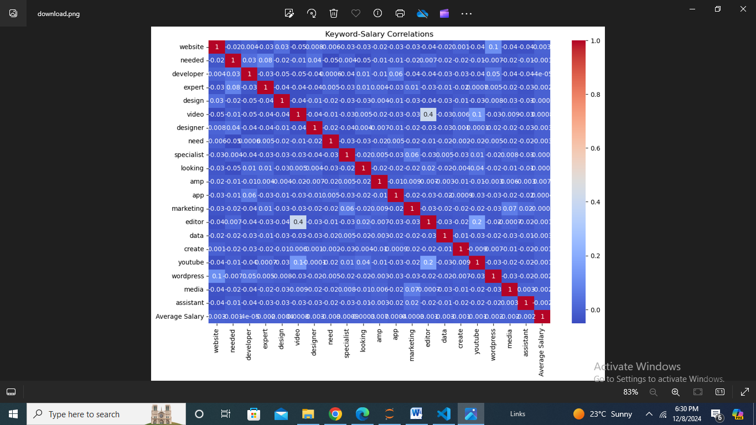

### Emerging Job Categories

Objective: Discover growing job categories based on job posting frequencies.

Implementation: Use clustering and time-series analysis to identify growth trends in job categories. Rank categories by their growth rates.

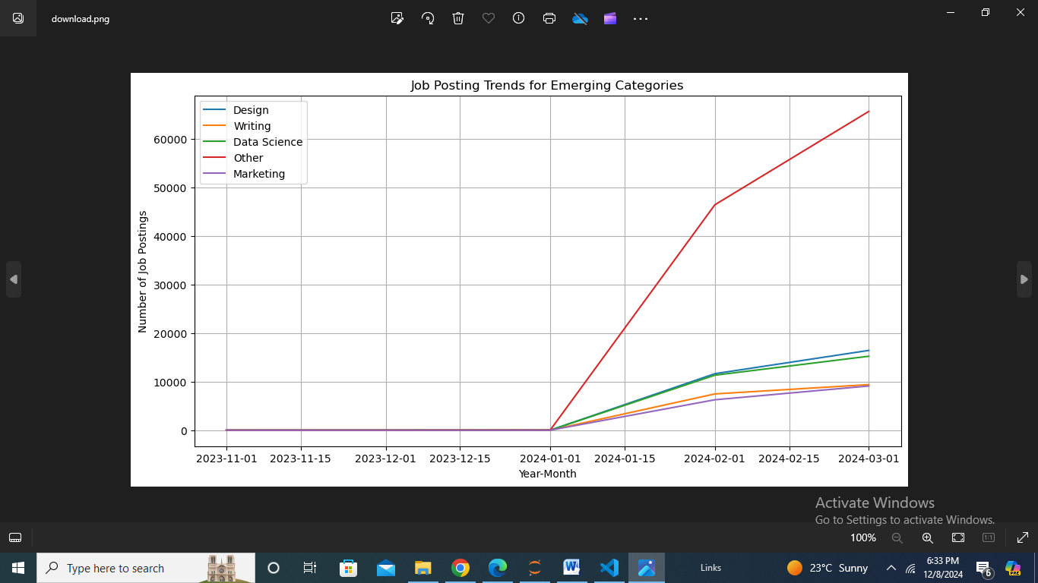

### High-Demand Job Role Prediction

Objective: Predict roles that are expected to see increased demand.

Implementation: Develop predictive models (e.g., Random Forest, XGBoost) using historical job posting data. Evaluate models based on metrics like accuracy and precision.

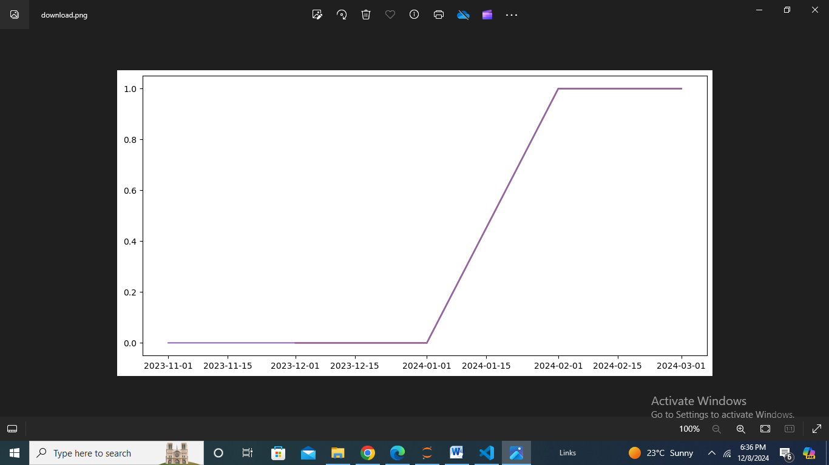

### Geographic Salary Analysis

Objective: Compare hourly wages across regions.

Implementation: Aggregate salary data by region and visualize using interactive maps. Perform regional comparisons and highlight wage disparities.

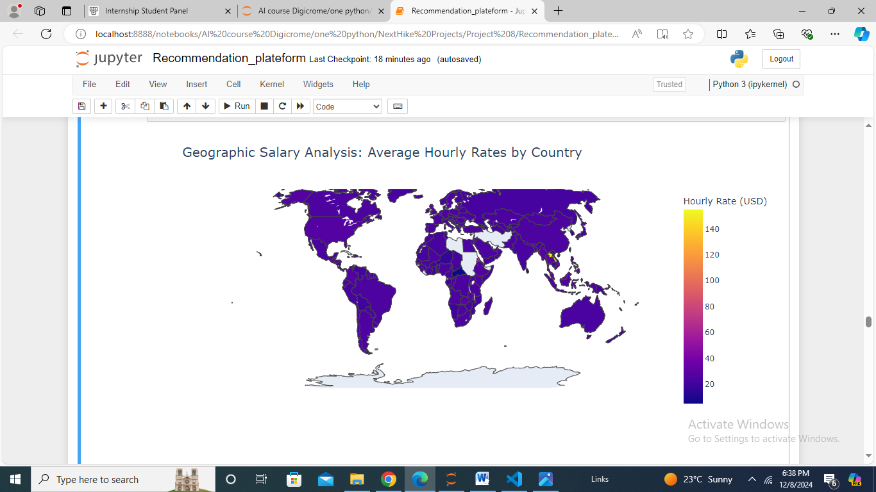

### Personalized Job Recommendation System

Objective: Provide tailored job recommendations based on user preferences.

Implementation: Build a recommendation engine using collaborative filtering or content-based methods. Integrate MLflow for experiment tracking.

### 

### Job Market Dynamics Dashboard

Objective: Visualize market trends dynamically.

Implementation: Build a Streamlit dashboard with real-time updates. Include interactive components to explore job postings, salary trends, and demand shifts.

### 

### Remote Work Trends Analysis

Objective: Examine the growing adoption of remote work.

Implementation: Analyze job postings to identify roles shifting to remote setups. Forecast future remote work trends using statistical models.

### 

### Future Workforce Trends Prediction

Objective: Predict long-term trends in the workforce.

Implementation: Use historical and real-time data for trend forecasting with machine learning models. Identify patterns in job postings, salaries, and remote work preferences.

## 

## Technology Stack

The project employs modern technologies to ensure efficient data processing, insightful analysis, and user-friendly interfaces:

- Data Processing: Python (Pandas, NumPy) and SQL.

- Machine Learning: Scikit-learn, TensorFlow.

- Visualization: Matplotlib, Seaborn, Plotly.

- Dashboard and Interaction: Streamlit for UI development.

- Experiment Tracking: MLflow for managing and versioning experiments.

## Innovative Features

Streamlit UI: Provides an intuitive, user-friendly dashboard. Allows real-time interaction and insights customization.

## Conclusion

The Dynamic Workforce Insights and Recommendation Platform is a comprehensive solution to address modern job market challenges. By combining advanced data analytics, machine learning, and user-friendly interfaces, the platform equips users with critical insights to navigate career decisions effectively. The integration of tools like MLflow and Streamlit ensures that the platform remains scalable, interactive, and impactful.