Trader Performance vs. Bitcoin Market Sentiment
Hyperliquid Historical Trades × Fear & Greed Index
Prepared by Geetansh | Data: 211,224 trades, 32 accounts, 246 coins, May 2023 – May 2025

1. Executive Summary
This analysis merges 211,224 Hyperliquid trade executions from 32 accounts with the daily Bitcoin Fear & Greed Index (Feb 2018 – May 2025, overlapping window May 2023 – May 2025) to test whether market-wide sentiment predicts trader profitability, positioning, and risk behavior. The headline finding runs counter to a simple 'buy the fear, sell the greed' retail narrative: on this dataset, traders were most profitable — both in win rate and return per trade — during Extreme Greed, not Extreme Fear. However, traders also showed a clear contrarian positioning bias, opening more long positions during fear and more shorts during greed, and trading volume spiked sharply on the worst Extreme Fear days, indicating this trader cohort is disproportionately active (and disproportionately reactive) during panics.

2. Data & Methodology
- Join method: Merged the two datasets on calendar date (IST), attaching each trade to that day's Fear & Greed classification and numeric index value (0–100).
- Coverage: 211,218 of 211,224 trades (99.997%) matched a sentiment label; 6 unmatched rows were dropped.
- PnL basis: 'Closed PnL' rows with a non-zero value are treated as realized trade outcomes for win-rate and return calculations; the full trade log (including opens/adds with PnL = 0) is used for activity and positioning metrics.
- Return on Position (ROI%): Defined as Closed PnL ÷ Size USD × 100, giving a size-normalized return per trade rather than raw dollar PnL, which is skewed by position size.

3. Key Finding #1 — Profitability Rises with Greed, Not Fear
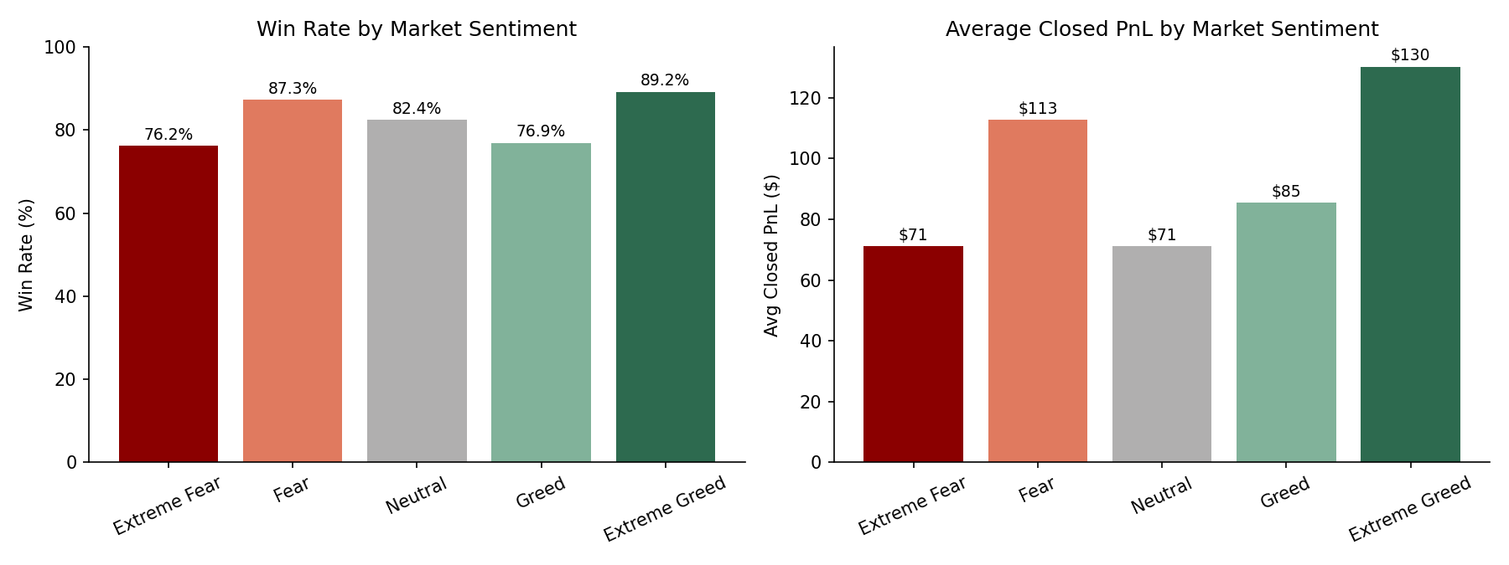
Figure 1. Win rate and average closed PnL per trade across the five sentiment regimes.
Both win rate and average PnL per trade are lowest in Extreme Fear (76% win rate, $71 avg PnL) and highest in Extreme Greed (89% win rate, $130 avg PnL). Fear and Neutral sit in between. This pattern holds even after normalizing for position size:
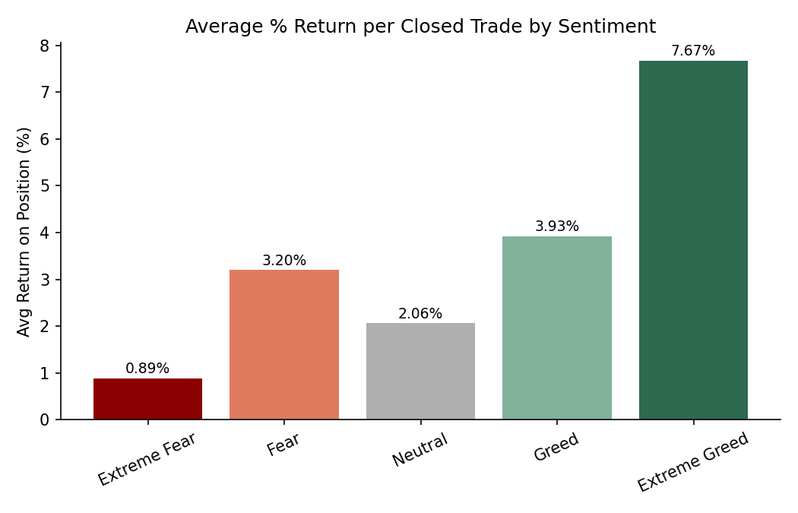
Figure 2. Average return on position (Closed PnL ÷ Size USD) by sentiment — the gap widens once trades are normalized for size.
The average return per trade during Extreme Greed (7.67%) is nearly 9× the return during Extreme Fear (0.89%), and roughly 2× the return during ordinary Greed (3.93%). This suggests the sharpest, most reliable edge in this dataset isn't at the panic extreme — it's in strongly trending, confidently bullish markets, where momentum trades on the winning side of the trend compound quickly.

4. Key Finding #2 — Traders Are Contrarian Positioners
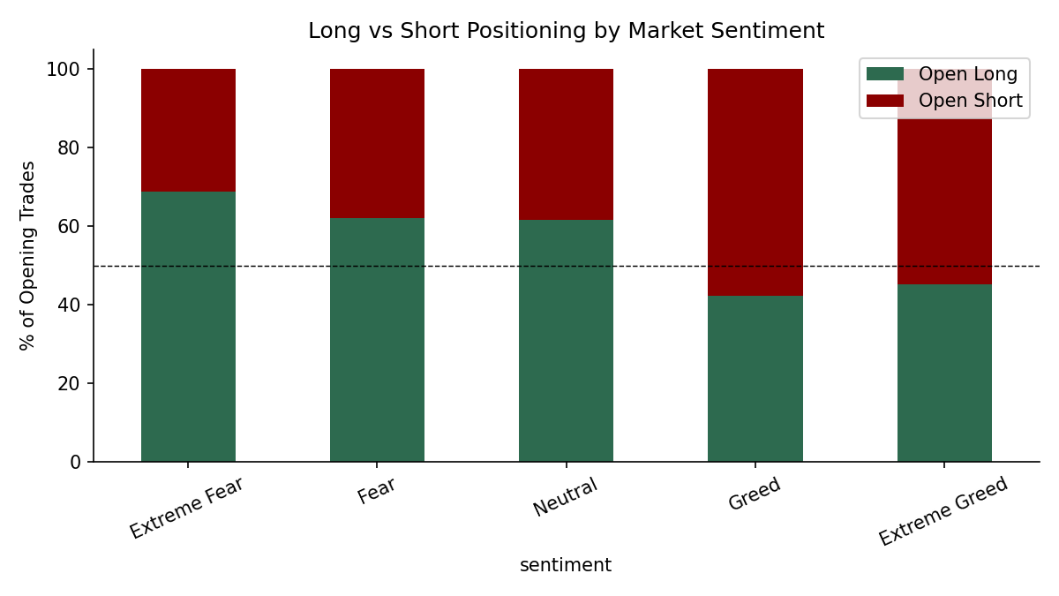
Figure 3. Share of long vs. short position openings by sentiment regime.
Despite fear being the least profitable regime, traders leaned long 69% of the time when opening positions during Extreme Fear, and only 45% long during Extreme Greed — a full positioning reversal. In other words, this cohort is buying dips and fading rallies, consistent with 'smart money' contrarian behavior rather than sentiment-chasing retail flow. That the more profitable regime (Extreme Greed) coincides with more short openings suggests either (a) many of the winning Extreme Greed trades are shorts that get closed quickly for small, high-probability gains, or (b) the minority of long trades placed during strong uptrends capture outsized momentum gains that dominate the average.

5. Key Finding #3 — Fear Drives Volume, Not Value
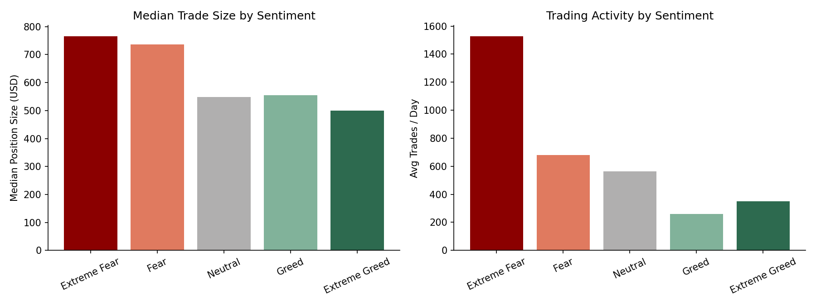
Figure 4. Median trade size and average daily trade count by sentiment.
Extreme Fear days saw by far the highest trading intensity — an average of ~1,529 trades/day versus 260–680 across the other regimes — concentrated in just 14 calendar days in the dataset (major volatility/crash events). Median position size is also largest in Fear ($766) and smallest in Extreme Greed ($500), suggesting traders scale into fear-driven volatility with bigger, more urgent size, even though those trades produce the weakest average returns. This is a classic overtrading-under-stress pattern: more activity and bigger bets exactly when the edge is thinnest.

6. Key Finding #4 — Performance Is Trader-Specific, Not Purely Sentiment-Driven
Grouping realized PnL by account and sentiment, 13 of the 32 accounts (the largest single group) perform best during Extreme Greed, while 7 perform best during Extreme Fear — confirming the aggregate pattern is not uniform. A meaningful minority of accounts have a genuine 'fear edge,' likely disciplined dip-buyers or liquidation hunters, while the majority ride momentum in strongly bullish conditions. This heterogeneity matters for any strategy design: sentiment regime should be one filter among several, not a blanket rule applied to all traders or coins.

7. Summary Statistics by Sentiment
Sentiment | Trades | Win Rate | Avg PnL/Trade | Avg ROI/Trade | Median Size | Avg Trades/Day
Extreme Fear | 21,400 | 0.76 | $71.03 | 0.89% | $766 | 1,528.6
Fear | 61,837 | 0.87 | $112.63 | 3.20% | $736 | 679.5
Neutral | 37,686 | 0.82 | $71.20 | 2.06% | $548 | 562.5
Greed | 50,303 | 0.77 | $85.40 | 3.93% | $555 | 260.6
Extreme Greed | 39,992 | 0.89 | $130.21 | 7.67% | $500 | 350.8

8. Strategic Recommendations
- 1. Lean into strength, not panic. Extreme Greed periods showed the highest win rate (89%) and return per trade (7.67%) in this dataset. A trend-following / momentum-long approach sized normally (not oversized) during confirmed Extreme Greed regimes historically outperformed.
- 2. Cap size and activity during Extreme Fear. Extreme Fear produced the weakest returns (0.89%) despite the heaviest trading activity. Consider hard position-size caps or a cooldown rule on high-volatility Extreme Fear days to avoid overtrading into the regime with the thinnest edge.
- 3. Make contrarian positioning selective, not automatic. The long/short bias reversal (69% long in Fear → 45% long in Extreme Greed) shows this cohort already trades contrarian to sentiment; the data suggests refining that instinct — being selectively long in fear (the minority of high-quality setups) rather than uniformly long — would likely improve the fear-regime win rate.
- 4. Segment strategy by trader/account profile. Because 13 of 32 accounts do best in Extreme Greed vs. 7 in Extreme Fear, a sentiment-based rule should be backtested per-account or per-strategy-style before being applied portfolio-wide.
- 5. Prioritize sentiment signals on the most-traded assets. BTC, HYPE, SOL, and ETH account for the large majority of traded volume; sentiment-based sizing rules should be validated primarily on these liquid majors before extending to long-tail coins where regime effects may differ.

9. Limitations
- 32 accounts is a small, non-random sample (likely already sentiment-aware traders), so results may not generalize to the broader market.
- Extreme Fear is represented by only 14 unique days, so its statistics are more sensitive to a handful of volatile events than the other, more frequently observed regimes.
- Sentiment is a single daily label applied to all trades that day; intraday sentiment shifts are not captured.
- Closed PnL reflects realized gains only and excludes unrealized mark-to-market exposure and funding payments, which can materially affect true regime-conditional profitability.

