

**The Perfect Analyst**

Analysis of Data Oriented Jobs

This proposal contains a detailed description of the plan and

design of database to use Data Oriented Job Application Tool

Created By:

Madathil Geetanjali Menon

Sri Sai Alekya Ghanta

Aishwarya Sadagopan

Nishanthi Ravichandran

**ABOUT**

**Mission Statement**

The project’s mission is to address certain common queries of Masters's students seeking jobs, particularly those applying for a full-time Data Oriented / Analyst role in the United States, via Indeed.com.

**Mission Objectives**

The project would focus on the following main deliverables:

Creating the relevant Database, consisting of the tables and views for the Entities (JobSeeker, Job, Company, Rating, Skill, ProfileMatch)

* Constructing an ER diagram and the Relational Schema, that would capture all the stated nuances.
* To build SQL queries to be able to extract data as per the Client’s requirement and present the same. These include the following:
  + From a Job Seeker’s point of view:
    - Top companies offering high salaries across each job function
    - Identify top skills required for each of the data oriented roles
    - Identify best-rated firms as per the reviews from Glassdoor and Indeed
    - Determine companies offering remote vs onsite opportunities
    - Companies with openings in more than one job function
    - To identify job seeker’s profile match rate with different jobs
  + From a Company’s / Organization’s point of view:
    - Understand reviews by current employees and leverage them for the company’s development
    - Identify top candidates for open positions, based on the required skills

**BACKGROUND**

**Goals:**

* Address common queries of Masters' students seeking full-time job opportunities in the Data Oriented / Analyst job functions across the United States, via Indeed.com

**End Users:**

* Graduate Students, Organizations’ Talent Acquisition Team are our target users

**Data Sources:**

The technique used to obtain data: Web Scraping

Data has been scraped from various sources such as:

* Indeed
* Glassdoor

The tools used to scrape data:

* Octoparse
* APIFY

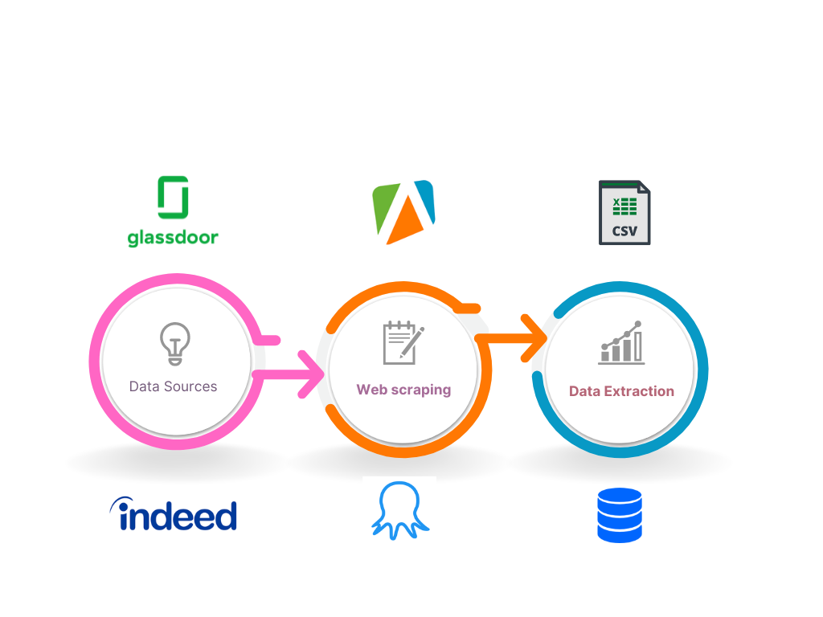

Figure 1: Representation of Data Sources

**BUSINESS PROCESS AND TRANSACTIONS**

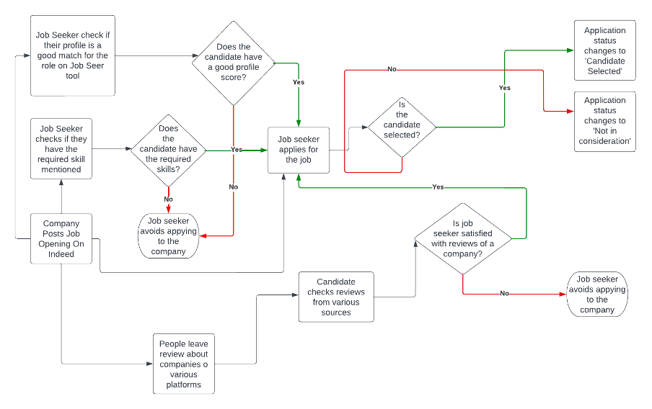

Figure 2: Business process

**DATABASE ANALYSIS**

**ER Schema**

## **Entities, Attributes and Primary Keys**

JobSeeker(**jbsId**, jbsName, -jbsFirstName,-jbsLastName, jbsBirthDate, jbsEmailId, jbsPhnNum, jbsAddress, -jbsCity, -jbsState, -jbsZipCode, jbsEducation[1..3],

jbsPrevExperience[1..5])

Company(**compId,** compName, compDesc, compLocation, -compCity, -compState, compSize)

Job(**jobId**, jobFunction, jobDesc, jobSalary, jobType, jobLocation, =avgSalaryByFunction)

Rating(**ratId**, ratCultureValue, ratWorkLifeBalance,

ratSeniorManagement, ratCompBenefits, ratCareerOpportunities, ratOverallRating,

=avgRating, ratSiteSource)

Skill(**sklId**, sklName)

ProfileMatch(**pmId**, pmScore, pmCategory, pmSkillMatch, pmNumOfAlumni)

## **Relationships, Attributes, Degrees, Participating Entities and Constraints**

**Require:** Ternary Relationship

1 JobSeeker and 1 Skill to 0 or many Jobs

1 Skill and 1 Job to 0 or many JobSeekers

1 JobSeeker and 1 Job to 1 or many Skills

**Has:** Binary Relationships

1 JobSeeker to 1 or many Skills

1 Skill to 0 or many JobSeekers

**Apply(**appDate, appStatus**):** Ternary Relationship

1 Job and 1 Company to 0 or many JobSeekers

1 Company and 1 JobSeeker to 0 or many Jobs

1 JobSeeker and 1 Job to 1 Company only

**Review:** Binary Relationship

1 Company to 0 or many Ratings

1 Rating to 1 Company

**Posts:** Binary Relationship

1 Company to 1 or many Jobs

1 Job to 1 Company

**Check:** Ternary Relationship

1 JobSeeker and 1 Job to 0 or 1 ProfileMatch

1 ProfileMatch and 1 Job to 1 JobSeeker

1 JobSeeker and 1 ProfileMatch to 1 Job

**ER diagram**

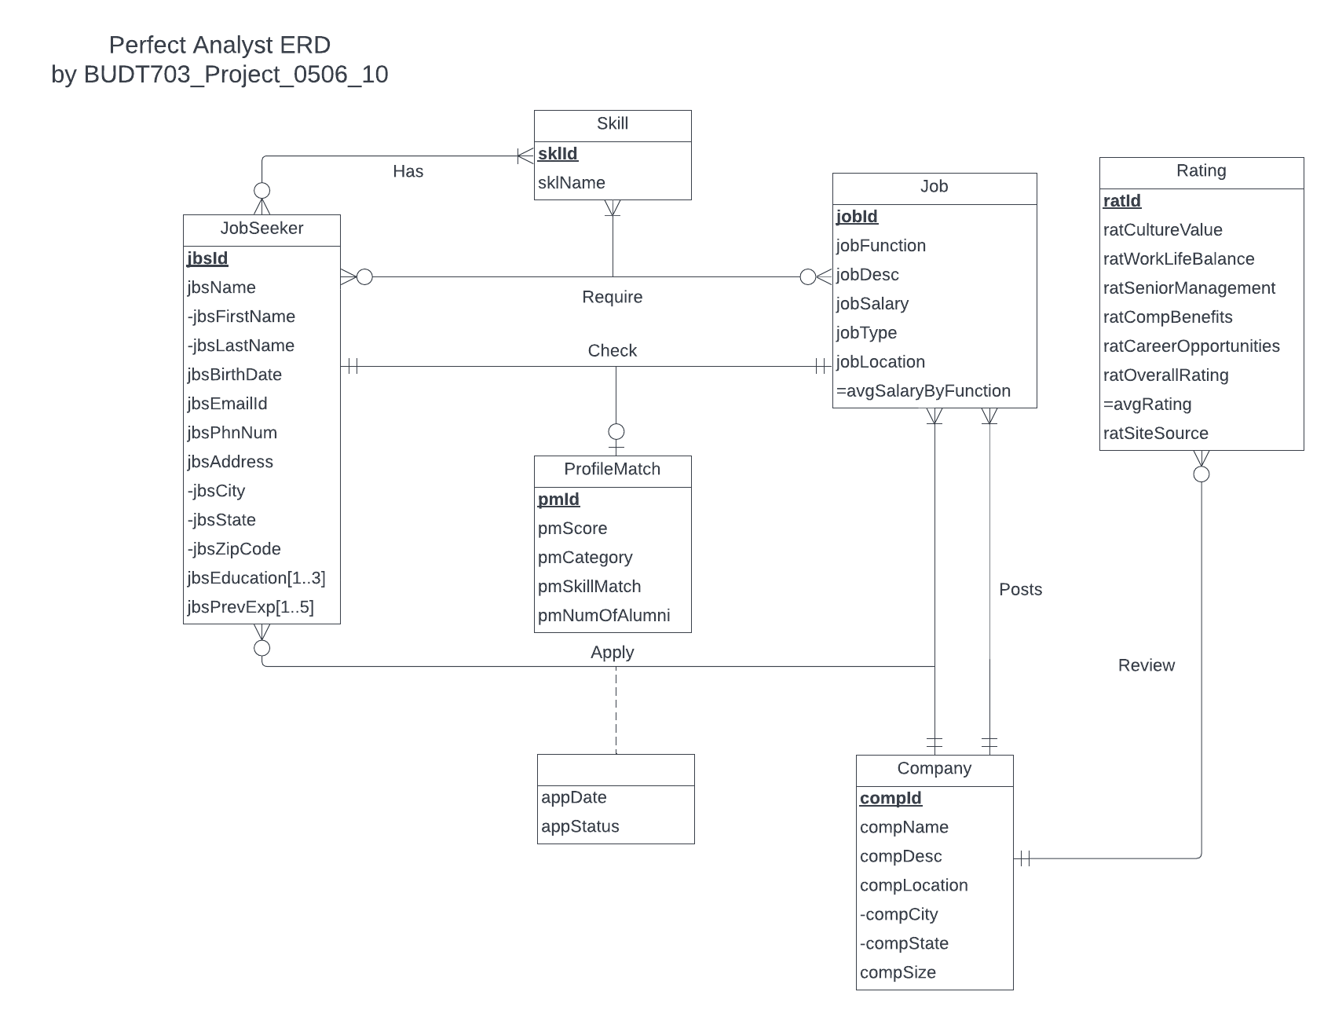

Figure 3: ER Diagram

**Relational Schema:**

JobSeeker (**jbsId**, jbsFirstName, jbsLastName, jbsBirthDate, jbsEmailId, jbsPhnNum, jbsCity, jbsState, jbsZipCode)

Job Seeker Education (***jbsId***, **jbsEducation**)

Job Seeker Previous Experience (***jbsId***, **jbsPrevExperience**)

Company (**compId**, compName, compDesc, compCity, compState, compSize)

Job (**jobId**, jobFunction, jobDesc, jobSalary, jobType, jobLocation, *compId*)

Rating (**ratId**, ratCultureValue, ratWorkLifeBalance, ratSeniorManagement, ratCompBenefits, ratCareerOpportunities, ratOverallRating, ratSiteSource, *compId*)

Skill (**sklId**, sklName)

ProfileMatch (**pmId**, pmScore, pmCategory, pmSkillMatch, pmNumOfAlumni)

Has (***jbsId***, ***sklId***)

Require (***jbsId****,* ***jobId****,* ***sklId***)

Check (***pmId****, jbsId, jobId*)

Apply (***jbsId****,* ***jobId****, compId,* appDate, appStatus)

## **Business rules:**

[R1]: For a JobSeeker having certain Skills, the JobSeeker information cannot be deleted from the database.

[R2]: For a JobSeeker having certain Skills, if the JobSeeker information is updated, then the corresponding Skill information must be updated.

[R3]: For a JobSeeker having certain Skills, the Skill information cannot be deleted as the JobSeeker already has acquired those Skills.

[R4]: For a JobSeeker having certain Skills, if the Skill information is updated, then the corresponding JobSeeker information must be updated.

[R5]: When a JobSeeker seeks a Job that requires certain Skills, the JobSeeker information cannot be deleted from the database.

[R6]: When a JobSeeker seeks a Job that requires certain Skills, if the JobSeeker information is updated, then the corresponding Job and Skill information should be updated.

[R7]: For a particular Job that requires certain Skills from a JobSeeker, if the job information is deleted, then the corresponding JobSeeker and Skill information should be deleted.

[R8]: For a particular Job that requires certain Skills from a JobSeeker, if the Job information is updated, then the corresponding JobSeeker and Skill information should be updated.

[R9]: For a Skill that is required by a Job from a JobSeeker, if the Skill information is deleted, then the corresponding JobSeeker and Job information should be deleted.

[R10]: For a Skill that is required by a Job from a JobSeeker, if the Skill information is updated, then the corresponding JobSeeker and Job information should be updated.

[R11]: For a ProfileMatch being checked by a JobSeeker for a particular Job, if the ProfileMatch information is deleted, then the corresponding Job and JobSeeker information should be deleted.

[R12]: For a ProfileMatch being checked by a JobSeeker for a particular Job, if the ProfileMatch information is updated, then the corresponding Job and JobSeeker information should be updated.

[R13]: For a JobSeeker checking ProfileMatch for a certain job, the JobSeeker information cannot be deleted.

[R14]: For a JobSeeker checking ProfileMatch for a certain Job, if the JobSeeker information is updated, then the corresponding Job and ProfileMatch information should be updated.

[R15]: If the Job information for a particular Job is deleted, then the corresponding details of the ProfileMatch and JobSeeker should also be deleted.

[R16]: If the Job information for a particular Job is updated, then the corresponding details of the ProfileMatch and the JobSeeker should also be updated.

[R17]: For a particular JobSeeker applying to a Job in a Company, then the JobSeeker information cannot be deleted.

[R18]: For a particular JobSeeker applying to a Job in a Company, if the JobSeeker information is updated, then the corresponding details of the Job, Company and application should be updated.

[R19]:If the Job information of a particular Job is deleted, then the corresponding details of the JobSeeker, Company and application should also be deleted.

[R20]:If the Job information for a particular Job is updated, then the corresponding details of the JobSeeker, Company and application should also be updated.

[R21]: If the Company information of a particular Company is deleted, then the corresponding details of the Job, JobSeeker and application should also be deleted.

[R22]: If the Company information of a particular Company is updated, then the corresponding details of the Job, JobSeeker and application should also be updated.

[R23]: If the Company information of a particular Company is deleted, then the corresponding details of the Rating should also be deleted.

[R24]: If the Company information of a particular Company is updated, then the corresponding details of the Rating should also be updated.

[R25]: For a JobSeeker who has education listed, the JobSeeker information cannot be deleted.

[R26]: For a JobSeeker who has education listed, if the JobSeeker information is updated then the corresponding JobSeeker education information should also be updated.

[R27]: For a JobSeeker who has previous experience listed, the JobSeeker information cannot be deleted.

[R28]: For a JobSeeker who has previous experience listed, if the JobSeeker information is updated then the corresponding JobSeeker previous experience information should also be updated.

[R29]: For a Company that has a Job listed, the Job details cannot be deleted from the database.

[R30]: For a Company that has a Job listed, the Job details cannot be updated on the database.

## 

## **Referential Integrities:**

|  |  |  |  |  |  |  |  |
| --- | --- | --- | --- | --- | --- | --- | --- |
| Relation | Foreign Key | Base Relation | Primary Key | Business Rule | Constraint: ON DELETE | Business Rule | Constraint: ON UPDATE |
| Has | jbsId | JobSeeker | jbsId | R1 | NO ACTION | R2 | CASCADE |
| Has | sklId | Skill | sklId | R3 | NO ACTION | R4 | CASCADE |
| Require | jbsId | JobSeeker | jbsId | R5 | NO ACTION | R6 | CASCADE |
| Require | jobId | Job | jobId | R7 | CASCADE | R8 | CASCADE |
| Require | sklId | Skill | sklId | R9 | CASCADE | R10 | CASCADE |
| Check | pmId | ProfileMatch | pmId | R11 | CASCADE | R12 | CASCADE |
| Check | jbsId | JobSeeker | jbsId | R13 | NO ACTION | R14 | CASCADE |
| Check | jobId | Job | jobId | R15 | CASCADE | R16 | CASCADE |
| Apply | jbsId | JobSeeker | jbsId | R17 | NO ACTION | R18 | CASCADE |
| Apply | jobId | Job | jobId | R19 | CASCADE | R20 | CASCADE |
| Apply | compId | Company | compId | R21 | CASCADE | R22 | CASCADE |
| Rating | compId | Company | compId | R23 | CASCADE | R24 | CASCADE |
| Job Seeker Education | jbsId | JobSeeker | jbsId | R25 | NO ACTION | R26 | CASCADE |
| Job Seeker Previous Experience | jbsId | JobSeeker | jbsId | R27 | NO ACTION | R28 | CASCADE |
| Job | compId | Company | compId | R29 | NO ACTION | R30 | NO ACTION |

**IMPLEMENTING DATABASE**

After the development of the database, 6 business transactions have been configured on SQL and Tableau as examples.

BUSINESS TRANSACTION 1: ***What are the top 5 companies by salary within each job function?***

SQL CODE:

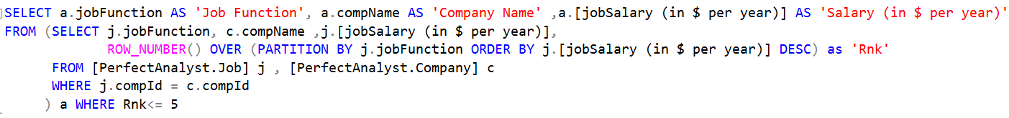

Figure 4: SQL Code for Business Transaction 1

SQL OUTPUT:

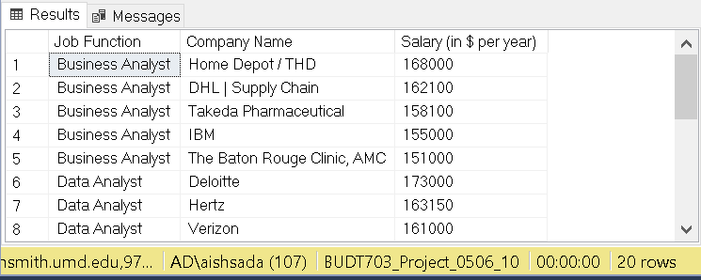

Figure 5: SQL Output for Business Transaction 1

TABLEAU:

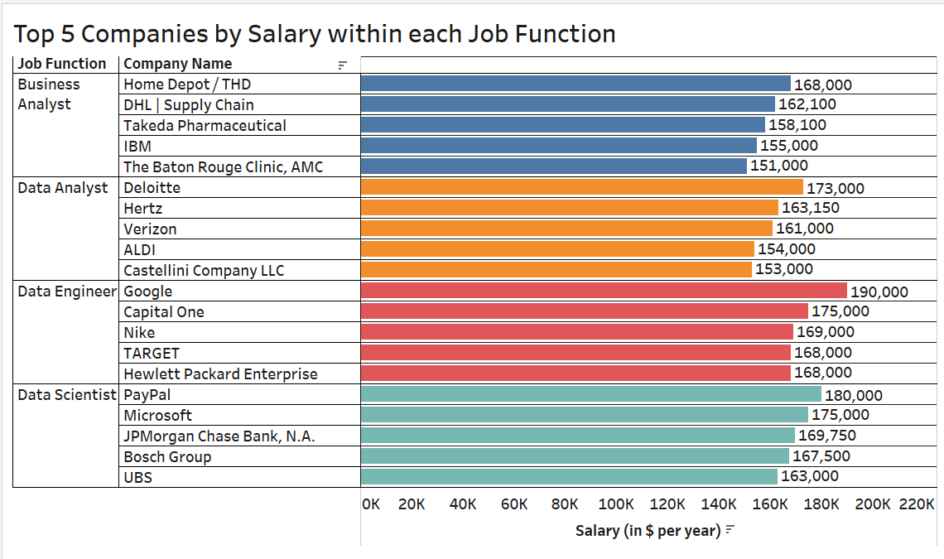

Figure 6: Tableau Output for Business Transaction 1

BUSINESS TRANSACTION 2:

***What are the percentage of different skills required in each job function?***

SQL CODE:

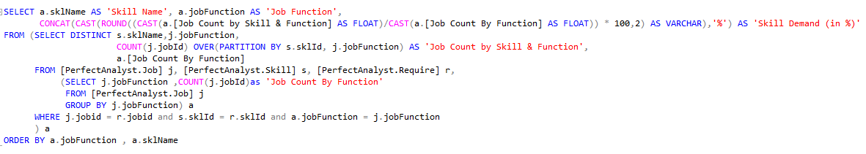

Figure 7: SQL Code for Business Transaction 2

SQL OUTPUT:

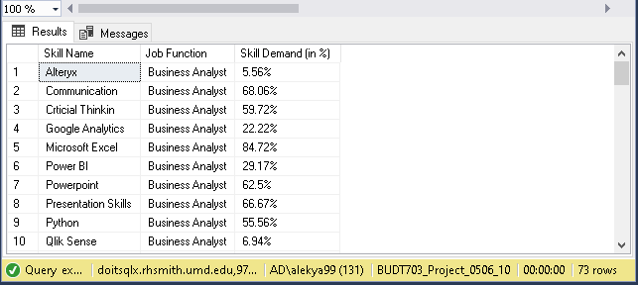

Figure 8: SQL Output for Business Transaction 2

TABLEAU:

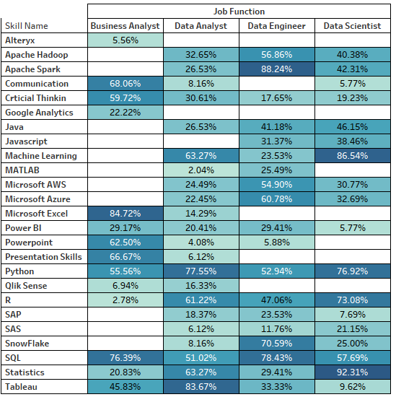

Figure 9: Tableau Output for Business Transaction 2

BUSINESS TRANSACTION 3: ***What are top 10 overall best-rated firms as per reviews from Glassdoor and Indeed?***

SQL CODE:

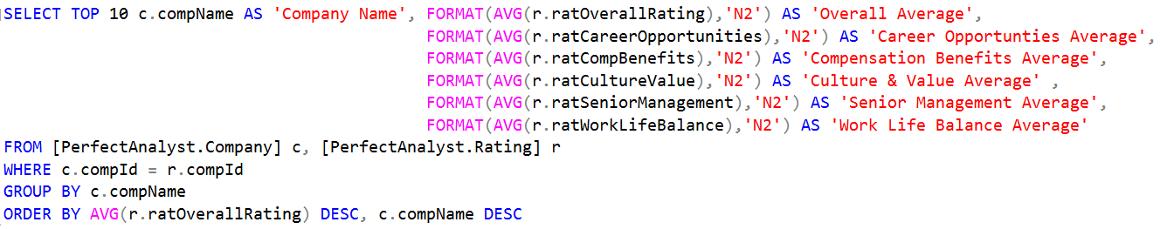

Figure 10: SQL Code for Business Transaction 3

SQL OUTPUT:

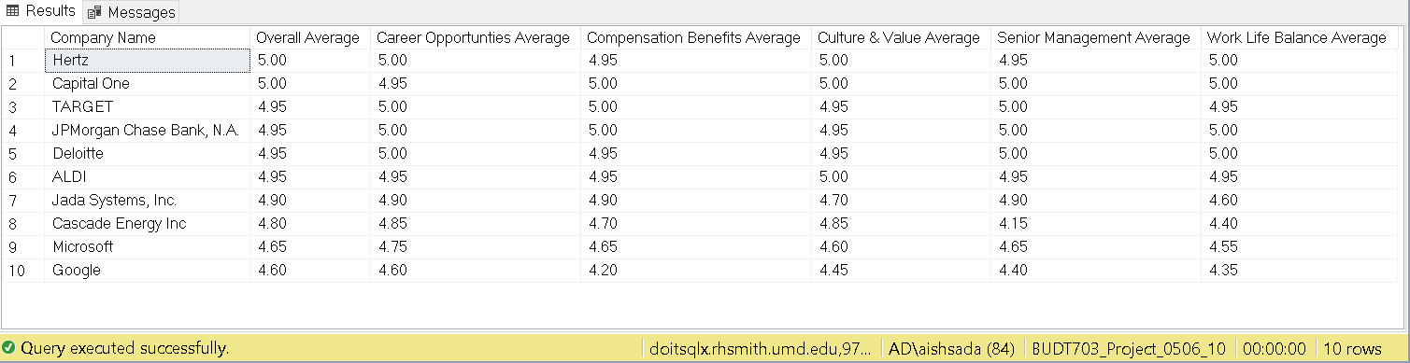

Figure 11: SQL Output for Business Transaction 3

TABLEAU:

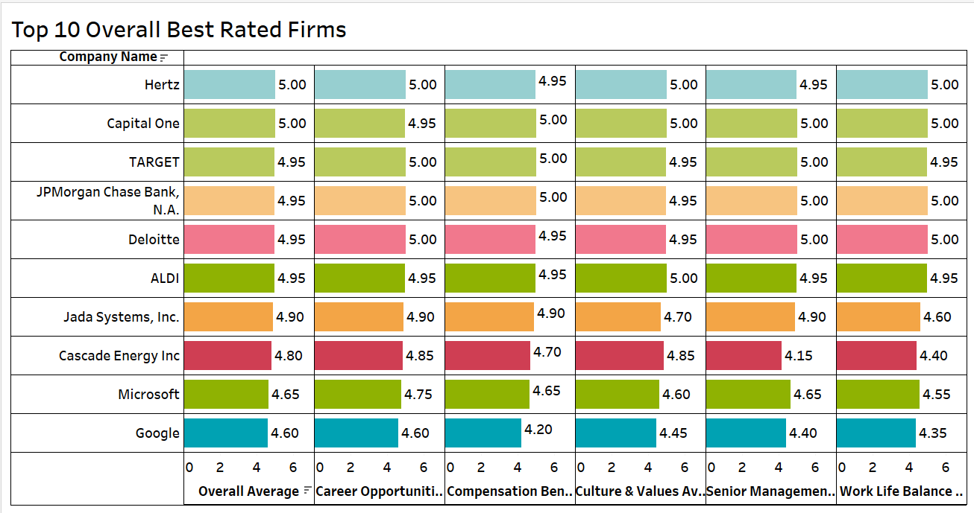

Figure 12: Tableau Output for Business Transaction 3

BUSINESS TRANSACTION 4: ***What is the percentage of remote vs onsite job opportunities?***

SQL CODE:



Figure 13: SQL Code for Business Transaction 4

SQL OUTPUT:



Figure 14: SQL Output for Business Transaction 4

TABLEAU:

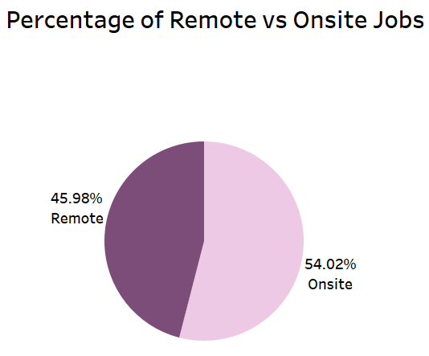

Figure 15: Tableau Output for Business Transaction 4

BUSINESS TRANSACTION 5: ***What are the companies with openings in multiple job functions?***

SQL CODE:

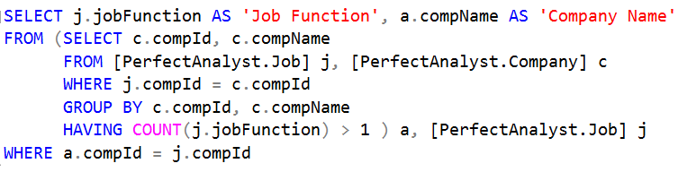

Figure 16: SQL Code for Business Transaction 5

SQL OUTPUT:

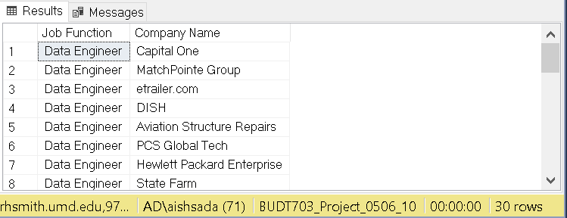

Figure 17: SQL Output for Business Transaction 5

TABLEAU:

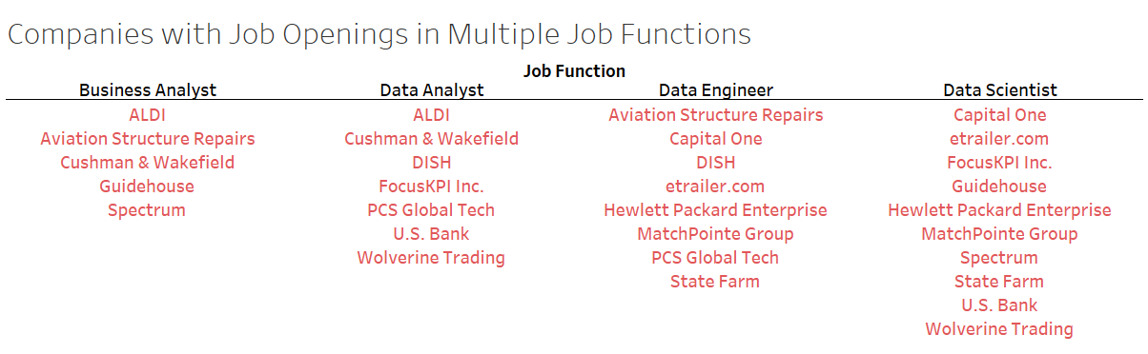

Figure 18: Tableau Output for Business Transaction 5

BUSINESS TRANSACTION 6: ***What is the profile match share by categories?***

SQL CODE:

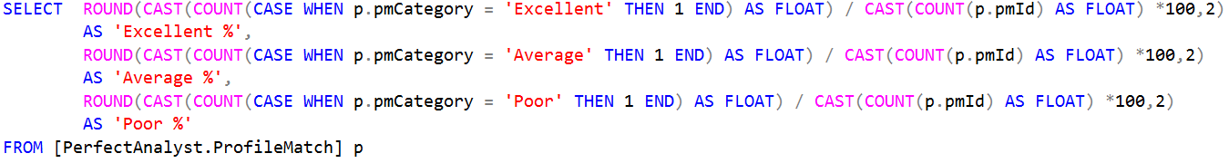

Figure 18: SQL Code for Business Transaction 6

SQL OUTPUT:



Figure 18: SQL Output for Business Transaction 6

TABLEAU:

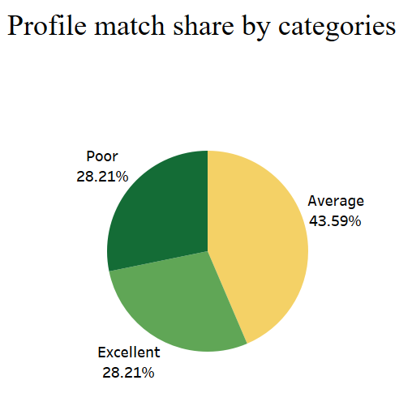

Figure 19: Tableau Output for Business Transaction 6

DASHBOARD:

