**Aim:** Designing User Interface and Wireframe for Multiple Layouts Using Figma.

**Description:**

The aim of this lab experiment is to understand the process of creating user interface (UI) designs and wireframes for multiple layouts using Figma, a collaborative design tool. The experiment focuses on developing responsive design layouts for different screen sizes and devices, utilizing Figma's features like auto-layout, components, and constraints.

**Objective:**

* To learn the basics of wireframing and UI design.
* To utilize Figma’s design tools and features effectively.
* To explore interactive elements for creating a functional prototype.

**Tools Required:**

* Figma (Free or paid account)
* Web Browser
* Stable Internet Connection

Figma is a vector graphics editor and prototyping tool primarily used for UI/UX design. It allows multiple users to collaborate in real-time. In this experiment, we will explore the concepts of wireframing (creating low-fidelity layouts) and UI design (developing high-fidelity interactive layouts). Wireframes serve as a blueprint for the structure of a digital product, while UI design focuses on aesthetic and interactive elements.

**Implementation:**

*Figma Setup:*

* Sign up or log in to Figma at [Figma Website](https://www.figma.com).
* Create a new file and choose the desired device frame (Desktop, Tablet, Mobile)

*Auto Layout & Constraints:*

* Use Figma’s **Auto Layout** feature to ensure that the UI elements align and resize automatically with changes in frame sizes. This is particularly useful for responsive design.
* Apply **Constraints** to elements to control their positioning and resizing as the frame adjusts. For example, pin elements to the left or right edges or set them to scale proportionally.

*Component Creation:*

* Identify common UI elements like buttons, icons, or navigation bars and convert them into **Components**.
* Components allow for reusable design elements that can be updated globally across multiple frames.

*UI Design:*

* Now, convert the wireframe into a high-fidelity UI by adding colors, typography, and images.
* Add **Icons** from Figma’s built-in libraries or external resources. Ensure all text is styled using a **consistent font and size**.
* Use the **Fill** and **Stroke** properties to adjust colors and effects.

*Prototype Development:*

* Once the UI design is complete, add interactivity using **Prototyping Tools**.
* Define interactions such as button clicks or navigation between pages.
* Link the frames together to create a working prototype of the design.

*Testing and Exporting:*

* Test the design prototype by clicking the “Present” button. This will simulate the user experience.
* Make adjustments based on feedback.
* Export individual assets or the entire design as needed by developers, using formats like PNG, SVG, or PDF.

**Prototype Design:**

To create a Figma design using various tools within Figma, follow these steps:

1. Create a New File/Project

* Open Figma and either create a new project or file.
* Set up the project by naming it and organizing your workspace.

2. Set Up Frames

* Tool: Frame Tool
* Frames in Figma act as containers for your design
* Select the Frame tool and choose from preset screen sizes (e.g., Desktop, Mobile) or define custom sizes.

3. Add Shapes and Objects

* Tool: Shape Tools
* Use the shape tools to create different objects in your design, such as buttons, containers, and icons.

4. Use the Pen Tool for Custom Shapes

* Tool: Pen Tool
* The Pen Tool helps you create custom shapes, paths, and vectors. Click to create anchor points and form custom designs.

5. Typography & Text Styling

* Tool: Text Tool
* Click anywhere on the frame to add text. You can adjust font, size, weight, color, and spacing from the right-hand properties panel.

6. Color Management

* Tool: Color Picker
* Select any object and use the color picker in the right-hand panel to change its color. You can set colors for fills, strokes, and backgrounds.
* Create color styles to keep your design consistent.

7. Add Images and Icons

* Tool: Place Image
* Drag and drop images or use the Place Image option to import visuals. You can also integrate plugins like Unsplash to directly pull in images.

8. Use Auto Layout for Responsive Designs

* Tool: Auto Layout
* Auto Layout allows you to create responsive designs that adapt to different screen sizes. Apply Auto Layout to groups of elements to control padding, alignment, and resizing behavior.

9. Components and Variants

* Tool: Component Tool
* Convert commonly used UI elements (like buttons, cards, etc.) into components so you can reuse them across the design. Use Variants for different states of components (e.g., active, hover, disabled).

10. Prototyping

* Tool: Prototype Tool (located on the right panel)
* Add interactivity to your design by connecting frames and creating interactions. Set up flows, transitions, and animations for a working prototype.

13. Export Designs

* Tool: Export Options
* Select frames or objects and choose export formats (PNG, SVG, PDF, etc.). Adjust resolution and export for different devices if needed.

By using these tools effectively, you can create detailed, responsive, and interactive designs within Figma.

*7Eleven Online Food Delivery App*

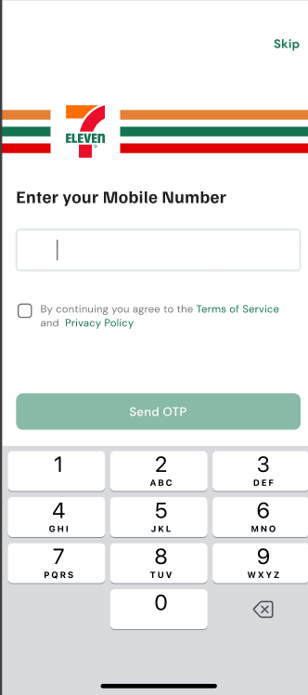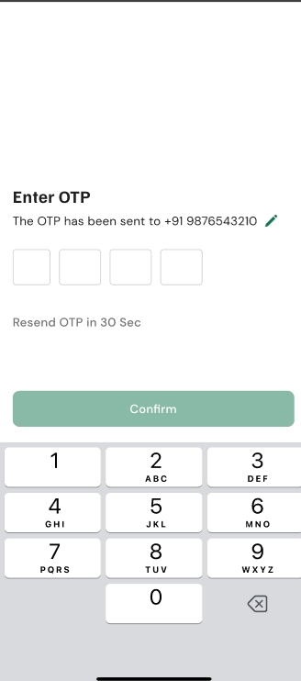

*Figure: Login & OTP Screen*

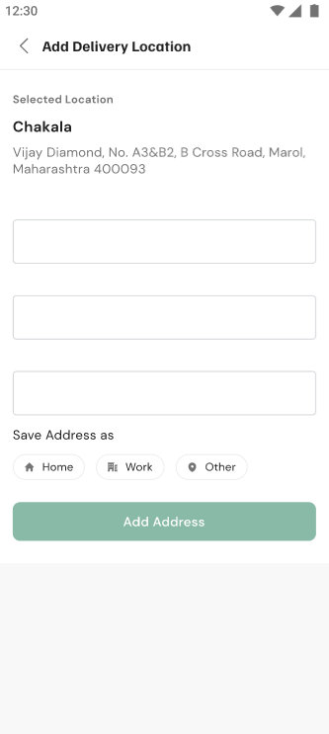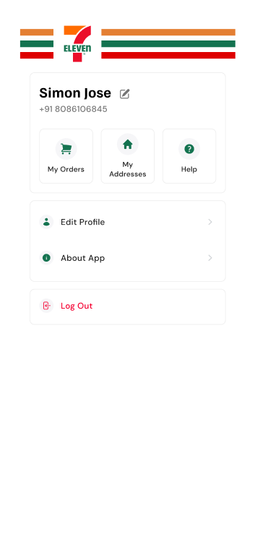

*Figure: Profile & Address Update*

**Conclusion:** By completing this experiment, we gained hands-on experience with Figma’s powerful design tools. We learned how to create wireframes, design responsive UI layouts, and add interactivity using prototyping features. This experiment highlights the importance of creating flexible, reusable components and considering multiple device layouts early in the design process. Figma’s collaborative features also facilitate real-time collaboration, making it an ideal tool for modern UI/UX design projects.