**Aim:** Setting Up the Development Environment for React Native and .NET MAUI on Windows and Building First Simple Application.

The aim of this lab experiment is to set up the development environment for React Native and .NET MAUI on a Windows system and build simple applications for both platforms. This will involve installing necessary tools, configuring the environment, and creating basic apps to demonstrate their functionality.

**Description:**

In this experiment, we set up the development environments for React Native and .NET MAUI on a Windows machine and built simple mobile applications using both frameworks. For React Native, we installed Node.js, React Native CLI, and Android Studio. The basic React Native app was created and run on an Android emulator. For .NET MAUI, we installed Visual Studio 2022 with the MAUI development workload. A simple cross-platform MAUI application was created and tested on an Android emulator.

***React Native:***

We created a project using the react-native init command, which generated a basic structure. The app displayed a simple "Hello World" message when run on the Android emulator. The React Native ecosystem uses JavaScript for app development and supports rapid UI iteration.

***.NET MAUI:***

The .NET MAUI app development followed a similar process, using C# and XAML for UI design. Visual Studio’s built-in tools simplified the development process, and we were able to build and run the app across multiple platforms (Android, iOS, Windows).

**Objective:**

* To set up the development environment for React Native on Windows.
* To set up the development environment for .NET MAUI on Windows.
* To develop a simple mobile application using both frameworks.
* To compare the initial setup and app development process for React Native and .NET MAUI.

**Tools Required:**

**1. For React Native:**

* ***Node.js****:*
  + Download from: <https://nodejs.org/>
  + Required to manage packages and run React Native CLI.
* ***React Native CLI****:*
  + Installed via npm (Node Package Manager). This command-line interface is used to create and manage React Native projects.
* ***Android Studio****:*
  + Download from: <https://developer.android.com/studio>
  + Includes Android SDK, Android Emulator, and ADB tools necessary for running and debugging Android apps.
* ***Java Development Kit (JDK)****:*
  + Download from: <https://www.oracle.com/java/technologies/javase-jdk11-downloads.html>
  + Required for Android development and building the app.
* ***Android Emulator or Physical Device****:*
  + Used for testing the React Native app.
* ***Code Editor*** *(Optional):*
  + **Visual Studio Code** is recommended. Download from: <https://code.visualstudio.com/>
  + Used for writing and editing JavaScript code.

**2. For .NET MAUI:**

* ***Visual Studio 2022****:*
  + Download from: <https://visualstudio.microsoft.com/>
  + Choose the **Mobile development with .NET** workload, which includes .NET MAUI support.
* ***.NET SDK****:*
  + Included with Visual Studio, needed to run and build .NET projects.
* ***Android SDK and Emulator*** *(Included in Visual Studio):*
  + Used for testing Android apps developed with .NET MAUI.
* ***Windows Subsystem for Android (Optional)****:*
  + For running Android apps on Windows, available with some Windows versions.

**Implementation:**

***ReactNative Installation:***

*There are a couple of things you need to install to set up the environment for React Native. -NodeJS and NPM*

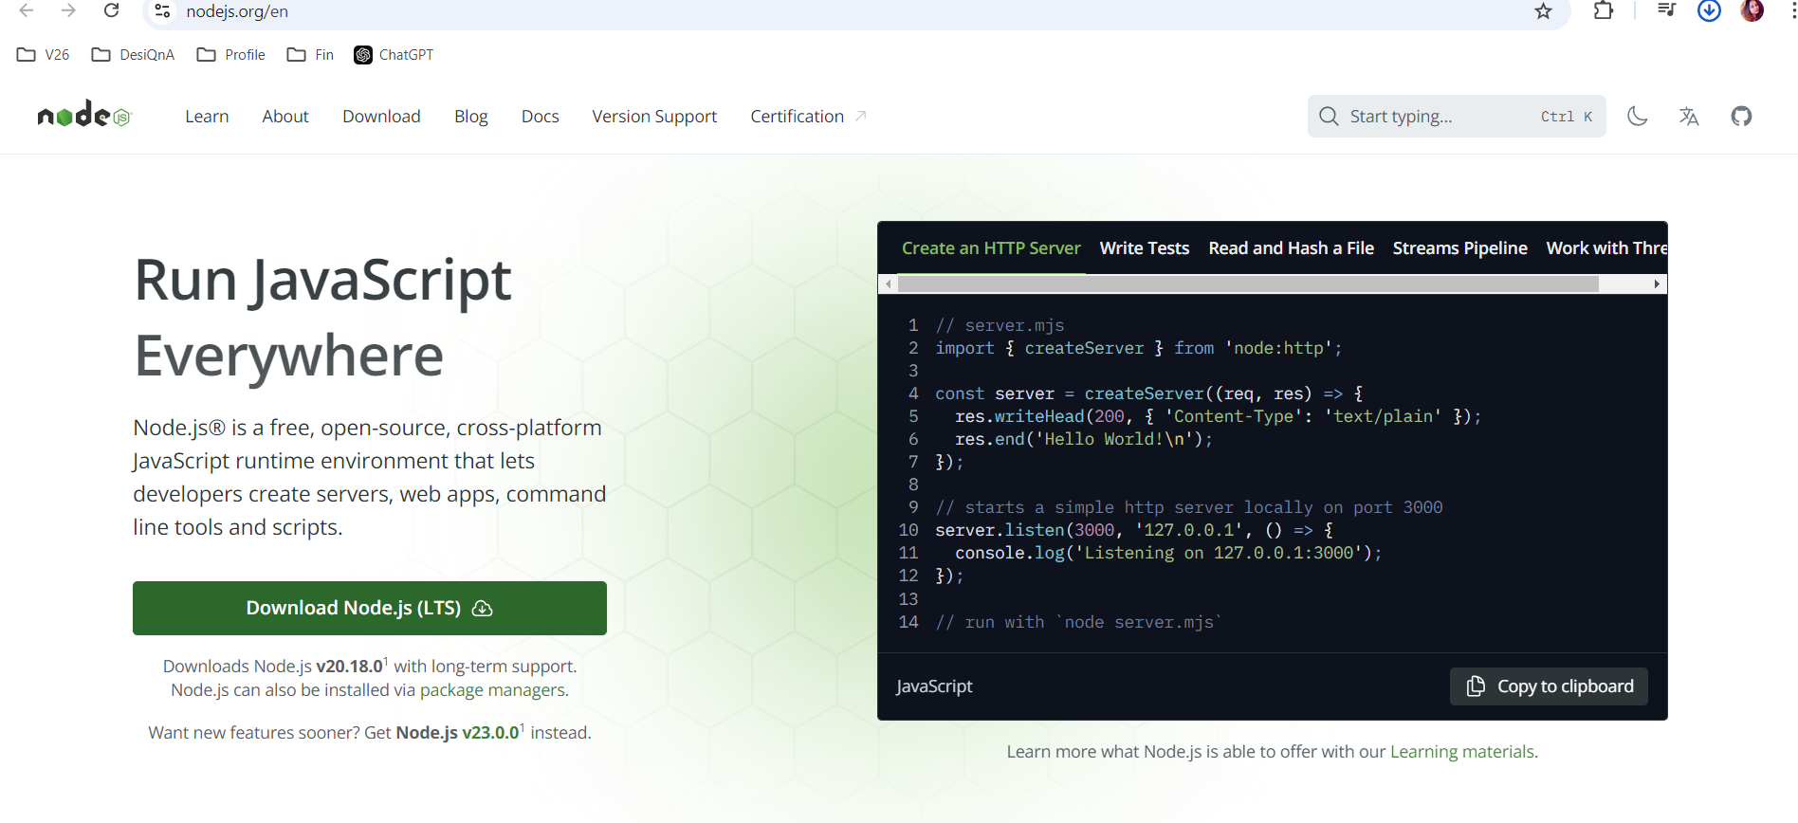

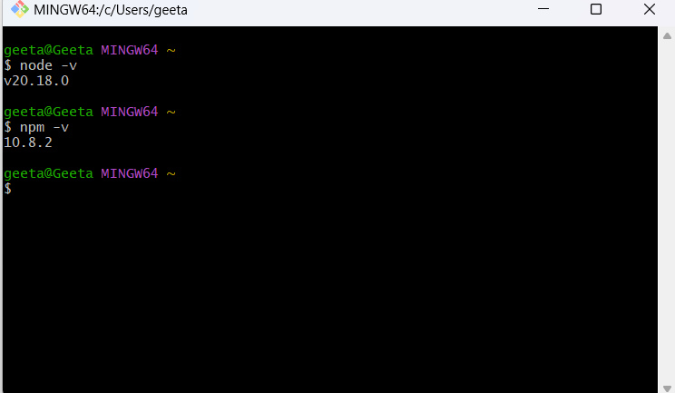

*Install the latest* ***JDK*** *from* [*Oracle's website*](https://www.oracle.com/java/technologies/javase-jdk11-downloads.html)*.*

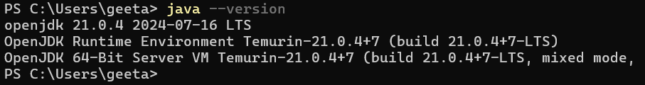

***Step 1: Install create-react-native-app***

*After installing NodeJS and NPM successfully in your system you can proceed with installation of create-react-native-app*

***Command - npm install -g create-react-native-app***

***Step 2: Create project***

*Browse through required folder and create a new react native project as shown below.*

***Command - cd <folder_name>***

***Command - create-react-native-app <app_name>***

***Step 3: Install React Native CLI***

*You can install react native command line interface on npm*

***Command - install -g react-native-cli***

***Step 4: Start react native***

*To verify the installation, browse through the project folder and try starting the project using,*

***Command- cd <folder_name>***

***Command – npm start***

*If everything went well you will get a QR code.*

***Step 5: Installing Android Studio***

*Visit the web page*[*https://developer.android.com/studio/*](https://developer.android.com/studio/)*and download android studio. After downloading the installation file of it, double click on it and proceed with the installation.*

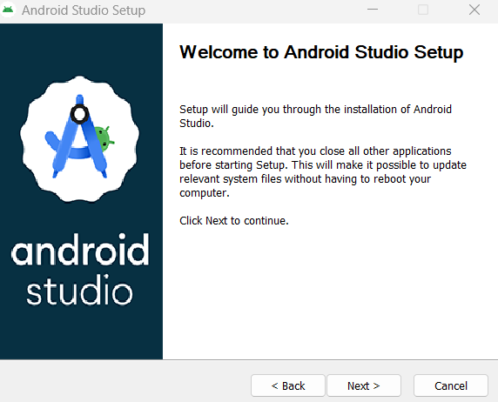

***Step 6: Running android***

*Open command prompt, browse through your project folder and, execute the****react-native run-android****command.*

***.NET MAUI Installation:***

*Download from:* [*https://visualstudio.microsoft.com/*](https://visualstudio.microsoft.com/)

*In Visual Studio Code, in the Extensions tab, search for ".NET MAUI" and install the*[*.NET MAUIextension*](https://aka.ms/mauidevkit-marketplace)*. The .NET MAUI extension automatically installs the*[*C# Dev Kit*](https://marketplace.visualstudio.com/items?itemName=ms-dotnettools.csdevkit)*and*[*C#*](https://marketplace.visualstudio.com/items?itemName=ms-dotnettools.csharp)*extensions, which are required for the .NET MAUI extension to run.*

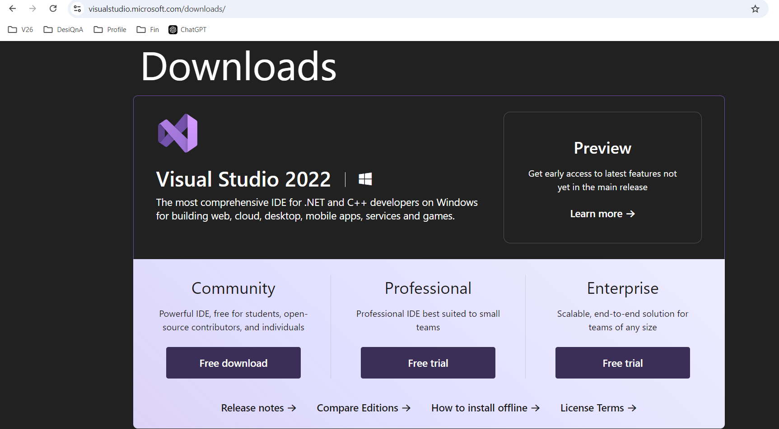

*Select community*

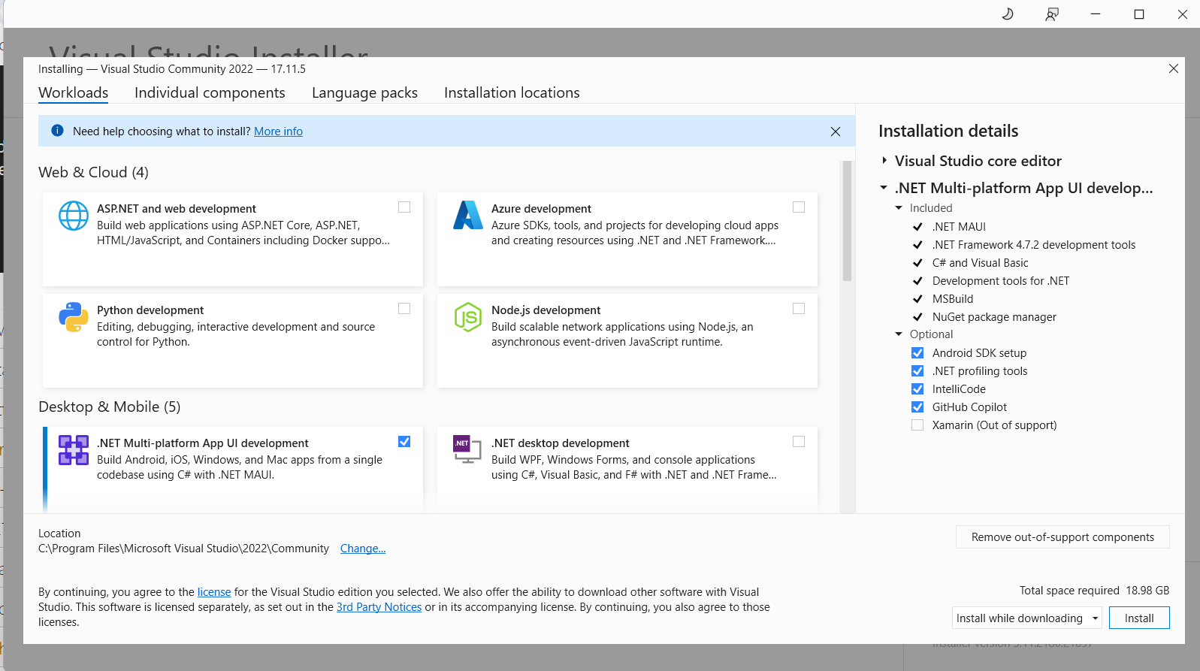

*Select .NET Multi-platform App UI development*

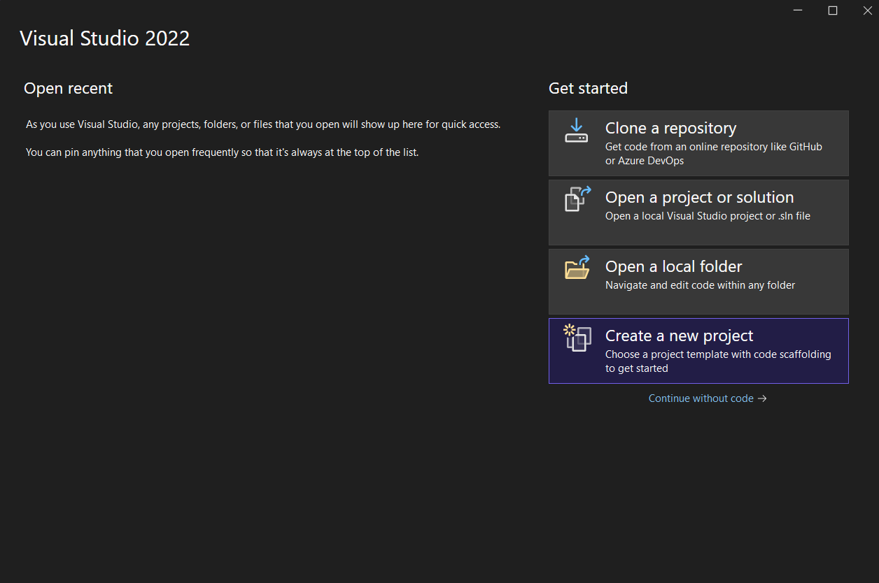

*Create a new project*

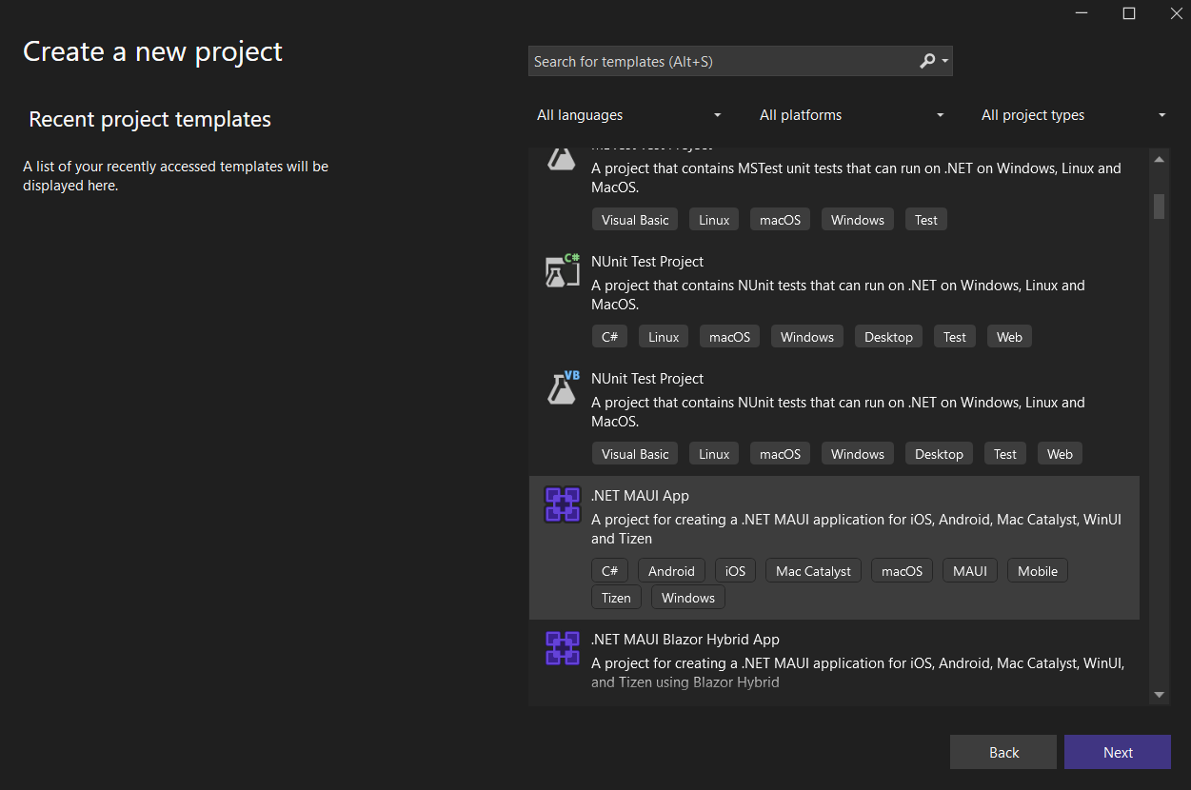

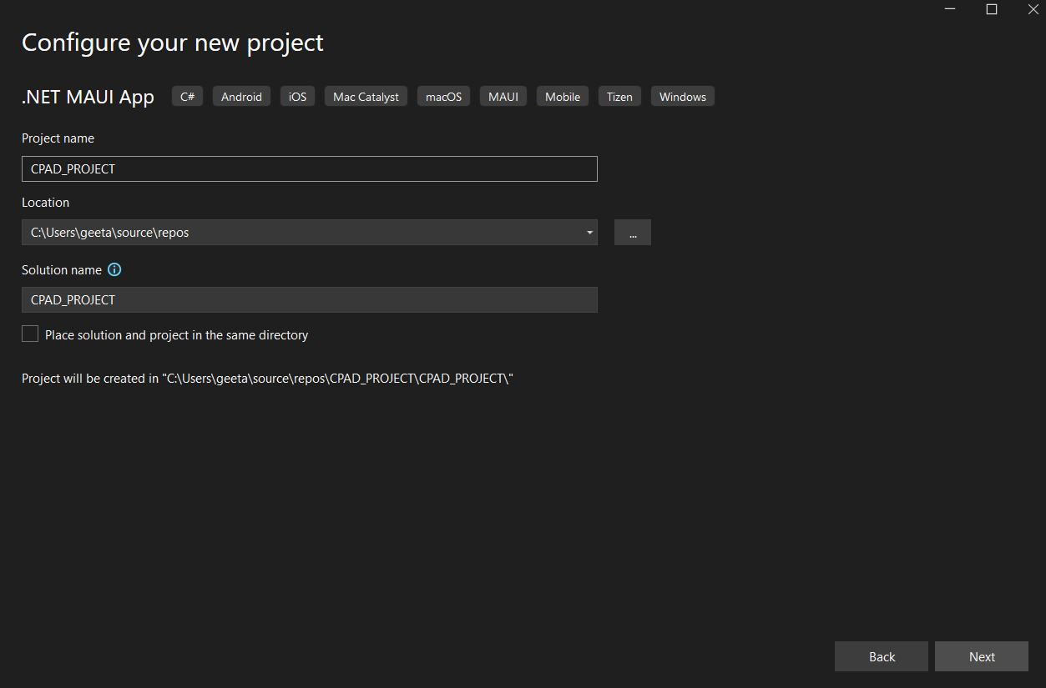

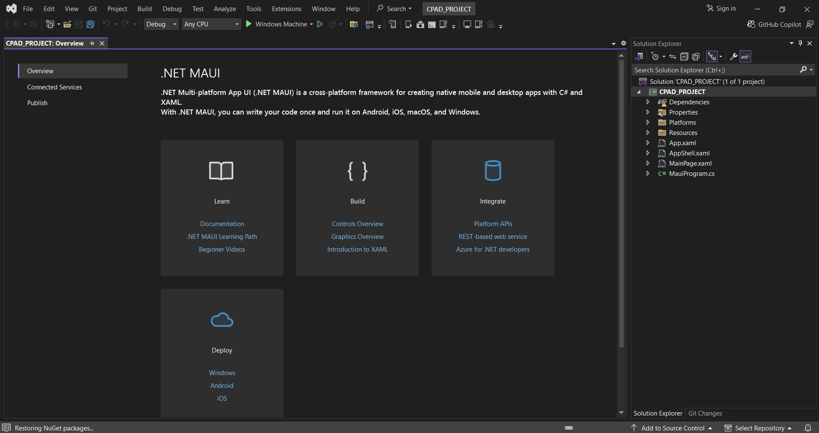

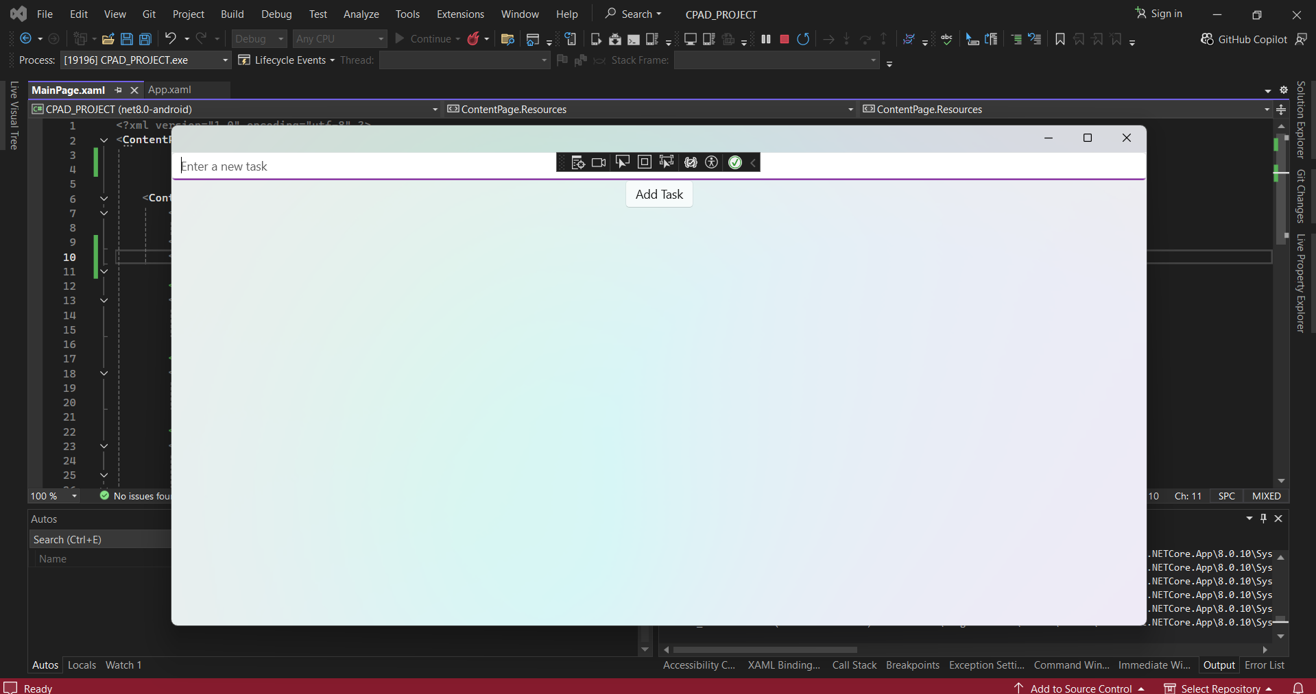

OUTPUT

App.xaml

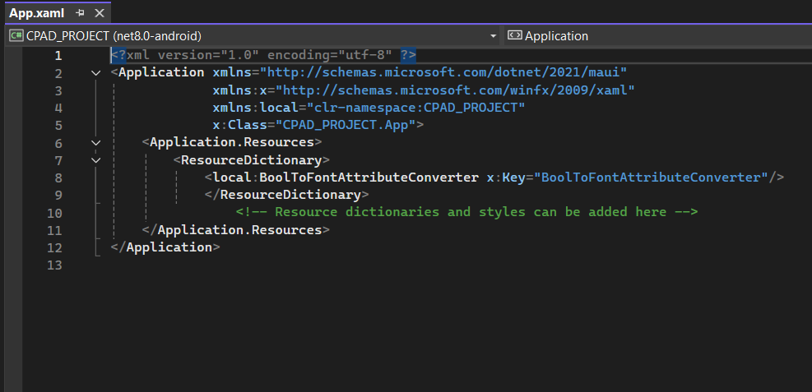

MainPage.xaml

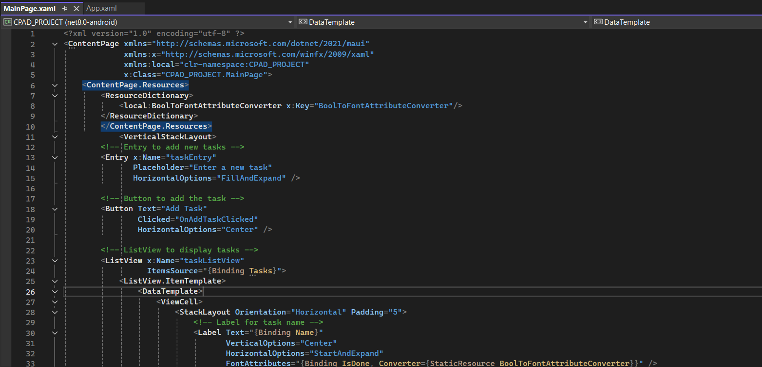

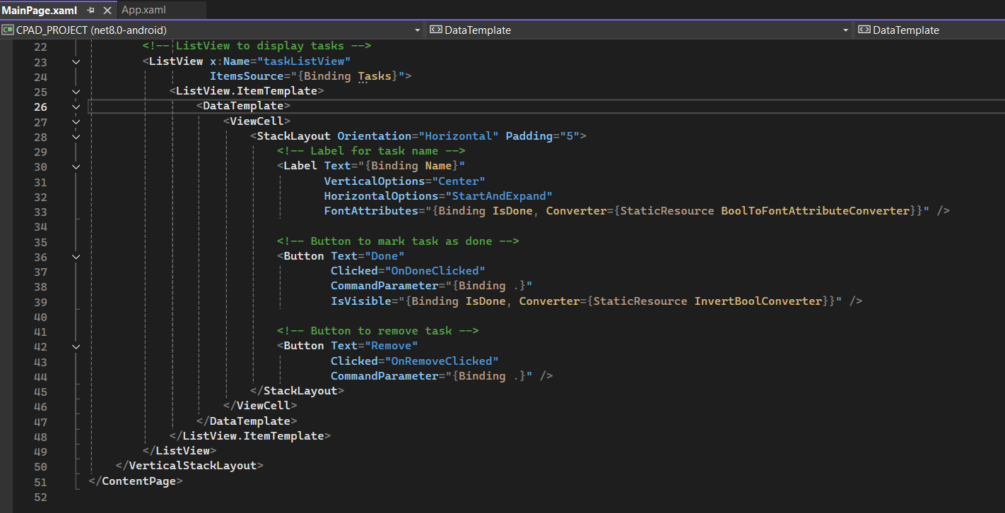

MainPage.xaml.cs

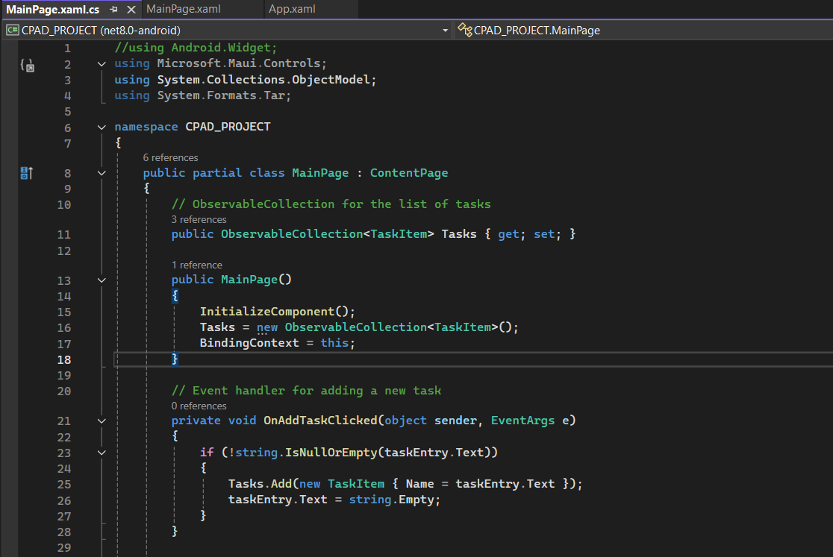

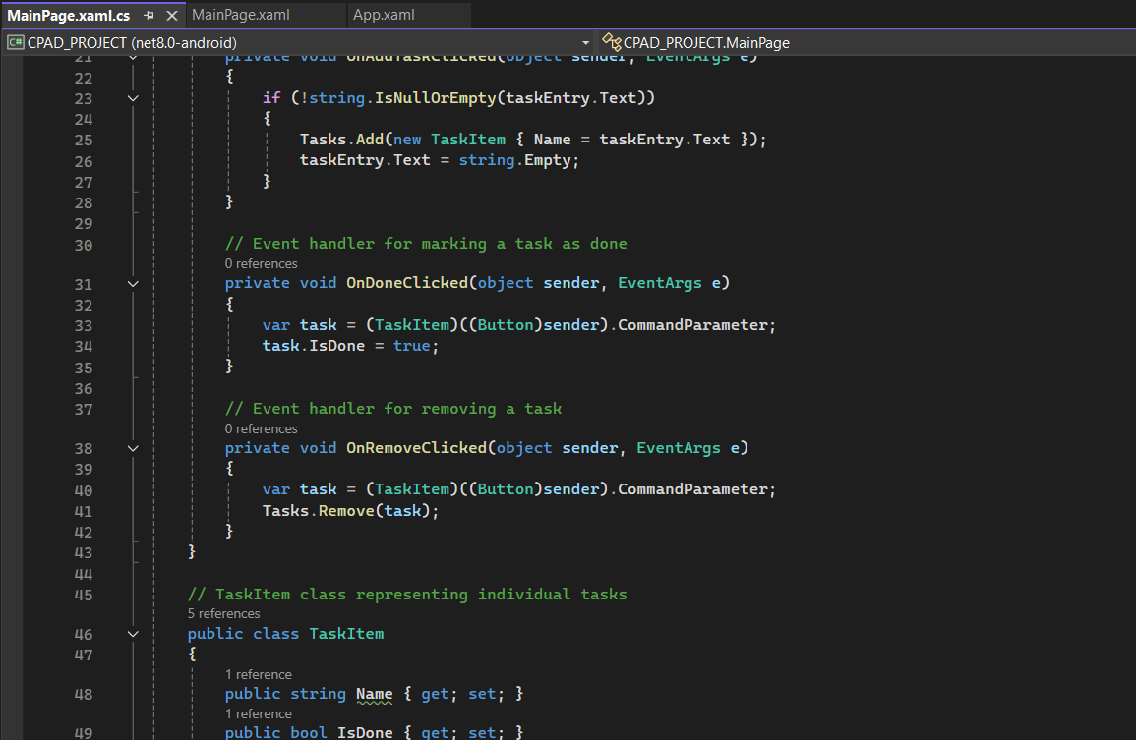

InvertBoolConverter.cs

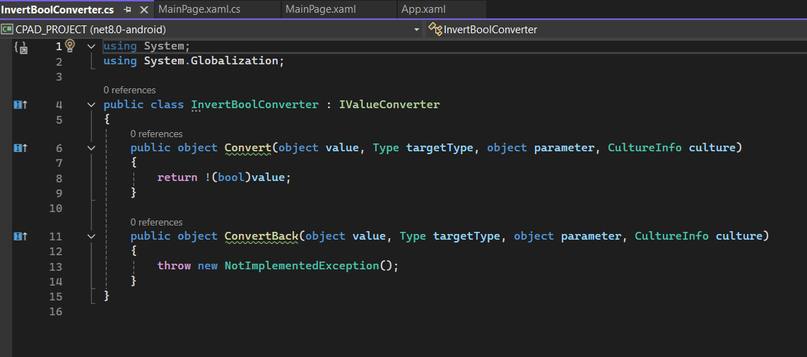

BoolToFontAttributeConverter.cs

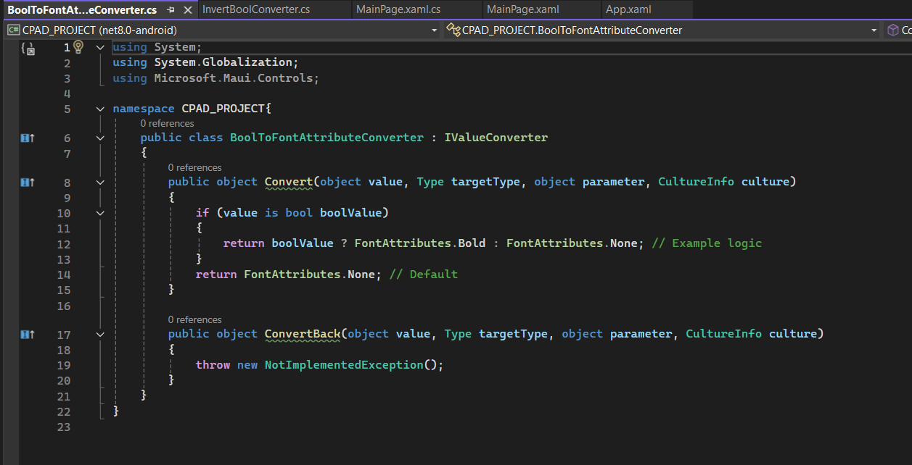

**Conclusion:** Both React Native and .NET MAUI are powerful frameworks for building cross-platform mobile applications, but they cater to different developer preferences and ecosystems. React Native relies on JavaScript and is widely used for its fast development cycles and community support. In contrast, .NET MAUI uses C# and XAML, making it ideal for developers with experience in Microsoft technologies. While React Native requires a bit more manual setup, .NET MAUI integrates tightly with Visual Studio, offering a more streamlined environment for developers familiar with the .NET ecosystem.

Both frameworks allow for the creation of efficient, performant mobile applications, but their toolsets and workflows cater to different audiences and project requirements.