**Aim:** Programs regarding concepts of JavaScript, JSX, XAML and C#.

The aim of this lab experiment is to understand and implement basic concepts of JavaScript, JSX, XAML, and C# through simple programs. The experiment will explore the syntax and functionality of each language within their respective environments (React Native for JavaScript and JSX, .NET MAUI for XAML and C#).

**Description:**

**Objective:**

* To learn the basic syntax and core concepts of JavaScript, JSX, XAML, and C#.
* To understand how JavaScript and JSX are used in React Native for front-end development.
* To explore XAML and C# within the .NET MAUI environment for cross-platform mobile app development.
* To implement simple programs that demonstrate the use of each language in their respective frameworks.

**Tools Required:**

* Node.js and React Native CLI for JavaScript and JSX (React Native development).
* Visual Studio 2022 with .NET MAUI for XAML and C# (cross-platform app development).
* Code editor: Visual Studio Code for JavaScript/JSX, Visual Studio 2022 for XAML and C#.
* Android Studio (for Android Emulator) or a physical device for testing mobile apps.

**Implementation:**

1. ***JavaScript in React Native:***

***Program:*** A simple React Native component using JSX to display Degree to Fahrenheit

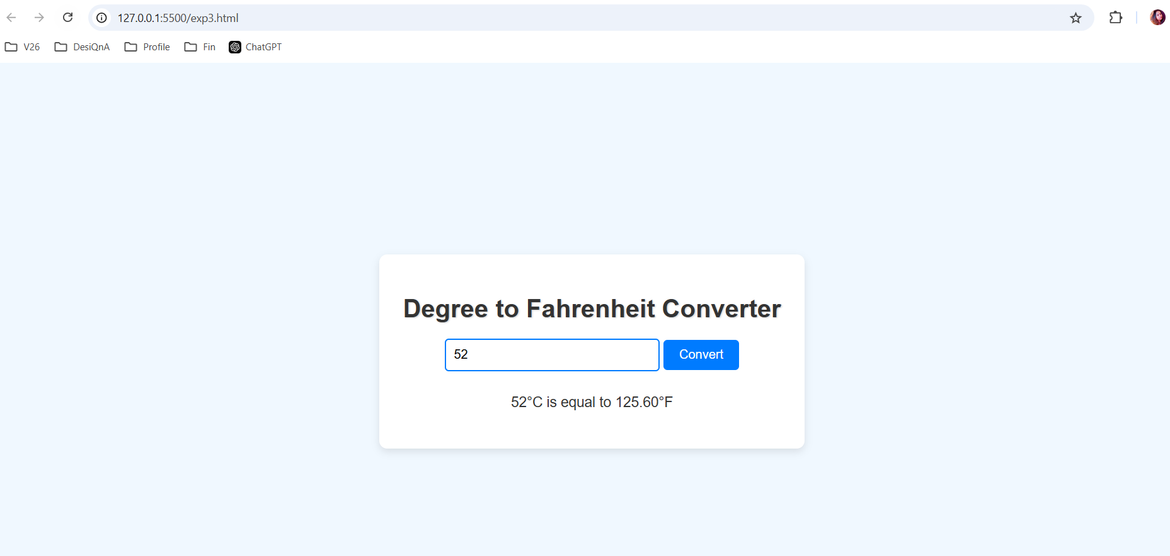

<!DOCTYPE html>

<html lang="en">

<head>

<meta charset="UTF-8">

<meta name="viewport" content="width=device-width, initial-scale=1.0">

<title>Degree to Fahrenheit Converter</title>

<style>

body {

font-family: Arial, sans-serif;

background-color: #f0f8ff;

margin: 0;

padding: 20px;

display: flex;

flex-direction: column;

align-items: center;

height: 100vh; /* Full height for centering */

justify-content: center; /* Center vertically */

}

h1 {

color: #333;

margin-bottom: 20px;

text-shadow: 1px 1px 2px rgba(0, 0, 0, 0.2);

}

.container {

background-color: #ffffff; /* White background for the container */

padding: 30px;

border-radius: 10px;

box-shadow: 0 4px 10px rgba(0, 0, 0, 0.1);

text-align: center; /* Center text in the container */

}

input[type="number"] {

padding: 10px;

border: 2px solid #007bff;

border-radius: 5px;

margin-bottom: 10px;

width: 250px;

font-size: 16px;

transition: border-color 0.3s; /* Smooth transition for border color */

}

input[type="number"]:focus {

border-color: #0056b3; /* Change border color on focus */

outline: none; /* Remove default outline */

}

button {

padding: 10px 20px;

background-color: #007bff;

color: white;

border: none;

border-radius: 5px;

cursor: pointer;

font-size: 16px;

transition: background-color 0.3s; /* Smooth transition for background color */

}

button:hover {

background-color: #0056b3;

}

p {

margin-top: 20px;

font-size: 18px;

color: #333;

}

@media (max-width: 500px) {

input[type="number"] {

width: 200px; /* Responsive input width */

}

button {

width: 100%; /* Full width button on small screens */

}

}

</style>

</head>

<body>

<div class="container">

<h1>Degree to Fahrenheit Converter</h1>

<input type="number" id="degreeInput" placeholder="Enter degrees Celsius">

<button onclick="convertToFahrenheit()">Convert</button>

<p id="result"></p>

</div>

<script>

function convertToFahrenheit() {

const celsius = parseFloat(document.getElementById('degreeInput').value);

if (isNaN(celsius)) {

document.getElementById('result').innerText = "Please enter a valid number.";

return;

}

const fahrenheit = (celsius * 9 / 5) + 32;

document.getElementById('result').innerText = `${celsius}°C is equal to ${fahrenheit.toFixed(2)}°F`;

}

</script>

</body>

</html>

***Description****: JSX (JavaScript XML) is a syntax extension for JavaScript, commonly used in React Native to define UI components. In this program, we use JSX to render a Text component within a View to display.*

1. ***C# in .NET MAUI:***
2. ***XAML in .NET MAUI:***

***Program:*** A basic .NET MAUI app that displays Degree to Fahrenheit

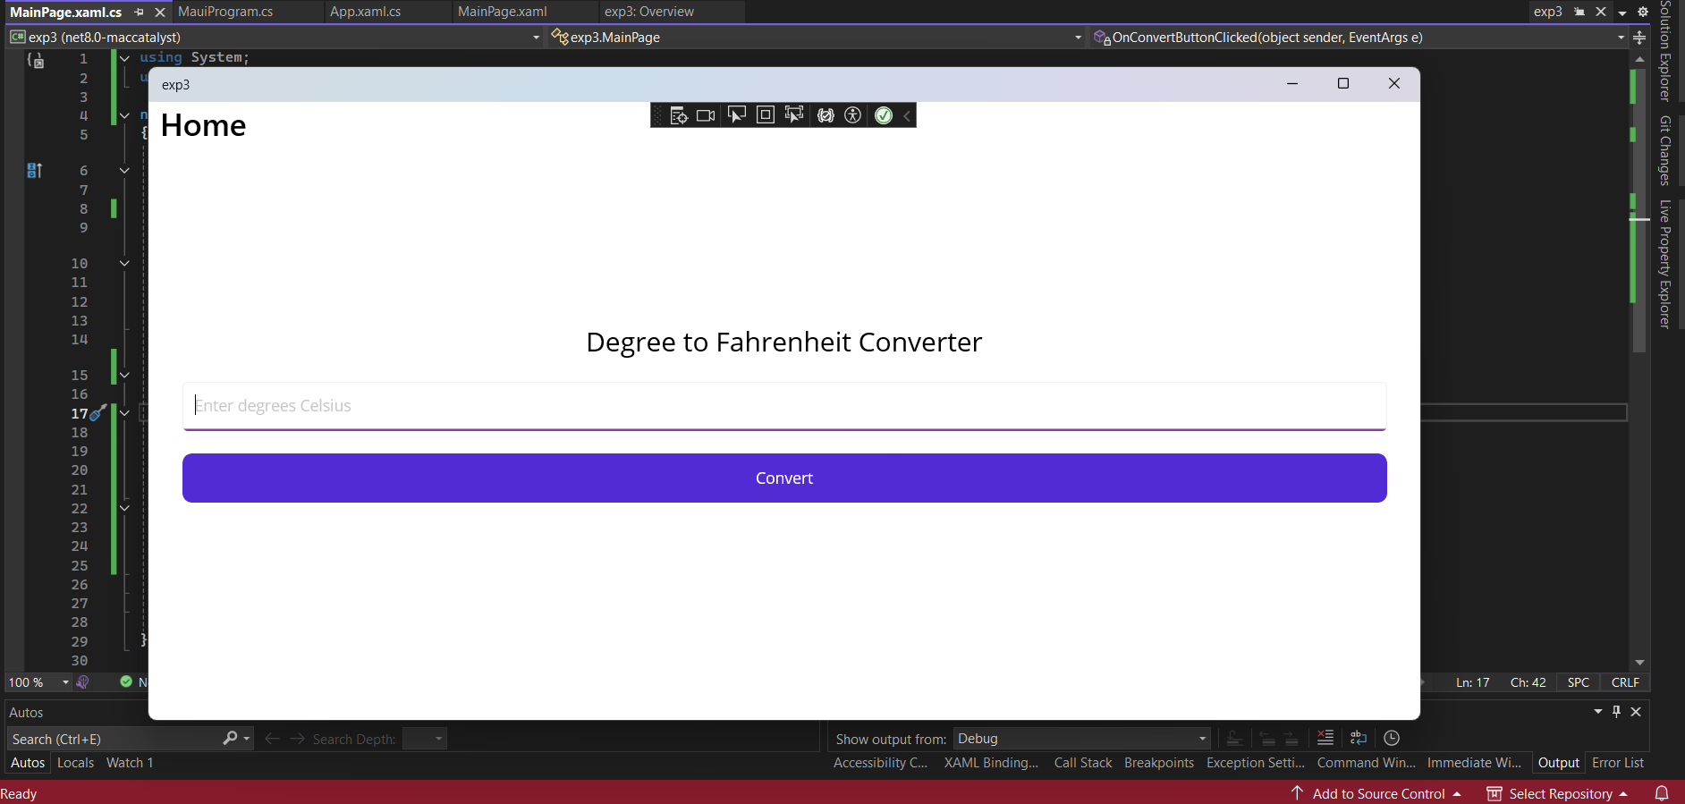

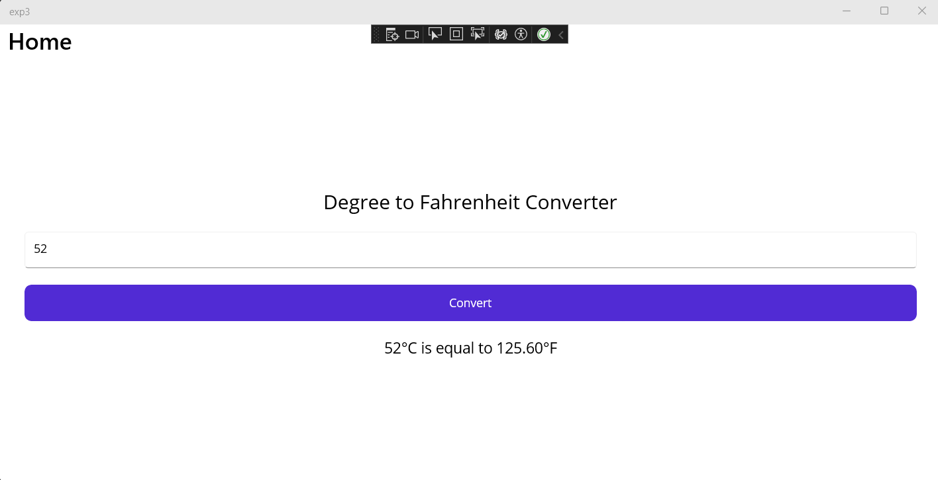

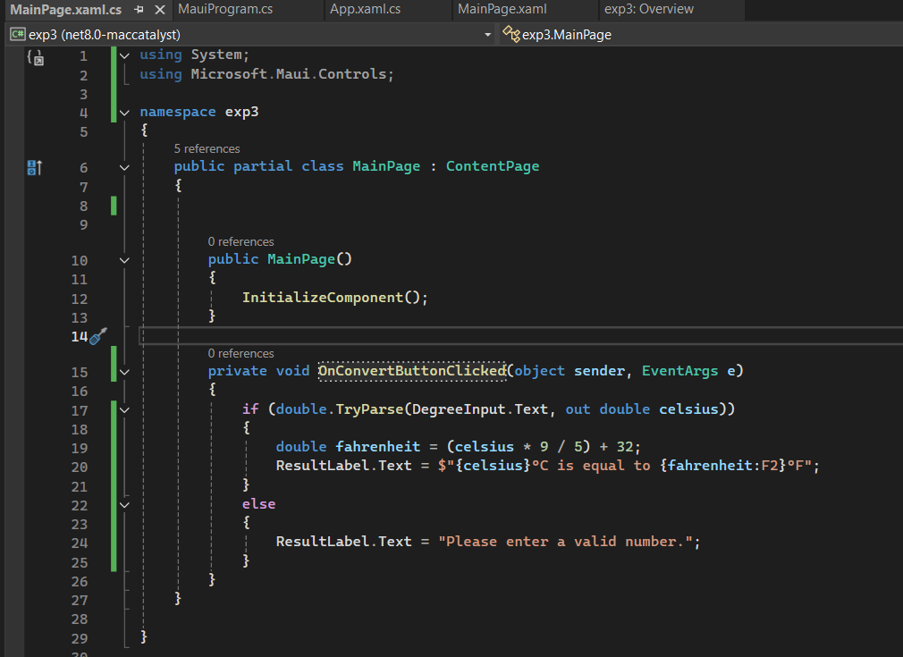

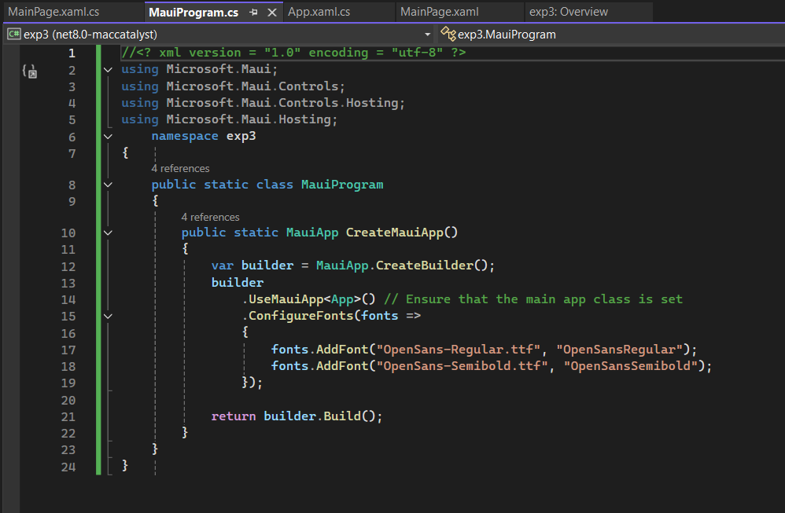

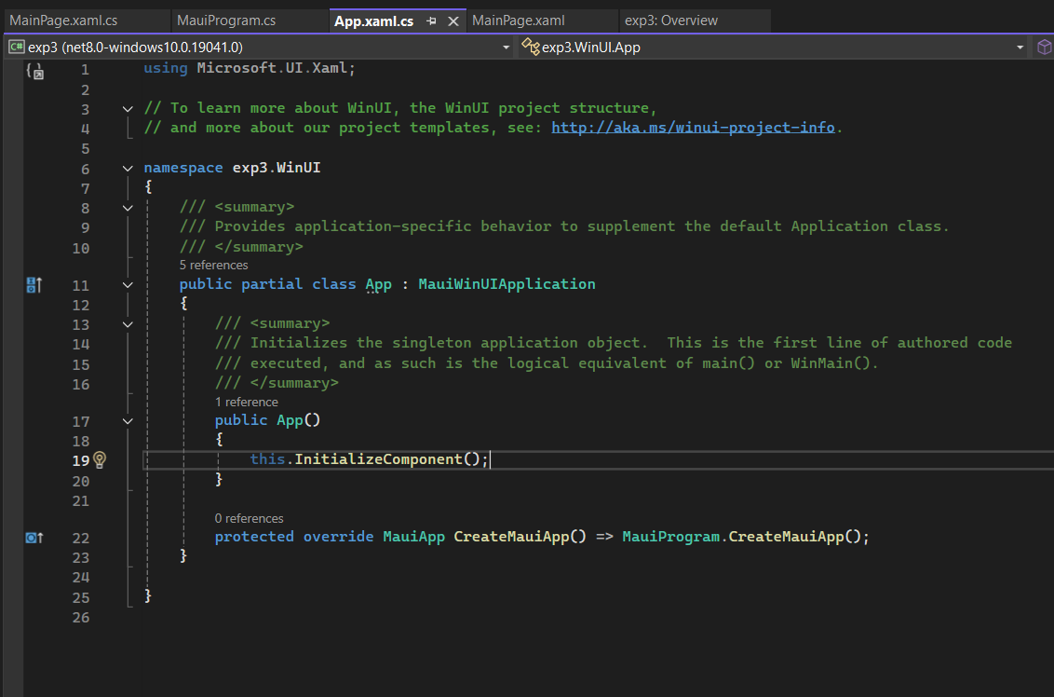

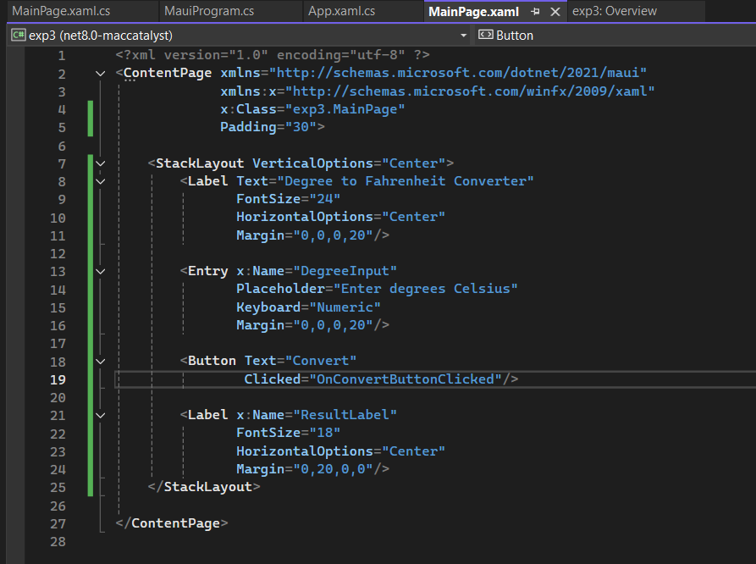

***Description****: XAML (Extensible Application Markup Language) is a markup language used in .NET MAUI for defining UI layouts. In this program, we define a simple user interface with a label and a button. When the button is clicked, a C# event handler will respond to the action.*

**Conclusion:**

This lab experiment demonstrated the basic usage of JavaScript, JSX, XAML, and C# within their respective frameworks—React Native and .NET MAUI. We learned how JavaScript and JSX are used for creating dynamic UI elements and logic in React Native applications, while XAML and C# provide a structured way to create and handle events in .NET MAUI apps. Understanding the syntax and capabilities of these languages allows developers to build cross-platform mobile applications with rich user interfaces and interactivity.