**Aim:** Write a Program to Perform Named Entity Recognition (NER)

**Description:**

Named Entity Recognition (NER) is a technique used in Natural Language Processing (NLP) to identify and classify named entities in text, such as names of people, organizations, locations, dates, etc. The goal of this program is to extract these entities from a given text.

**Objective:**

The objective is to build a Python program that performs NER on a given text using a pre-trained model from popular NLP libraries such as **spaCy**.

**Steps Overview:**

• Install Required Libraries: Use Python libraries like spaCy that come with pre-trained NER models.

• Load Pre-trained NER Model: Load a pre-trained NER model from the library.

• Text Input: Accept or define an input text.

• Perform NER: Process the input text using the NER model.

• Extract Entities: Extract and classify named entities such as persons, organizations, locations, etc.

• Display Results: Output the identified named entities.

**Implementation:**

*import spacy*

*# Load the pre-trained NER model*

*nlp = spacy.load("en_core_web_sm")*

*# Input text for entity recognition*

*text = """*

*Elon Musk, the CEO of SpaceX and Tesla, was in San Francisco on January 20, 2023.*

*He met with Tim Cook, the CEO of Apple, to discuss a new partnership.*

*"""*

*# Process the text using spaCy NER model*

*doc = nlp(text)*

*# Extract and display named entities*

*print("Named Entities, Phrases, and Concepts:")*

*for ent in doc.ents:*

*print(f"{ent.text} ({ent.label_})")*

**Output:**

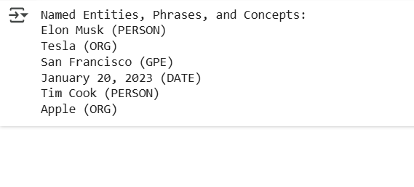

**Conclusion:**

This program successfully identifies named entities in a given text using **spaCy**, a popular NLP library. By leveraging a pre-trained model, it can recognize entities such as names, organizations, locations, and dates. This technique can be extended to more complex use cases, such as document analysis or automatic tagging in large datasets.