**Aim:** Write a program to perform the trigger word/keyword detection from speech data.

**Description:**

The aim of this project is to develop a program that detects specific trigger words or keywords from speech data. This is often used in applications such as virtual assistants (e.g., "Hey Siri" or "Ok Google"). The detection involves processing audio input, converting it to text using Automatic Speech Recognition (ASR), and searching for a predefined set of keywords.

**Objective:**

• Implement speech recognition to capture and analyze spoken input.

• Detect the presence of predefined keywords in the speech.

• Provide an alert or response when the trigger word is detected.

**Steps Overview:**

1. **Collect Audio Data:**
   * Use a microphone or recorded speech data as input.
2. **Preprocessing of Audio Data:**
   * Convert the audio into a format suitable for processing (e.g., PCM format).
   * Perform noise reduction and normalization if necessary.
3. **Speech-to-Text Conversion (ASR):**
   * Use an ASR tool or library like Google Speech API, CMU Sphinx, or SpeechRecognition in Python to transcribe the speech to text.
4. **Keyword Detection:**
   * Define a list of trigger words/keywords to search for in the transcribed text.
   * Perform text matching to check if any keyword is present in the transcript.
5. **Alert or Response:**
   * If a trigger word is detected, take appropriate action, such as printing a
   * message or triggering an event (e.g., sending a command or playing a sound).

**Implementation:**

**Install SpeechRecognition**

*!pip install SpeechRecognitionImplementation*

*!pip install pydub*

*!apt install ffmpeg*

**Upload MP3 file**

*from google.colab import files*

*uploaded = files.upload()*

**Convert MP3 to WAV**

*from pydub import AudioSegment*

*# Replace 'hello.mp3' with your actual file name*

*audio = AudioSegment.from_mp3("hello.mp3")*

*audio.export("hello.wav", format="wav")*

**Run Trigger Word Detection**

*import speech_recognition as sr*

*recognizer = sr.Recognizer()*

*with sr.AudioFile("hello.wav") as source:*

*audio_data = recognizer.record(source)*

*try:*

*text = recognizer.recognize_google(audio_data)*

*print("Recognized Speech:", text)*

*trigger_word = "hello"*

*if trigger_word.lower() in text.lower():*

*print(f"Trigger word '{trigger_word}' detected!")*

*else:*

*print("No trigger word detected.")*

*except sr.UnknownValueError:*

*print("Could not understand the audio.")*

*except sr.RequestError as e:*

*print(f"API error: {e}")*

**Output:**

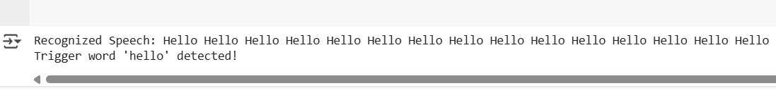

**Conclusion:**

This program demonstrates how to detect a specific trigger word from live speech input using speech recognition techniques. It can be extended to handle multiple keywords, perform additional processing, or integrate with other applications, such as triggering actions in a home automation system or sending a command to a device.