**Aim:** Prepare software test plan for the software

**Description:**

**What is a Test Plan?**

A [*test plan*](https://www.geeksforgeeks.org/software-testing-test-plan-estimates-and-strategy/)is a document that consists of all future testing-related activities. It is prepared at the project level and in general, it defines work products to be tested, how they will be tested, and test type distribution among the testers. Before starting testing there will be a test manager who will be preparing a test plan. In any company whenever a new project is taken up before the tester is involved in the testing the test manager of the team would prepare a test Plan.

* The test plan serves as the blueprint that changes according to the progressions in the project and stays current at all times.
* It serves as a base for conducting testing activities and coordinating activities among a QA team.
* It is shared with Business Analysts, Project Managers, and anyone associated with the project.

**What is the Importance of Test Plan?**

Making Test Plan document has multiple benefits

* Help people outside the test team such as developers, business managers, customers **understand** the details of testing.
* Test Plan **guides** our thinking. It is like a rule book, which needs to be followed.
* Important aspects like test estimation, test scope. Strategy are **documented** in Test Plan, so it can be reviewed by Management Team and re-used for other projects.

**How to write a Test Plan**

You already know that making a **Test Plan** is the most important task of Test Management Process. Follow the seven steps below to create a test plan:

1. Analyse the product
2. Design the Test Strategy
3. Define the Test Objectives
4. Define Test Criteria
5. Resource Planning
6. Plan Test Environment
7. Schedule & Estimation
8. Determine Test Deliverables

**Approach:**

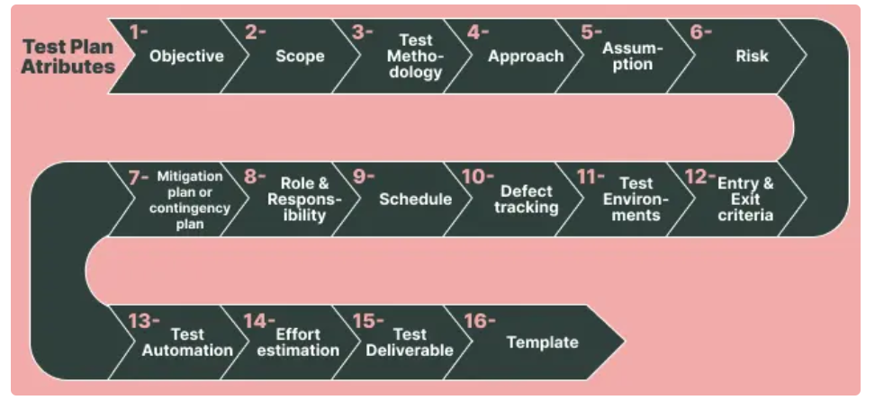

Example: test plan for a login page

Below is an example of preparing various test cases for a login page with a username and password.

* *Unit Test case:* Here we are only checking if the username validates at least for the length of eight characters.

| Test Id | Test Condition | Test Steps | Test Input | Test Expected Result | Actual Result | Status | Remarks |
| --- | --- | --- | --- | --- | --- | --- | --- |
| 1. | Check if the username field accepts the input of thirteen characters. | 1. Give input | geetaseshapalli | Accepts for fifteen characters | Accepts for thirteen characters | Pass | None |

Here it is only checked whether the passing of input of fifteen characters is valid or not. So since the character word ‘geetaseshapalli’ is entered then the test is successful it would have failed for any other test case.

* *Functionality Test case:* Here it is checked whether the username and password both work together on the login click.

| Test Id | Test Condition | Test Steps | Test Input | Test Expected Result | Actual Result | Status | Remarks |
| --- | --- | --- | --- | --- | --- | --- | --- |
| 1. | Check that with the correct username and password able to log in. | 1. Enter the username  2. Enter the password  3. Click on the login | username: geeta  password: seshapalli | Login successful | Login successful | Pass | None |
| 2. | Check that if with an incorrect username and password able to not login. | 1. Enter the username  2. Enter the password  3. Click on the login | username: geetas  password: geetss | Login unsuccessful | Login unsuccessful | Pass | None |

Here it is being checked whether passing wrong and right inputs and if the login functionality is working or not, it is showing login is successful for the right credentials and unsuccessful for the wrong ones, hence both tests have passed otherwise would have failed.

* *User Acceptance Test Case:* Here the user feedback is taken if the login page is loading properly or not.

| Test Id | Test Condition | Test Steps | Test Input | Test Expected Result | Actual Result | Status | Remarks |
| --- | --- | --- | --- | --- | --- | --- | --- |
| 1. | Check if the loading page loading efficiently for the client. | 1. Click on the login button. | None | Welcome to the login page. | Welcome to the login page. | Fail | The login page is not loaded due to a browser compatibility issue on the user’s side. |

Here it is being checked in by clicking on the login button if the page is loaded and the ‘Welcome to login page ‘message is displayed. The test has failed here as the page was not loaded due to a browser compatibility issue, it would have loaded if the test had passed.

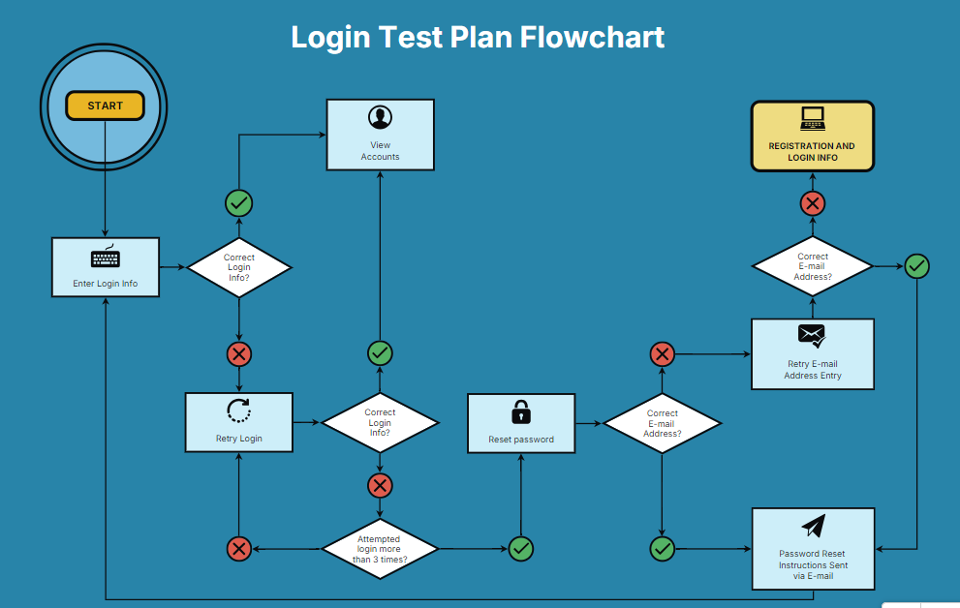

**Conclusion:** Writing effective test plan is a fundamental part of the software testing process. It ensures that the software is tested thoroughly, and any defects are identified and resolved early in the development cycle. Effective test cases are clear, concise, and comprehensive, covering all possible scenarios to ensure the software’s functionality, performance, and reliability. By following a structured approach to writing test cases, testers can improve the quality of the software, reduce the risk of defects, and ensure that the software meets the requirements and expectations of the stakeholders.