Heat Exchanger Design and Performance Analysis Tool Using Python

Abstract:
This project presents the development of a Python-based heat exchanger design and performance analysis tool for a double-pipe heat exchanger. The objective of the project is to apply fundamental heat transfer concepts and investigate the influence of operating parameters on heat exchanger performance. The tool implements the Log Mean Temperature Difference (LMTD) method and the NTU-effectiveness approach to calculate heat duty, heat transfer area, effectiveness, heat capacity rates, capacity ratio and energy balance error.
The tool was further utilized to generate performance plots illustrating the effects of key parameters such as mass flow rate and overall heat transfer coefficient on heat duty, effectiveness, and required heat transfer area. The results show that the required heat transfer area decreases with increasing overall heat transfer coefficient and increases with increasing fluid flow rates. The effectiveness versus overall heat transfer coefficient plot produced a nearly horizontal trend under the assumptions employed in the analysis. A comparison between parallel-flow and counterflow heat exchangers shows that both configurations exhibit increasing effectiveness with counterflow effectiveness always higher than parallel flow effectiveness for increasing NTU, eventually approaching an asymptotic value. We further verified our calculations by simulating a counter current heat exchanger in DWSIM, the results showed by the software showed that our tool gave perfect output with less than 0.05% error. In overall, the project successfully combines heat transfer theory with Python programming to create an engineering analysis tool and provides insights into the design and performance characteristics of heat exchangers.

Introduction:
Heat transfer is the process of transfer of thermal energy from a region of higher temperature to a region of lower temperature. It is the fundamental mechanism involved in many industrial equipment such as heaters, heat exchangers, refrigerators, and distillation columns. One of the simplest types of heat exchangers is the double-pipe heat exchanger, which can operate in either parallel-flow or counterflow arrangement. These two configurations exhibit different thermal performance under the same operating conditions.
Since the performance of a heat exchanger depends on various operating parameters, it is important to study their influence on heat transfer and overall performance. This project aims to analyze the behavior of a double-pipe heat exchanger and study the effect of parameters such as fluid flow rate, overall heat transfer coefficient, and NTU on its performance. It also compares the performance of parallel-flow and counterflow heat exchangers to better understand their operating characteristics.

Theory:
#Heat Duty: the amount of heat a system/fluid can loose or gain due to a temperature gradient is called its heat duty. It is given by the equation
$$Q=\dot{m} C_{p} ΔT$$
$$Q=U A ΔT_{lmtd}$$

#Heat Capacity Rate: it is defined as the rate at which a flowing fluid can absorb or release heat.
$$C=\dot{m} C_{p}$$

# Capacity Ratio: it tells how similar the two streams are in absorbing or releasing heat. Value closer to 1 means both are similar while if close to 0 then one fluid undergoes a larger temperature change than the other.
$$C_{r}=\frac{C_{min}}{C_{max}}$$

#Maximum possible heat transfer: it is the measure of the maximum heat transfer that can take place between the two fluids irrespective of the amount of heat they are capable of releasing or absorbing individually.
$$Q_{max}= C_{min}(T_{h,i}-T_{c,i})$$

The minimum heat capacity rate is used because it represents the stream that limits the maximum possible heat transfer. Using $C_{max}$would imply that the other stream must undergo a temperature change beyond its physically achievable limit under the given inlet conditions.

#Log Mean Temperature Difference (LMTD): it is used instead of the arithmetic mean temperature difference because the temperature difference between the two fluids varies continuously along the length of the heat exchanger. It provides the appropriate average driving force for calculating the required heat transfer area.
$$T_{lmtd}= \frac{ΔT_{1}-ΔT_{2}}{ln⁡(\frac{ΔT_{1}}{ΔT_{2}})}$$

#NTU (Number of transfer units): The NTU-effectiveness method is commonly used to determine the performance of a heat exchanger, particularly when the outlet temperatures are unknown. It is given by
$$NTU=\frac{UA}{C_{min}}$$

The value of NTU is also used to calculate the effectiveness of exchanger with parallel flow, counter flow, shell and tube and cross flow type flow arrangements.

#Effectiveness: It is the ratio of the actual heat transfer to the maximum possible heat transfer. It indicates how efficiently a heat exchanger transfers heat relative to the maximum possible heat transfer. An effectiveness of 1 represents an ideal heat exchanger, while values closer to 0 indicate poorer performance.
$$ε=\frac{Q}{Q_{max}}$$

Parallel flow effectiveness is given by:
$$ε=1-\exp\left(\frac{-NTU\left(1+\left(\frac{C_{min}}{C_{max}}\right)\right)}{1+\left(\frac{C_{min}}{C_{max}}\right)}\right)$$
Counterflow effectiveness is given by:
$$ε=1-\exp\left(\frac{-NTU\left(1-\left(\frac{C_{min}}{C_{max}}\right)\right)}{1-\left(\frac{C_{min}}{C_{max}}\right)}\right)$$

The above equations form the basis of the computational model developed in Python. The user inputs the operating parameters, after which the program performs the required calculations and generates plots to analyze the influence of different parameters on heat exchanger performance.

Methodology:
#Software Used: The computational tool was developed using Python 3.x. The built-in math module was used to perform mathematical calculations required for the LMTD and NTU-effectiveness methods, while the Matplotlib library was used to generate engineering plots for performance analysis. The program was developed and executed using Visual Studio Code and validated by simulating a heat exchanger in DWSIM under steady state.

#Input Parameters: The user is asked to input inlet temperatures, heat capacities, mass flow rates and overall heat transfer coefficient for the two fluid streams.

#Computational procedure:
1. The program first accepts the required input parameters, including the inlet and outlet temperatures of the hot and cold fluids, mass flow rates, specific heat capacities, and the overall heat transfer coefficient.
2. Using these inputs, the heat duties of the hot and cold fluids are calculated.
3. The heat capacity rates, capacity ratio, and maximum possible heat transfer are then determined.
4. The Log Mean Temperature Difference (LMTD) is calculated from the temperature differences at the two ends of the heat exchanger.
5. The required heat transfer area is obtained using the LMTD method.
6. The effectiveness of the heat exchanger and the energy balance error are then evaluated.
7. Finally, the program performs parametric analyses by varying selected operating parameters and generates plots to study the performance of the heat exchanger.

User Inputs → Calculate Heat Duties → Calculate Capacity Rates & Capacity Ratio
↓
Calculate Heat Transfer Area ← Calculate LMTD
↓
Calculate Effectiveness & Error → Generate Performance Plots

Results and Discussion:

# Required Heat Transfer Area vs Overall Heat Transfer Coefficient:
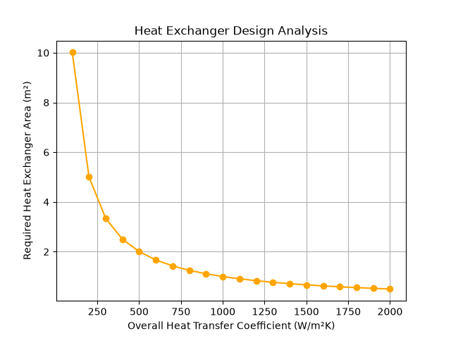
$Q=UA{ΔT}_{lmtd}$ $A∝\frac{1}{U}$
From this plot, we can observe that increasing the overall heat transfer coefficient ($U$) results in a decrease in the required heat transfer area ($A$) to achieve a given heat duty, assuming all other parameters remain constant. Therefore, a system with a lower overall heat transfer coefficient requires a larger heat transfer area than one with a higher coefficient. This relationship is useful during heat exchanger design, as it helps determine an appropriate combination of heat transfer area and overall heat transfer coefficient for the desired operating conditions.

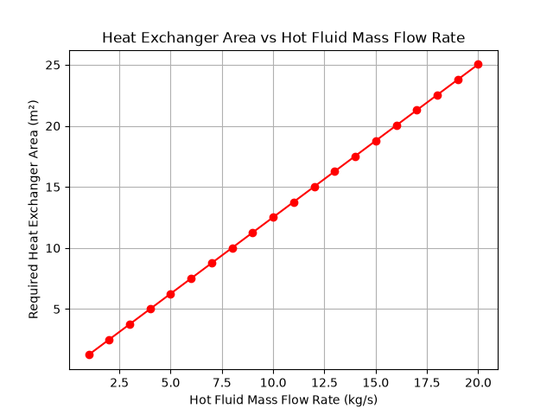
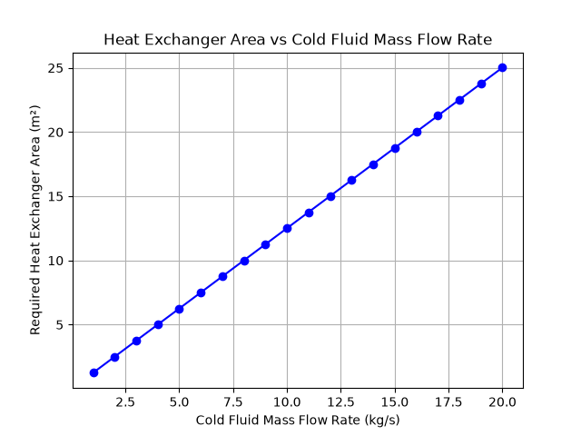
#Required heat transfer area v/s hot fluid flow rate and Required heat transfer area v/s cold fluid flow rate:

From the above plots, it can be observed that the required heat transfer area increases linearly with both the hot and cold fluid mass flow rates. Therefore, increasing the flow rate of either stream requires a larger heat transfer area to achieve the corresponding heat duty. This trend can be explained using the heat duty and LMTD equations:

$$Q_{c}=m_{c}*C_{p,c}*{ΔT}_{c} Q_{h}=m_{h}*C_{p,h}*{ΔT}_{h}$$
$$Q=UA{ΔT}_{lmtd}$$

From these equations, if we assume that the inlet and outlet temperatures, heat capacities as well as overall heat transfer coefficients are constant then

$$Q_{c}∝m_{c} Q_{h}∝m_{h} Q∝A$$
Also, for an ideal system we know that Q_{c} = Q_{h} =Q. So,
$$m_{c}∝A and m_{h}∝A$$
Since the required heat transfer area is directly proportional to the heat duty under these assumptions, the heat transfer area also varies linearly with the mass flow rate, resulting in the observed linear trend.
#Effectiveness v/s overall heat transfer coefficient:
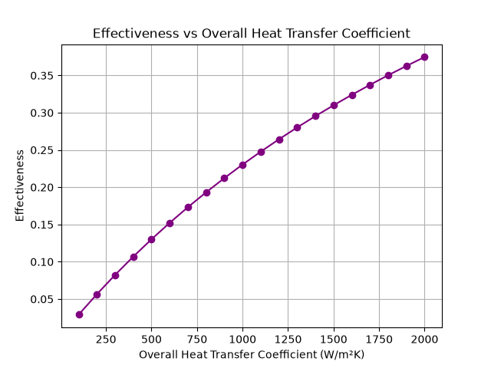
\
When we plot effectiveness against a range of U, we get a graph showing an increasing curve. This behavior occurs because an increase in the overall heat transfer coefficient results in increase in increase in NTU given other parameters remain constant. Since effectiveness depends on NTU and the capacity ratio, the effectiveness also increases. Therefor when we increase the overall heat transfer coefficient, we would be indirectly increasing the efficiency of the system.

$$NTU=\frac{UA}{C_{min}} so, if U↑ NTU ↑$$

$$since ε=f\left(NTU,C_{r}\right) thus ε also increases$$

# Effectiveness comparison, Parallel v/s Counter flow:
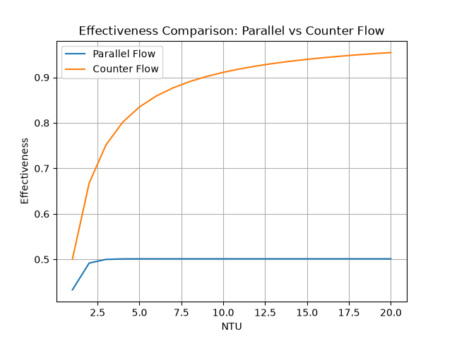
The comparison between parallel-flow and counterflow heat exchangers shows that the effectiveness of both configurations increases with increasing NTU and gradually approaches an asymptotic value. However, the counterflow heat exchanger consistently exhibits higher effectiveness than the parallel-flow heat exchanger over the entire NTU range. This indicates that, for the same operating conditions, a counterflow arrangement utilizes the available temperature difference more effectively and therefore provides better thermal performance.

#Sample Output
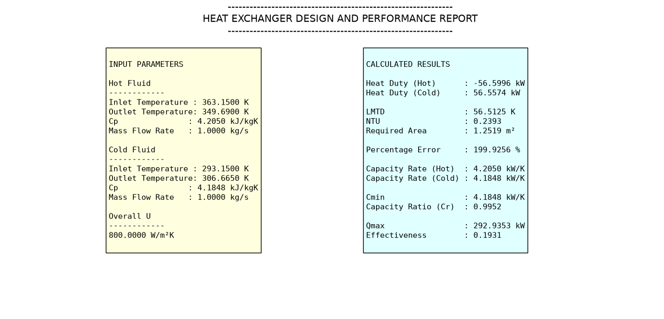
# Validation through DWSIM
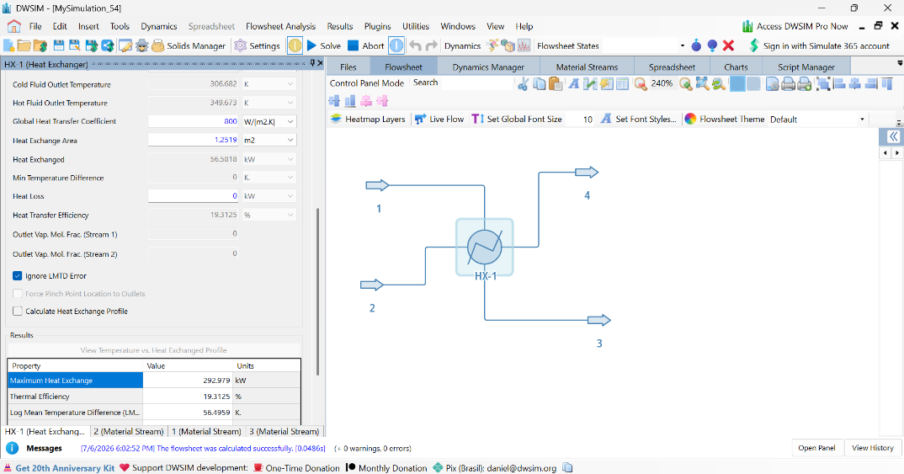
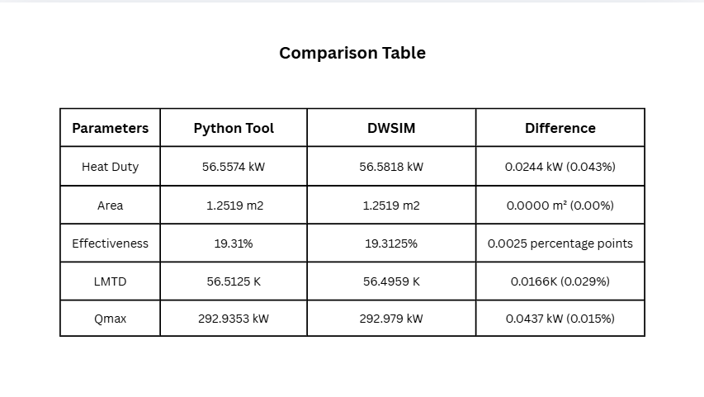

Conclusion:
In this project, a Python-based tool was developed to analyze and calculate the performance of a double-pipe heat exchanger. The program was designed to take basic operating parameters as input and calculate important performance values such as heat duty, effectiveness, heat transfer area, and other parameters that assist in heat exchanger analysis and design. The generated plots verify fundamental heat transfer relationships and illustrate how variations in operating parameters affect the performance of the heat exchanger, making them an important part of the analysis. The results were further verified by simulating a heat exchanger in DWSIM, we observed that the tool hardly showed 0.05% error compared to the software. Overall, the project demonstrates how Python can be used to simplify engineering calculations and visualize the effect of different operating parameters on heat exchanger performance.

