1. What are the differences between operators and values in the following?

*

'hello'

-87.8

-

/

+

6

Answer 1 :

Operators are used to perform operations on variables and values.

e.g . a =10 , here **a is variable** and **10 is value** assigned to that.

c = 10+5 , + is the arithmetic operator

* is an arithmetic operator used for multiplication

‘hello’ is string value

-87.8 is float value

- is an arithmetic operator used for subtraction

/ is an arithmetic operator used for division

+

6 is int value

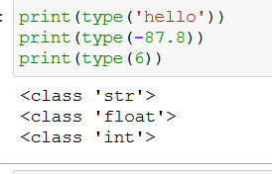

2. What is the difference between string and variable?

spam

'spam'

Answer 2 : spam is a variable and ‘spam’ is value for a string variable

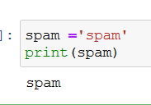

3. Describe three different data forms.

Answer 3 :

4. What makes up an expression? What are the functions of all expressions?

Answer 4 :

An expression is a combination of operators, constants and variables. An expression may consist of one or more operands, and zero or more operators to produce a value.

5. In this chapter, assignment statements such as spam = 10 were added. What's the difference between a declaration and an expression?

6. After running the following code, what does the variable bacon contain?

bacon = 22

bacon + 1

Answer 6 : 22

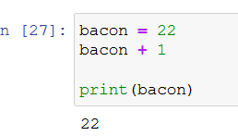

7. What should the values of the following two terms be?

'spam' + 'spamspam'

'spam' * 3

Answer7:

Output for 'spam' + 'spamspam' = spamspamspam

Output for 'spam' * 3 = spamspamspam

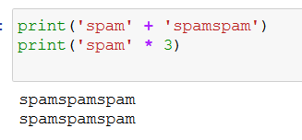

8. Why is it that eggs is a true variable name but 100 is not?

Answer 8:

A variable is like a container which can store a value , so eggs can be used a variable name and eggs also not a keyword .

The left hand side of the = operator needs to be a variable

Whereas using 100 as variable name will give ***SyntaxError: cannot assign to literal***.

When you use an assignment operator, you assign the value of what is on the right to the variable or element on the left , there is no variable or element on the left, but instead an interpreted value: you are trying to assign a value to something that isn't a “container”.

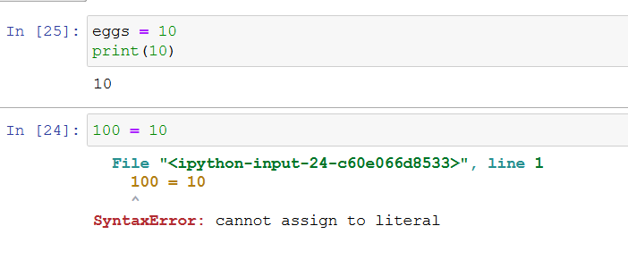

9. Which of the following three functions may be used to convert a value to an integer, a floating-point number, or a string?

Answer 9 :

int(),  float()  and str(),  function

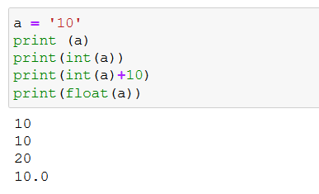

10. What is the error caused by this expression? What would you do about it?

'I have eaten ' + 99 + ' burritos.'

Answer 10 :

The cause by the above expression is :

TypeError: can only concatenate str (not "int") to str

