1. How do you distinguish between shutil.copy() and shutil.copytree()?

Ans1 :

copy() will copy a single file, shutil. copytree() will copy an entire folder and every folder and file contained in it. Calling shutil. copytree( source, destination ) will copy the folder at the path source , along with all of its files and subfolders, to the folder at the path destination

2. What function is used to rename files??

Ans2:

os. rename() method in Python is used to rename a file or directory. This method renames a source file/ directory to specified destination file/directory.

3. What is the difference between the delete functions in the send2trash and shutil modules?

Ans3:

The send2trash functions will move a file or folder to the recycle bin, while shutil functions will permanently delete files and folders.

4.ZipFile objects have a close() method just like File objects’ close() method. What ZipFile method is equivalent to File objects’ open() method?

Ans4:

ZipFile object . ZipFile objects are conceptually similar to the File objects which returned by the open() function .

5. Create a programme that searches a folder tree for files with a certain file extension (such as .pdf or .jpg). Copy these files from whatever location they are in to a new folder.

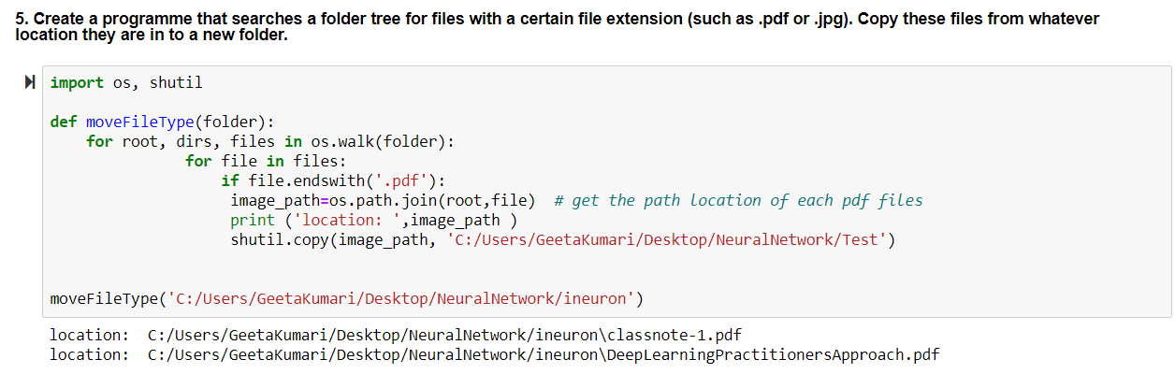

|  |
| --- |
| import os, shutil  def moveFileType(folder):  for root, dirs, files in os.walk(folder):  for file in files:  if file.endswith('.pdf'):  image_path=os.path.join(root,file) # get the path location of each pdf files  print ('location: ',image_path )  shutil.copy(image_path, 'C:/Users/GeetaKumari/Desktop/NeuralNetwork/Test')  moveFileType('C:/Users/GeetaKumari/Desktop/NeuralNetwork/ineuron') |

Output:

location: C:/Users/GeetaKumari/Desktop/NeuralNetwork/ineuron\classnote-1.pdf

location: C:/Users/GeetaKumari/Desktop/NeuralNetwork/ineuron\DeepLearningPractitionersApproach.pdf