1. What are the Boolean data type's two values? How do you go about writing them?

Answer 1: The two values of Boolean data type’s is : True and False.

We can use them as below

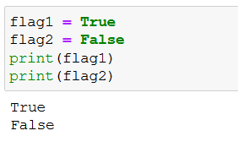

2. What are the three different types of Boolean operators?

Answer 2 : The three different types of Boolean operators are ‘and’ , ‘or’ and ‘not’

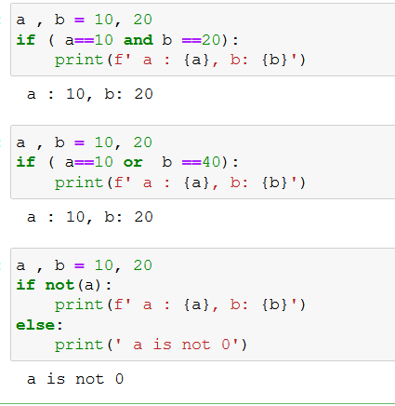

3. Make a list of each Boolean operator's truth tables (i.e. every possible combination of Boolean values for the operator and what it evaluate).

Answer 3 :

|  |  |  |  |  |
| --- | --- | --- | --- | --- |
| condition 1(x) | condition 2(y) | ( not x ) | ( x and y ) | ( x or y ) |
| false | false | true | false | false |
| false | true | true | false | true |
| true | false | false | false | true |
| true | true | false | true | true |

4. What are the values of the following expressions?

(5 > 4) and (3 == 5)

not (5 > 4)

(5 > 4) or (3 == 5)

not ((5 > 4) or (3 == 5))

(True and True) and (True == False)

(not False) or (not True)

**Answer 4 :**

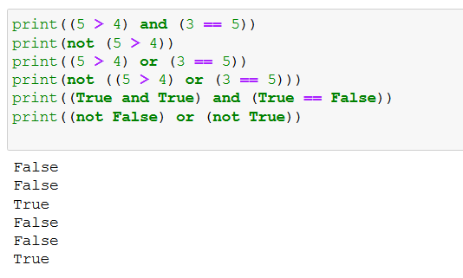

5. What are the six comparison operators?

Ans 5:

### 1. Less Than (<) Operator

### 2. Greater Than (>) Operator

### 3. Less Than or Equal To (<=) Operator

### 4.Equal To or Greater Than (>=) Operator

### 5. Equal To (==) Operator

### 6. Not Equal Operator (!=) Operator

6. How do you tell the difference between the equal to and assignment operators? Describe a condition and when you would use one.

Answer 6 :

Equal(=)  is an assignment operator. It is used for assigning the value to a variable.

x = 5

print(x)

O/P -> **5**

Assignment(==) is a relational or comparison operator. It is used for comparing two values. It returns 1 if both the values are equal otherwise returns 0.

The equal to operator returns True if the values on either side of the operator are equal.

>>> 3=='3'

o/p -> **False**

7. Recognize the following three blocks in this code:

spam = 0

if spam == 10:

print('eggs')

if spam > 5:

print('bacon')

else:

print('ham')

print('spam')

print('spam')

Answer 8 :

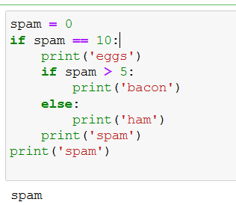

9. Create a programme that prints. If 1 is stored in spam, prints Hello; if 2 is stored in spam, prints Howdy; and if 3 is stored in spam, prints Salutations! if there's something else in spam.

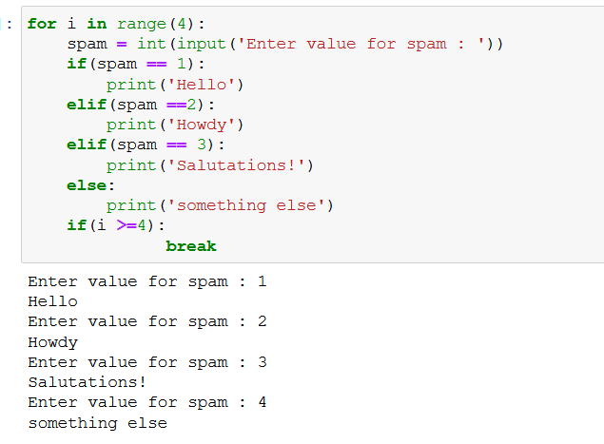

9.If your programme is stuck in an endless loop, what keys can you press?

Answer 9 :

 CTRL + C

10. How can you tell the difference between break and continue?

Answer 10:

The difference between break and continue statement is that when break keyword is encountered, it will exit the loop. In case of continue keyword, the current iteration that is running will be stopped, and it will proceed with the next iteration

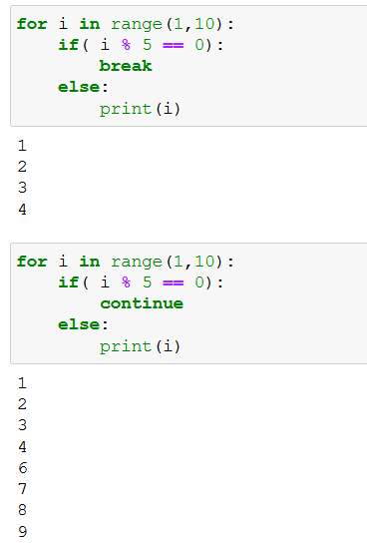

11. In a for loop, what is the difference between range(10), range(0, 10), and range(0, 10, 1)?

Answer 11 :

All are three are same. Syntax for range() is : range*(start, stop, step*) .

Default value for start and step is 1 .

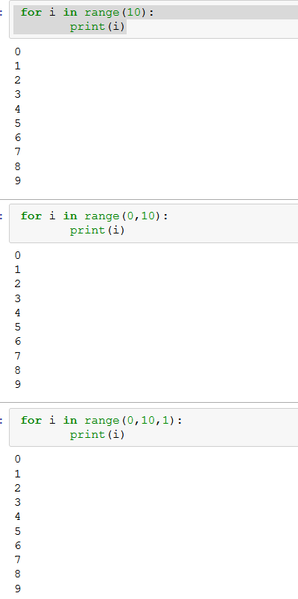

12. Using a for loop, write a short programme that prints the numbers 1 to 10 Then, using a while loop, create an identical programme that prints the numbers 1 to 10.

Answer 12:

Using for loop:

for i in range(1,11):

print(i)

Using While loop:

i =1

while (i<11):

print(i)

i+=1

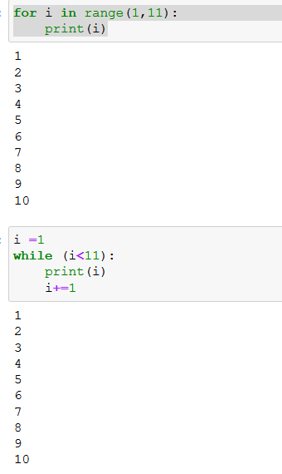

13. If you had a bacon() function within a spam module, what would you call it after importing spam?

Answer 13: spam.bacon()