1. Why are functions advantageous to have in your programs?

Ans 1:

The following are the advantages of Function:

* Avoid repetition of codes.
* Increases program readability.
* Divide a complex problem into simpler ones.
* Reduces chances of error.
* Modifying a program becomes easier by using function

2. When does the code in a function run: when it's specified or when it's called?

Ans 2:

The code in a function run when it’s called.

3. What statement creates a function?

Ans 3:

The “def” keyword is a statement for defining a function in Python.

4. What is the difference between a function and a function call?

Ans 4:

A function consists of the def statement and the code in its def clause

A Function is block of code than accepts some values processes the desire task on it and return the result value.

A function is procedure to achieve a particular result while function call is using this function to achieve that task.

e.g

# function

def my_function():  
  print("Hello from a function")  
  
my_function() # function call

5. How many global scopes are there in a Python program? How many local scopes?

Ans 5:

There is one global scope, and a local scope is created whenever a function is called.

6. What happens to variables in a local scope when the function call returns?

Ans 6 :   Local variable lifetime ends when the function completes its execution.

When a function returns, the local scope is destroyed, and all the variables in it are forgotten

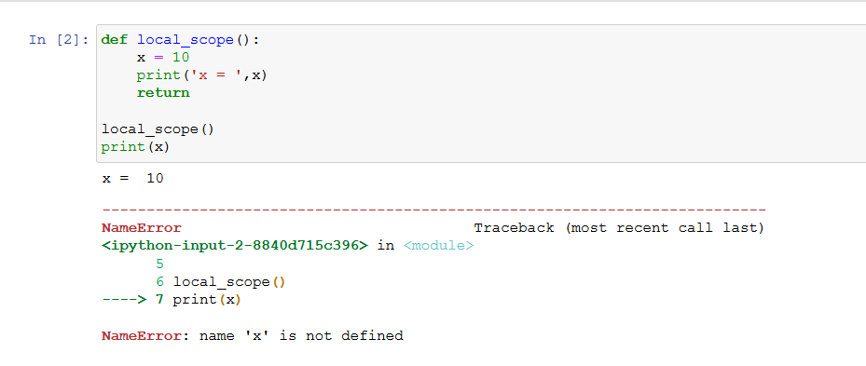

7. What is the concept of a return value? Is it possible to have a return value in an expression?

Ans 7:

A return value is the value that a function call evaluates to. Like any value, a return value can be used as part of an expression.

A return is a value that a function returns to the calling script or function when it completes its task.

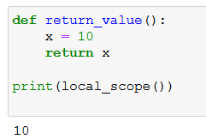

8. If a function does not have a return statement, what is the return value of a call to that function?

Ans8:

If there is no return statement for a function, its return value is None.

9. How do you make a function variable refer to the global variable?

Ans 9:

We can use ‘global’ keyword to make a function variable refer to the global variable.

A global statement will force a variable in a function to refer to the global variable.

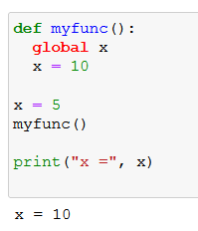

10. What is the data type of None?

Ans 10:

The data type of None is NoneType.

11. What does the sentence import areallyourpetsnamederic do?

Ans 11:

That import statement imports a module named areallyourpetsnamederic. (This isn’t a real Python module, by the way.)

12. If you had a bacon() feature in a spam module, what would you call it after importing spam?

Ans 12:

This function can be called with spam.bacon().

13. What can you do to save a programme from crashing if it encounters an error?

Ans 13:

purpose of the except clause Place the line of code that might cause an error in a try clause.

14. What is the purpose of the try clause? What is the?

Ans 14:

The code that could potentially cause an error goes in the try clause.

The code that executes if an error happens goes in the except clause.