1. What does an empty dictionary's code look like?

Ans1: {}

2. What is the value of a dictionary value with the key 'foo' and the value 42?

Ans2: {‘foo’,42}

3. What is the most significant distinction between a dictionary and a list?

Ans3: The items in dictionary are unordered while the items in list are ordered.

4. What happens if you try to access spam['foo'] if spam is {'bar': 100}?

Ans4: We will get KeyError error.

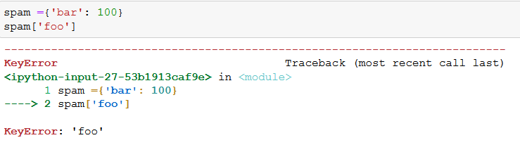

5. If a dictionary is stored in spam, what is the difference between the expressions 'cat' in spam and 'cat' in spam.keys()?

Ans5: There is no difference.

6. If a dictionary is stored in spam, what is the difference between the expressions 'cat' in spam and 'cat' in spam.values()?

Ans6: 'cat' in spam checks whether there is a 'cat' key in the dictionary, while 'cat' in spam.values() checks whether there is a value 'cat' for one of the keys in spam.

7. What is a shortcut for the following code?

if 'color' not in spam:

spam['color'] = 'black'

Ans7: spam.setdefault('color', 'black')

8. How do you "pretty print" dictionary values using which module and function?

Ans8: pprint.pprint()